**ASM Workbench is now LIVE**

The new ASM workbench is now live. New display and functionality make it easier for users to manage their programs from a single focal point.

Once a program is entered, users can create surveys and assessments, view files and add points of contact all from the workbench. Information is entered one time and carries through to Program Protection Plans (PPPs), Supply Chain Risk Management (SCRM) surveys, and all assessments and reports.

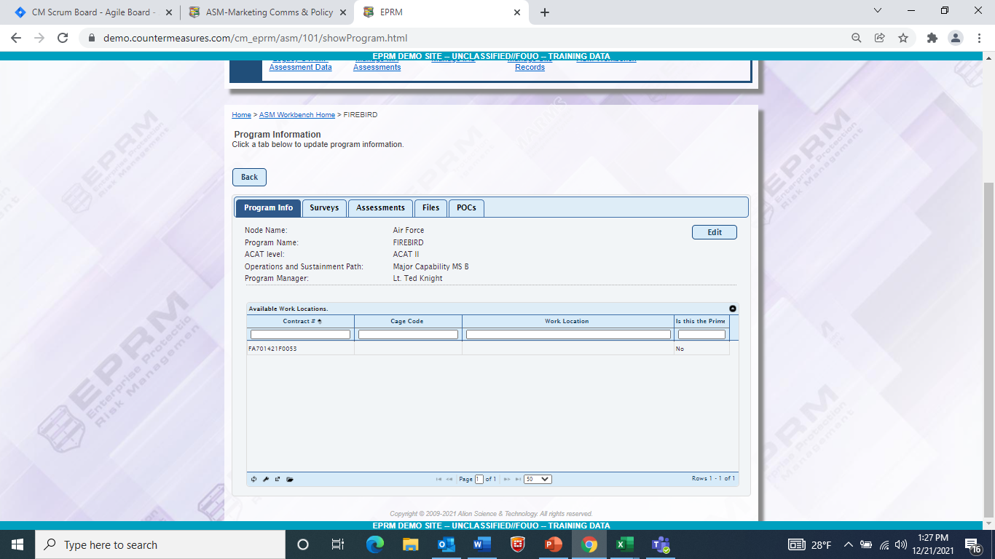

**General information flows to surveys, assessments, and reports.**

**Manage multiple areas of a program from a single point**

**Enhanced instructions on each tab**

**Read more…**

Figure ASM Workbench

**What it Means to ASM Users**

Now when you login into ASM, you will immediately be brought to the workbench with a list of programs.

If you do not see your program, you can add it.

1. Click on the **Create** button.
2. **Answer the questions**.
3. Click **Save**.
4. **Double click** on your program to open.

Nodal hierarchy logic remains intact. This means you only see programs at your node and below. As an assessor, you able to open and view your own program. (You can *see* other programs but cannot open them). As an assessment manager, you can see and open everything in your node and below.

**OTHER ENHANCEMENTS**

**Release/Unrelease Functionality**

Now when you begin a survey or an assessment, the work is “hidden” until you’re ready for it to be viewed by others. You can see it and share it with others but those above you will not be able to see it in their list or in reports until you release it for viewing. This means you can freely work on a PPP or SCRM survey and take your time without worry someone will see unfinished work.

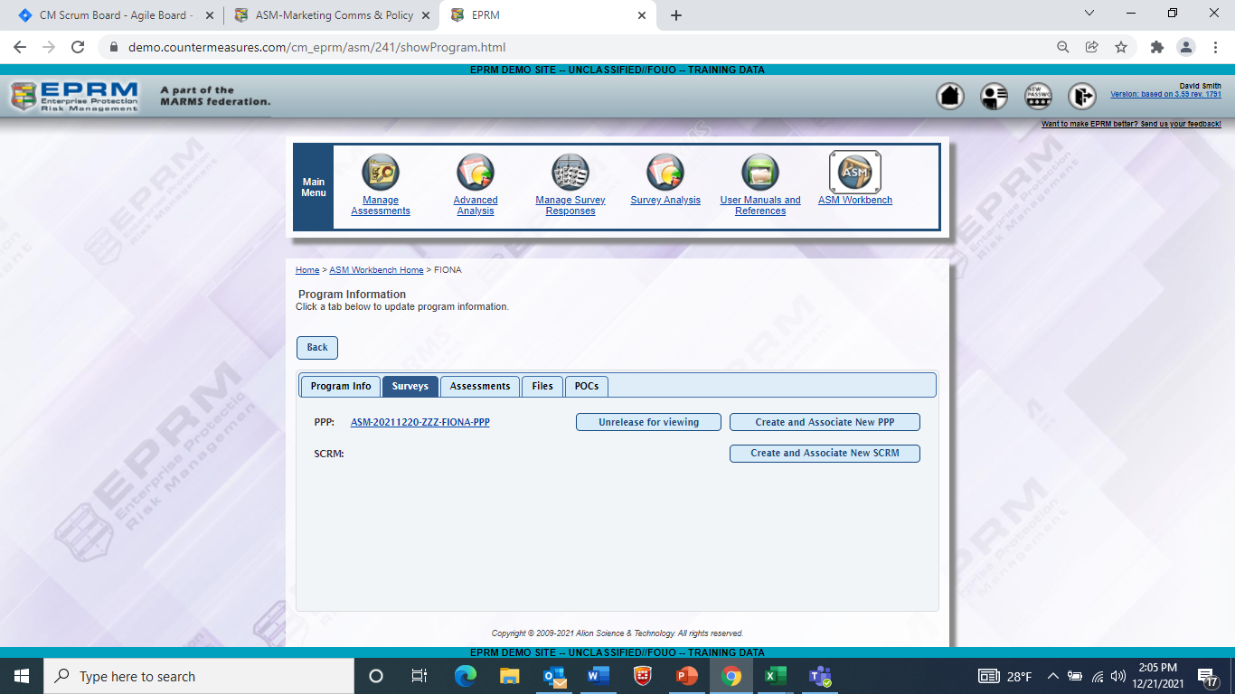

**Hyperlink to open the survey**

**Release or unrelease work using a toggle button.**

Figure Users can manage surveys from the workbench and release work when ready.

**Automated Assessment Creation**

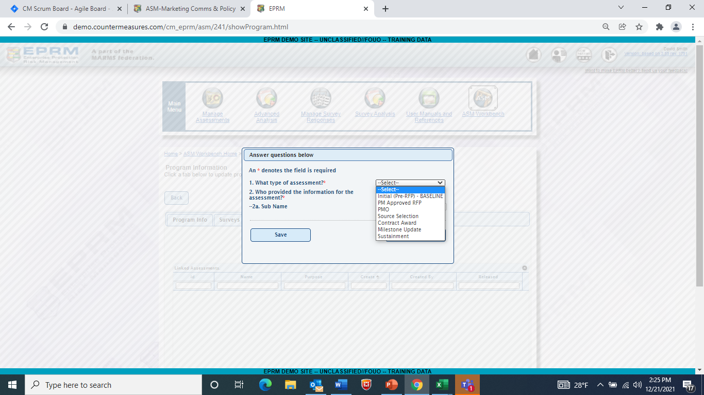The assessment process remains intact but now you no longer need worry about how to create the correct assessment for the stage in the program. Select the type of assessment and ASM does the background work for you, making sure the correct assessment is created.

Figure The new assessment creation page in the workbench makes it easy to create different types of assessments.

**Enhanced Reports**

As part of this upgrade, reports have been enhanced to allow you easily create status updates. You can now also identify programs with specific criteria such as Tier 1 and 2 technologies.

As soon as you complete your first survey, you can begin utilizing enhanced reports and analysis.

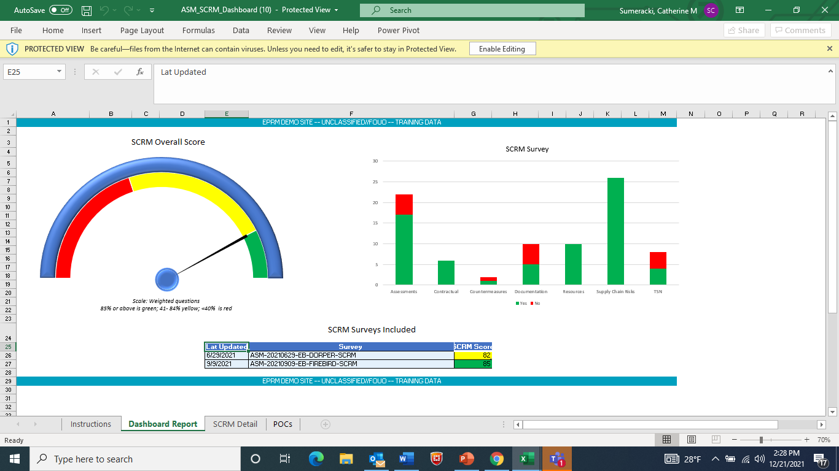

**More detail on the Detail tab**

Figure Example SCRM Dashboard Report

**Visit the ASM Demo Site**

You can experience ASM now by visiting the demo site at <https://demo.countermeasures.com>

Click on the “Request a login” button to get started.

