TABLE 1

| Location | Total cases | New cases reported in the last 24 hours | Rate of new daily infections per 100,000 | Active cases | Total deaths | Total tests performed | Cumulative percent of test positives | Rate of tests performed per thousand | Number of negative tests per positive (last 7 days) | Average number of tests performed per day for last 7 days | Average number of tests performed per day for last 7 days per thousand | Percent Positivity (Mar 7-13) |
| --- | --- | --- | --- | --- | --- | --- | --- | --- | --- | --- | --- | --- |
| British Columbia | 89,427 | 498 | 9.7 | 4,933 | 1,411 | 2,061,086 | 4.6% | 400 | 14.2 | 8,431 | 1.64 | 6.6% |
| Alberta | 139,622 | 479 | 10.8 | 4,918 | 1,956 | 3,532,816 | 3.9% | 799 | 20.2 | 8,682 | 1.96 | 4.4% |
| Saskatchewan | 30,970 | 87 | 7.4 | 1,264 | 410 | 614,152 | 5.3% | 521 | 16.6 | 2,503 | 2.12 | 5.8% |
| Manitoba | 32,996 | 96 | 7.0 | 1,035 | 917 | 560,485 | 6.4% | 406 | 17.1 | 1,887 | 1.37 | 5.3% |
| Ontario | 321,956 | 1,508 | 10.2 | 12,512 | 7,187 | 11,671,156 | 3.1% | 792 | 31.8 | 48,987 | 3.32 | 2.8% |
| Quebec | 299,450 | 703 | 8.2 | 6,833 | 10,570 | 6,696,559 | 4.3% | 781 | 34.4 | 25,304 | 2.95 | 2.8% |
| Newfoundland and Labrador | 1,013 | 0 | 0.0 | 40 | 6 | 212,699 | 0.7% | 407 | 286.4 | 862 | 1.65 | 0.2% |
| New Brunswick | 1,477 | 1 | 0.1 | 43 | 30 | 250,489 | 0.7% | 321 | 268.1 | 654 | 0.84 | 0.3% |
| Nova Scotia | 1,674 | 2 | 0.2 | 15 | 65 | 391,434 | 0.5% | 400 | 1,058.1 | 2,118 | 2.16 | 0.1% |
| Prince Edward Island | 144 | 0 | 0.0 | 4 | 0 | 117,465 | 0.1% | 736 |  | 465 | 2.91 | 0.0% |
| Yukon | 72 | 0 | 0.0 | 0 | 1 | 8,357 | 1.1% | 199 | 37.0 | 11 | 0.26 | 1.2% |
| Northwest Territories | 42 | 0 | 0.0 | 1 | 0 | 15,381 | 0.5% | 341 |  | 45 | 0.99 | 0.0% |
| Nunavut | 383 | 0 | 0.0 | 2 | 1 | 9,135 | 4.2% | 232 | 99.0 | 29 | 0.73 | 1.0% |
| Repatriated travellers | 13 | 0 |  | 0 | 0 |  |  |  |  |  |  |  |
| Total | 919,239 | 3,374 | 8.9 | 31,600 | 22,554 | 26,141,290 | 3.7% | 688 | 28.0 | 99,976 | 2.63 | 3.2% |

# TABLE 2

| Location | Total cases, March 11, 2021 | Total new cases, March 11, 2021 | Total cases, March 12, 2021 | Total new cases, March 12, 2021 | Total cases, March 13, 2021 | Total new cases, March 13, 2021 | Total cases, March 14, 2021 | Total new cases, March 14, 2021 | Total cases, March 15, 2021 | Total new cases, March 15, 2021 | Total cases, March 16, 2021 | Total new cases, March 16, 2021 | Total cases, March 17, 2021 | Total new cases, March 17, 2021 |
| --- | --- | --- | --- | --- | --- | --- | --- | --- | --- | --- | --- | --- | --- | --- |
| British Columbia | 86,219 | 569 | 86,867 | 648 | 87,422 | 555 | 87,913 | 491 | 88,373 | 460 | 88,929 | 556 | 89,427 | 498 |
| Alberta | 137,137 | 364 | 137,562 | 425 | 138,036 | 474 | 138,424 | 388 | 138,788 | 364 | 139,143 | 355 | 139,622 | 479 |
| Saskatchewan | 30,193 | 165 | 30,369 | 176 | 30,522 | 153 | 30,617 | 95 | 30,727 | 110 | 30,883 | 156 | 30,970 | 87 |
| Manitoba | 32,509 | 91 | 32,605 | 96 | 32,699 | 94 | 32,743 | 44 | 32,792 | 49 | 32,900 | 108 | 32,996 | 96 |
| Ontario | 313,520 | 1,092 | 314,891 | 1,371 | 316,359 | 1,468 | 318,106 | 1,747 | 319,374 | 1,268 | 320,448 | 1,074 | 321,956 | 1,508 |
| Quebec | 295,390 | 738 | 296,129 | 739 | 296,918 | 789 | 297,592 | 674 | 298,186 | 594 | 298,747 | 561 | 299,450 | 703 |
| Newfoundland and Labrador | 1,011 | 1 | 1,012 | 1 | 1,012 | 0 | 1,012 | 0 | 1,012 | 0 | 1,013 | 1 | 1,013 | 0 |
| New Brunswick | 1,462 | 2 | 1,465 | 3 | 1,465 | 0 | 1,470 | 5 | 1,471 | 1 | 1,476 | 5 | 1,477 | 1 |
| Nova Scotia | 1,665 | 0 | 1,665 | 0 | 1,669 | 4 | 1,670 | 1 | 1,670 | 0 | 1,672 | 2 | 1,674 | 2 |
| Prince Edward Island | 143 | 0 | 143 | 0 | 143 | 0 | 143 | 0 | 143 | 0 | 144 | 1 | 144 | 0 |
| Yukon | 72 | 0 | 72 | 0 | 72 | 0 | 72 | 0 | 72 | 0 | 72 | 0 | 72 | 0 |
| Northwest Territories | 42 | 0 | 42 | 0 | 42 | 0 | 42 | 0 | 42 | 0 | 42 | 0 | 42 | 0 |
| Nunavut | 381 | 0 | 381 | 0 | 383 | 2 | 383 | 0 | 383 | 0 | 383 | 0 | 383 | 0 |
| Repatriated travellers | 13 | 0 | 13 | 0 | 13 | 0 | 13 | 0 | 13 | 0 | 13 | 0 | 13 | 0 |
| Total | 899,757 | 3,022 | 903,216 | 3,459 | 906,755 | 3,539 | 910,200 | 3,445 | 913,046 | 2,846 | 915,865 | 2,819 | 919,239 | 3,374 |

# 14-DAY TREND ANALYSIS

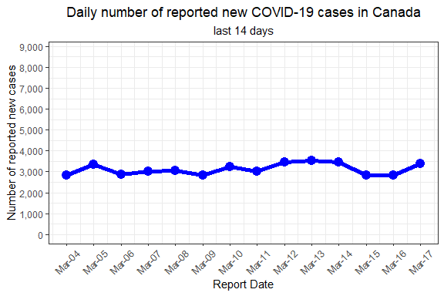

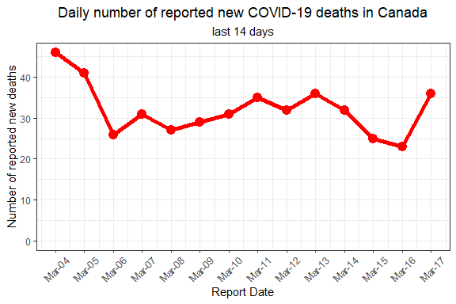

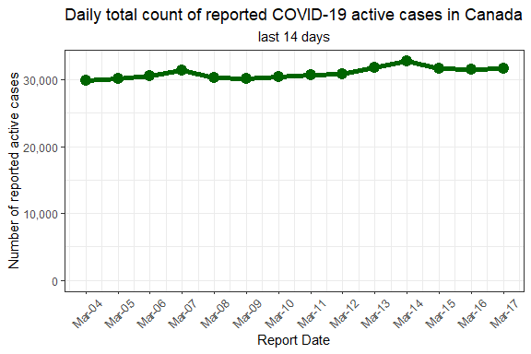

# LTC DEATHS

| Province | Population | Total Deaths | Total Deaths in LTC Facilities |
| --- | --- | --- | --- |
| BC | 5,147,712 | 1,411 | 953 |
| AB | 4,421,876 | 1,956 | 1,231 |
| SK | 1,178,681 | 410 | 120 |
| MB | 1,379,263 | 917 | 442 |
| ON | 14,734,014 | 7,187 | 4,069 |
| QC | 8,574,571 | 10,570 | 7,984 |
| NL | 522,103 | 6 | 0 |
| NB | 781,476 | 30 | 17 |
| NS | 979,351 | 65 | 57 |
| PE | 159,625 | 0 | 0 |
| YT | 42,052 | 1 |  |
| NT | 45,161 | 0 | 0 |
| NU | 39,353 | 1 | 0 |
| CA | 38,005,238 | 22,554 |  |