Bug No # 1: UOM count is not updating after search
Module: UOM
Steps to Reproduce:
- Open UOM list screen.
- Search any UOM from the search field.
- Observe the total count on the list screen.
Actual Result:
UOM list is filtered, but the count is not updating according to search results.
Expected Result:
Count should update correctly based on searched UOM results.
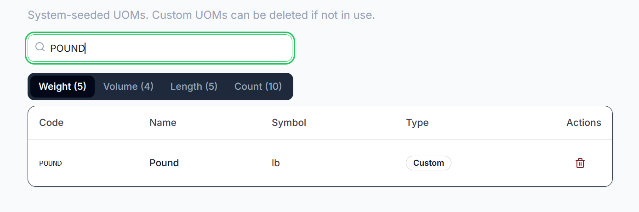
Bug No # 2 Table bottom corners are cut on last row hover
Module: UOM List Screen
Steps to Reproduce:
- Open UOM list screen.
- Move cursor/hover on the last row of the table.
- Observe the bottom left and bottom right corners of the table.
Actual Result:
On hovering the last row, the table is cut from the bottom left and right corners.
Expected Result:
Table corners should remain properly visible and aligned on last row hover.
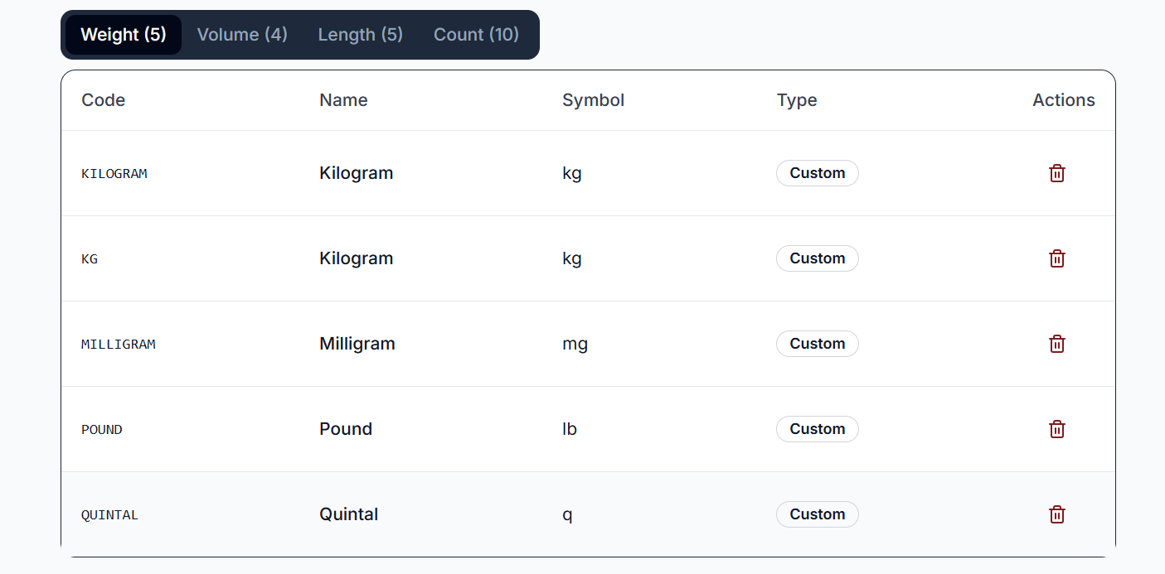
Bug No # 3 Duplicate Raw Material Code appears in API response after deleting and re-adding Raw Material
Module: Raw Material
Steps to Reproduce:
- Create a new Raw Material with a unique code.
- Delete the created Raw Material.
- Re-add a Raw Material using the same code.
- Call the Raw Material API and review the response.
Actual Result:
The API response contains duplicate entries for the same Raw Material code after the Raw Material is deleted and re-added.
Expected Result:
The API should return only the active/latest Raw Material record, and duplicate Raw Material codes should not appear in the response.
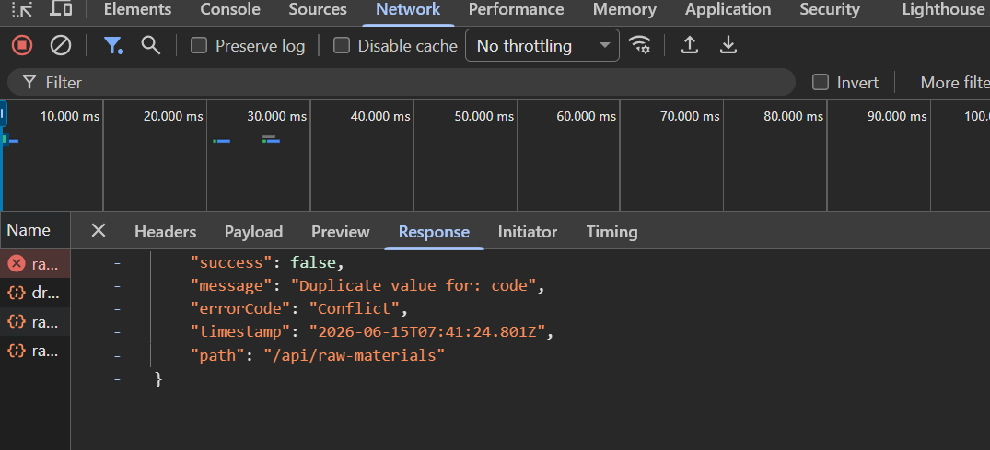
Bug No # 4 User redirects to Raw Material details screen after editing instead of list screen
Module: Raw Material
Steps to Reproduce:
- Open Raw Material list screen.
- Edit any existing Raw Material.
- Save the changes.
- Observe the redirection.
Actual Result:
User is redirected to the Raw Material details screen after editing.
Expected Result:
User should be redirected back to the Raw Material list screen after successful edit.
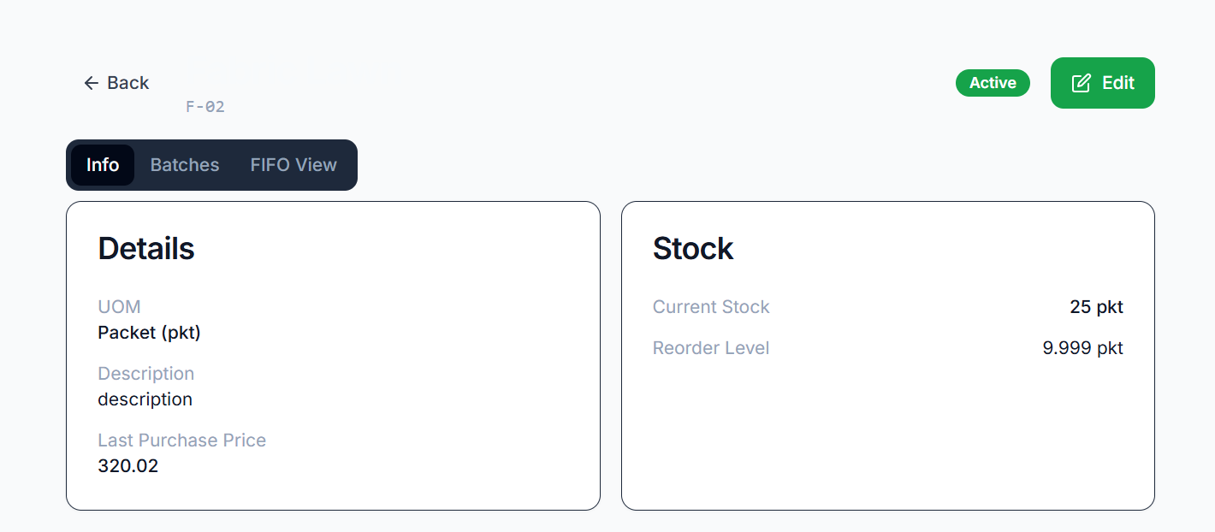Bug No # 5 Removed optional field data reappears when editing Raw Material
Module: Raw Material
Steps to Reproduce:
- Create or edit a Raw Material with values in optional fields.
- Remove the data from one or more optional fields and save the Raw Material.
- Open the same Raw Material in edit mode again.
- Observe the optional fields.
Actual Result:
Previously removed optional field data appears again when editing the Raw Material.
Expected Result:
Once optional field data is removed and saved, the fields should remain empty when the Raw Material is opened for editing again.
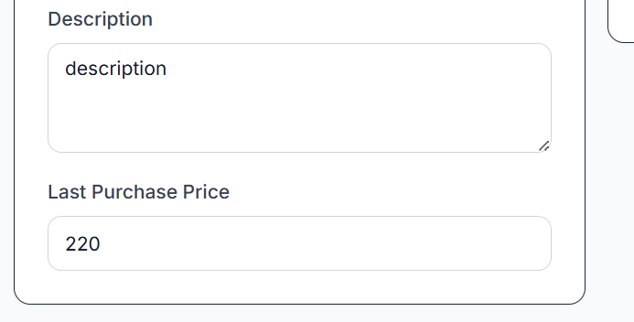
Bug # 6 Card text appears blurred on FIFO View tab of Details screen
Module: FIFO View – Details Screen
Steps to Reproduce:
- Navigate to the Details screen.
- Open the FIFO View tab.
- Observe the text displayed on the cards.
Actual Result:
Card text appears blurred, making it difficult to read.
Expected Result:
Card text should be clear, sharp, and easily readable on all cards within the FIFO View tab.
Bug No # 7 Raw Material can be created with Preorder Level set to 0
Module: Raw Material
Steps to Reproduce:
- Navigate to the Create Raw Material screen.
- Enter all mandatory fields with valid data.
- Set the Preorder Level value to 0.
- Save the Raw Material.
Actual Result:
Raw Material is created successfully with Preorder Level set to 0.
Expected Result:
The system should validate the Preorder Level field and prevent creation when the value is 0. A validation message should be displayed indicating that the Preorder Level must be greater than 0.
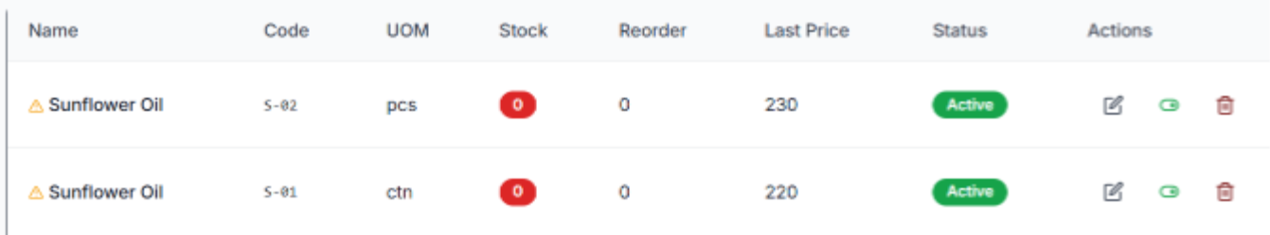
Bug No # 8 Success alert message appears twice when adding or editing Supplier
Module: Supplier
Steps to Reproduce:
- Navigate to the Supplier module.
- Add a new Supplier or edit an existing Supplier.
- Save the changes.
- Observe the success notification.
Actual Result:
The success alert message is displayed twice after successfully adding or editing a Supplier.
Expected Result:
The success alert message should be displayed only once per successful add or edit operation.
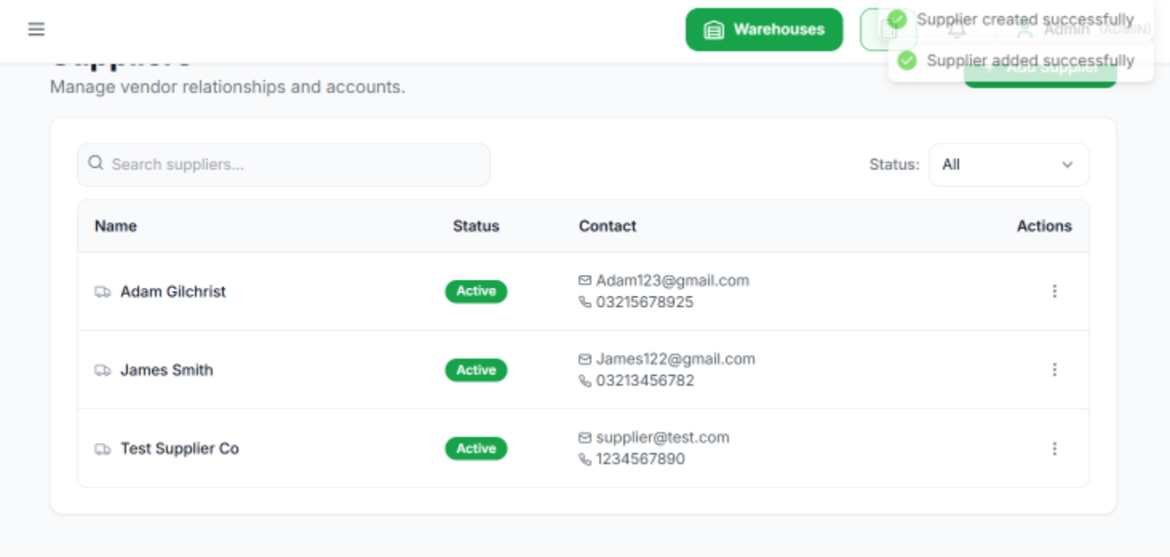
Bug No # 9 Incorrect total supplier count displayed on Supplier Ledger screen
Module: Supplier Ledger
Steps to Reproduce:
- Navigate to Supplier Ledger screen.
- Observe the total supplier count.
- Compare it with the actual supplier records.
Actual Result:
Total supplier count is showing incorrectly.
Expected Result:
Total supplier count should display correctly according to the available supplier records.
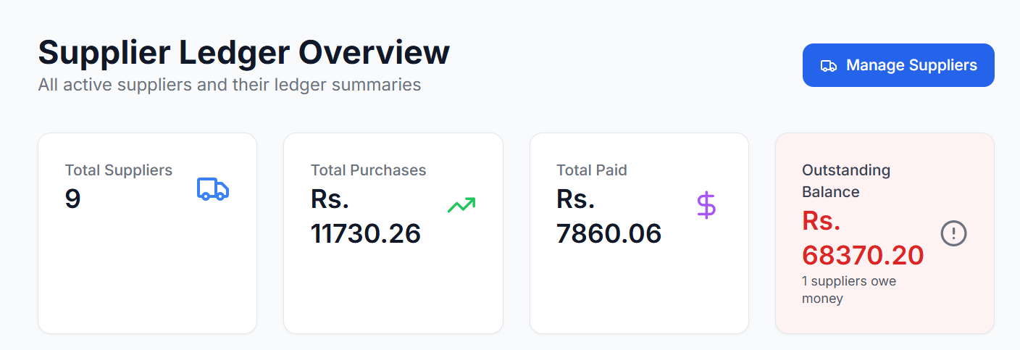
Bug No # 10: Clear button alignment issue on Supplier Ledger screen
Module: Supplier Ledger
Steps to Reproduce:
- Navigate to the Supplier Ledger screen.
- Locate the Clear button in the filter/search section.
- Observe its alignment relative to other fields and buttons.
Actual Result:
The Clear button is not properly aligned with the surrounding UI elements.
Expected Result:
The Clear button should be properly aligned and consistent with the layout and design of other controls on the screen.
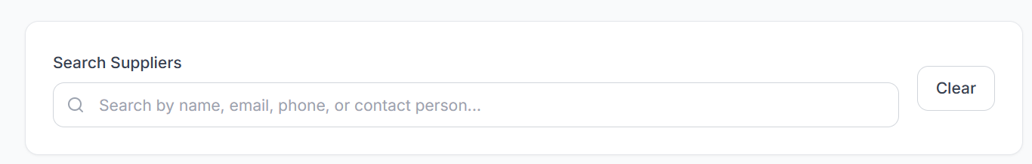
Bug # 11: Supplier Ledger screen shows blank page with loader on every typed letter
Module: Supplier Ledger
Steps to Reproduce:
- Navigate to Supplier Ledger screen.
- Click in the search field.
- Type any letter one by one.
- Observe the screen while loader is running.
Actual Result:
On every typed letter, the screen becomes blank while the loader appears, then the ledger list screen loads again.
Expected Result:
Search should work smoothly without showing a blank screen on every typed letter. Loader should appear without hiding the existing list.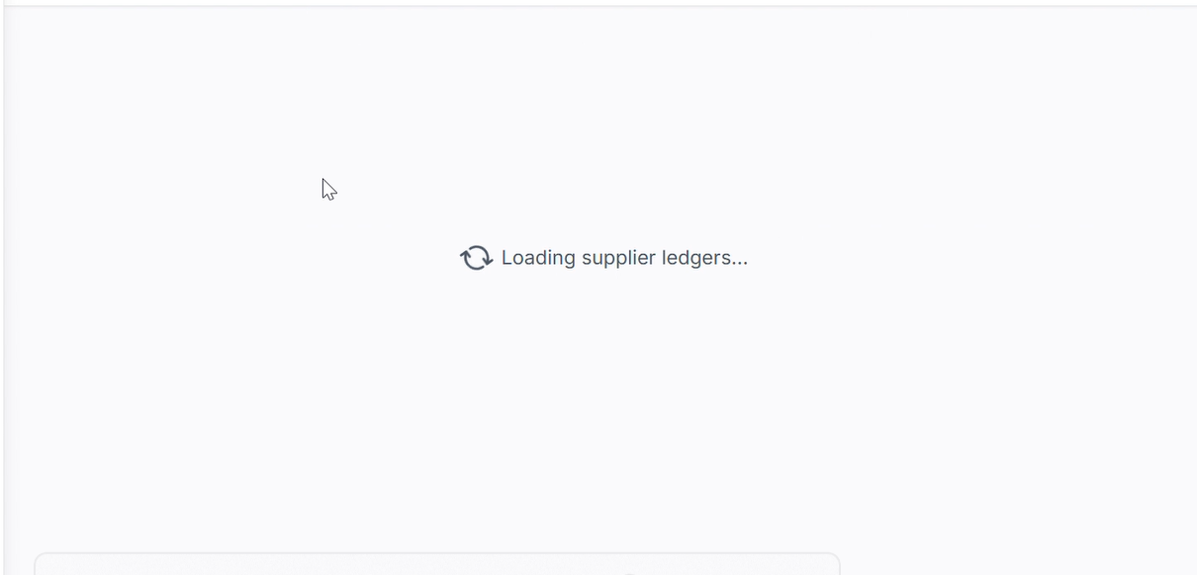
Bug No # 12: White blank screen appears on invalid search instead of “No Active Suppliers” message
Module: Supplier Ledger
Steps to Reproduce:
- Navigate to Supplier Ledger screen.
- Enter an invalid supplier name/code in the search field.
- Observe the search result area.
Actual Result:
White blank screen is displayed after invalid search.
Expected Result:
Proper message should be displayed, such as “No Active Suppliers” or “No records found”.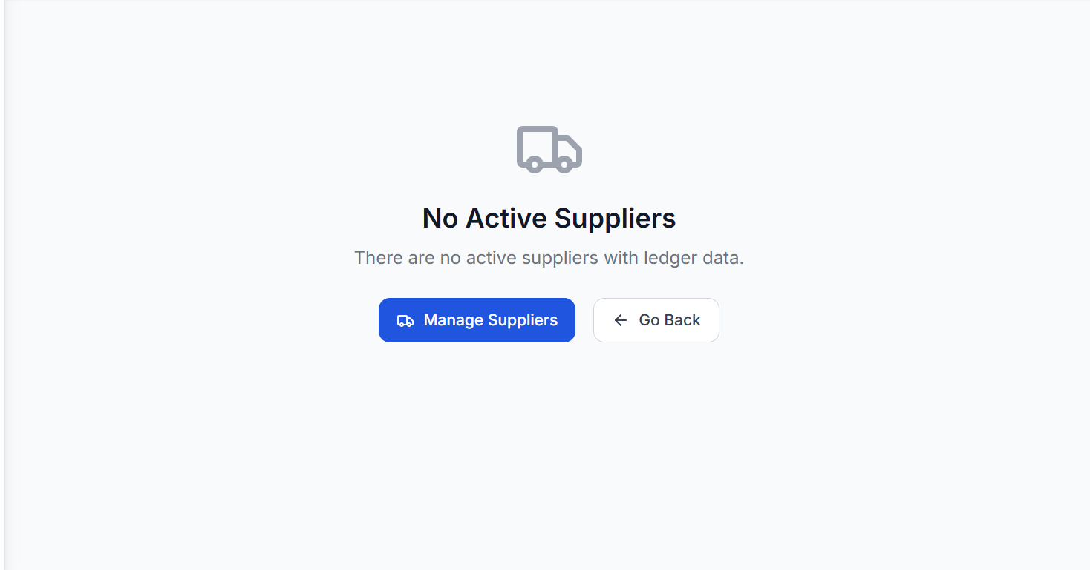
Bug No # 13: Export CSV and Export PDF files are not downloading on Supplier Ledger details screen
Module: Supplier Ledger Details
Steps to Reproduce:
- Navigate to Supplier Ledger screen.
- Open any supplier ledger details.
- Click on Export CSV button.
- Click on Export PDF button.
- Observe the download behavior.
Actual Result:
CSV and PDF files are not downloading after clicking the export buttons.
Expected Result:
CSV and PDF files should download successfully when clicking Export CSV and Export PDF.
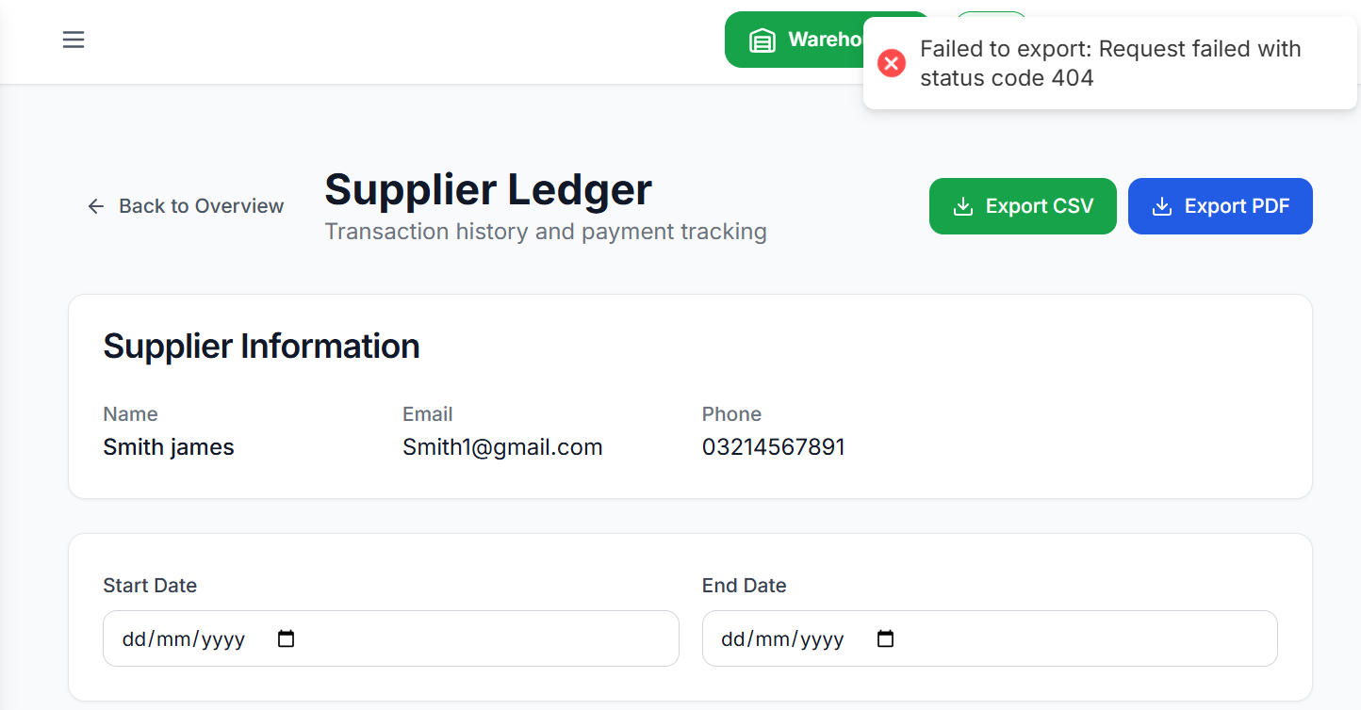
Bug No # 14: Product Type and UOM dropdown data not fetching on Edit Product screen
Module: Product
Steps to Reproduce:
- Navigate to Product list screen.
- Open any existing Product in edit mode.
- Click on Product Type dropdown.
- Click on UOM dropdown.
- Observe the dropdown data.
Actual Result:
Product Type and UOM dropdowns are not fetching/showing data on the Edit Product screen.
Expected Result:
Product Type and UOM dropdowns should fetch and display available data correctly on the Edit Product screen.
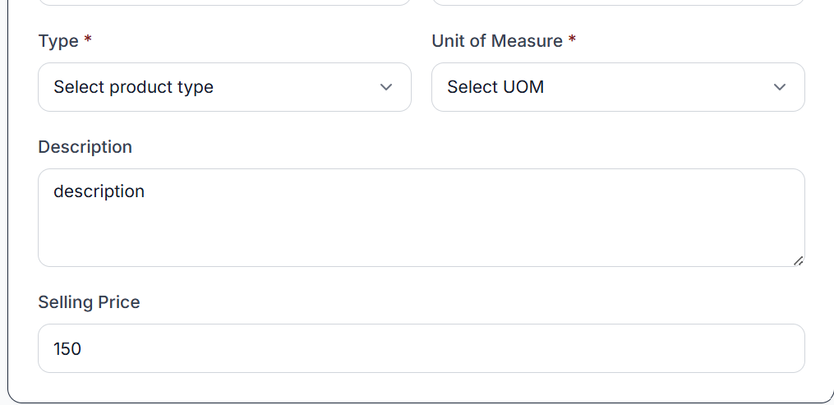
Bug Title # 15: Type, Category, Location,Capacity , and Manager dropdown data not fetching on Edit Site screen
Module: Site
Steps to Reproduce:
- Navigate to Site list screen.
- Open any existing Site in edit mode.
- Click on Type dropdown.
- Click on Category dropdown.
- Click on Location dropdown.
- Click on Manager dropdown.
- Observe the dropdown data.
Actual Result:
Type, Category, Location, and Manager dropdowns are not fetching/showing data on the Edit Site screen.
Expected Result:
All dropdowns should fetch and display available data correctly on the Edit Site screen.
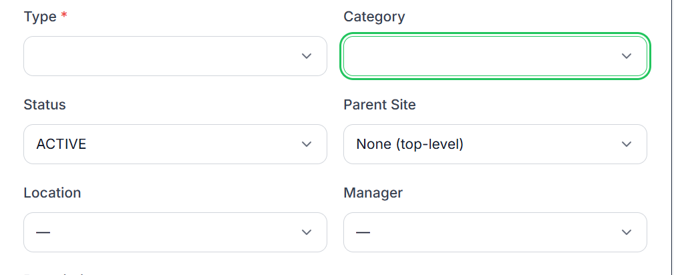
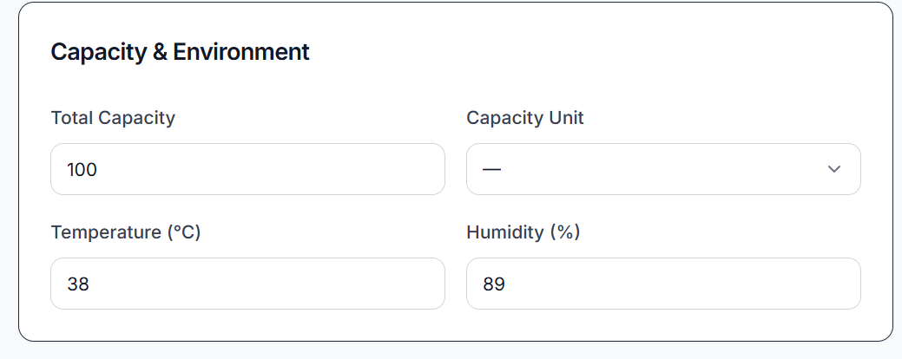
Bug No # 16 : Dropdown label text is not visible and dash is shown on Add/Edit Site screen
Module: Site
Steps to Reproduce:
- Navigate to Add Site screen.
- Observe Type, Category, Location, and Manager dropdowns.
- Navigate to Edit Site screen.
- Observe the same dropdowns again.
Actual Result:
Dash “-” is displayed on Type, Category, Location, and Manager dropdowns, and the label text is not visible.
Expected Result:
Dropdown label text should be clearly visible, and dash should not appear unless it is intended as a valid placeholder.
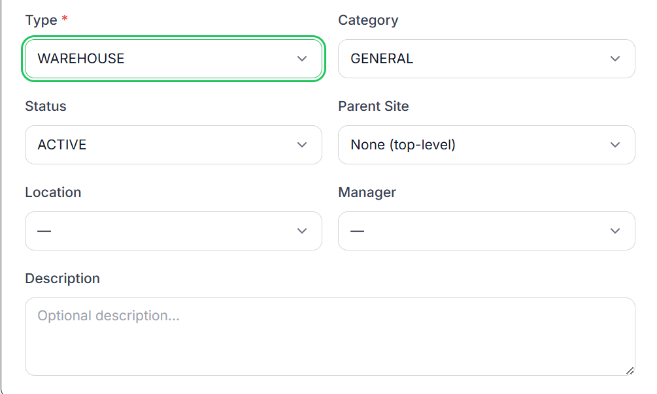
Bug No # 17: Incorrect Total Order and Pending Delivery count displayed on Purchase Order list screen
Module: Purchase Order
Steps to Reproduce:
- Navigate to Purchase Order list screen.
- Observe the Total Order and Pending Delivery count.
- Compare both counts with actual Purchase Order records.
Actual Result:
Total Order and Pending Delivery count are showing incorrectly.
Expected Result:
Total Order and Pending Delivery count should display correctly according to the actual Purchase Order records.
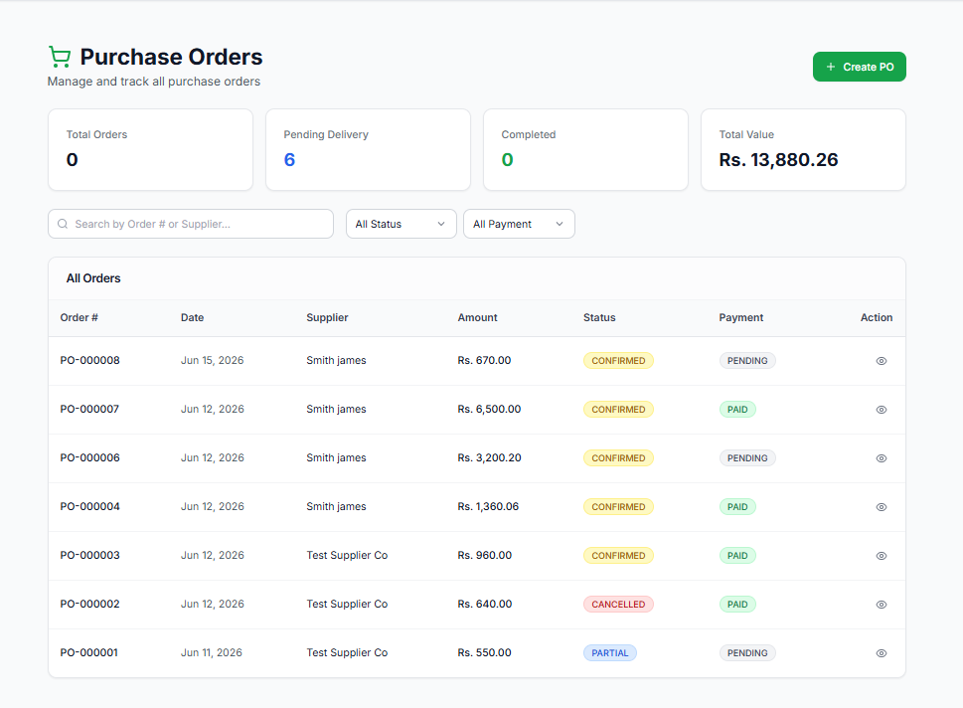
Bug No # 18: Order Item is not added when clicking on Add Order Item button on Add Purchase Order screen
Module: Purchase Order
Steps to Reproduce:
- Navigate to the Add Purchase Order screen.
- Fill in the required Purchase Order details.
- Click on Add Order Item.
- Observe the behavior.
Actual Result:
Order Item is not added after clicking the Add Order Item button.
Expected Result:
A new Order Item row/section should be added successfully when the Add Order Item button is clicked.
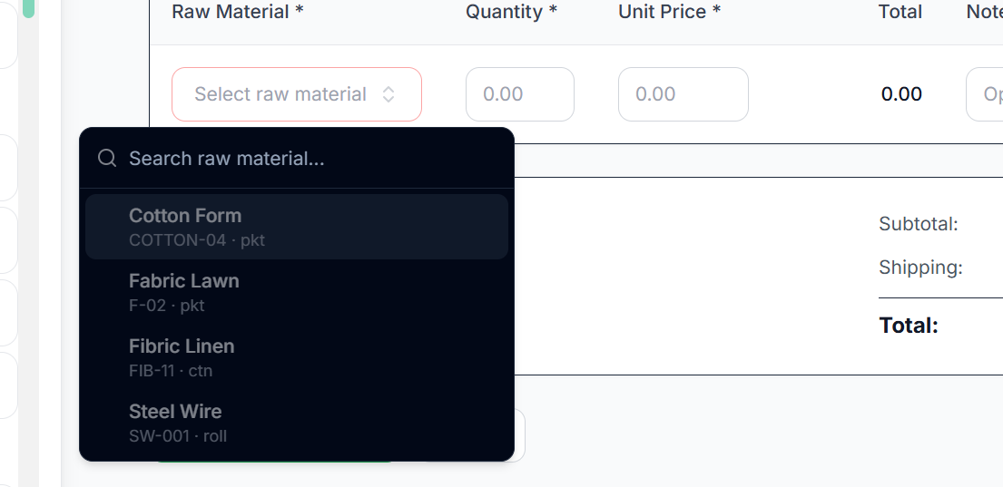

Bug No # 19: Supplier dropdown data is not fetching on Edit Purchase Order screen
Module: Purchase Order
Steps to Reproduce:
- Navigate to the Purchase Order list screen.
- Open any existing Purchase Order in edit mode.
- Click on the Supplier dropdown.
- Observe the dropdown data.
Actual Result:
Supplier dropdown is not fetching/showing data on the Edit Purchase Order screen.
Expected Result:
Supplier dropdown should fetch and display available supplier data correctly.
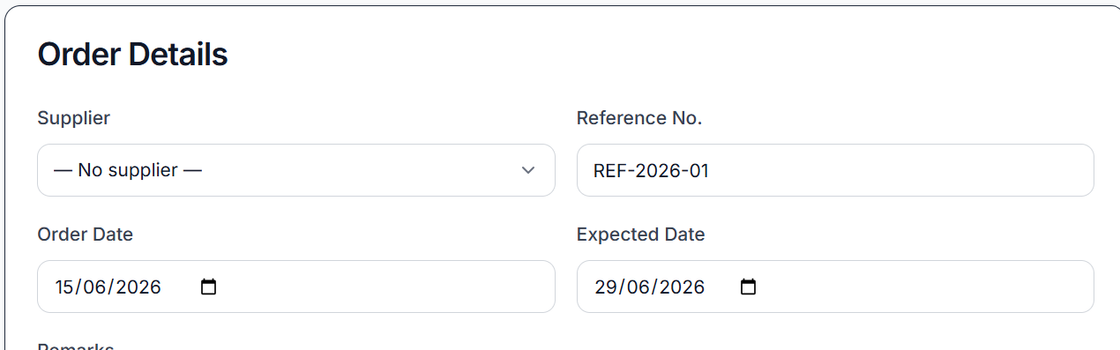
Bug No # 20: NaN is displayed in Quantity field on Items tab of GRN Details screen
Module: GRN
Steps to Reproduce:
- Navigate to the GRN Details screen.
- Open the Items tab.
- Observe the Quantity value.
Actual Result:
Quantity is showing as NaN on the Items tab.
Expected Result:
Quantity should display the correct numeric value.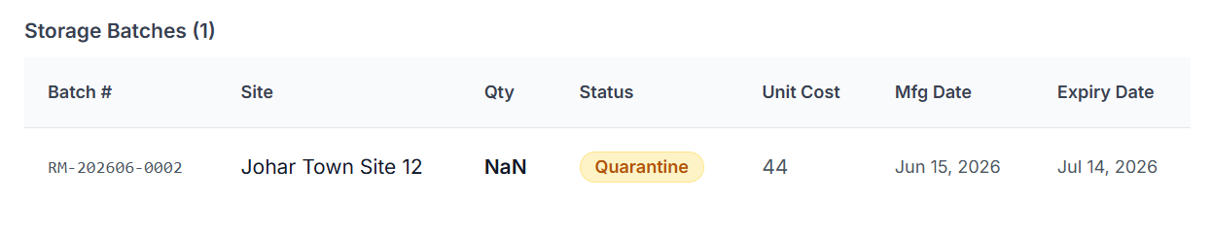
Bug No # 21: Purchase Return module is not visible on frontend
Module: Purchase Return
Steps to Reproduce:
- Login to the application.
- Check the frontend navigation/menu.
- Search or navigate for the Purchase Return module.
Actual Result:
Purchase Return module is not visible on the frontend.
Expected Result:
Purchase Return module should be visible and accessible on the frontend.
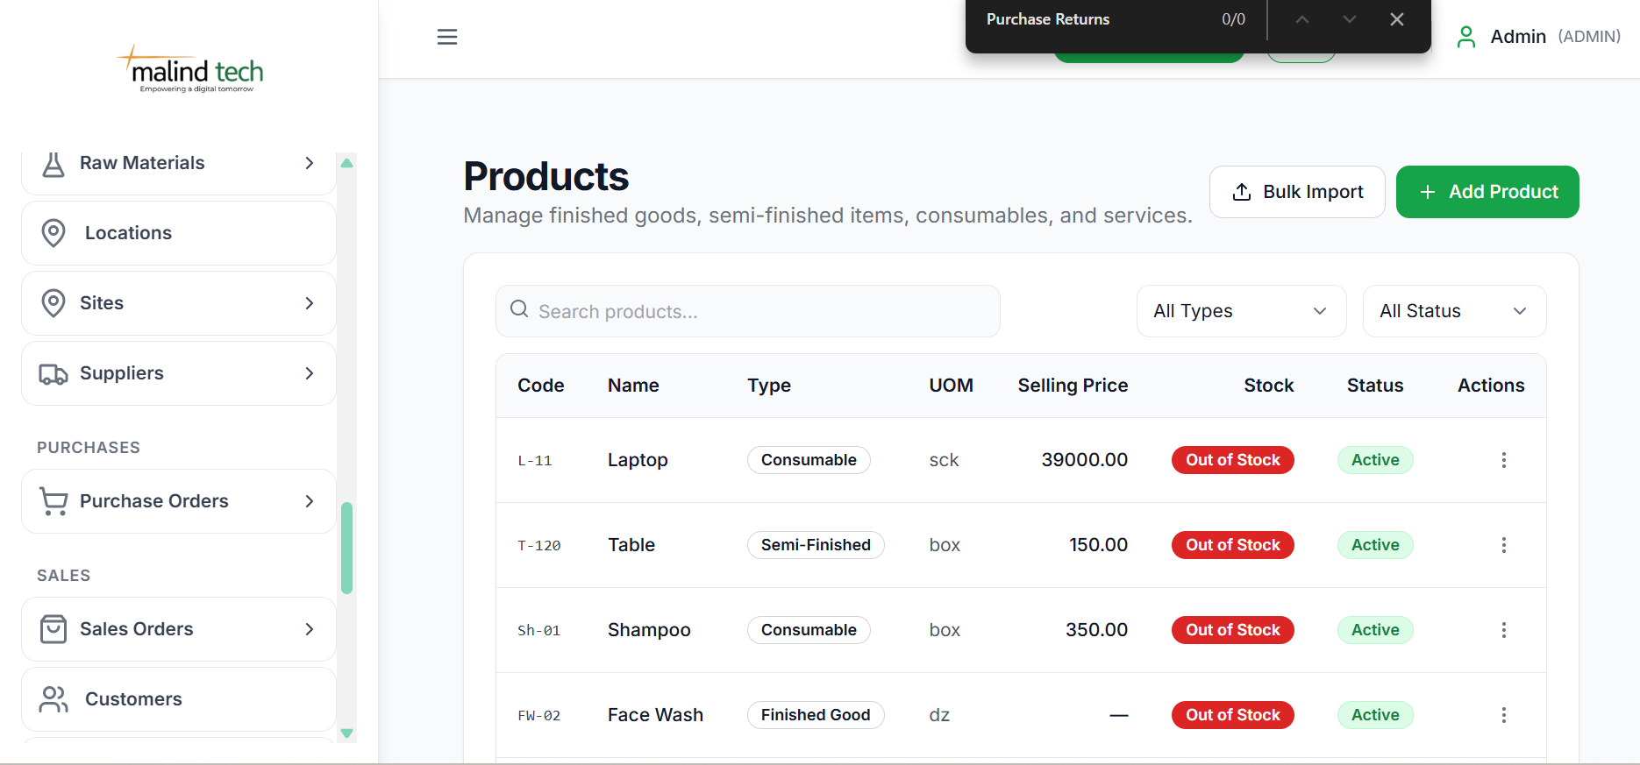
Bug No #22: BOM already exists error appears after deleting and re-adding BOM
Module: BOM / Bill of Material
Steps to Reproduce:
- Create a BOM.
- Delete the created BOM.
- Add the same BOM again.
- Observe the system response.
Actual Result:
System shows “BOM already exists” error after deleting and re-adding the BOM.
Expected Result:
User should be able to re-add the BOM after deletion, or deleted BOM should not be considered as an existing active record.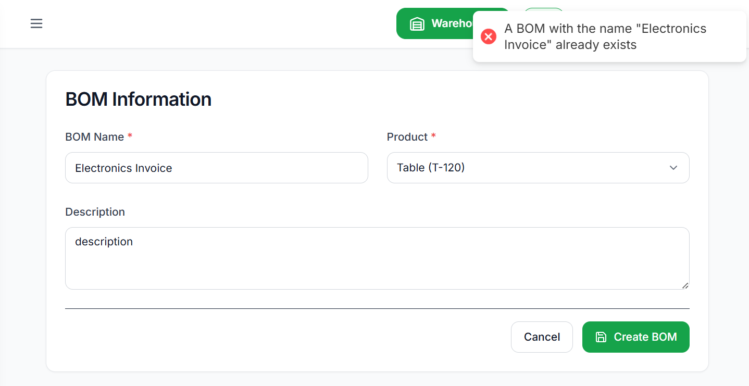
Bug No # 23: Blur overlay appears on popup after clicking three dots on Waste Management list screen
Module: Waste Management
Steps to Reproduce:
- Navigate to the Waste Management list screen.
- Click on the three dots action menu.
- Observe the popup/menu.
Actual Result:
Blur is visible on the popup, affecting UI clarity.
Expected Result:
Popup/menu should display clearly without unwanted blur effect.
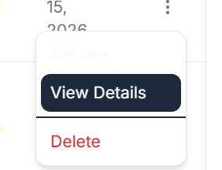
Bug No # 24: Site dropdown data is not fetching on Edit Production Order screen
Module: Production Order
Steps to Reproduce:
- Navigate to the Production Order list screen.
- Open any existing Production Order in edit mode.
- Click on the Site dropdown.
- Observe the dropdown data.
Actual Result:
Site dropdown is not fetching/showing data on the Edit Production Order screen.
Expected Result:
Site dropdown should fetch and display available site data correctly on the Edit Production Order screen.
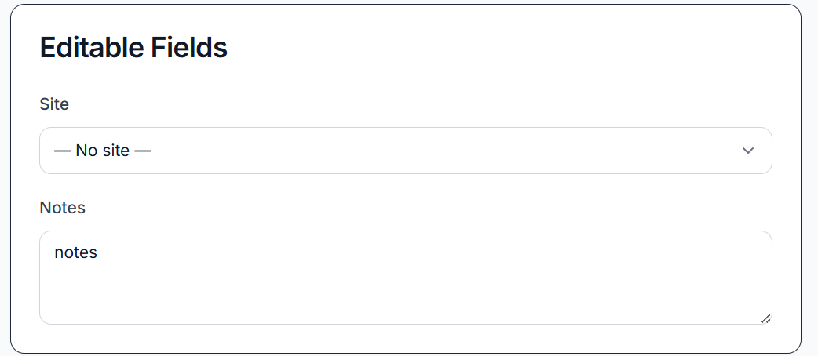
Bug Title # 25: Count is not updating after applying filters on Audit Logs screen
Module: Audit Logs
Steps to Reproduce:
- Navigate to the Audit Logs screen.
- Apply any available filter.
- Observe the records count.
Actual Result:
Audit Logs records are filtered, but the count is not updating according to the filtered results.
Expected Result:
Count should update correctly based on the applied filters.
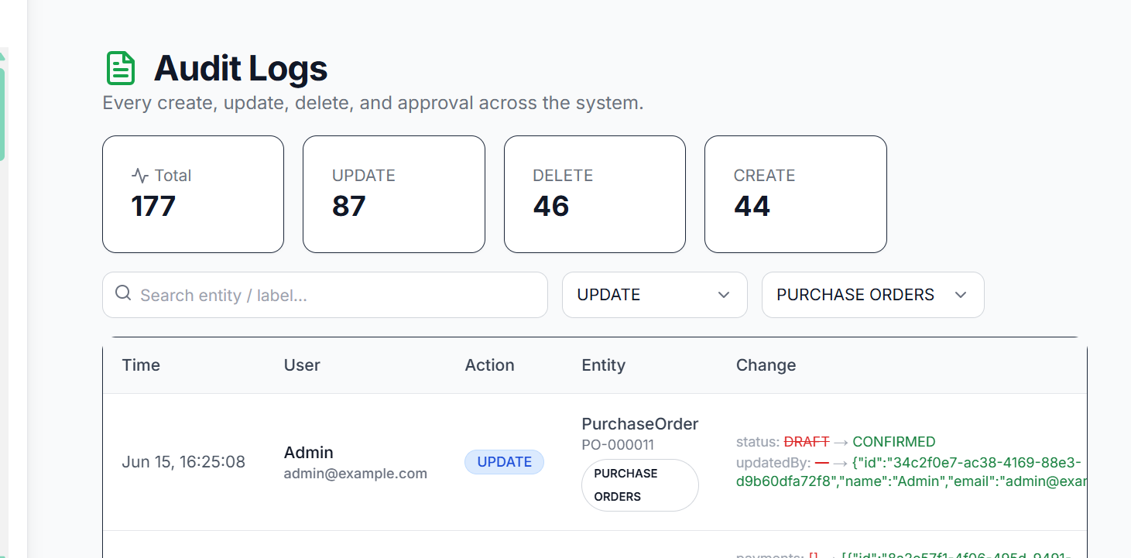
Bug No # 26: Add Raw Material form retains filled data after closing and reopening on BOM Details screen
Module: BOM
Steps to Reproduce:
- Navigate to the BOM Details screen.
- Open Add Raw Material form/modal.
- Fill in the Raw Material fields.
- Close the form/modal without saving.
- Reopen the Add Raw Material form/modal.
Actual Result:
Previously filled data is still showing in the fields after reopening.
Expected Result:
Fields should be cleared/reset when the Add Raw Material form/modal is closed and reopened.
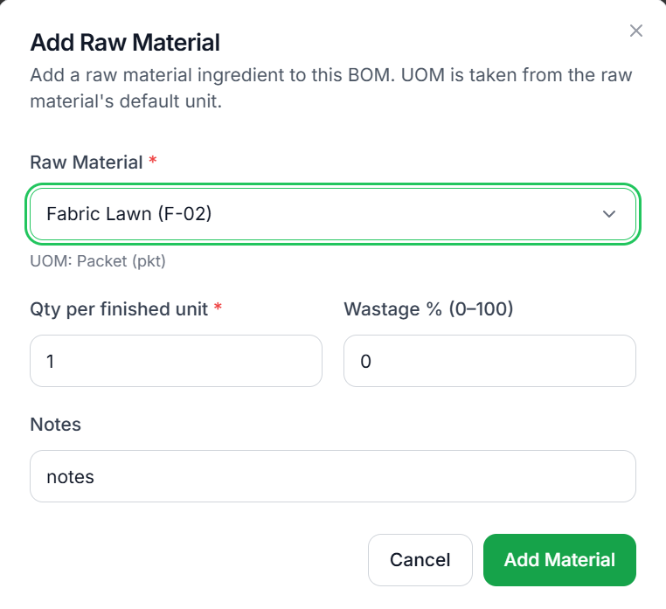
Bug No # 27: "Cannot PATCH" error appears when updating Site status from action menu
Module: Site
Steps to Reproduce:
- Navigate to the Site List screen.
- Click on the three dots (action menu) for any site.
- Select Change Status.
- Choose a new status.
- Click Update Status.
- Observe the response.
Actual Result:
System displays a "Cannot PATCH" error when attempting to update the site status.
Expected Result:
Site status should be updated successfully, and a success message should be displayed without any errors.
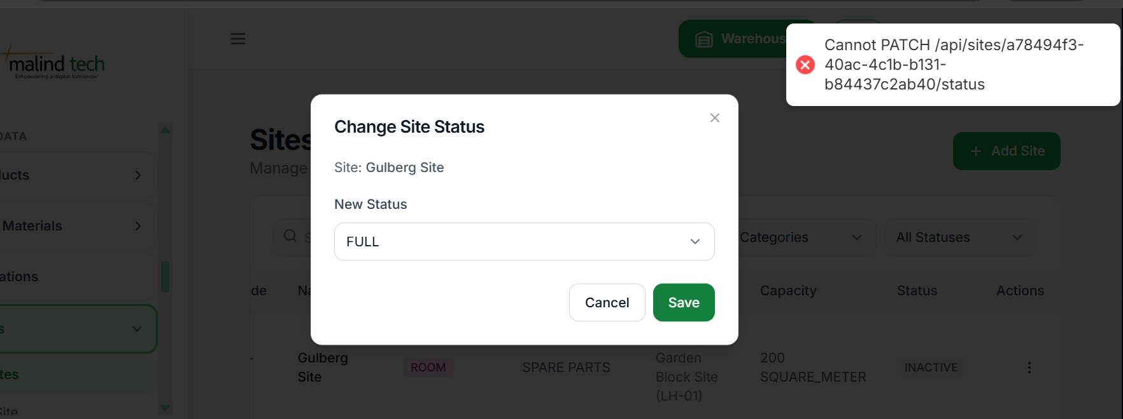
Bug No # 28 : Created By field shows “Unknown” instead of username on Purchase Order detail screen
Module: Purchase Order
Steps to Reproduce:
- Navigate to the Purchase Order List screen.
- Open any Purchase Order detail screen.
- Observe the Created By field.
Actual Result:
Created By field shows “Unknown”.
Expected Result:
Created By field should display the actual username who created the Purchase Order.
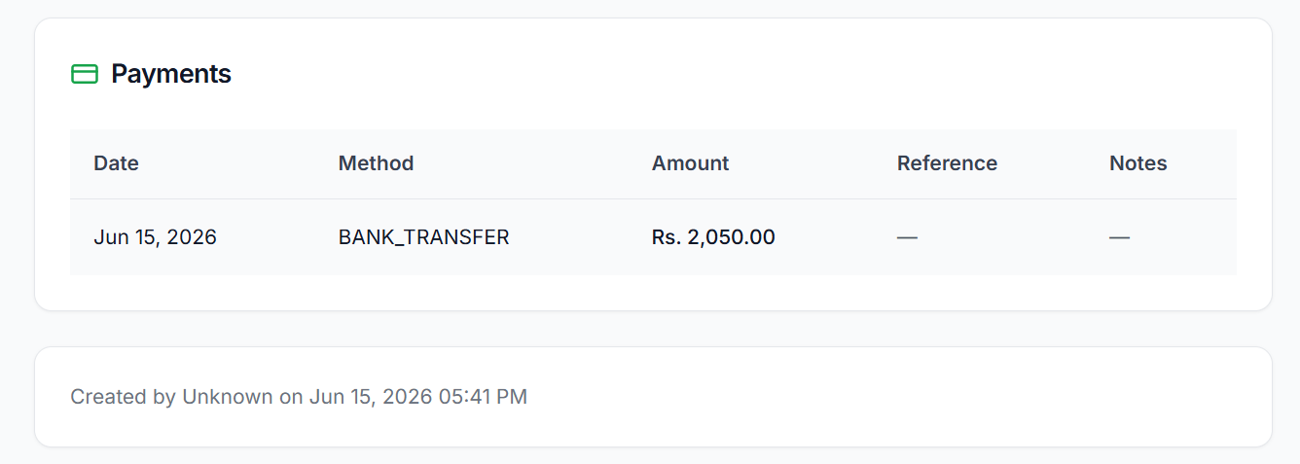
Bug No # 29: Raw Material name is not visible on Raw Material Details screen
Module: Raw Material
Steps to Reproduce:
- Navigate to the Raw Material List screen.
- Open any Raw Material details screen.
- Observe the Raw Material Name field/header.
Actual Result:
Raw Material name is not visible on the details screen.
Expected Result:
Raw Material name should be displayed correctly and be clearly visible on the details screen.
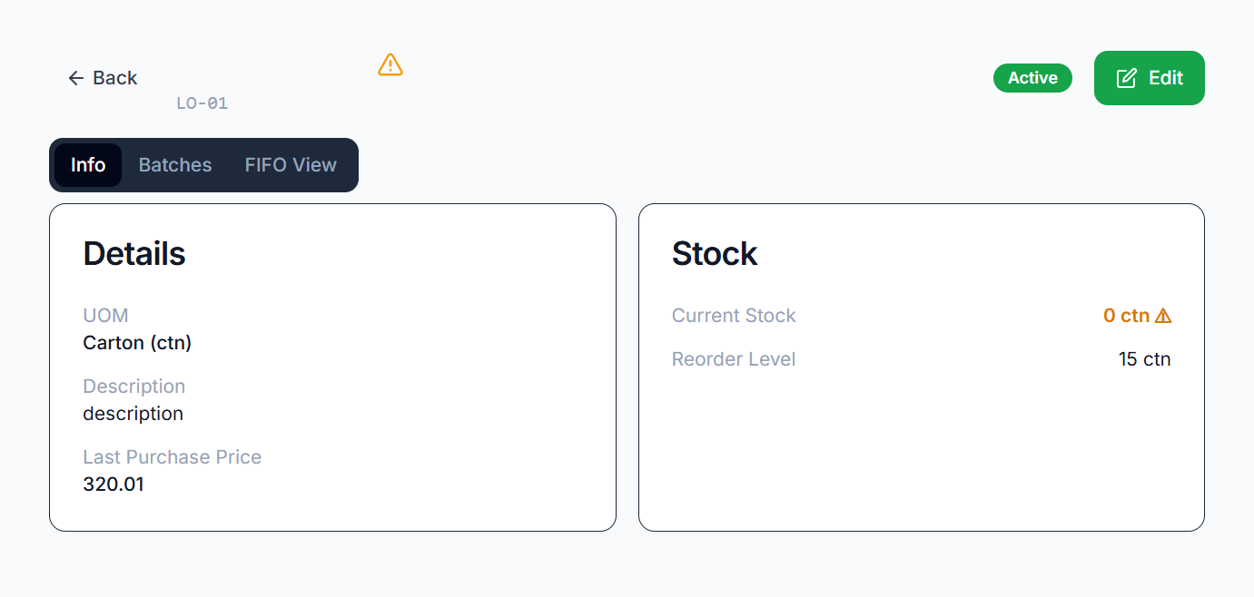
Bug No # 30: Backend validation error messages are not displayed on the frontend
Module: Multiple Modules
Steps to Reproduce:
- Navigate to any module (e.g., Raw Material, Product, Supplier).
- Perform an action that triggers a backend validation error (e.g., create a record with an existing duplicate code).
- Submit the form.
- Observe the error message displayed on the frontend.
Actual Result:
Backend validation error messages (e.g., "Duplicate code already exists") are not displayed on the frontend. Users receive a generic error or no meaningful message.
Expected Result:
Frontend should display the exact validation message returned by the backend, such as "Duplicate code already exists", to help users understand and resolve the issue.
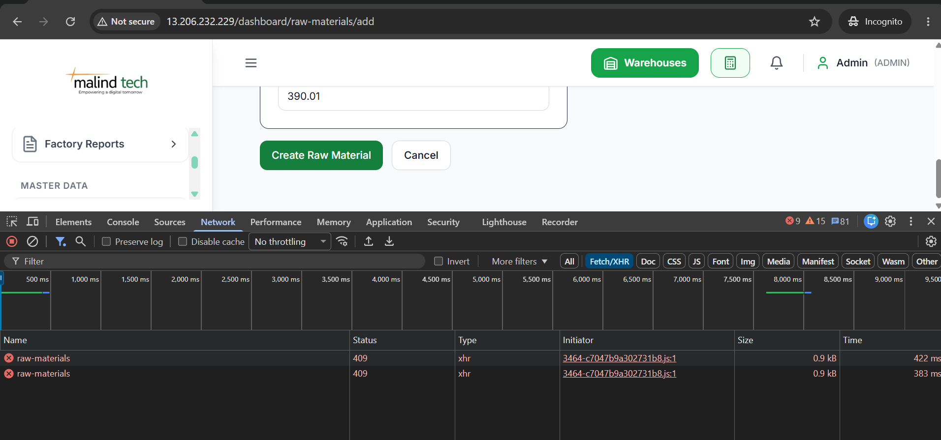
Bug No # 31: Out of Stock section alignment breaks after marking a product as inactive
Module: Product
Steps to Reproduce:
- Navigate to the Product List screen.
- Select an active product.
- Change the product status to Inactive.
- Return to the Product List screen.
- Observe the Out of Stock section/card.
Actual Result:
The alignment/layout of the Out of Stock section becomes distorted after the product is marked as inactive.
Expected Result:
The Out of Stock section should maintain proper alignment and layout regardless of the product status.
