* ***User Manual of Inventory Module***

For the user manual of the Inventory module, Users have to follow those steps. Which is given below.

First Click on the Facility Module from the screen. When the user clicks on the Facility module then Facility module will be open. In the system, we are considering facility module as Inventory module.

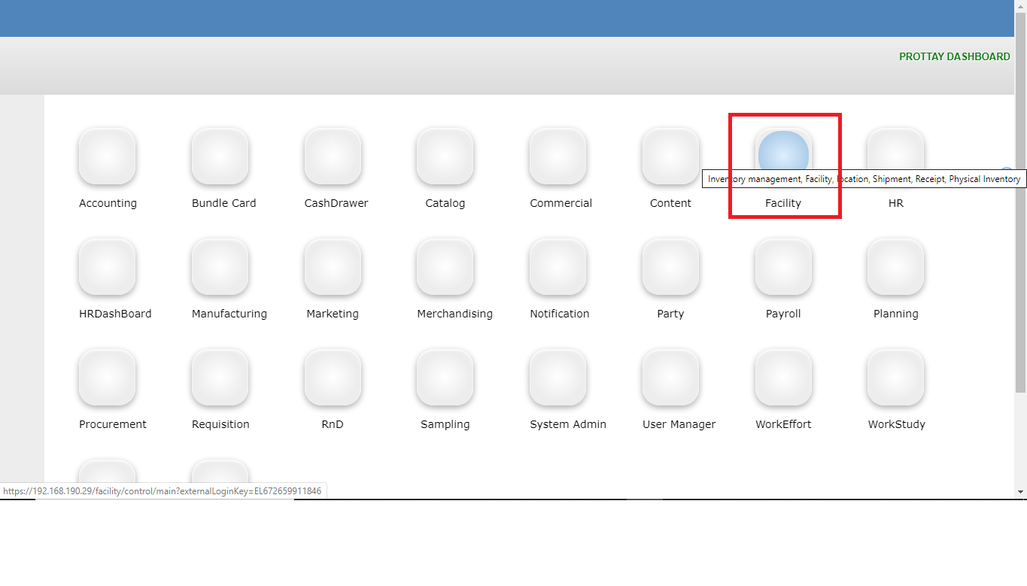

When the User click on the Facility Module then user will see the below screen. In this screen user get Inventory Manager, where user will see all of the menu of inventory module.

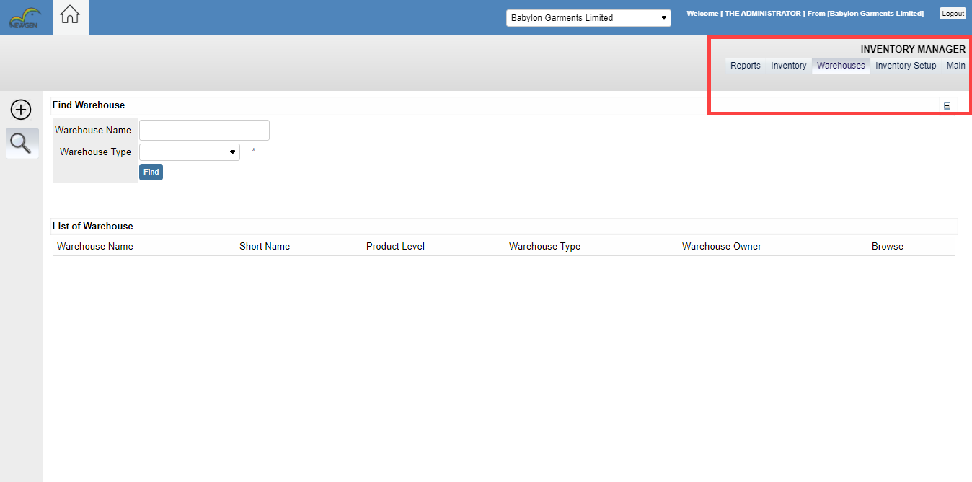

After opening the Inventory module, User have to click on the Inventory menu then user will find a sub menu under the Inventory menu. Where user will get **Find Inventory** **> Receive inventory > Issue Inventory > Goods Storing > Shade Grouping > Delivery Challan** as like below screenshot.

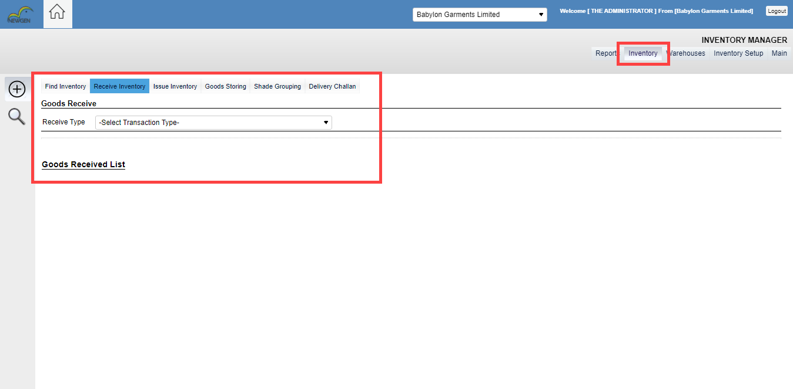

In the Receive Inventory user will get two choices. The two choices are user can create General good receive by click on the **“+”** icon and user can find receive list by click on the Search icon.

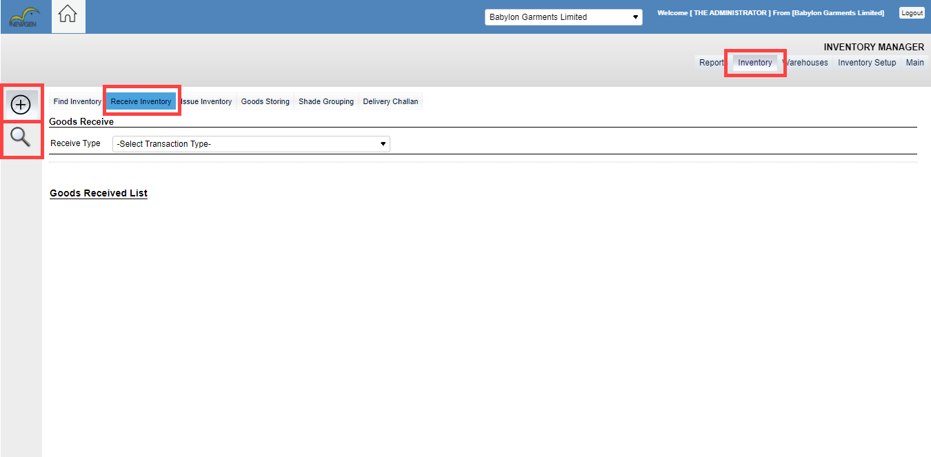

If the users want to find Receive list, then user have to click on the search icon. When user click on the Search icon then user will find below screen. User can search receive list by receive number, receive type, challan number, Invoice number, PO, Sales order, Style name, From date to End date.

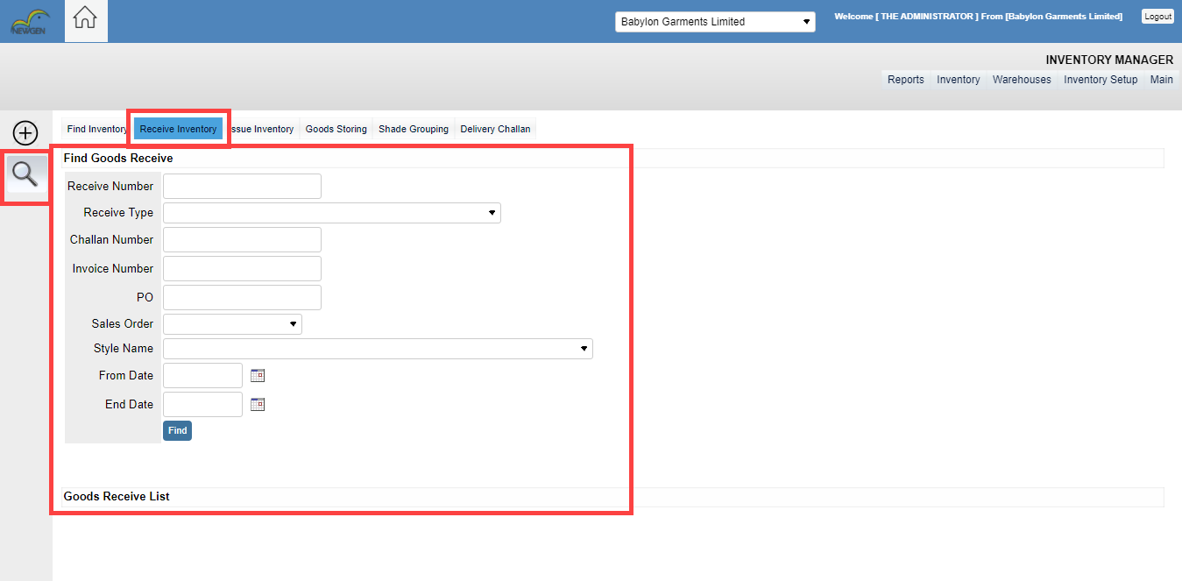

If user wants to Create general good receive, then user have to click on the **“+”** icon. After click on the **“+”** icon. In the receive type, users will get a dropdown menu. In that dropdown menu, user can select Transaction type. Transaction types are given below. This transaction is depending on the users, which type of transaction he wants to generate.

* RECEIVE AGAINEST PO (General)
* RECEIVE AGAINEST PO (Work Order)
* RECEIVE FINISHED GOODS
* RECEIVE RETURNED GOODS FROM INTERNAL PRODUCTION
* RECEIVE LEFT OVER GOODS INTERNAL PRODUCTION

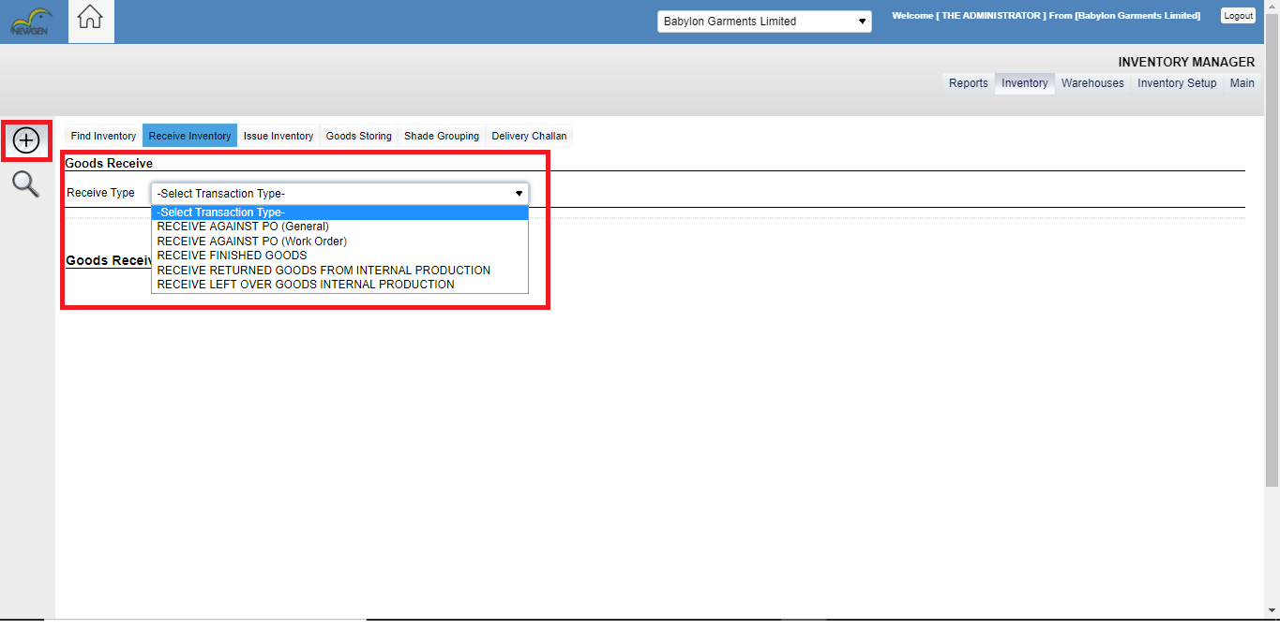

If the user Select Receive Against PO (Work order) from the dropdown. User will get below screen. In this screen user have to fill-up all of the yellow field because those fields are mandatory field. If user

