Bugs:

1. **“Confirm Form Resubmission” error page appears when clicking on the “Back” button**

Steps:

1. Fil the input fields with wrong data
2. Click on the “login” button
3. Click on “forgot my password” button under the “password” input field
4. Click on the “Back” button in the top left of the page

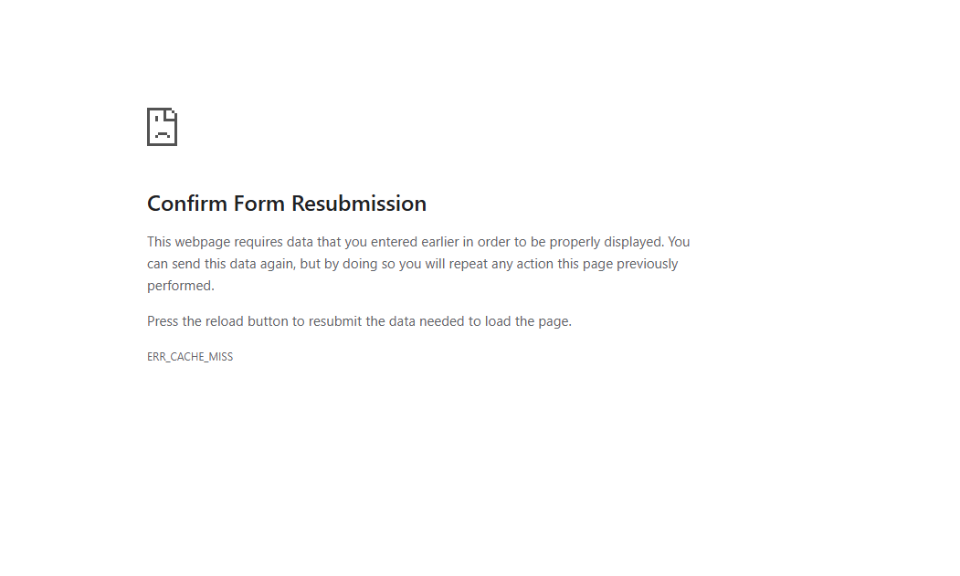

1. **Expected the “login” button to be disabled when the input fields are empty**
2. **The logo is not a link, it doesn’t do anything when clicking on it**

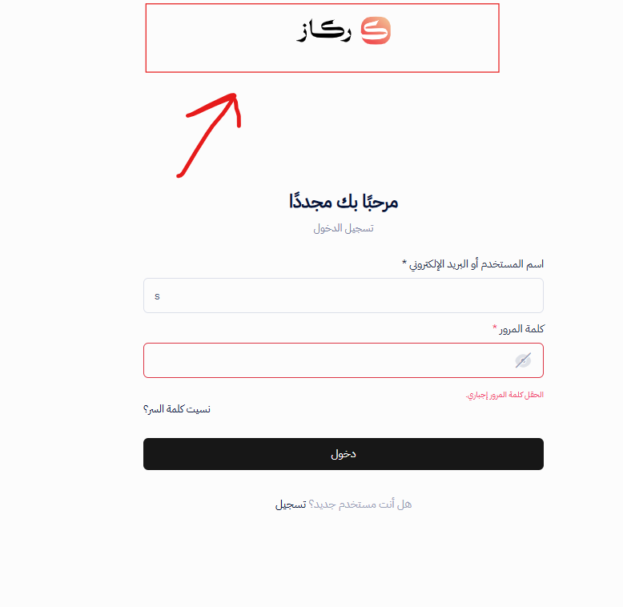

1. **The text is not consistent between the Arabic and the English**

**Arabic** => “تسجيل الدخول” **English** = “Login to your account”

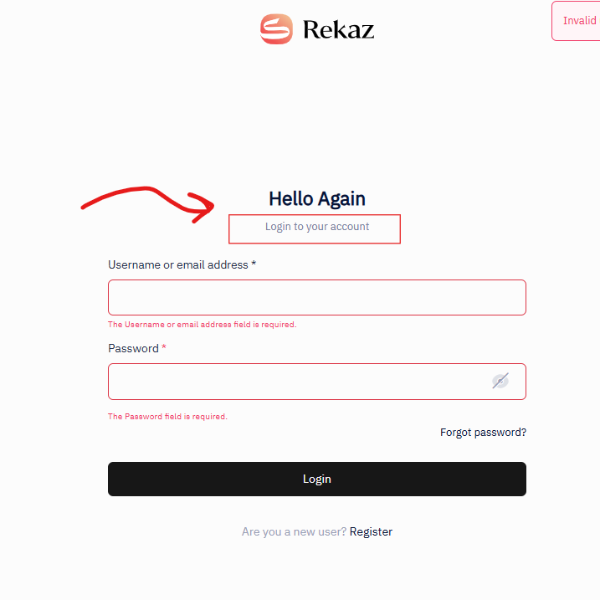

1. **When changing the page to “English” the error notification still appears**

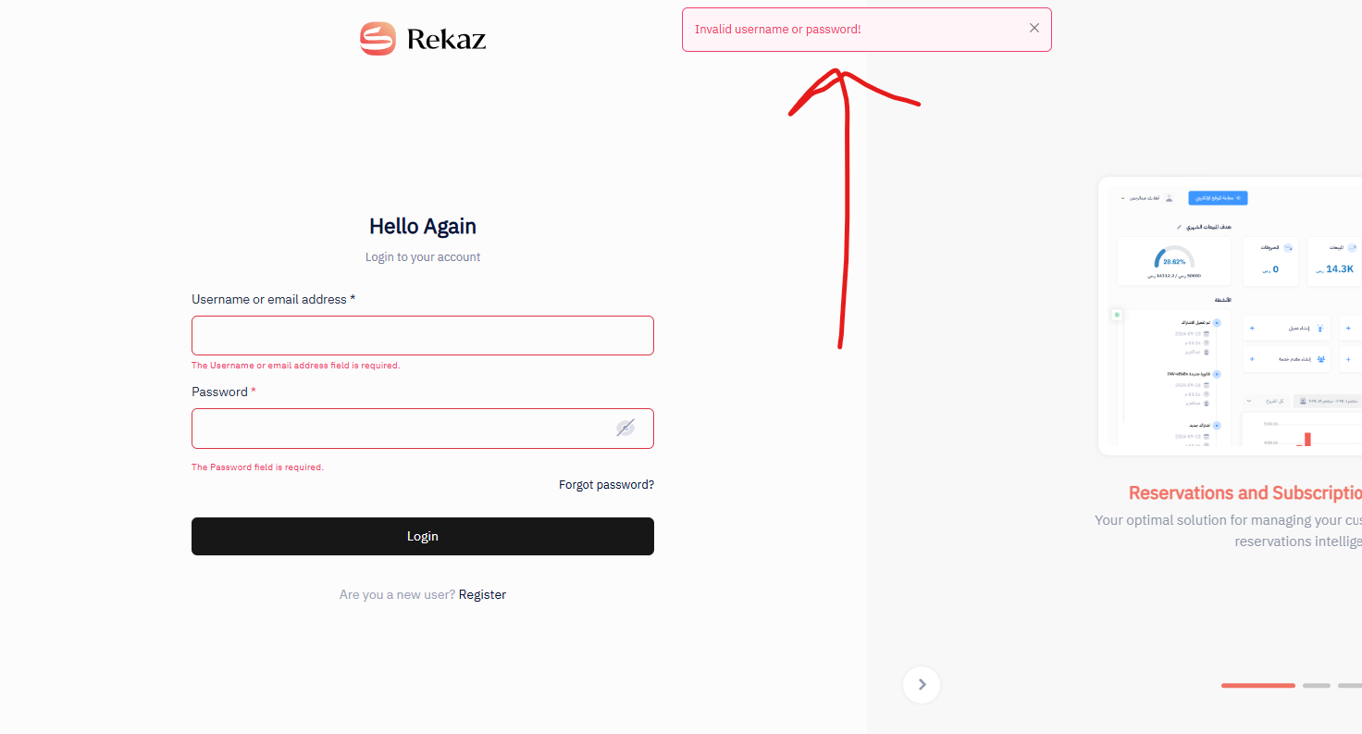

1. **Expect the notification error message to disappear after some seconds**
   1. Fil the form with wrong data
   2. Click “login” button
   3. A notification error message will appear and stuck (expect it to disappear after few seconds)

