***Software Design Document(SDD)***

***HR management system***

Version 1.1

June 5, 2017

***Team names:***

***ISLAM MAGDY***

***AHMAD PASTAOI***

***OMAR DAHAWY***

***AMR ROSHDY***

***TAREK HASSEN***

***TABLE OF CONTENTS:***

***1. INTRODUCTION***

* + Purpose
  + Scope
  + Overview
  + Reference Material
  + Definitions and Acronyms

***2. SYSTEM OVERVIEW***

***3 .use cases***

* 3.1 actors
* 3.2 list of use cases
* 3.3 -Use Case Diagrams:
* Use cases

***4. DESIGN overview***

* 4.1 introduction
* 4.2 System Architecture

Class diagram

ER diagram

5-functional requirements

6-nonfunctional requirements

7-constrains

8-façade design pattern

9. objects interactions

* 5.1- Sequence digram

***10. INTERFACE DESIGN***

* 6.1 Screen Images

***11. APPENDICES***

* Future work

***1-Introduction:***

The Software Design Document is a document to provide documentation which will be used to aid in software development by providing the details for how the software should be built. Within the Software Design Document are narrative and graphical documentation of the software design for the project including use case models, sequence diagrams, and other supporting requirement information.

***1.1-Purpose***

The purpose of the Software Design Document is to provide a description of the design of a system fully enough to allow for software development to proceed with an understanding of what is to be built and how it is expected to built. The Software Design Document provides information necessary to provide description of the details for the software and system to be built.

***1.2-Scope***

This Software Design Document is for a base level system which will work as a proof of concept for the use of building a system the provides a base level of functionality to show feasibility for large scale production use. This Software Design is focused on the base level system and critical parts of the system. For this particular Software Design Document, the focus is p laced on generation of the documents and modification of the documents.

***1.3-Overview***

The Software Design Document is divided into many sections with various subsections. The sections of the Software Design Document are:

1 – Introduction

*2. SYSTEM OVERVIEW*

*3. SYSTEM ARCHITECTURE*

*4. DATA DESIGN*

*5. COMPONENT DESIGN*

*6. HUMAN INTERFACE DESIGN*

*7. REQUIREMENTS MATRIX*

*8. APPENDICES*

***1.4-Reference Material***

1. IEEE Std 830-1998: IEEE Recommended Practice for Software Requirements Specifications.
2. <http://hrdailyadvisor.blr.com>
3. <http://www.softwareadvice.com>
4. <http://www.webdunia.net/CaseStudy/internal_caseStudies/CaseStudyHRMS2.pdf>
5. <http://www.ibm.com/developerworks/rational/library/769.html>
6. <http://www.cs.iusb.edu/thesis/SLingareddy_thesis.pdf>
7. <http://en.wikipedia.org/wiki/Eclipse_(software)>
8. <http://www.eclipse.org/org/>

[http://hrdailyadvisor.blr.com](http://hrdailyadvisor.blr.com/)

***1.5-Definitions and Acronyms***

* **HR:** Human resource
* **HRMS:** Human resources management system
* **HRIS:** Human Resource information system
* **LMS:** Learning Management System
* **SAAS:** Software as a Service
* **EPR:** Enterprise Resource Planning

***2. SYSTEM OVERVIEW***

HUMAN RESOURCE Management System aims to fulfill needs of most of company's sectors by many important functions.

* Keep information of all exist data of employees.
* Keep & manage contracts of the employees.
* Keep the financial information of the employee and sectors.
* Keep the information of salaries.
* Keep the information of deductions
* Keep the information of incentives.
* Keep the information of loans.
* Keep the information of the attendance and absence
* Keep the information of the vacations
* Keep the information of the overtimes

We found that almost all free HR management system contains limited functions and the small companies can’t afford a high cost to get full functions of hr management system.

***3-Use cases***

3.1- Actors:

* **Admin:** The most familiar user with the HRMS and his responsibilities are:
  + Access setting functions
* **HR:** The most frequent users who is the most familiar user with the system and his responsibilities are**:**
* Search employees
* Get reports & generate HR-related reports
* Add employee
* Add contacts
* edit contacts
* add deduction
* add incentives
* add bonus
* record attendance
* confirm vacation request
* record overtime
* view overtime
* payroll month salary
* **Employee:** user of the system who uses the system to
* Add employee
* View contract
* View total salary
* Record loan
* Add vacation request
* View over time
* **Manager:** The less frequent user who deal with system to
* Search employees
* View contracts
* View contract info
* View loan
* Confirm loan request
* View total salary
* Add salary
* Edit salar

3.2 -List of Use Cases:

* Search employees
* Add employee
* Add contacts
* edit contacts
* add deduction
* add incentives
* add bonus
* record attendance
* confirm vacation request
* record overtime
* view overtime
* payroll month salary
* View contract
* View total salary
* Record loan
* Add vacation request
* View contract info
* View loan
* Confirm loan request

3.3 -Use Case Diagrams:

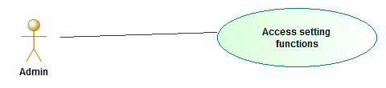

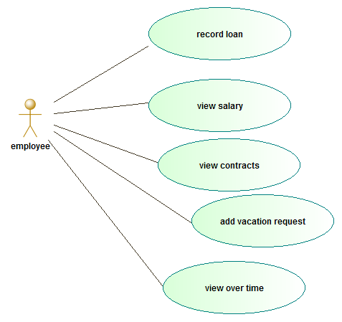

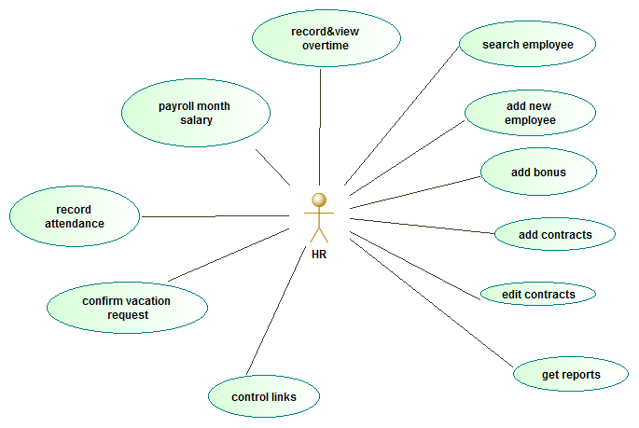

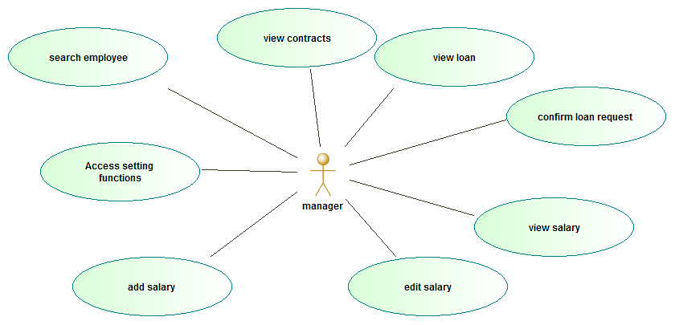

***4 - Design Overview***

4.1 Introduction

The Design Overview is section to introduce and give a brief overview of the design. The System Architecture is a way to give the overall view of a system and to place it into context with external systems. This allows for the reader and user of the document to orient themselves to the design and see a summary before proceeding into the details of the design.

4.2 System Architecture:

***4.2.1 class diagram***

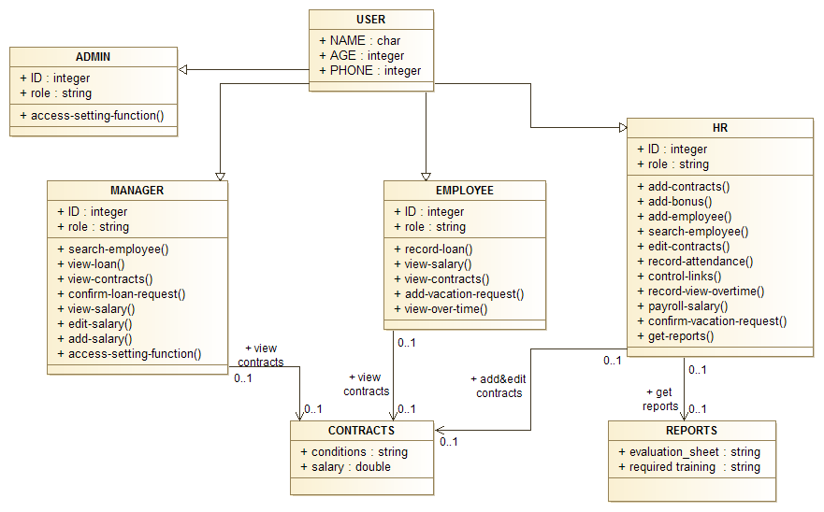

***NOTE:***

*Each function has a name show what is its important in the system*

***The class USER:***

Has many attributes: the name, age, and phone.

The user may be admin, manager, employee, and HR.

***The class ADMIN:***

Has attributes the id and role.

And has a function called access-setting functions

The make the admin able to access all sections of the system and make him add a role of each one that give any actor the permission to access his own part only and can access the part of other actors

***The class manager:***

Has attributes the id and the role.

And has many functions like:

1. Search employee
2. View loan
3. View contract
4. Confirm loan requests
5. View salary
6. Edit salary
7. Add salary
8. Access setting functions

***The class EMPLOYEE:***

Has attributes the id and the role.

And has functions:

1. Record loan
2. View salary
3. View contracts
4. Add vacation request
5. View over time

***The class HR:***

Has attributes id and role.

1. And has functions :add contracts
2. Add bonus
3. Add employee
4. Search employee
5. Edit contracts
6. Record attendance
7. Control links
8. Record view overtime
9. Payroll salary
10. Confirm vacation request
11. Get reports

***The class REPORTS:***

Has a relation only with the HR class.

as a HR only can access it to get reports.

***The class CONTRACTS:***

The class HR, EMPLOYE, and MANAGER can access it to view the contracts information

***4.2.2 ER diagram***

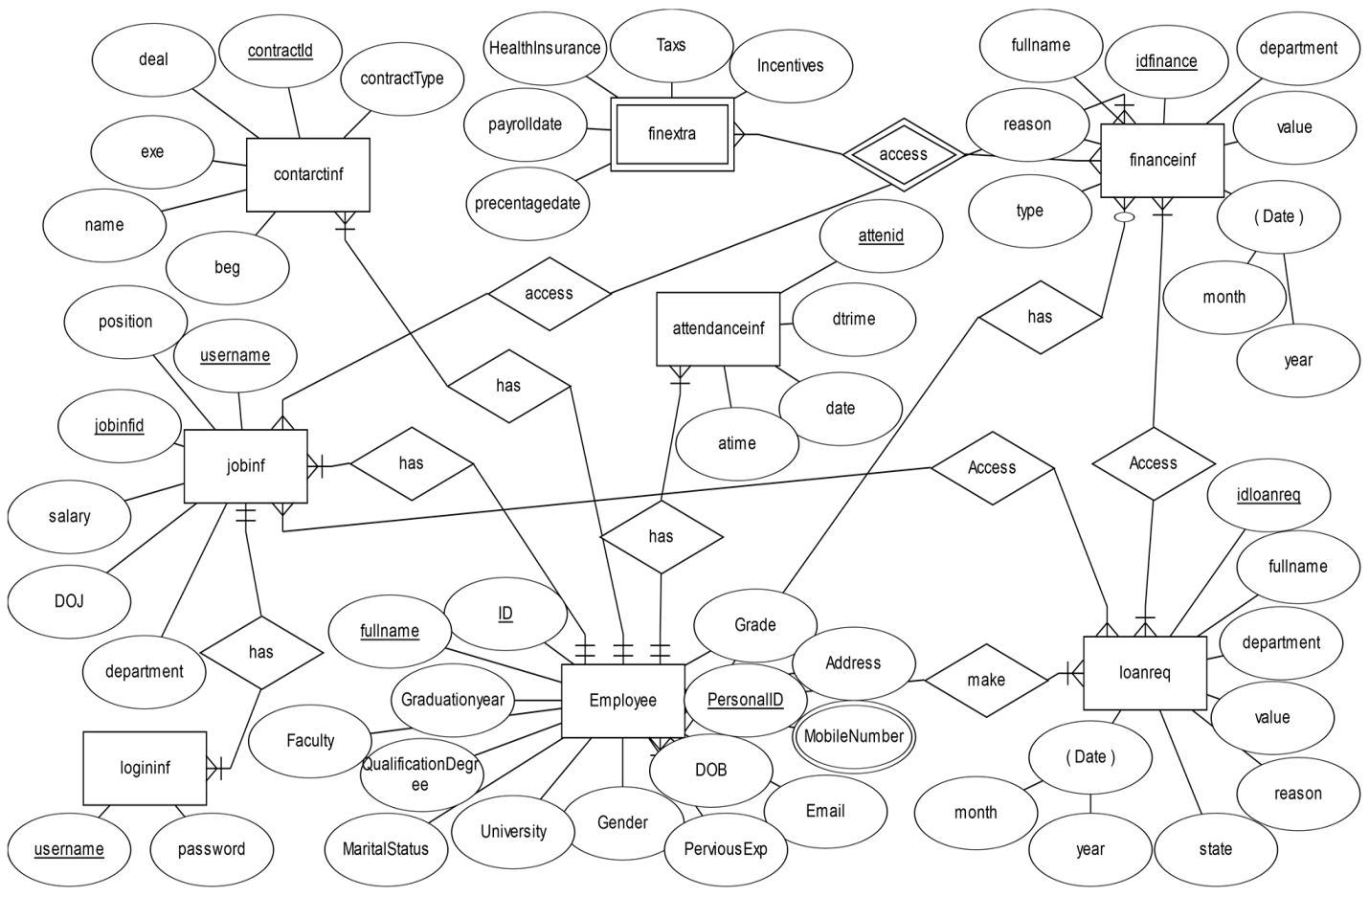

## *5- Functional requirements:*

HRMS implements some major functions in order to accomplish required tasks. These functions constitute a basis for the whole system

And we can say that our system is divided to many sub systems like:

### *5.1-Process Data*

**Edit in employee personal data:**  
 can update some basic personal data like contact information, marital status etc.

**Edit in employees' contracts:** can update and add contract details.  
 **Access and edit financial information**:  
 Add the organization financial data and edit these data .  
 **Add & edit salaries:** Add, edit salaries & adoption salaries with one click.

**search the database:**  
 in order to obtain the list of the users' which has the properties desired.   
  
**Make a report:** may also see the specific information about a user or all users which can be named as report.

### 5.2-Recruitment

**Add a new employee:**  
 HR role type is able to add a new employee to the database.

**Add a new user**:  
 creating a new user by the specified id assigned in the “Add a new employee” feature.

## *6-Nonfunctional requirements*

### 6.1-Performance requirements:

1- The number of the online user of the HRMS can be estimated as 500 at most.  
 2- The number of the total user of the HRMS stored in data base can be estimated as 10000 at most.

### 6.2-Privacy

Nobody should be allowed to tamper with data; Enhanced Security for sensitive data. It should be made sure that only users who are given specific rights can access data and all actions are logged, thus providing an extensive role based authorization**.**

### 6.3-Security

### Secure transmission such as SSL which encrypts the data as it transmits over the internet. Internal security is also critical; information should be guarded by passwords that have varying levels of access in relation to what is needed for the job position. 6.4-Reliability

The SDMS should store and retrieve information accurately as provided by the user.

In the event a user’s session times out, any task which requires future dependent information shall be cancelled.

### 6.5-System availability

availability is constrained by the availability of the application cloud server, database server, and other supporting software servers.

## *7-Constraints*

### 7.1-Company policies

All employees' reports should be ready as hardcopy and follow all the other policies of the company

### 7.2- Hardware Limitation

Use two-phase commit works across a distributed transaction to avoid a system failure.

### 

### 7.3-Software Limitation

Use operating system that support JDE

***Note:*** in this system we use facade design pattern

***8-Facade design pattern:***

Facade discusses encapsulating a complex subsystem within a single interface object. This reduces the learning curve necessary to successfully leverage the subsystem. It also promotes decoupling the subsystem from its potentially many clients. On the other hand, if the Facade is the only access point for the subsystem, it will limit the features and flexibility that "power users" may need.

The Facade object should be a fairly simple advocate or facilitator. It should not become an all knowing oracle or "god" object.

***Advantage:***

Provide a unified interface to a set of interfaces in a subsystem. Facade defines a higher level interface that makes the subsystem easier to use.Wrap a complicated subsystem with a simpler interface.

***Disadvantage:***

A segment of the client community needs a simplified interface to the overall functionality of a complex subsystem.

***9-object interactions***

Sequence diagram:

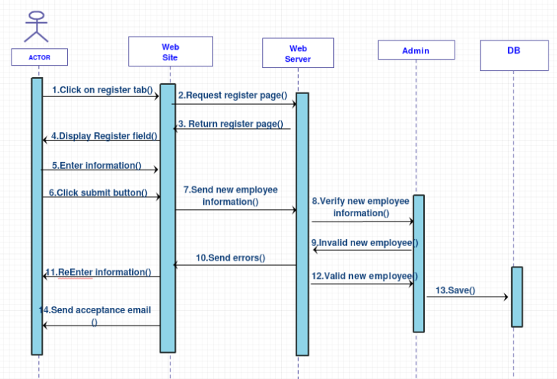

# *10. Interface design*

***Login page:***

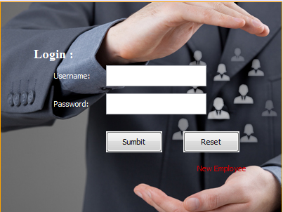

in this interface the actor must write his name and password to be able to enter the system and according to the roles that the admin set it this actor can be able to access his own partion only

***employee***

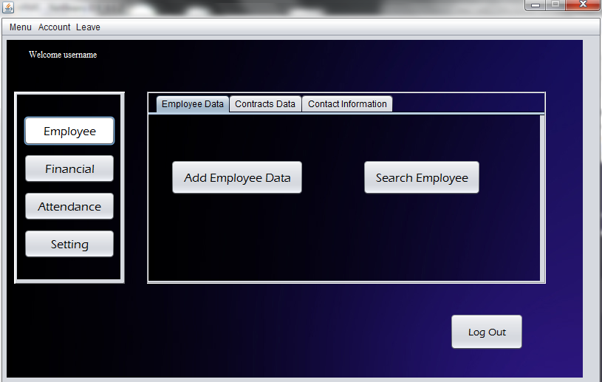

In this interface we are treating the employee functions like employee data and contract data and contract info.

The actor can only can access his own functions only that mean that all these functions is not ready to use for all type of users

***Finance***

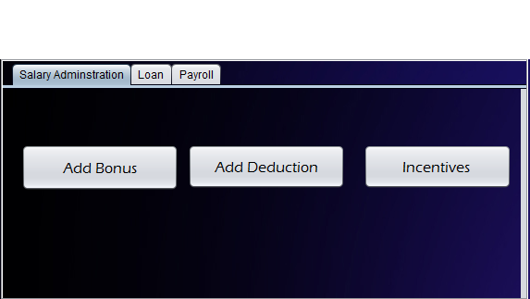

In this interface we are treating the finance functions like salary adminstration, loan, and payroll.

The actor can only can access his own functions only that mean that all these functions is not ready to use for all type of users

***Attendance:***

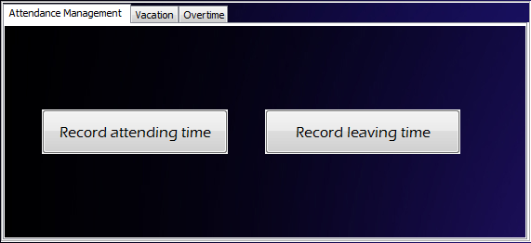

In this interface we are treating the attendance functions like attendance management, vacations, and overtimes.

The actor can only can access his own functions only that mean that all these functions is not ready to use for all type of users

***Loan request:***

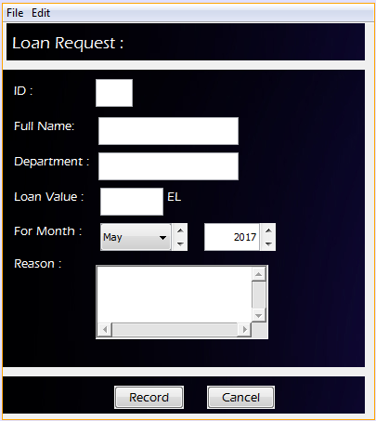

*In this section we can add details about the loan request*

***Search employee:***

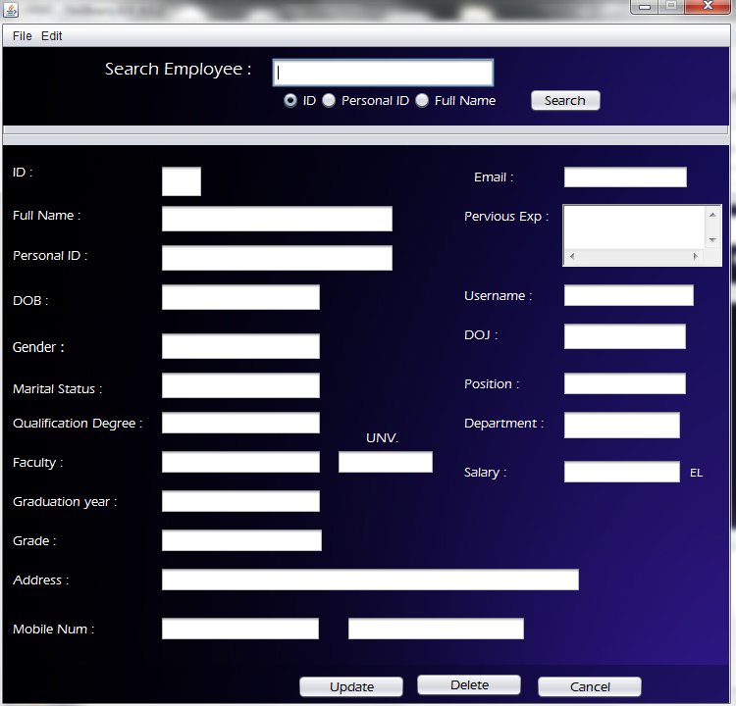

*in this section we can search a certain employee by his own personal data*

***Add bonus:***

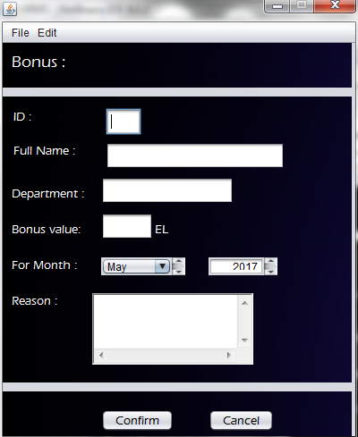

*in this section we can add the details about the bonus added*

***Add contracts:***

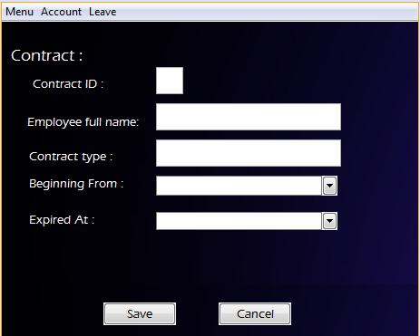

Here we can add the details about the new added contract

***Add deduction:***

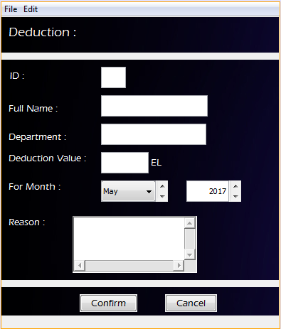

Here we can add the details about the new added deduction

***11-Future work:***

***Prepare end of service forms.***

**Make an Evaluation sheet**

**Evaluate the employees and note their performance.**

**Rollout performance review program**

It is generally best to introduce a new performance review program by assembling all of the employees for a meeting..

### *Benefits Administration*

allows employers to set up rules like auto-enroll, tax percentages, dependent types, and benefits tiers2.1.5 Learning Management.

### *Learning Management*

A learning management system, or LMS is what is being used any time that eLearning takes place. Learning management systems are being used across many different industries to improve organizational efficiency and are also being used in schools for online and blended courses.