بسم الله الرحمن الرحيم

Palestine Polytechnic University



**College of Information Technology and Computer Engineering**

**Database System**

**Constructor name:**

**Nabil Arman**

**Student name:**

**Islam Alama**

**Lama Halayka**

**Mays Dabbas**

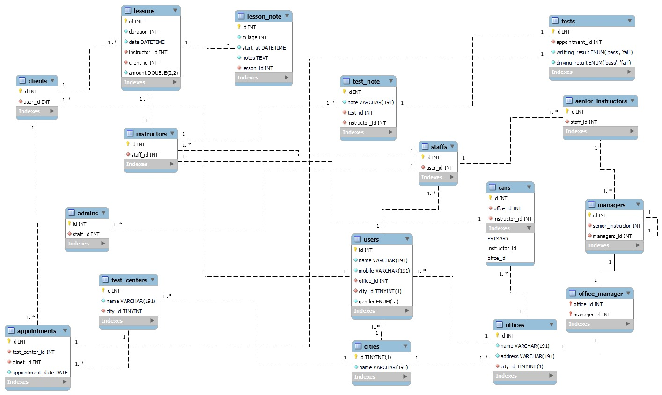**PART 1: conceptual modelling**

MAPPING

Test

|  |  |  |  |
| --- | --- | --- | --- |
| Id | Writing result | Driving result | Appointment id |

Pk: id

FK: appointment id

Normalization :

-Test in 1NF because it’s a relation

-Test in 2NF because there is only one pk and all attribute are fully dependant for it

- Test is in 3NF because all attribute are dependant in id INT and the attribute are prime

users

|  |  |  |  |  |  |
| --- | --- | --- | --- | --- | --- |
| Id | Name | mobile | Gender | Office id | City id |

Pk : id

Fk: office.id , city.id

Normalization:

-Users in 1NF because it’s a relation

-Users in 2NF because there is only one pk and all attribute are fully dependant for it

-Users is in 3NF because all attribute are dependant in id INT and the attribute are prime

Staffs

|  |  |
| --- | --- |
| id | User id |

Pk: id

Fk: user.id

Normalization:

-Staffs in 1NF because it’s a relation

-Staffs in 2NF because there is only one pk and all attribute are fully dependant for it

-Staffs is in 3NF because all attribute are dependant in id INT and the attribute are prime

Admin

|  |  |
| --- | --- |
| Id | Staff id |

Pk: id

Fk: staff id

Normalize:

-Admins in 1NF because it’s a relation

-Admins in 2NF because there is only one pk and all attribute are fully dependant for it

-Admins is in 3NF because all attribute are dependant in id INT and the attribute are prime

Instructor

|  |  |
| --- | --- |
| id | Staff id |

Pk: id

Fk: staff id

Normalization:

Instructors in 1NF because it’s a relation

Instructors in 2NF because there is only one pk and all attribute are fully dependant for it

Instructors is in 3NF because all attribute are dependant in id INT and the attribute are prime

Senior Instructors

|  |  |
| --- | --- |
| id | Staff id |

Pk: id

Pk : staff id

Normalize:

NormSenior _instructors in 1NF because it’s a relation

Senior _instructors in 2NF because there is only one pk and all attribute are fully dependant for it

Senior _instructors is in 3NF because all attribute are dependant in id INT and the attribute are primealization:

Manegar

|  |  |
| --- | --- |
| id | Senior Instructor id |

Pk : id

Fk: senior instructor

Normalization:

managers in 1NF because it’s a relation

managers in 2NF because there is only one pk and all attribute are fully dependant for it

managers is in 3NF because all attribute are dependant in id INT and the attribute are prime

Offices

|  |  |  |  |
| --- | --- | --- | --- |
| Id | Name | address | City id |

Pk: id

Fk: city id

Normalization:

offices in 1NF because it’s a relation

offices in 2NF because there is only one pk and all attribute are fully dependant for it

offices is in 3NF because all attribute are dependant in id INT and the attribute are prime

Office _manger

|  |  |
| --- | --- |
| Office id | Manager id |

Pk: office id , manager id

Normalization:

office_manager in 1NF because it’s a relation

office_manager in 2NF because there pk independent attribute .

office_manager  is in 3NF

Client

|  |  |
| --- | --- |
| Id | User id |

Pk: id

Fk: user id

Normalization:

_clients in 1NF because it’s a relation

-clients in 2NF because there is only one pk and all attribute are fully dependant for it

-clients is in 3NF because all attribute are dependant in id INT and the attribute are prime

Lessons

|  |  |  |  |  |  |
| --- | --- | --- | --- | --- | --- |
| Id | Duration | Date | Amount doubel | Instructor id | Client id |

Pk: id

Fk: instructor id , client id

Normalization:

lessons in 1NF because it’s a relation

lessons in 2NF because there is only one pk and all attribute are fully dependant for it

lessons is in 3NF because all attribute are dependant in id INT and the attribute are prime

Appointment

|  |  |  |  |
| --- | --- | --- | --- |
| Id | Appointment data | Test center id | Client id |

Pk: id

Fk: test center id , client id

Normalization:

appointments in 1NF because it’s a relation

appointments in 2NF because there is only one pk and all attribute are fully dependant for it

appointments is in 3NF because all attribute are dependant in id INT and the attribute are prime

Test center

|  |  |  |
| --- | --- | --- |
| Id | Name | City id |

Pk: id

Fk: city id

Normalization:

test_centers in 1NF because it’s a relation

test_centers in 2NF because there is only one pk and all attribute are fully dependant for it

test_centers is in 3NF because all attribute are dependant in id INT and the attribute are prime

Lesson note

|  |  |  |  |  |
| --- | --- | --- | --- | --- |
| id | Milage | Start | Note text | Lesson id |

Pk: id

Fk: lesson id

Normalize:

lesson_note in 1NF because it’s a relation

lesson_note in 2NF because there is only one pk and all attribute are fully dependant for it

lesson_note is in 3NF because all attribute are dependant in id INT and the attribute are prime

Test note

|  |  |  |  |
| --- | --- | --- | --- |
| Id | Note | Test id | Instructor id |

Pk: id

Fk: test id , instructor id

Normalization:

test_note in 1NF because it’s a relation

test _note in 2NF because there is only one pk and all attribute are fully dependant for it

test _note is in 3NF because all attribute are dependant in id INT and the attribute are prime

Cities

|  |  |
| --- | --- |
| Id | Name |

Pk: id

Normalization:

cities in 1NF because it’s a relation

cities in 2NF because there is only one pk and all attribute are fully dependant for it

cities is in 3NF because all attribute are dependant in id TINYINT and the attribute are prime

Cars

|  |  |  |
| --- | --- | --- |
| Id | Office id | Instructor id |

Pk : id

Fk: office id , instructor id

Normalization:

Car in 1NF because it’s a relation

car in 2NF because there is only one pk and all attribute are fully dependant for it

car is in 3NF because all attribute are dependant in id TINYINT and the attribute are prime

Part 2 : implementation the database

Create the table in SQL

-- Table structure for table `admins`

CREATE TABLE `admins` (

`id` int(20) NOT NULL,

`staff_id` int(20) NOT NULL

) ENGINE=InnoDB DEFAULT CHARSET=latin1;

------------------------------------------------------------------------------

-- Table structure for table `appointments`

CREATE TABLE `appointments` (

`id` int(20) NOT NULL,

`test_center_id` int(20) NOT NULL,

`clinet_id` int(20) NOT NULL,

`appointment_date` date NOT NULL

) ENGINE=InnoDB DEFAULT CHARSET=latin1;

-------------------------------------------------------------------------------

-- Table structure for table `cars`

CREATE TABLE `cars` (

`id` int(20) NOT NULL,

`offce_id` int(20) NOT NULL,

`instructor_id` int(20) NOT NULL

) ENGINE=InnoDB DEFAULT CHARSET=latin1;

-- Table structure for table `cities`

CREATE TABLE `cities` (

`id` tinyint(1) NOT NULL,

`name` varchar(191) NOT NULL

) ENGINE=InnoDB DEFAULT CHARSET=latin1;

---------------------------------------------------------------------------------------------------

-- Table structure for table `clients`

CREATE TABLE `clients` (

`id` int(20) NOT NULL,

`user_id` int(20) NOT NULL

) ENGINE=InnoDB DEFAULT CHARSET=latin1;

-------------------------------------------------------------------------------------------------

-- Table structure for table `instructors`

CREATE TABLE `instructors` (

`id` int(20) NOT NULL,

`staff_id` int(20) NOT NULL

) ENGINE=InnoDB DEFAULT CHARSET=latin1;

-- --------------------------------------------------------

-- Table structure for table `lessons`

CREATE TABLE `lessons` (

`id` int(20) NOT NULL,

`duration` int(10) NOT NULL,

`date` datetime NOT NULL,

`instructor_id` int(20) NOT NULL,

`client_id` int(20) NOT NULL,

`amount` double(2,2) NOT NULL

) ENGINE=InnoDB DEFAULT CHARSET=latin1;

-- --------------------------------------------------------

-- Table structure for table `lesson_note`

CREATE TABLE `lesson_note` (

`id` int(20) NOT NULL,

`milage` int(20) NOT NULL,

`start_at` datetime NOT NULL,

`notes` text NOT NULL,

`lesson_id` int(11) NOT NULL

) ENGINE=InnoDB DEFAULT CHARSET=latin1;

-- --------------------------------------------------------

-- Table structure for table `managers`

CREATE TABLE `managers` (

`id` int(20) NOT NULL,

`senior_instructor` int(20) NOT NULL

) ENGINE=InnoDB DEFAULT CHARSET=latin1;

-- --------------------------------------------------------

-- Table structure for table `offices`

CREATE TABLE `offices` (

`id` int(20) NOT NULL,

`name` varchar(191) NOT NULL,

`address` varchar(191) NOT NULL,

`city_id` tinyint(1) NOT NULL

) ENGINE=InnoDB DEFAULT CHARSET=latin1;

-- Table structure for table `office_manager`

CREATE TABLE `office_manager` (

`office_id` int(20) NOT NULL,

`manager_id` int(20) NOT NULL

) ENGINE=InnoDB DEFAULT CHARSET=latin1;

-- Table structure for table `senior_instructors`

CREATE TABLE `senior_instructors` (

`id` int(20) NOT NULL COMMENT '\r\n',

`staff_id` int(20) NOT NULL

) ENGINE=InnoDB DEFAULT CHARSET=latin1;

-- --------------------------------------------------------

-- Table structure for table `staffs`

CREATE TABLE `staffs` (

`id` int(20) NOT NULL,

`user_id` int(20) NOT NULL

) ENGINE=InnoDB DEFAULT CHARSET=latin1;

-- --------------------------------------------------------

-- Table structure for table `tests`

CREATE TABLE `tests` (

`id` int(20) NOT NULL,

`appointment_id` int(20) NOT NULL,

`writting_result` enum('pass','fail') NOT NULL,

`driving_result` enum('pass','fail') NOT NULL

) ENGINE=InnoDB DEFAULT CHARSET=latin1;

-- --------------------------------------------------------

-- Table structure for table `test_centers`

CREATE TABLE `test_centers` (

`id` int(11) NOT NULL,

`name` varchar(191) NOT NULL,

`city_id` tinyint(20) NOT NULL

) ENGINE=InnoDB DEFAULT CHARSET=latin1;

-- --------------------------------------------------------

-- Table structure for table `test_note`

CREATE TABLE `test_note` (

`id` int(20) NOT NULL,

`note` varchar(191) NOT NULL,

`test_id` int(20) NOT NULL,

`instructor_id` int(20) NOT NULL

) ENGINE=InnoDB DEFAULT CHARSET=latin1;

-- --------------------------------------------------------

-- Table structure for table `users`

CREATE TABLE `users` (

`id` int(20) NOT NULL,

`name` varchar(191) NOT NULL,

`mobile` varchar(191) NOT NULL,

`office_id` int(20) NOT NULL,

`city_id` tinyint(1) NOT NULL,

`gender` enum('male','female') NOT NULL

) ENGINE=InnoDB DEFAULT CHARSET=latin1;

---------------------------------------------------------------------------

-- Indexes for table `admins`

ALTER TABLE `admins`

ADD PRIMARY KEY (`id`),

ADD KEY `staff_id` (`staff_id`);

-- Indexes for table `appointments`

ALTER TABLE `appointments`

ADD PRIMARY KEY (`id`),

ADD KEY `clinet_id` (`clinet_id`),

ADD KEY `test_center_id` (`test_center_id`);

---------------------------------------------------------------------------------

-- Indexes for table `cars`

ALTER TABLE `cars`

ADD PRIMARY KEY (`id`),

ADD KEY `instructor_id` (`instructor_id`),

ADD KEY `offce_id` (`offce_id`);

-- Indexes for table `cities`

ALTER TABLE `cities`

ADD PRIMARY KEY (`id`);

-------------------------------------------------------------------------------------------------

-- Indexes for table `clients`

--

ALTER TABLE `clients`

ADD PRIMARY KEY (`id`),

ADD KEY `user_id` (`user_id`);

-- Indexes for table `instructors`

ALTER TABLE `instructors`

ADD PRIMARY KEY (`id`),

ADD KEY `staff_id` (`staff_id`);

-- Indexes for table `lessons`

ALTER TABLE `lessons`

ADD PRIMARY KEY (`id`),

ADD KEY `client_id` (`client_id`),

ADD KEY `instructor_id` (`instructor_id`);

-- Indexes for table `lesson_note`

ALTER TABLE `lesson_note`

ADD PRIMARY KEY (`id`),

ADD KEY `lesson_id` (`lesson_id`);

-- Indexes for table `managers`

ALTER TABLE `managers`

ADD PRIMARY KEY (`id`),

ADD KEY `senior_instructor` (`senior_instructor`);

-- Indexes for table `offices`

ALTER TABLE `offices`

ADD PRIMARY KEY (`id`),

ADD KEY `city_id` (`city_id`);

-- Indexes for table `office_manager`

ALTER TABLE `office_manager`

ADD PRIMARY KEY (`manager_id`,`office_id`),

ADD KEY `office_id` (`office_id`);

-- Indexes for table `senior_instructors`

ALTER TABLE `senior_instructors`

ADD PRIMARY KEY (`id`),

ADD KEY `staff_id` (`staff_id`);

-- Indexes for table `staffs`

ALTER TABLE `staffs`

ADD PRIMARY KEY (`id`),

ADD KEY `user_id` (`user_id`);

-- Indexes for table `tests`

ALTER TABLE `tests`

ADD PRIMARY KEY (`id`),

ADD KEY `appointment_id` (`appointment_id`);

-- Indexes for table `test_centers`

ALTER TABLE `test_centers`

ADD PRIMARY KEY (`id`),

ADD KEY `city_id` (`city_id`);

-- Indexes for table `test_note`

ALTER TABLE `test_note`

ADD PRIMARY KEY (`id`),

ADD KEY `instructor_id` (`instructor_id`),

ADD KEY `test_id` (`test_id`);

-- Indexes for table `users`

ALTER TABLE `users`

ADD PRIMARY KEY (`id`),

ADD KEY `city_id` (`city_id`),

ADD KEY `office_id` (`office_id`);

-- AUTO_INCREMENT fo dumped table

-- AUTO_INCREMENT for table `admins`

ALTER TABLE `admins`

MODIFY `id` int(20) NOT NULL AUTO_INCREMENT;

-- AUTO_INCREMENT for table `appointments`

ALTER TABLE `appointments`

MODIFY `id` int(20) NOT NULL AUTO_INCREMENT;

-- AUTO_INCREMENT for table `cars

ALTER TABLE `cars`

MODIFY `id` int(20) NOT NULL AUTO_INCREMENT;

-- AUTO_INCREMENT for table `cities`

ALTER TABLE `cities`

MODIFY `id` tinyint(1) NOT NULL AUTO_INCREMENT;

-- AUTO_INCREMENT for table `clients`

ALTER TABLE `clients`

MODIFY `id` int(20) NOT NULL AUTO_INCREMENT;

-- AUTO_INCREMENT for table `instructors`

ALTER TABLE `instructors`

MODIFY `id` int(20) NOT NULL AUTO_INCREMENT;

-- AUTO_INCREMENT for table `lessons`

ALTER TABLE `lessons`

MODIFY `id` int(20) NOT NULL AUTO_INCREMENT;

-- AUTO_INCREMENT for table `lesson_note`

ALTER TABLE `lesson_note`

MODIFY `id` int(20) NOT NULL AUTO_INCREMENT;

-- AUTO_INCREMENT for table `managers`

ALTER TABLE `managers`

MODIFY `id` int(20) NOT NULL AUTO_INCREMENT;

-- AUTO_INCREMENT for table `offices`

ALTER TABLE `offices`

MODIFY `id` int(20) NOT NULL AUTO_INCREMENT;

-- AUTO_INCREMENT for table `senior_instructors`

ALTER TABLE `senior_instructors`

MODIFY `id` int(20) NOT NULL AUTO_INCREMENT COMMENT '\r\n';

-- AUTO_INCREMENT for table `staffs

--

ALTER TABLE `staffs`

MODIFY `id` int(20) NOT NULL AUTO_INCREMENT;

-- AUTO_INCREMENT for table `tests`

ALTER TABLE `tests`

MODIFY `id` int(20) NOT NULL AUTO_INCREMENT

-- AUTO_INCREMENT for table `test_centers`

ALTER TABLE `test_centers`

MODIFY `id` int(11) NOT NULL AUTO_INCREMENT;

-- AUTO_INCREMENT fo table `test_note`

ALTER TABLE `test_note`

MODIFY `id` int(20) NOT NULL AUTO_INCREMENT;

-- AUTO_INCREMENT for table `users`

ALTER TABLE `users`

MODIFY `id` int(20) NOT NULL AUTO_INCREMENT;

-- Constraints for dumped tables

-- Constraints for table `admins`

ALTER TABLE `admins`

ADD CONSTRAINT `admins_ibfk_1` FOREIGN KEY (`staff_id`) REFERENCES `staffs` (`id`);

-- Constraints for table `appointments`

ALTER TABLE `appointments`

ADD CONSTRAINT `appointments_ibfk_1` FOREIGN KEY (`clinet_id`) REFERENCES `clients` (`id`),

ADD CONSTRAINT `appointments_ibfk_2` FOREIGN KEY (`test_center_id`) REFERENCES `test_centers` (`id`);

-- Constraints for table `cars`

ALTER TABLE `cars`

ADD CONSTRAINT `cars_ibfk_1` FOREIGN KEY (`instructor_id`) REFERENCES `instructors` (`id`),

ADD CONSTRAINT `cars_ibfk_2` FOREIGN KEY (`offce_id`) REFERENCES `offices` (`id`);

--

-- Constraints for table `clients`

--

ALTER TABLE `clients`

ADD CONSTRAINT `clients_ibfk_1` FOREIGN KEY (`user_id`) REFERENCES `users` (`id`);

--

-- Constraints for table `instructors`

--

ALTER TABLE `instructors`

ADD CONSTRAINT `instructors_ibfk_1` FOREIGN KEY (`staff_id`) REFERENCES `staffs` (`id`);

--

-- Constraints for table `lessons`

--

ALTER TABLE `lessons`

ADD CONSTRAINT `lessons_ibfk_1` FOREIGN KEY (`client_id`) REFERENCES `clients` (`id`),

ADD CONSTRAINT `lessons_ibfk_2` FOREIGN KEY (`instructor_id`) REFERENCES `instructors` (`id`);

--

-- Constraints for table `lesson_note`

--

ALTER TABLE `lesson_note`

ADD CONSTRAINT `lesson_note_ibfk_1` FOREIGN KEY (`lesson_id`) REFERENCES `lessons` (`id`);

--

-- Constraints for table `managers`

--

ALTER TABLE `managers`

ADD CONSTRAINT `managers_ibfk_1` FOREIGN KEY (`senior_instructor`) REFERENCES `senior_instructors` (`id`);

--

-- Constraints for table `offices`

--

ALTER TABLE `offices`

ADD CONSTRAINT `offices_ibfk_1` FOREIGN KEY (`city_id`) REFERENCES `cities` (`id`);

--

-- Constraints for table `office_manager`

--

ALTER TABLE `office_manager`

ADD CONSTRAINT `office_manager_ibfk_1` FOREIGN KEY (`manager_id`) REFERENCES `managers` (`id`),

ADD CONSTRAINT `office_manager_ibfk_2` FOREIGN KEY (`office_id`) REFERENCES `offices` (`id`);

--

-- Constraints for table `senior_instructors`

--

ALTER TABLE `senior_instructors`

ADD CONSTRAINT `senior_instructors_ibfk_1` FOREIGN KEY (`staff_id`) REFERENCES `staffs` (`id`);

--

-- Constraints for table `staffs`

--

ALTER TABLE `staffs`

ADD CONSTRAINT `staffs_ibfk_1` FOREIGN KEY (`user_id`) REFERENCES `users` (`id`);

--

-- Constraints for table `tests`

--

ALTER TABLE `tests`

ADD CONSTRAINT `tests_ibfk_1` FOREIGN KEY (`appointment_id`) REFERENCES `appointments` (`id`);

--

-- Constraints for table `test_centers`

--

ALTER TABLE `test_centers`

ADD CONSTRAINT `test_centers_ibfk_1` FOREIGN KEY (`city_id`) REFERENCES `cities` (`id`);

-- Constraints for table `test_note`

ALTER TABLE `test_note`

ADD CONSTRAINT `test_note_ibfk_1` FOREIGN KEY (`instructor_id`) REFERENCES `instructors` (`id`),

ADD CONSTRAINT `test_note_ibfk_2` FOREIGN KEY (`test_id`) REFERENCES `tests` (`id`);

-- Constraints for table `users`

ALTER TABLE `users`

ADD CONSTRAINT `users_ibfk_1` FOREIGN KEY (`city_id`) REFERENCES `cities` (`id`),

ADD CONSTRAINT `users_ibfk_2` FOREIGN KEY (`office_id`) REFERENCES `offices` (`id`);

COMMIT;

*Insert value for the table in sql :

INSERT INTO `cities` (`id`, `name`) VALUES ('1', 'Hebron') ;

INSERT INTO `cities` (`id`, `name`) VALUES ('2', 'Bethlahem') ;

INSERT INTO `cities` (`id`, `name`) VALUES ('3',’ Nablus') ;

INSERT INTO `cities` (`id`, `name`) VALUES ('4', 'Jerusalem') ;

INSERT INTO `cities` (`id`, `name`) VALUES ('5', 'Yafa') ;

INSERT INTO `offices` (`id`, `name`, `address`, `city_id`) VALUES ('01', 'office 19', 'aa_123', '1');

INSERT INTO `offices` (`id`, `name`, `address`, `city_id`) VALUES ('02', 'office 20', 'ab_123', '2');

INSERT INTO `offices` (`id`, `name`, `address`, `city_id`) VALUES ('03', 'office 21', 'bb_123', '3');

INSERT INTO `offices` (`id`, `name`, `address`, `city_id`) VALUES ('04', 'office 22', 'cc_123', '4');

INSERT INTO `offices` (`id`, `name`, `address`, `city_id`) VALUES ('05', 'office 23', 'dd_123', '5');

INSERT INTO `test_centers` (`id`, `name`, `city_id`) VALUES ('11', 'test center 1', '1');

INSERT INTO `test_centers` (`id`, `name`, `city_id`) VALUES ('22', 'test center 2', '2');

INSERT INTO `test_centers` (`id`, `name`, `city_id`) VALUES ('33', 'test center 3', '3');

INSERT INTO `test_centers` (`id`, `name`, `city_id`) VALUES ('44', 'test center 4', '4');

INSERT INTO `test_centers` (`id`, `name`, `city_id`) VALUES ('55', 'test center 5', '5');

INSERT INTO `users` (`id`, `name`, `mobile`, `office_id`, `city_id`, `gender`) VALUES ('20', 'Muhammad', '0595000000', '01', '1', 'male');

INSERT INTO `users` (`id`, `name`, `mobile`, `office_id`, `city_id`, `gender`) VALUES ('30', 'Nada', '0595000001', '02', '2', 'female');

INSERT INTO `users` (`id`, `name`, `mobile`, `office_id`, `city_id`, `gender`) VALUES ('40', 'Lama', '0595000002', '03', '3', 'female');

INSERT INTO `users` (`id`, `name`, `mobile`, `office_id`, `city_id`, `gender`) VALUES ('50', 'Islam', '0595000003', '04', '4', 'female');

INSERT INTO `users` (`id`, `name`, `mobile`, `office_id`, `city_id`, `gender`) VALUES ('60', 'Mais', '0595000004', '05', '5', 'female');

INSERT INTO `staffs` (`id`, `user_id`) VALUES ('100', '20');

INSERT INTO `staffs` (`id`, `user_id`) VALUES ('200', '30');

INSERT INTO `staffs` (`id`, `user_id`) VALUES ('300', '40');

INSERT INTO `staffs` (`id`, `user_id`) VALUES ('400', '50');

INSERT INTO `staffs` (`id`, `user_id`) VALUES ('500', '60');

-----------------------------------------------------------------------------------------------

INSERT INTO `clients` (`id`, `user_id`) VALUES ('111', '20');

------------------------------------------------------------------------------------------------

INSERT INTO `instructors` (`id`, `staff_id`) VALUES ('1111', '100');

----------------------------------------------------------------------------------------------------

INSERT INTO `senior_instructors` (`id`, `staff_id`) VALUES ('11111', '100');

----------------------------------------------------------------------------------------------------------------------

INSERT INTO `managers` (`id`, `senior_instructor`) VALUES ('111111', '11111');

INSERT INTO `admins` (`id`, `staff_id`) VALUES ('1010', '100');

INSERT INTO `office_manager` (`office_id`, `manager_id`) VALUES ('01', '111111');

INSERT INTO `cars` (`id`, `offce_id`, `instructor_id`) VALUES ('1212', '01', '1111');

INSERT INTO `appointments` (`id`, `test_center_id`, `clinet_id`, `appointment_date`) VALUES ('56', '11', '111', '2022-12-14');

INSERT INTO `lessons` (`id`, `duration`, `date`, `instructor_id`, `client_id`, `amount`) VALUES ('77', '1', '2022-12-28 23:45:42', '1111', '111', '200');

INSERT INTO `lesson_note` (`id`, `milage`, `start_at`, `notes`, `lesson_id`) VALUES ('123', '3', '2022-12-29 23:49:07', 'nothing to worry about.', '77');

INSERT INTO `tests` (`id`, `appointment_id`, `writting_result`, `driving_result`) VALUES ('788', '56', 'pass', 'fail');

INSERT INTO `test_note` (`id`, `note`, `test_id`, `instructor_id`) VALUES ('7777', 'distracted.', '788', '1111');

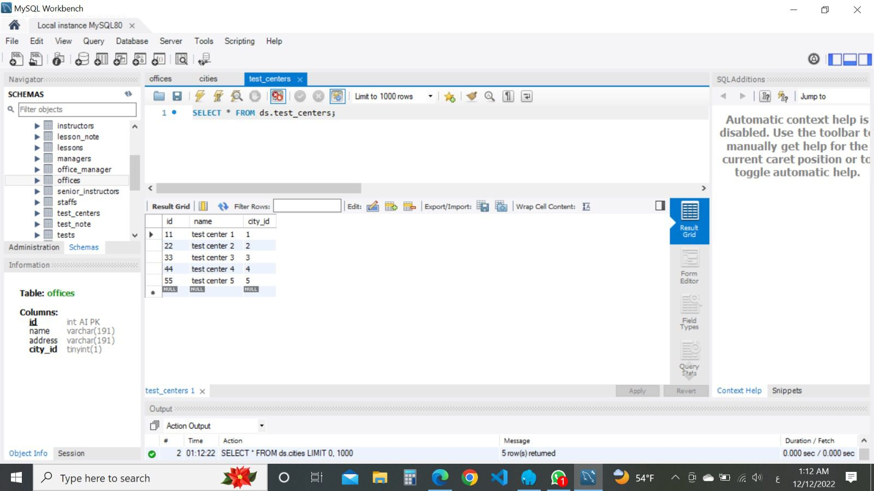

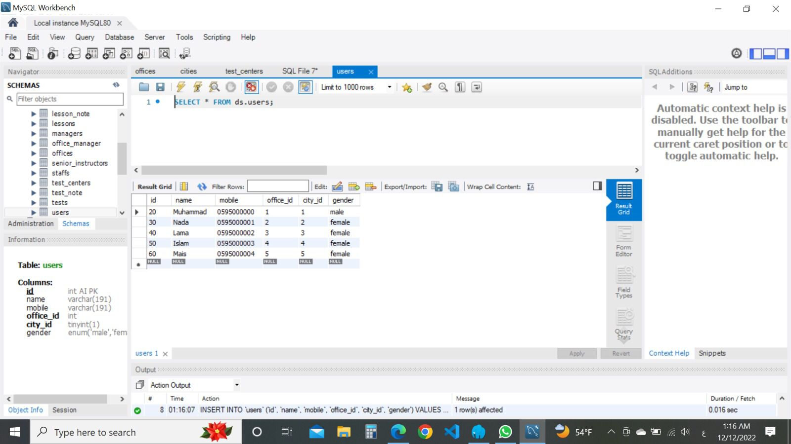

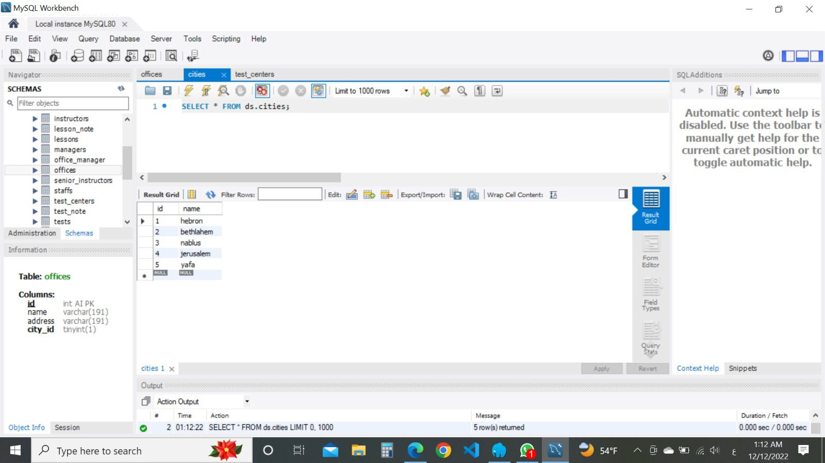

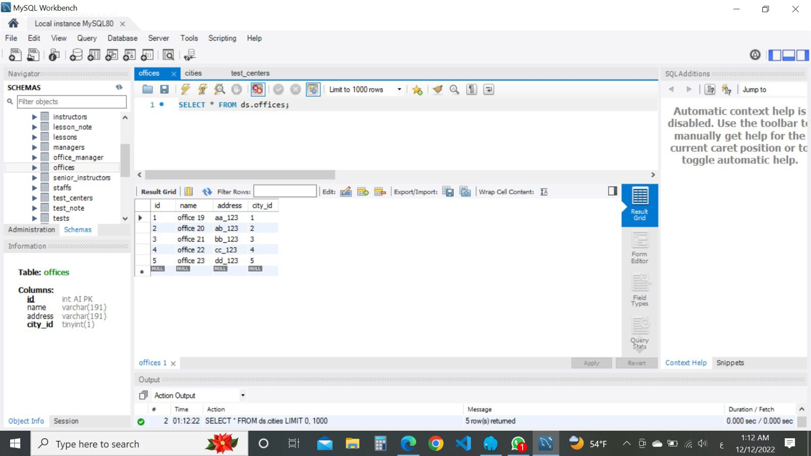

PART 3: QUERY THE DATABASES

1. SELECT users.mobile,users.name FROM office_manager

LEFT JOIN managers ON office_manager.manager_id = managers.id

LEFT JOIN senior_instructors ON managers.senior_instructor = senior_instructors.id

LEFT JOIN staffs ON senior_instructors.staff_id = staffs.id

LEFT JOIN users ON staffs.user_id = users.id

LEFT JOIN offices ON office_manager.office_id = offices.id

2 ) SELECT * FROM `offices` WHERE city_id=2;

SELECT * FROM `offices`

LEFT JOIN cities ON offices.city_id = cities.id

WHERE cities.name ='jerusalem';

3) SELECT users.name FROM instructors

LEFT JOIN staffs on instructors.staff_id = staffs.id

LEFT JOIN users on staffs.user_id = users.id

LEFT JOIN offices on users.office_id = offices.id

WHERE users.gender = 'female'

ORDER BY offices.name ASC

4) SELECT offices.name,count(users.id) FROM staffs

LEFT JOIN users ON staffs.user_id = users.id

LEFT JOIN offices ON users.office_id =offices.id

GROUP by offices.id

5) SELECT cities.name,count(users.id) FROM clients

LEFT JOIN users ON clients.user_id = users.id

LEFT JOIN cities ON users.city_id =cities.id

GROUP by cities.id

6- SELECT offices.name,users.gender,count(users.id) FROM clients

LEFT JOIN users ON clients.user_id = users.id

LEFT JOIN offices ON users.city_id =offices.id

GROUP by offices.id,users.gender

7 -SELECT

users.name,

(SELECT count(tests.id) FROM tests

LEFT JOIN appointments ON tests.appointment_id = appointments.id

WHERE tests.writting_result='fail' and tests.driving_result='fail' and appointments.clinet_id = clients.id

) AS fail

FROM clients

LEFT JOIN users ON clients.user_id = users.id

HAVING fail>3

8- SELECT AVG(lesson_note.milage) FROM lessons

LEFT JOIN lesson_note on lesson_note.lesson_id = lessons.id

WHERE lessons.duration = 1