1. Create MySql database named singlepack.[same as db_name inside “resources/config.ini” file]

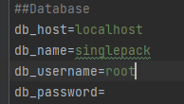

1. Load the .sql file to that database. [If multiple .sql file load the latest one]

|  |  |  |
| --- | --- | --- |
| Database File Name | GUI_IO_description_Rev | Project Version |
| singlepack_2024_06_12_Rev19 | 19 | 1.0.1 |
|  |  |  |
|  |  |  |
|  |  |  |