Wireshark
report
Metric | Result
Total packets | 152229
ICMP packet | 8
DNS | 215
HTTP | 62
ARP | 8
TCP | 151229

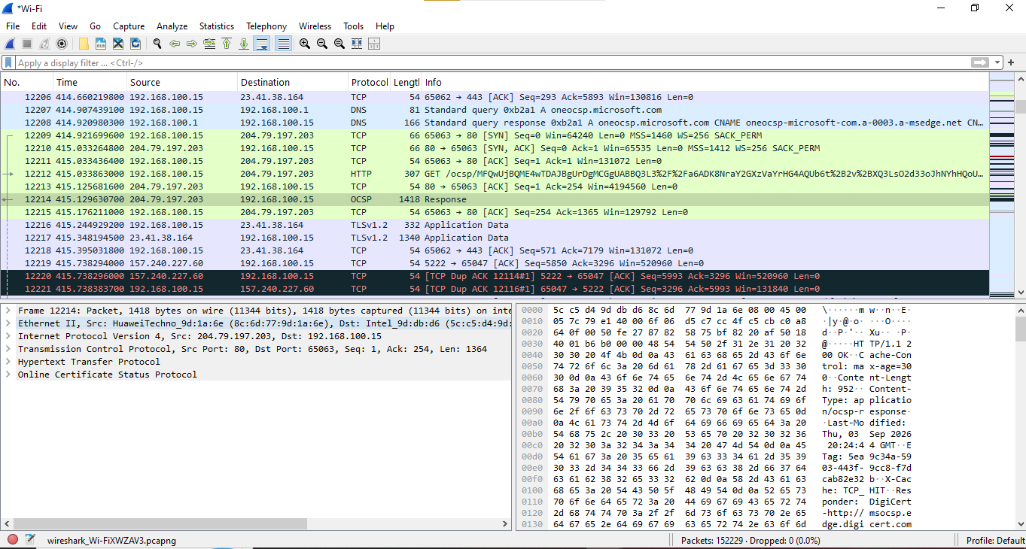
Icmp
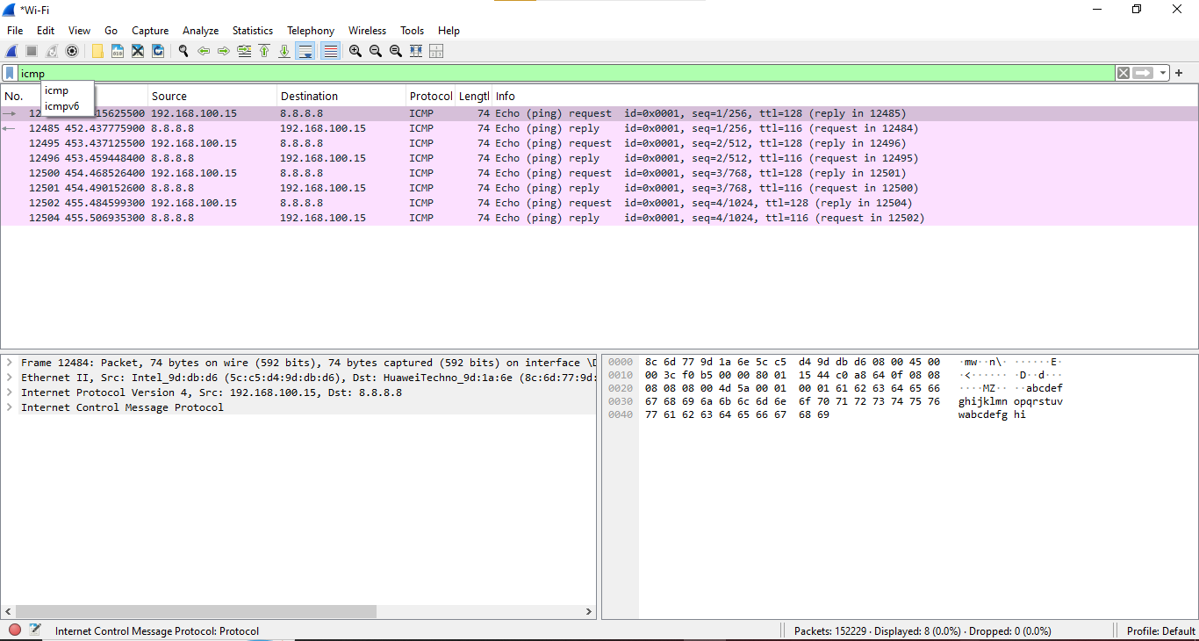dns
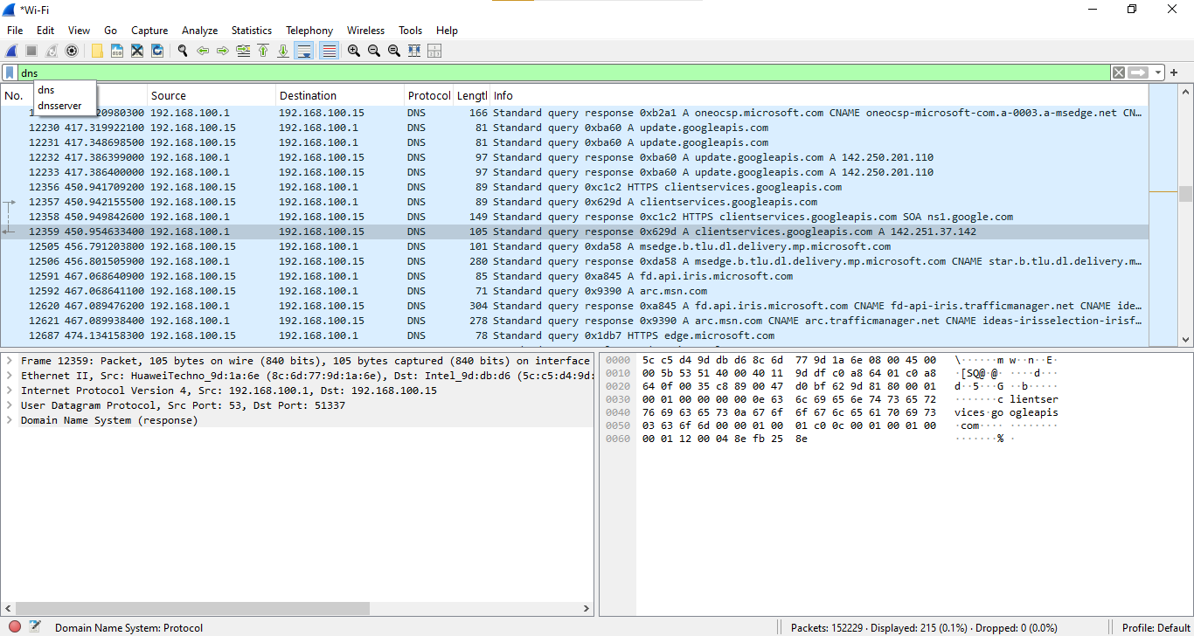
http
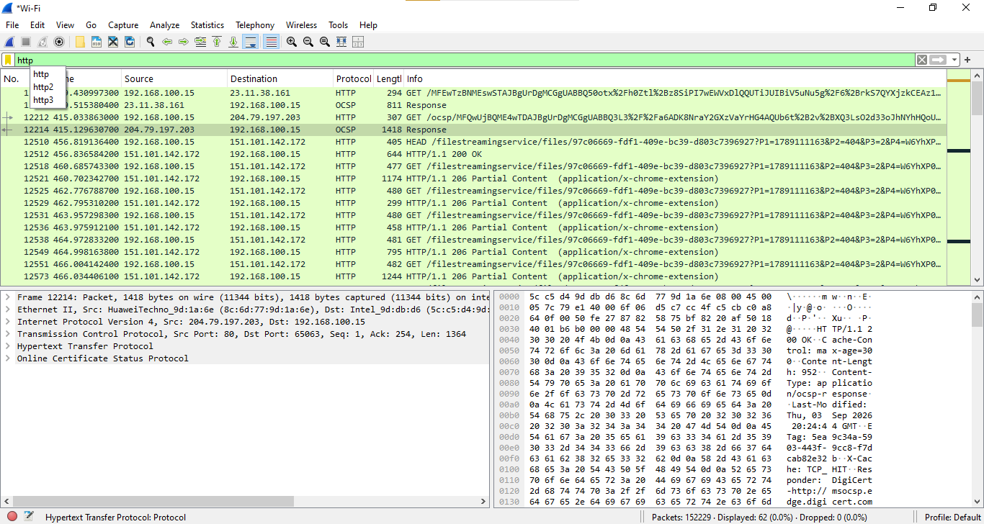
Arp
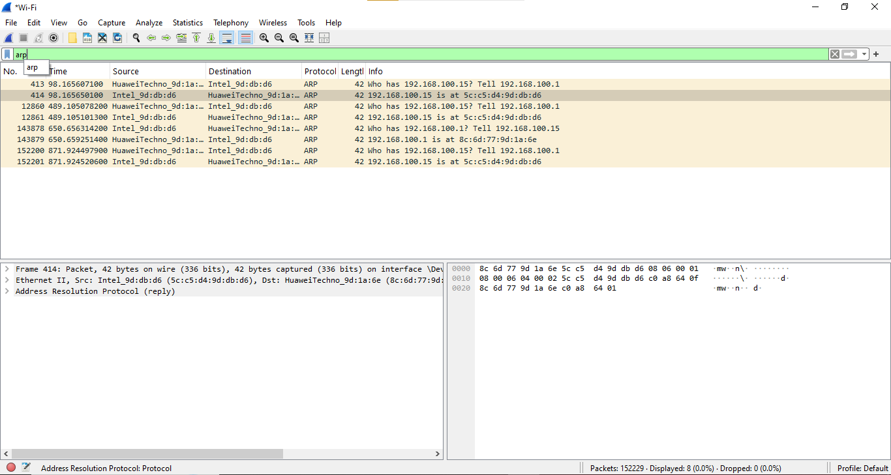
Tcp


