Retail Network Testing

Test 1: ICMP Traffic
Filter: "icmp"
Purpose:To verify that ICMP traffic can be identified in Wireshark.
Result:ICMP packets were tested using the Wireshark filter.
Evidence:
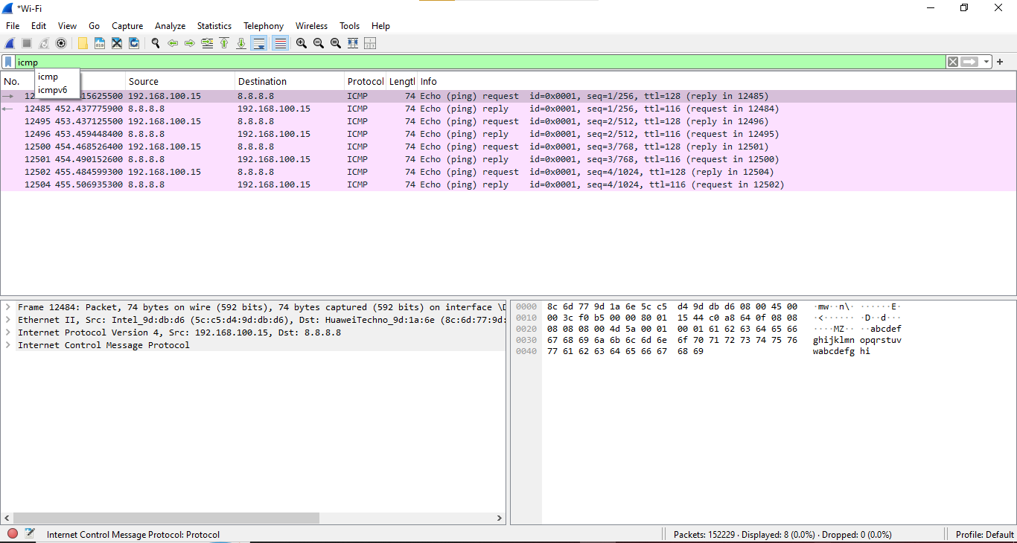
Test 2: DNS Traffic
Filter: "dns"
Purpose:To verify that DNS traffic can be identified.
Result:DNS packets were displayed successfully.
Evidence:
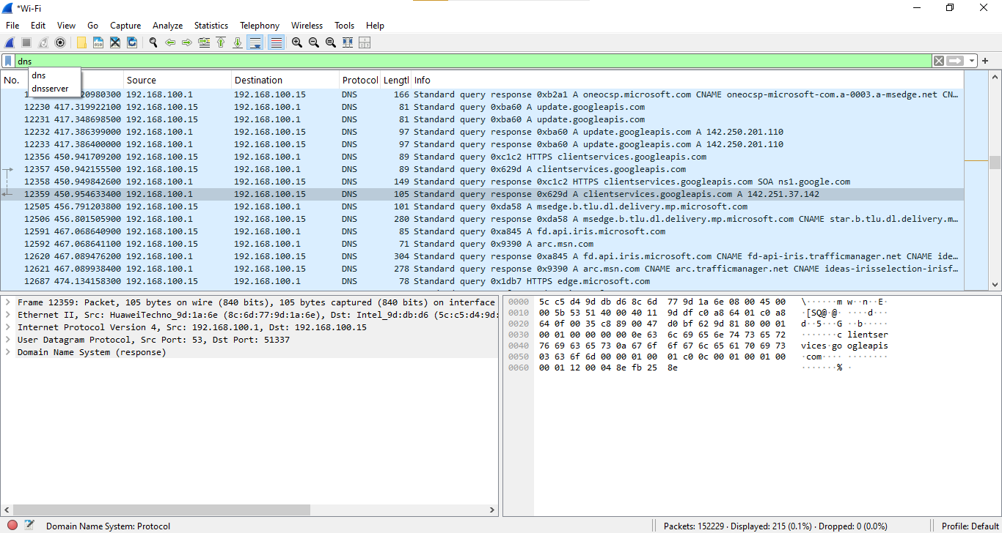
Test 3: TCP Traffic
Filter: "tcp"
Purpose:To verify TCP network traffic.
Result:TCP packets were displayed successfully.
Evidence:
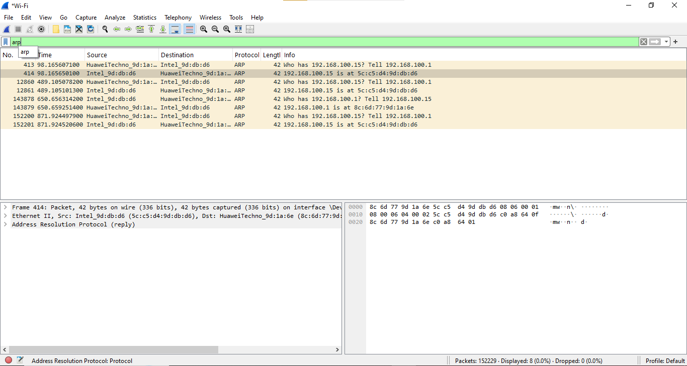

Test 4: HTTP Traffic
Filter: "http"
Purpose:To verify HTTP traffic.
Result:HTTP traffic was tested using the Wireshark filter.
Evidence:
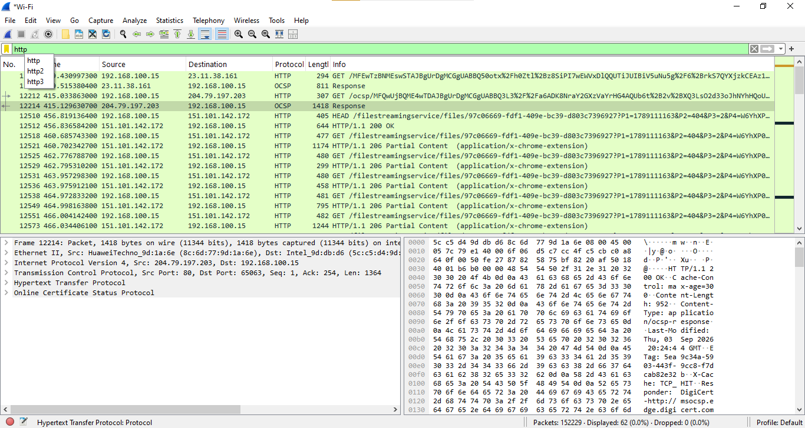

Test 5: ARP Traffic
Filter: "arp"
Purpose:
To verify ARP traffic.
Result:
ARP packets were displayed successfully.
Evidence:

Overall Testing Result

The Wireshark filters were tested successfully to identify different types of network traffic. Screenshots were captured as evidence of the testing process.

