**Task day5**

1-Create a simple form with Add and Reset buttons takes user`s information (name age and email) with validation for each field and all fields are required.

Show the message for user in case error

2- cheak the resource file and Dom_node file you will trun it to this

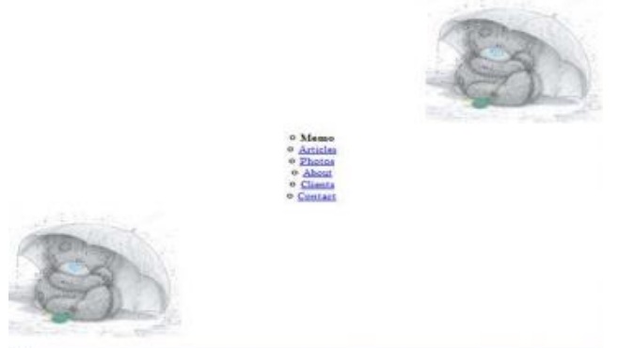

fig c : final state I want

ALT

2-1- list : bullets type and position

2-copy the image and change the position