Books Network Project

Team
ID | Name | Email | Mobile
20120443 | Heba mobarak kamel | Hebakamel373@yahoo.com | 01016243287
20120457 | Yasmeen Mokhtar Mohamed | yassomokhtar@gmail.com | 01156528207
20120453 | Yara Abbas Muhamed | Yara_fci@yahoo.com | 01111494921
20120373 | Mariam Sobhy Aziz | mariamsobhy55@yahoo.com | 01115737792

Document Purpose and Audience

-This document enable to explain you about the system where you can read any favorite books from anywhere in the world also you can add or share your books with your friends to read or give your opinion .

- Audience: teacher assistants

Introduction

- Purpose of the system
The purpose of the project Books Network is to facilitate communication among
People and sharing their opinions via new social media and it provide a free text books without any effort also for encourage people to read .

- Scope of the system

this system is social communication where you can read any book from anywhere and share this with friends you need and you can adding new books also you can communicate with each other by creating group and joining in it and adding posts and comments and give the system their opinion and increase knowledge in each technology where all this will reflect on the system which will be completely with variation books then the system must do reviewing books at internal time and for facility communication creating group for user's friends .

Functional Requirements

Because of technological progress, we need to educate more areas in order to keep up with this progress and therefore the main function of this system is to enable many people to be contacted via virtual reading club or cataloging system and sharing their opinions by knowing the latest update for each user profile which consists of basic information about shelves, favorite books with rates, favorite authors, favorite genres. This system also give any user the potential of adding and searching for any book in the public books list .

1- Adding friends ➔ this function enable users to added other users to follow their activities on books , what books finish read, currently reading, want to read, reviews and ratings.

2-Adding books ➔ this function enable the user of the system to add new book in any shelve or any department.

3- Search ➔ this function enable users to Search about any book in the public books list and add it manually if this book not founded.

4-View Books ➔ System user can view his books in different ways; either to view a list of books in each own shelves, or by view books in each category

5- Reviewing and Rating books ➔ this function enable any user to know the latest updates of his friends review books that he read and rate it up to 5 stars and other users can see this reviews , like it and also comment on it .

6-Creating group for friends ➔ this function allow other users join in this group, add posts and comments.

Non Functional Requirements

-Non functional requirements describe quality of system:-

Books Network will be done within any time to add , search book any doing any function , system Not defining time.

Network is using internet technology .

System allows up to any number of users , Not defining number of users.

The system has high quality of using technology and it is being easily of communication between users.

-some types for non functional requirements:-
Details
Books Network system will be done within any time , Not defining time. | Performance
System is using internet technology and new technology tools. So , it is becoming very easy for any user to use it. | Usability
System is enable to change for adding new books for system or copy of old book in system. | Portability

Use Case Tables:-

Use Case ID:
Use Case Name: | Books Network
Actors: | user
Pre-conditions: | Adding books in books Network system.
Post-conditions: | User can add new book in books network by easily.
Flow of events: | User Action | System Action
Flow of events: | 1- User Enter Card and Password.
Flow of events: |  | 2- System Verify user data
Flow of events: | 3- User Select Vodafone from the list
Flow of events: |  | 4- System retrieves Vodafone bills
Flow of events: | and so on
Exceptions: | User to can add new book , he should ensure new book there is not finding in books network.
Includes: | System include user to add new book.
Notes and Issues: | New book is not finding in books network.

Use Case ID:
Use Case Name: | Books Network
Actors: | user
Pre-conditions: | Search book
Post-conditions: | User can search about book in books network by enter book name.
Flow of events: | User Action | System Action
Flow of events: | 1- User Enter Card and Password.
Flow of events: |  | 2- System Verify user data
Flow of events: | 3- User Select Vodafone from the list
Flow of events: |  | 4- System retrieves Vodafone bills
Flow of events: | and so on
Exceptions: | User to can search about book , he should enter book name in books network.
Includes: | System include user to search about any book.
Notes and Issues: | Searching book may be not finding in books network.

Use Case ID:
Use Case Name: | Books Network
Actors: | user
Pre-conditions: | Reviewing and Rating books.
Post-conditions: | User to know the latest updates of his friends review books that he read and rate it up to 5 stars and other users can see this reviews , like it and also comment on it .
Flow of events: | User Action | System Action
Flow of events: | 1- User Enter Card and Password.
Flow of events: |  | 2- System Verify user data
Flow of events: | 3- User Select Vodafone from the list
Flow of events: |  | 4- System retrieves Vodafone bills
Flow of events: | and so on
Exceptions: | User to know last update , he should enter rate 5 stars to can comment for updating books.
Includes: | System include user to know last updating about books.
Notes and Issues: | User may be not finding updating for books.

Use Case ID:
Use Case Name: | Books Network
Actors: | user
Pre-conditions: | Adding friends in books networks.
Post-conditions: | User can add other users to follow their activities on books , what books finish read, currently reading, want to read, reviews and ratings.
Flow of events: | User Action | System Action
Flow of events: | 1- User Enter Card and Password.
Flow of events: |  | 2- System Verify user data
Flow of events: | 3- User Select Vodafone from the list
Flow of events: |  | 4- System retrieves Vodafone bills
Flow of events: | and so on
Exceptions: | User to can add new user for system , he should ensure his friend not finding in system from before.
Includes: | System include users to can add new user.
Notes and Issues: | New friend is not finding in books network.

Use Case ID:
Use Case Name: | Books Network
Actors: | user
Pre-conditions: | Creating group for friends.
Post-conditions | Other users can join in this group, add posts and comments.
Flow of events: | User Action | System Action
Flow of events: | 1- User Enter Card and Password.
Flow of events: |  | 2- System Verify user data
Flow of events: | 3- User Select Vodafone from the list
Flow of events: |  | 4- System retrieves Vodafone bills
Flow of events: | and so on
Exceptions: | To create group for friends , user should ensure this group not finding from before.
Includes: | Users can add comments posts about books by creating group.
Notes and Issues: | New group there is not in books network.

use case (books network)

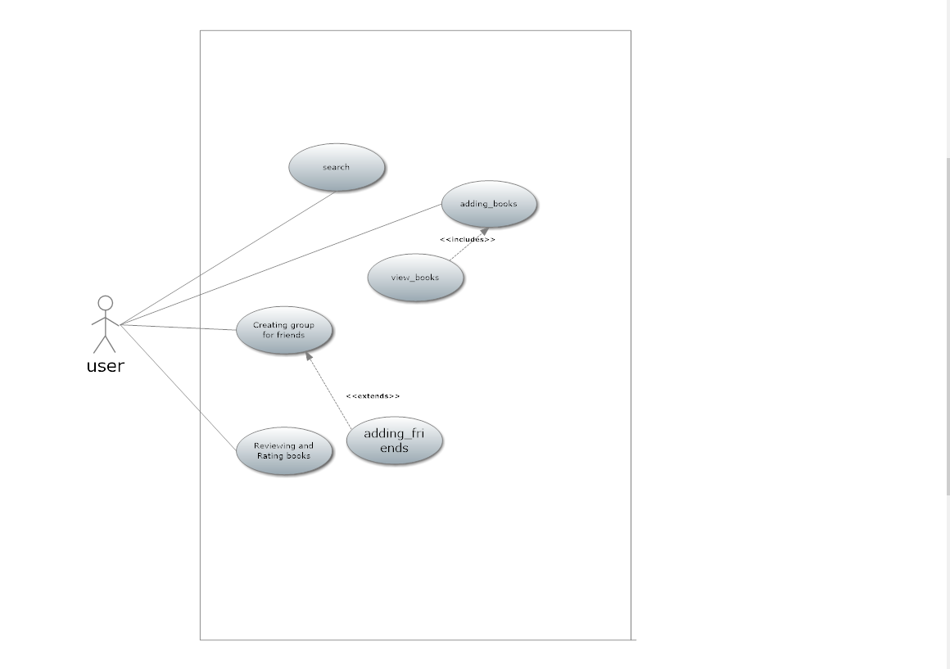assumption:-

where actor is user has five function first is search ,review books include from function add books ,add friends extends from creating group

