**What is Lighthouse?**

**Lighthouse** is a built-in tool in Chrome DevTools that helps you **audit and analyze your website's performance**, accessibility, SEO, best practices, and more.

It gives you a **report** with scores (0–100) and suggestions on how to improve your web page.

**What Can Lighthouse Audit?**

Lighthouse checks:

* **Performance** (page speed, load time, etc.)
* **Accessibility** (for users with disabilities)
* **Best Practices** (secure and modern code)
* **SEO** (search engine optimization)
* **Progressive Web App (PWA)** (optional)

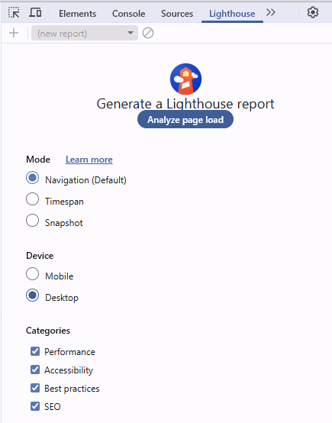**How to Use Lighthouse in Chrome DevTools**

1. **Open Chrome**
2. Go to the web page you want to analyze.
3. **Right-click** on the page > choose **Inspect** (or press Ctrl+Shift+I)
4. In DevTools, go to the **“Lighthouse”** tab (move right using >> if it's not visible).
5. Choose what categories you want to audit:
   * Performance
   * Accessibility
   * Best Practices
   * SEO
   * PWA (optional)
6. Choose the mode:
   * **Mobile** (default)
   * **Desktop**
7. Click **"Analyze page load"** (or **"Generate report"**)

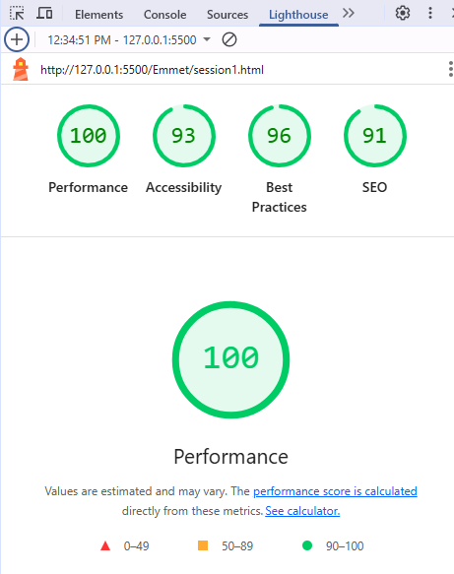

**Understanding the Report**

Each category shows:

* **Score (0–100)**
* **Opportunities**: What you can improve (e.g., "Reduce unused CSS")
* **Diagnostics**: Technical info
* **Passed audits**: What’s already good

**Tips**

* Scores under 50 = Needs work
* Scores 50–89 = Room to improve
* Scores 90–100 = Great

**Understanding the Report**

| **Section** | **What It Checks** | **Good Score** |
| --- | --- | --- |
| Performance | Page speed, load time, etc. | 90–100 |
| Accessibility | Is your site usable by all users? | 90–100 |
| Best Practices | Uses HTTPS? Secure code? | 90–100 |
| SEO | Is your page search-engine friendly? | 90–100 |
| PWA (Optional) | Checks if your app is installable | – |

**Common Terms Explained**

Here are some **important terms** you’ll see in the Performance section:

| **Term** | **Meaning** |
| --- | --- |
| **FCP** (First Contentful Paint) | Time until something is drawn on screen |
| **Speed Index** | How fast content is visually shown |
| **LCP** (Largest Contentful Paint) | Time until the main content loads |
| **TBT** (Total Blocking Time) | Time the browser is blocked from responding |
| **CLS** (Cumulative Layout Shift) | Measures visual stability (e.g., shifting text/images) |
| **TTI** (Time to Interactive) | Time until the page becomes fully usable |

**"Opportunities" Section**

This section gives **tips to improve speed**, like:

* **Eliminate render-blocking resources**
* **Reduce unused CSS/JS**
* **Use WebP images**
* **Enable text compression**
* **Preload key requests**

Click each suggestion to expand and learn **what to fix**.

**Rerun After Fixes**

Once you improve things (e.g., compress images, fix layout shift), go back and **re-run Lighthouse** to see new scores!

**Want Help Reading a Report?**

If you want:

* You can **share a screenshot** or **copy some parts of the Lighthouse report** here.
* I’ll explain what they mean, and how to fix the problems (like "Reduce unused JavaScript").

Bottom of Form