# Research Motivation

# Why is suicide a complex problem?

Suicide is a complex societal problem with multiple social, psychological, biological, and cultural factors. It is one of the top 20 leading causes of death in the world for all ages [5]. An estimated one million people die annually from suicide, i.e., a global mortality rate of 16 per 100,000, or one death every 40 seconds [5]. Due to the interactions of so many factors, suicide has no singular cause.

Though it might seem intuitive to categorize suicidal ideation, attempted suicide, and completed suicide as strictly a psychiatric or medical issue or a mental illness, not all who commit suicide are mentally ill. “Mental illness is often not clearly distinguishable from normal distress” [11]. Stressful experiences, such as exposure to trauma, the death of a loved one, a job loss, a change in physical health or relationships and individual characteristics and behaviors are also associated with suicide [13].

To underscore the complex nature of the suicide problem, and to show how causes of suicide can vary between countries, we contrast the situations in Zimbabwe and Russia. Zimbabwe has suffered endemic poverty, hyperinflation, and high unemployment for years. On the other hand, Russia’s levels of alcohol consumption are among the highest in the world. Though their underlying conditions appear to be markedly different, both nations suffer from high rates of suicide.

# Where is this a problem

## Economics - Zimbabwe

Political crisis coupled with failed economic policy led to the decline of Zimbabwe’s economic output. Over the past few decades, Zimbabwe’s economic decline has resulted in endemic poverty, hyperinflation, and an unemployment rate of over 90% [12]. Zimbabwe’s economic woes are often attributed to the policies of former dictator Robert Mugabe. Post Mugabe, Zimbabwe continues to deal with debt issues, difficulty attracting foreign investment, and currency instability.

The WHO estimates that 19 persons per 100k take their own life deliberately in Zimbabwe per annum (2019). Of the 166 countries in our study, Zimbabwe ranks 13th in the world for suicides per capita.

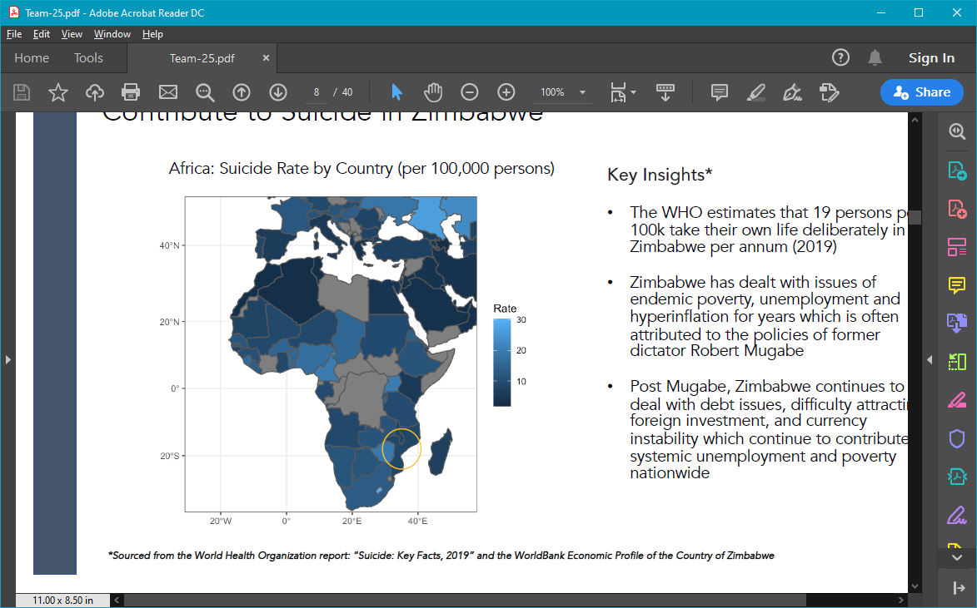

**Africa: Suicide Rate by Country (per 100,000 persons)**

*\*Sourced from the World Health Organization report: “Suicide: Key Facts, 2019” and the WorldBank Economic Profile of the Country of Zimbabwe*

## Alcohol - Russia

* + 1. Alcohol use disorder (AUD), defined in the WHO’s *International Classification of Diseases,* is a chronic disease characterized by compulsive alcohol consumption, loss of control over of alcohol intake, and negative emotional state when not consuming alcohol. In Russia, the prevalence of AUD is about 4.7%, meaning that almost 1-in-20 suffer from alcohol dependence. Alcoholism has been a problem because drinking is not only pervasive, but also a socially acceptable behavior in Russian society.
    2. The WHO estimates that 27 persons per 100k take their own life deliberately in Russia per annum (2019). Of the 166 countries in our study, Russia ranks 3rd in the world for suicides per capita.



**Russia: Suicide Rate by Country (per 100,000 persons)**

*\*Sourced from the World Health Organization report: “Suicide: Key Facts, 2019”*

## Defining the scope of our research

Due to the sheer number of potential factors associated with suicide and the complex nature of the relationships between them, we wanted to identify those that were best associated with suicide rates at the country level. We chose to limit our study to a small set of factors that could be controlled for and acted upon via policy interventions.

The domains, from which we drew the factors, had to be broad enough to reasonably represent as many of the potential causes or mitigators of suicide as possible. Among the domains in consideration were lifestyle, medical/mental health, economic, and suicide-focused policy.

[1]  "WHO | Global status report on alcohol and health 2018 - World ...." 21 Sep. 2018, <https://www.who.int/substance_abuse/publications/global_alcohol_report/en/>. Accessed 5 Apr. 2020.

[2]  "Global strategy to reduce harmful use of alcohol - WHO.", <https://www.who.int/substance_abuse/activities/gsrhua/en/>. Accessed 5 Apr. 2020.

[3] "Public health science and the global strategy on alcohol - WHO." <https://www.who.int/bulletin/volumes/88/9/10-081729/en/>. Accessed 5 Apr. 2020.

[4] "A meta-analysis of acute use of alcohol and the risk of suicide ...." 8 Dec. 2016, <https://www.ncbi.nlm.nih.gov/pmc/articles/PMC5340592/>. Accessed 5 Apr. 2020.

 [5]  "Alcohol-Related Risk of Suicidal Ideation, Suicide Attempt ...." 20 May. 2015, <https://www.ncbi.nlm.nih.gov/pmc/articles/PMC4439031/>. Accessed 5 Apr. 2020.

[6] “Alcohol Consumption”, <https://ourworldindata.org/alcohol-consumption>. Access 6 Apr. 2020.

[7] “Where Global Alcohol Consumption Is Rising and Falling”,

<https://www.forbes.com/sites/niallmccarthy/2019/05/09/where-global-alcohol-consumption-is-rising-falling-infographic>. Accessed 6 Apr. 2020.

[11] “Does suicide always indicate a mental illness?”, Sanati, A 2009,

<https://www.ncbi.nlm.nih.gov/pmc/articles/PMC4222167/>. Accessed 12 Apr. 2020.

[12] “The Economic Decline of Zimbabwe”, Munangagwa, C.L. 2009

<https://cupola.gettysburg.edu/cgi/viewcontent.cgi?article=1021&context=ger>. Accessed 12 Apr. 2020

[13] “Suicide Prevention Framework”

<https://www.canada.ca/en/public-health/services/publications/healthy-living/suicide-prevention-framework.html>. Accessed 12 Apr. 2020

[14] <https://www.mindbank.info/> Accessed 16 Apr. 2020