2.1 Variables and Data Sources:

Due to the sheer number of potential factors associated with suicide and the complex nature of the relationships between them, we wanted to identify those that were best associated with suicide rates at the country level. We chose to limit our study to a small set of factors that could be controlled for and acted upon via policy interventions. The domains from which we drew the factors, had to be broad enough to reasonably represent as many of the potential causes or mitigators of suicide as possible. Among the domains in consideration were lifestyle, medical/mental health, economic, and suicide-focused policy. The core dataset we plan to rely on comes directly from the World Health Organization. The key measure of interest for our study is the age-standardized suicide rate by country, which is defined as a weighted average of the age-specific mortality rates per 100,000 persons, where the weights are the proportions of persons in the corresponding age groups of the WHO standard population, see the Appendix section ##### INSERT APPENDIX SECTION, for how this is calculated. This data is provided by the World Health Organization. These estimates of age-standardized suicide rates were taken in the year with the most recent available data for each country. In addition to relying on the core suicide rate statistics provided above, we intend to append country-level data from ancillary data sources. Health Expenditure and GDP per capita were chosen to reflect the resources that a country has its disposal to reduce the suicide rate. Liters of Alcohol per capita was chosen to account for an aspect of culture (alcohol consumption) that the media often links to mental health outcomes. The prevalence of a suicide prevention strategy, the number of psychiatrists, and the number of mental hospitals were chosen to reflect how a country has deployed its resources to improve mental health outcomes. The female/male labor participation ratio was included to control for this aspect of a country’s culture. The data for these variables along with the suicide rate variable was available for 166 countries. Below is the full set of considered independent variables:

-Current Health Expenditure as a percentage of GDP - World Health Organization

-Labor force participation rate, female to male ratio - United Nations Development Programme

-GDP per capita, adjusted by Purchasing Power Parity - World Bank

-Liters of Alcohol consumption per capita - World Bank

-Prevalence of a Suicide Prevention Strategy - World Health Organization

-Psychiatrists in mental health, per 100,000 population - World Health Organization

-Mental hospitals, per 100,000 population - World Health Organization

Note that more detailed descriptions of the data and the source links can be found in the appendix INSERT APPENDIX SECTION.

BELOW SHOULD BE INCLUDED IN THE APPENDIX AND BIBLIOGRAPHY

Table 1: Data Sources

|  |  |  |
| --- | --- | --- |
| **Input** | **Data Description** | **Source** |
| Current Health Expenditure as a Percentage of GDP | This data provides an indication on the level of resources channeled to health relative to other uses. It shows the importance of the health sector in the whole economy and indicates the societal priority which health is given measured in monetary terms. | World Health Organization [2] |
| Labor force participation rate (female-male ratio) | Ratio of female to male of proportion of a country’s working-age population (ages 15 and older) that engages in the labor market, either by working or actively looking for work, expressed as a percentage of the working-age population. | United Nations Development Programme [1] |
| GDP per capita, PPP | Gross Domestic Product converted to international dollars using purchasing power parity (PPP) rates and divided by total population. This data is in terms of PPP in order to account for differences in the cost of living between countries. | World Bank [1] |
| Liters of Alcohol per capita | Total (sum of recorded and unrecorded alcohol) amount of alcohol consumed per person (15 years of age or older) over a calendar year, in liters of pure alcohol, adjusted for tourist consumption. | World Bank [2] |
| Suicide Prevention Strategy | Countries which are known have a stand-alone national suicide prevention strategy are included as 1s, else 0. Note that the plan must be stand-alone, and may not be integrated into another plan, in order to count in the dataset. | World Health Organization [3] |
| Psychiatrists in mental health, per 100,000 pop. | Number of Psychiatrists working in the mental health sector, per 100,000 population. | World Health Organization [4] |
| Mental hospitals, per 100,000 pop. | Number of hospitals dedicated to mental health per 100,000 population | World Health Organization [5] |

• World Health Organization [1] : <https://apps.who.int/gho/data/node.main.MHSUICIDEASDR?lang=en>

• World Health Organization [2] : <https://www.who.int/data/gho/data/indicators/indicator-details/GHO/current-health-expenditure-(che)-as-percentage-of-gross-domestic-product-(gdp)-(-)>

• World Health Organization [3] : <https://apps.who.int/iris/handle/10665/279765>

• World Health Organization [4] <https://apps.who.int/gho/data/node.main.MHHR?lang=en>

• World Health Organization [5] : <https://apps.who.int/gho/data/node.main.MHFAC?lang=en>

• United Nations Development Programme [1] : <http://hdr.undp.org/en/content/labour-force-participation-rate-female-male-ratio>

• World Bank [1] : <https://data.worldbank.org/indicator/NY.GDP.PCAP.PP.CD>

• World Bank [2] : <https://data.worldbank.org/indicator/SH.ALC.PCAP.LI>

Defining Suicide Rate:

In order to properly analyze the problem, we must define suicide. It is the age-standardized, meaning that it is a weighted average of the age-specific mortality rates per 100,000 persons, where the weights are the proportions of persons in the corresponding age groups of the WHO standard population [1]. To calculate the age standardized rate see Equation 1 below [2].

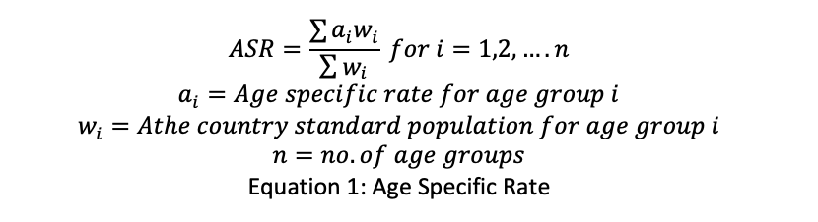

Equation 1: Age Specific Rate

The age standardized rate was used instead of crude as it allows for an age normalized view of suicide. In addition, there are no age-related statistics in data inputs considered.

[1] <https://apps.who.int/gho/data/node.main.MHSUICIDEASDR?lang=en>

[2] <https://www.slideshare.net/RamnathTakiar/cr-aar-age-specific-rates-in-cancer>