Documentation of results
The structure of the project is as follows:
The Record.java file offers a way of parsing the raw data file. Using the constructor, all necessary information for this exercise is initialized.
This time mappers and reducers are existing twice:
- RecordMapperNaive and MeanTemperatureReducerNaive for Task 1
- RecordMapperCombine and MeanTemperatureReducerCombine for Task 2

In both Mappers, custom counters are incremented if respective conditions are met.

For Task 2 MeanTemperatureCombiner was implemented. A new class acting as data transfer object was introduced as well (SumCountWritable). This class is then used in input/output values of mapper, reducer and combiner. For testing the combiner, every input/output data had to be the same:
- Mapper Output: <Text, SumCountWritable >
- Combiner Input: <Text, SumCountWritable >
- Combiner Output: <Text, SumCountWritable>
- Reducer Input: <Text, SumCountWritable>

Therefore, RecordMapperCombine had to be implemented (which is also using SumCountWritable in signature)

Tests are provided in the MeanTemperatureTestNaive class. While Mapper and Reducer are tested individually and in combination, another test also assures that only valid records are processed. In addition, counter-logic is tested as well.
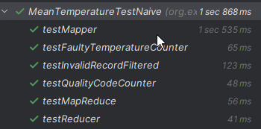

In MeanTemperatureTestCombine the combiner is tested as well.
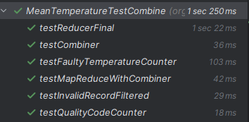

The results are:
