Documentation of results
The structure of the project is as follows:
The Record.java file offers a way of parsing the raw data file. Using the constructor, all necessary information for this exercise is initialized.
RecordMapper and MaxTemperatureReducer does typical Hadoop MapReduce work. While RecordMapper already filters for only valid temperatures, MaxTemperatureReducer searches for the maximum temperature per year. At the end, the maximum temperature is converted to degrees Celsius as only converting the maximum is sufficient.
Tests are provided in the MaxTemperatureTest class. While Mapper and Reducer are tested individually and in combination, another test also assures that only valid records are processed.
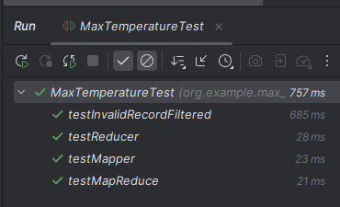

As an addition, results were also compared by executing provided bash script. The screenshot below shows, that considering the bash script does not convert to degrees Celsius, both solutions provide the same result.
