Documentation of results
The structure of the project is as follows:
The Record.java file offers a way of parsing the raw data file. Using the constructor, all necessary information for this exercise is initialized.

Task 1
The MedianTemperatureMapper reads each input line, creates a Record object, and filters out records with invalid temperatures. For valid records, it emits an Avro key containing both the year and the air temperature, while the value is set to NullWritable. This composite Avro key enables a secondary sort, where records are first grouped by year and then sorted by temperature.
The MedianTemperatureReducer receives all temperature values for a given year in sorted order. It collects the temperatures, computes the median depending on whether the number of values is odd or even, and outputs the year as an Avro key together with the corresponding median temperature as an Avro value. The MedianTemperatureDriver configures the job to use Avro input and output formats and defines the required Avro schemas. As a result, the job produces a final output mapping each year to its median temperature.
To compute user-defined percentiles, the desired percentile values are passed to the reducers via the Hadoop Configuration of MedianTemperatureDriver. The reducer reads these parameters during setup and computes the corresponding percentile positions based on the sorted temperature values obtained through secondary sorting.
Using, functionality of implementation is tested:
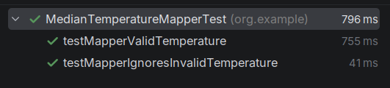

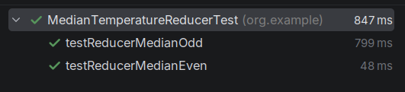

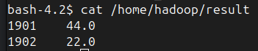

Task 2
The SortByTemperatureMapper reads each input line as Text, creates a Record object from it, and filters out records with invalid temperatures using isValidTemperature(). For valid records, the air temperature is extracted and used as an IntWritable key, while the complete original line is emitted as the Text value. This ensures that the data is numerically sortable by temperature.
In the SortByTemperatureDriver, no reducer is configured (setNumReduceTasks(0)), so each mapper operates independently. The output is written using SequenceFileOutputFormat, producing efficient binary SequenceFiles. In addition, BLOCK compression with Snappy is enabled to reduce storage space and I/O overhead. Each mapper writes its results to a separate compressed part-m-* file, which is internally sorted by temperature.

Using SortByTemperatureMapperTest, functionality of implementation is tested:
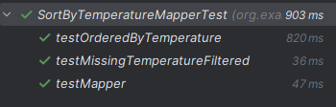

Task 3
Think about solutions to produce a globally sorted file (a file that contains all weather records sorted by temperature).
The probably least efficient and scalable solution would be to sort the generated files without MapReduce. (after processing)
Global sorting (a single file, sorted entirely by temperature) is not possible with the current map-only job. To obtain a single globally sorted file, a reducer is required. Hadoop guarantees a total order of keys between mappers and reducers.
A more scalable solution would include using TotalOrderPartitioner. Hadoop distributes keys across multiple reducers. TotalOrderPartitioner guarantees global order across all reducers

