WEEK 3 TASK REPORT
Advanced Data Analysis and Visualization in Logistics
Exploratory analysis of a hypothetical logistics shipment dataset

Report detail | Description
Task | Week 3 – Advanced Data Analysis and Visualization in Logistics
Domain | Shipment delivery and transportation operations
Tools | Python, Pandas, NumPy, Matplotlib
Dataset size | 60 simulated shipment records
Data note | All records are hypothetical and created for educational demonstration.

1. Executive Summary
This report performs exploratory data analysis on 60 simulated logistics shipments recorded from January to June 2026. The analysis examines shipment volumes, route distance, delivery time, transport cost, monthly trends, destination-level differences, and relationships among numeric variables. Five visualizations are included: delivery-time distribution, monthly delivery-time trend, average cost by destination, distance-cost scatter plot, and a correlation matrix.
In this illustrative dataset, mean delivery time is 16.7 hours and median delivery time is 14.9 hours. Mean transport cost is ₹4,304 per shipment, while median cost is ₹3,888. The analysis uses these values to demonstrate how logistics managers can identify routes for review and monitor service performance. These are simulated results, not real operational findings.

2. Objectives
- Define the structure of a hypothetical logistics dataset.
- Conduct exploratory data analysis using Python.
- Calculate descriptive statistics and examine distributions.
- Measure correlations among distance, shipment volume, delivery time, and transport cost.
- Create visualizations that reveal trends, differences, and possible bottlenecks.
- Translate the analysis into practical recommendations and stakeholder reporting.

3. Dataset Description
The dataset contains one row per shipment, with 60 records across six months. Hyderabad is used as the origin, with destinations including Hyderabad-area deliveries, Warangal, Vijayawada, Bengaluru, and Chennai. Carrier categories are simulated. Delivery durations and costs are generated from distance, shipment volume, carrier-level cost effects, seasonal increments, and random variation. A small number of records are deliberately assigned longer delivery times to represent possible disruptions.
Variable | Description | Type
shipment_id | Unique shipment identifier | Categorical / ID
shipment_date | Shipment date between January and June 2026 | Date
origin / destination | Starting and receiving locations | Categorical
carrier | Simulated transport provider | Categorical
distance_km | Approximate route distance | Numeric
shipment_volume_units | Number of units in shipment | Integer
delivery_hours | Elapsed delivery time | Numeric
transport_cost_inr | Transport cost in Indian rupees | Numeric
delayed | Illustrative delay flag based on simulated route threshold | Categorical

The delay flag is a simplified teaching indicator. In real logistics, delay should be defined against the promised delivery time or service-level agreement (SLA).

4. Methodology

4.1 Data loading and validation
The CSV file is loaded with Pandas. Row counts, field names, data types, missing values, duplicates, and numerical ranges should be checked before analysis. The provided dataset has 60 records and is generated without intentionally missing values.

4.2 Descriptive statistics
Mean, median, standard deviation, minimum, maximum, and quartiles summarize typical performance and variability. Comparing mean and median helps identify possible skew from unusually long deliveries or high costs.

4.3 Distribution analysis
A histogram is used to view the spread of delivery times and assess whether most shipments cluster in a range or whether a long-delay tail exists.

4.4 Trend analysis
Monthly average delivery time is plotted to identify whether service performance changes over the six-month observation period. Trends should be interpreted cautiously because only ten simulated shipments are generated per month.

4.5 Group comparisons
Average transport cost is compared across destinations. This highlights route-level cost differences but does not isolate the effects of distance, shipment volume, or carrier choice.

4.6 Relationship and correlation analysis
A scatter plot explores distance and transport cost. A correlation matrix summarizes linear relationships between distance, shipment volume, delivery time, and cost. Correlation does not establish causation.

5. Exploratory Data Analysis Results
Metric | Mean | Median | Std. dev. | Minimum | Maximum
Distance (km) | 330.00 | 275.00 | 236.95 | 25.00 | 630.00
Shipment volume (units) | 52.87 | 52.50 | 26.48 | 10.00 | 97.00
Delivery time (hours) | 16.67 | 14.95 | 7.30 | 3.40 | 37.50
Transport cost (₹) | 4,304.06 | 3,888.06 | 2,015.46 | 1,118.70 | 7,381.65

The dataset has 60 unique shipment IDs. Mean delivery time (16.67 hours) is above the median (14.95 hours), which suggests some higher-duration shipments influence the average. The standard deviation indicates how widely individual shipments vary around the mean.

5.1 Destination-level summary
Destination | Shipments | Avg delivery (h) | Avg cost | Delay flag rate
Chennai | 12 | 20.8 | ₹6,806 | 25.0%
Bengaluru | 12 | 25.5 | ₹6,300 | 58.3%
Vijayawada | 12 | 15.2 | ₹3,879 | 50.0%
Warangal | 12 | 12.1 | ₹2,833 | 58.3%
Hyderabad | 12 | 9.8 | ₹1,703 | 50.0%

Destination averages are useful for prioritizing review, but the longer routes are expected to cost more. Fair comparison should account for distance, volume, and carrier mix.

5.2 Carrier-level summary
Carrier | Shipments | Avg delivery (h) | Avg cost | Delay flag rate
Carrier A | 20 | 14.8 | ₹4,137 | 20.0%
Carrier B | 20 | 16.1 | ₹4,637 | 35.0%
Carrier C | 20 | 19.1 | ₹4,139 | 90.0%

Carrier-level averages in a synthetic dataset are illustrative only. A real carrier scorecard should control for route, distance, volume, service level, and shipment type.

6. Visualizations and Interpretation
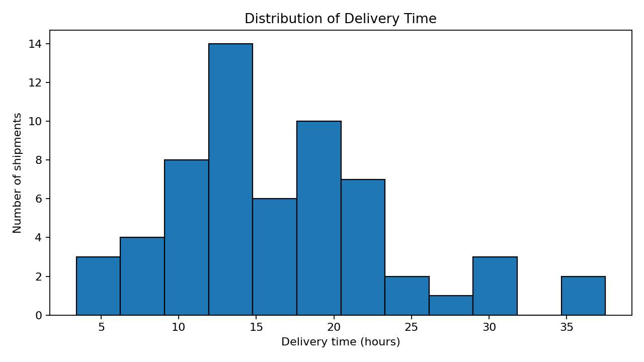
Figure 1. Distribution of delivery time
A histogram groups delivery durations into bins. It shows the typical delivery range and whether a small number of long shipments create a right tail. Operations teams can use the tail to create an exception list for checking delays, scan timestamps, route conditions, or hand-off problems.
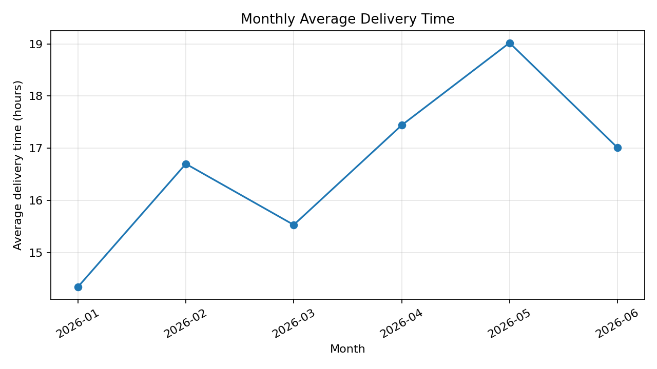
Figure 2. Monthly average delivery time
A line chart is suitable for time-ordered metrics because it makes changes across months easy to see. A rising average can indicate congestion, seasonal demand, carrier capacity constraints, or a change in route mix. The team should compare shipment counts and destination mix before concluding that performance has worsened.
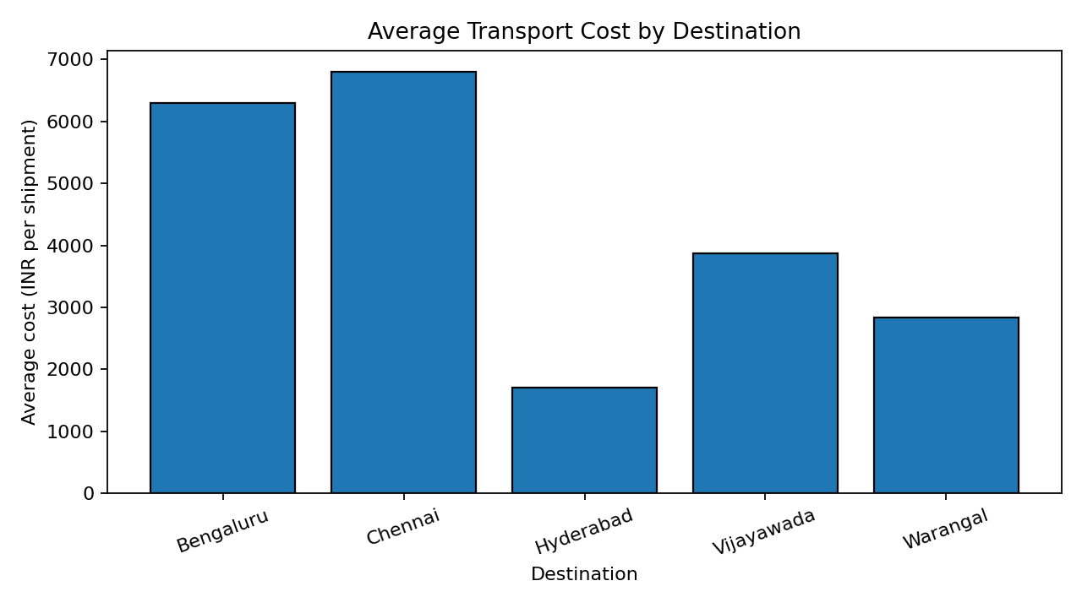
Figure 3. Average transport cost by destination
A bar chart supports straightforward category comparisons. Higher-cost destinations may be farther away, have higher shipment volumes, or use more expensive carriers. The next step is to compare cost per kilometre or cost per unit, not just cost per shipment.
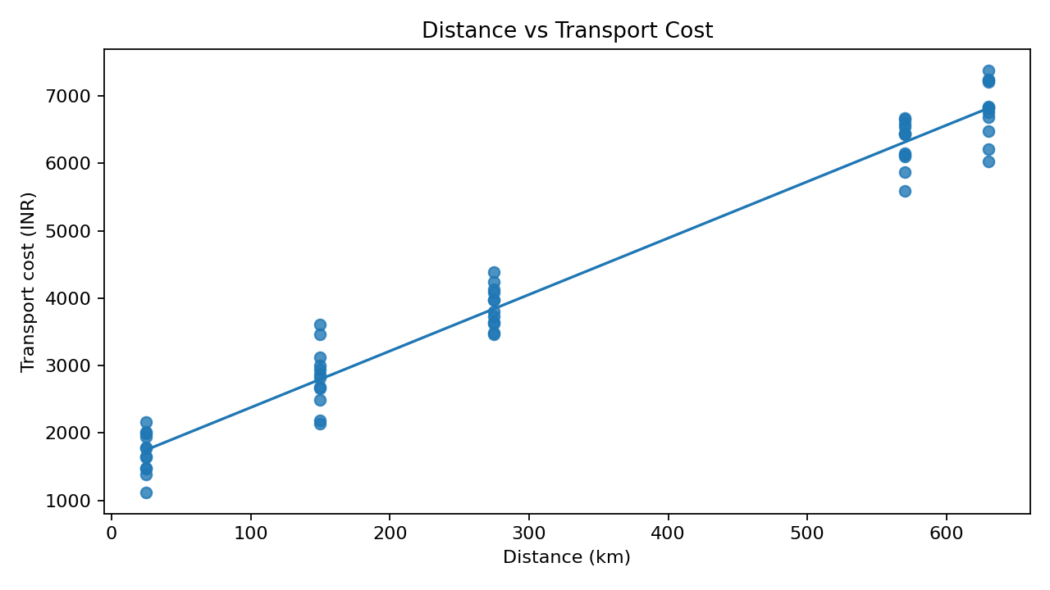
Figure 4. Distance versus transport cost
A scatter plot displays individual shipments and helps reveal whether cost generally increases with distance. Points far above the overall pattern may warrant invoice or surcharge review. Shipment volume and carrier choice also affect cost, so distance alone does not explain every difference.
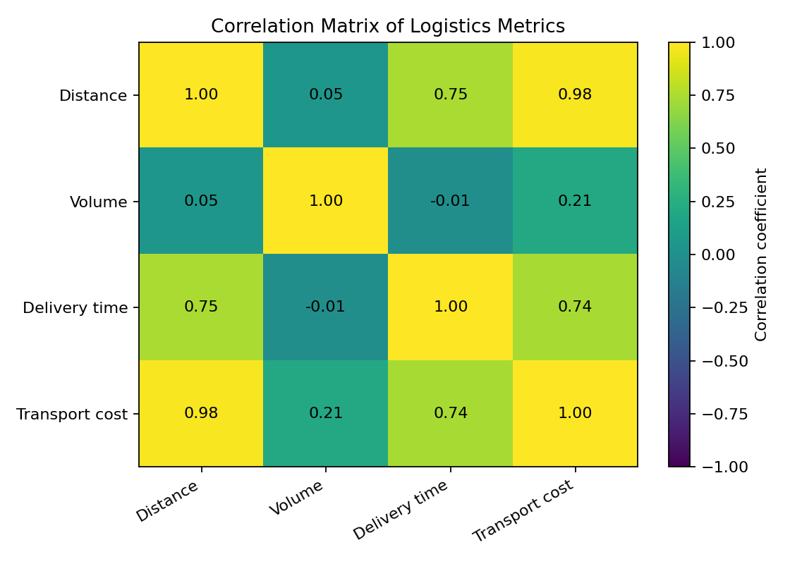
Figure 5. Correlation matrix
The correlation matrix summarizes the direction and strength of linear relationships. Values near +1 indicate a strong positive linear association, values near −1 indicate a strong negative association, and values near 0 indicate little linear association. Correlation is descriptive and should not be interpreted as proof of cause.

6.1 Correlation values
Metric A | Metric B | Pearson correlation
Distance | Volume | 0.05
Distance | Delivery time | 0.75
Distance | Transport cost | 0.98
Volume | Delivery time | -0.01
Volume | Transport cost | 0.21
Delivery time | Transport cost | 0.74

Use the correlation values to form questions for further investigation, not to replace operational context or causal analysis.

7. Key Analytical Insights
1. **Destination cost variation:** Chennai has the highest average cost per shipment in this simulated sample (₹6,806). This should trigger a cost-per-kilometre and cost-per-unit comparison before any route or carrier change.
2. **Delivery-time differences:** The highest destination-level average delivery time is Bengaluru (25.5 hours), while the lowest is Hyderabad (9.8 hours). Route distance is an important factor, so raw hours should be considered alongside distance and promised delivery windows.
3. **Monthly performance variation:** The highest monthly average delivery time occurs in 2026-05 (19.0 hours), compared with 2026-01 (14.3 hours) in the lowest month. Operations should check whether this difference is due to seasonality, destination mix, or the intentionally simulated disruption records.
4. **Cost driver investigation:** Distance and shipment volume are plausible contributors to transport cost. The scatter plot and correlation matrix help quantify their associations, but a multivariable model or matched-route comparison would be needed to estimate separate effects.
5. **Delay monitoring:** 29 of 60 shipments (48.3%) are marked delayed by the simplified simulated rule. A real KPI should use promised delivery time and clearly documented eligibility rules.

8. Recommendations
- Create a weekly logistics dashboard showing on-time delivery rate, median delivery time, cost per shipment, cost per kilometre, and shipment volume.
- Investigate the longest-duration shipments first using dispatch scans, delivery scans, route events, and carrier notes.
- Compare destinations using cost per kilometre and cost per unit to avoid penalizing long routes unfairly.
- Evaluate carriers on comparable routes and service commitments rather than comparing raw averages alone.
- Review high-cost scatter-plot points against invoices, fuel surcharges, shipment volume, and special handling fees.
- Monitor monthly metrics alongside shipment counts and route mix; avoid interpreting a small synthetic sample as a stable trend.
- Define the delay KPI against the promised delivery time or SLA and retain the definition in reporting documentation.

9. Stakeholder Communication
Stakeholder | What to report | Decision/action
Logistics operations | Delivery-time trend, delay exceptions, route-level service performance | Investigate bottlenecks and adjust dispatch or route plans
Finance/procurement | Cost per shipment, cost per kilometre, unusual charges | Validate invoices and review carrier pricing
Carrier manager | Comparable carrier metrics, exceptions, SLA performance | Discuss corrective actions and service improvements
Senior management | 3–5 KPIs, month-over-month change, risks, owners and due dates | Prioritize improvement initiatives and track impact

Reports should identify the time period, sample size, KPI definition, data limitations, and action owner. A recommendation should have a follow-up date and measurable success criterion.

10. Python Code Excerpt
import pandas as pd
import matplotlib.pyplot as plt
df = pd.read_csv("data/logistics_shipments.csv",
parse_dates=["shipment_date"])
metrics = ["distance_km", "shipment_volume_units",
"delivery_hours", "transport_cost_inr"]
print(df[metrics].describe().round(2))
print(df[metrics].corr().round(2))
# Delivery-time distribution
plt.hist(df["delivery_hours"], bins=12, edgecolor="black")
plt.xlabel("Delivery time (hours)")
plt.ylabel("Number of shipments")
plt.title("Distribution of Delivery Time")
plt.tight_layout()
plt.show()
# Monthly average delivery-time trend
df["month"] = df["shipment_date"].dt.to_period("M").astype(str)
monthly = df.groupby("month")["delivery_hours"].mean()
monthly.plot(marker="o")
plt.ylabel("Average delivery time (hours)")
plt.title("Monthly Average Delivery Time")
plt.tight_layout()
plt.show()
The full executable script in src/analyze_logistics.py generates all five charts and two KPI summary CSV files.

11. Limitations
- All data is simulated and does not represent actual carrier or company performance.
- The dataset is small, with only 60 shipments over six months.
- The delay indicator is a simplified teaching label, not a formal SLA-based KPI.
- Destination cost comparisons are affected by route distance, shipment volume, and carrier mix.
- Correlation describes linear association and does not establish causation.
- Operational decisions require validation with real records, domain knowledge, and a larger time period.

12. Conclusion
This project demonstrates how exploratory data analysis and visualization can support logistics decision-making. Descriptive statistics summarize typical performance and variability, histograms show delivery-time distributions, line charts highlight monthly changes, bar charts compare destination costs, scatter plots explore cost drivers, and correlation matrices summarize relationships among metrics. The findings suggest practical areas for further investigation, including high-cost destinations, long delivery times, and monthly performance changes. Because the data is hypothetical, the results are methodological examples rather than claims about real operations. A production analysis should use validated shipment records, SLA-based delay definitions, and comparable route and carrier metrics.

Appendix A. Project Structure
Week-3-Logistics-Analysis/
├── README.md
├── requirements.txt
├── data/
│ └── logistics_shipments.csv
├── src/
│ └── analyze_logistics.py
├── visualizations/
│ ├── delivery_time_distribution.png
│ ├── monthly_delivery_trend.png
│ ├── cost_by_destination.png
│ ├── distance_vs_cost.png
│ ├── correlation_matrix.png
│ └── KPI summary CSV files
└── report/
└── Week_3_Advanced_Logistics_Analysis_Report.docx

References
- Pandas documentation: https://pandas.pydata.org/docs/
- Matplotlib documentation: https://matplotlib.org/stable/
- NumPy documentation: https://numpy.org/doc/
- Scikit-learn documentation: https://scikit-learn.org/stable/

