液晶显示模块使用手册

型号：LX12864B12系列

版本: 1.0

客户确认
客户确认： |  | 盖章
客户建议：

编制
拟制 | 确认 | 批准

深圳市力先电子有限公司
深圳市宝安区西乡三围航空路30号B栋4楼
电话:+86(755)29582963
传真:+86(755)22144273
技术: 18948703963

Email: lcd@lcdlcd.cn
HTTP://ww.lcdlcd.cn

RECORD OF REVISION

Version | Revision Date | Contents | Editor
1.0 | 2014-08-28 | New Release | YOU

1. PHYSICAL DATA
Item | Contents | Unit
LCD type | STN/黄绿/正显 | ---
LCD duty | 1/64 | ---
LCD bias | 1/9 | ---
Viewing direction | 6 | o’clock
Module size (W×H×T) | 56.7×38.6×2.7 | mm
Number of dots(W×H) | 128 × 64 | dots
Dot Size(W×H)) | 0.35×0.36 | mm
Dot Pitch(W×H)) | 0.38×0.39 | mm
工作温度 | -30 ℃ -- +80℃
存储温度 | -40 ℃ -- +90℃

Item | Contents | Unit
背光电压 | 2.9V-3.1V
背光电流 | 35ma--55ma-
2.EXTERNAL DIMENSIONS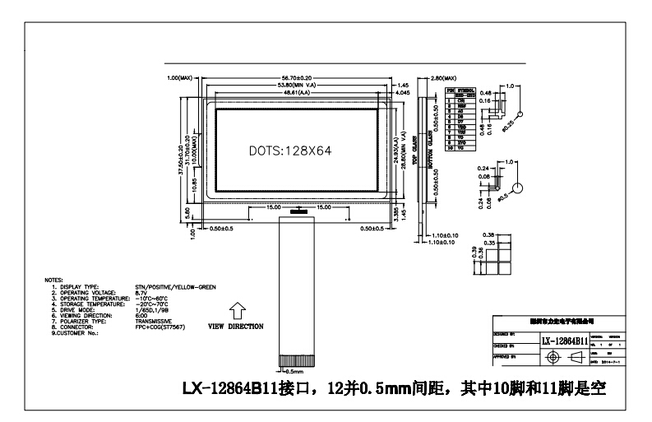
特别注明，按以上图看正面，右边为第一脚（CS)

背光结构图
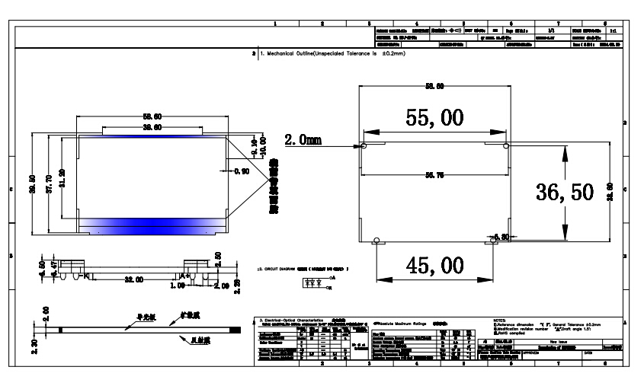
- BLOCK DIAGRAM
外围电路
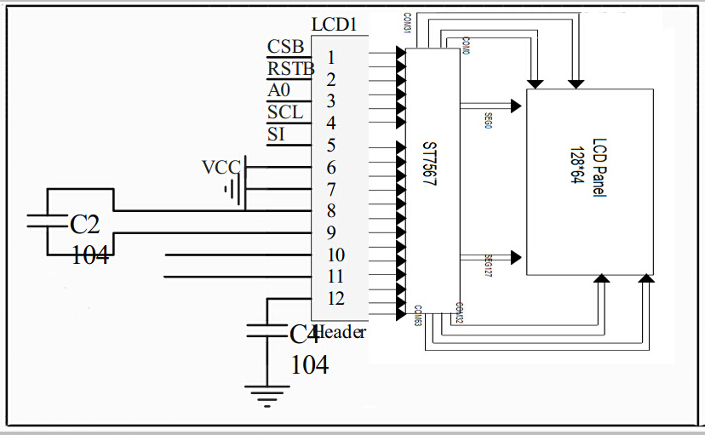
注：以上图外围电路原理串口

- 以下引脚是并口和串口（SPI)，LX-12864B11以串口为准

PIN NO. | Symbol | Level | Description
1 | NC |  | NC
2 | CS | H/L | Chip select.
3 | RES | H/L | Reset pin.
4 | A0 | H/L | A0=“H”: data. A0=“L”: Instruction command.
5 | /WR | --- | When Bus Mode is 6800, R/W=R/W  When Bus Mode is 8080, R/W=/RW
6 | /RD | H/L | When Bus Mode is 6800, E=E  When Bus Mode is 8080, E =/RD
7 | DB0 | H/L | This is an 8-bit bi-directional data bus that connects to an 8-bit or 16-bit standard MPU data bus.  When the serial interface (SPI-4) is selected (P/S = “L”) :  D7 : serial data input (SI) ; D6 : the serial clock input (SCL).  D0 to D5 should be connected to VDD or floating.
8 | DB1 | H/L
9 | DB2 | H/L
10 | DB3 | H/L
11 | DB4 | H/L
12 | DB5 | H/L
13 | DB6（SCL） | H/L
14 | DB7（SI） | H/L
15 | VDD | --- | Power supply.
16 | VSS | --- | Ground.
17 | VOUT | --- | Negative power for LCD.
18 | C3+ | --- | DC/DC voltage converter. Connect a capacitor between this terminal and the CAP2N terminal.
19 | C1+ | --- | DC/DC voltage converter. Connect a capacitor between this terminal and the CAP1N terminal.
20 | C1- |  | DC/DC voltage converter. Connect a capacitor between this terminal and the CAP1P terminal.

21 | C2+ |  | DC/DC voltage converter. Connect a capacitor between this terminal and the CAP1N terminal. Reset signal.
22 | C2- |  | DC/DC voltage converter. Connect a capacitor between this terminal and the CAP2N terminal.
23~26 | V1~V4 | --- | This is a multi-level power supply for the liquid crystal drive.
27 | V0 | --- | Contrast adjustment input.
28 | C86 | H/L | C86 = “H”: 6800 Series MPU interface.  C86 = “L”: 8080 Series MPU interface.
39 | P/S | H/L | P/S = “H”: Parallel data input/output.  P/S = “L”: Serial data input.
30 | NC | --- | NC

4. ABSOLUTE MAXIMUM RATINGS
- Electrical Absolute Ratings

Item | Symbol | Min. | Max. | Unit | Note
Power Supply for Logic | V_{DD}-V_{SS} | 0 | 3.47 | Volt | Note 1
Power Supply for LCD | V_{LCD} | 0 | 13.0 | Volt
Input Voltage | V_{I} | 0 | V_{DD} | Volt
Note 1 : Operator should be grounded during handling LCM

（2）Environmental Absolute Maximum Ratings
Item | Normal Temperature |  |  |  | Wide Temperature
Item | Operating |  | Storage |  | Operating |  | Storage
Item | Min. | Max, | Min. | Max, | Min. | Max, | Min. | Max,
Ambient Temperature | 0℃ | +50℃ | -10℃ | +60℃ | -20℃ | +70℃ | -30℃ | +80℃
Humidity(without condensation) | Note 2,4 |  | Note 3,5 |  | Note 4,5 |  | Note 4,6

Note 2 Ta≦50℃: 80% RH max
Ta>50℃: Absolute humidity must be lower than the humidity of 85%RH at 50℃

Note 3 Ta at -20℃ will be<48hrs at 70℃will be <120hrs when humidity is higher than 75%.
Note 4 Background color changes slightly depending on ambient temperature. This phenomenon
is reversible.

Note 5 Ta≦70℃: 75RH max
Ta>70℃: absolute humidity must be lower than the humidity of 75%RH at 70℃
Note 6 Ta at -20℃ will be <48hrs, at 80 ℃ will be <120hrs when humidity is higher than 75%.

5. ELECTRICAL CHARACTERISTICS

DC Characteristics (VDD=3.3V;VSS=0V；Ta=-20～70℃)

Item | Symbol | Condition | Min. | Typ. | Max. | Unit
Power Supply for Logic | V_{DD}-V_{SS} | --- | 3.14 | 3.3 | 3.47 | Volt
Input Voltage | V_{IL} | --- | VSS | --- | 0.2VDD | Volt
Input Voltage | V_{IH} | --- | 0.8VDD | --- | VDD | Volt
Output Voltage | V_{OH} | IOL =-0.5mA | 0.8VDD | --- | VDD | Volt
Output Voltage | V_{OL} | IOL = +0.5mA | VSS | --- | 0.2VDD | Volt
LCM Recommend LCD Module Driving Voltage | V_{LCD} | T_{a}＝0℃ | --- | --- | --- | Volt
LCM Recommend LCD Module Driving Voltage | V_{LCD} | T_{a}＝25℃ | 9.15 | 9.35 | 9.6 | Volt
LCM Recommend LCD Module Driving Voltage | V_{LCD} | T_{a}＝50℃ | --- | --- | --- | Volt
Power Supply Current  for LCM | I_{DD}(B/L OFF) | --- | --- | --- | TBD | mA

AC Characteristics
System Bus Timing for 6800 Series MPU
(VDD=3.3V, Ta=25℃)
Item | Signal | Symbol | Condition | Min. | Max. | Unit
Address setup time | A0 | tAW6 |  | 0 | — | ns
Address hold time | A0 | tAH6 |  | 0 | — | ns
System cycle time | E | tCYC6 |  | 240 | — | ns
Enable L pulse width (WRITE) | E | tEWLW |  | 80 | — | ns
Enable H pulse width (WRITE) | E | tEWHW |  | 80 | — | ns
Enable L pulse width (READ) | E | tEWLR |  | 80 | — | ns
Enable H pulse width (READ) | E | tEWHR |  | 80 |  | ns
Write data setup time | D[7:0] | tDS6 |  | 30 | — | ns
Write data hold time | D[7:0] | tDH6 |  | 10 | — | ns
Read data access time | D[7:0] | tACC6 | CL = 100 pF | — | 70 | ns
Read data output disable time | D[7:0] | tOH6 | CL = 100 pF | 10 | 50 | ns

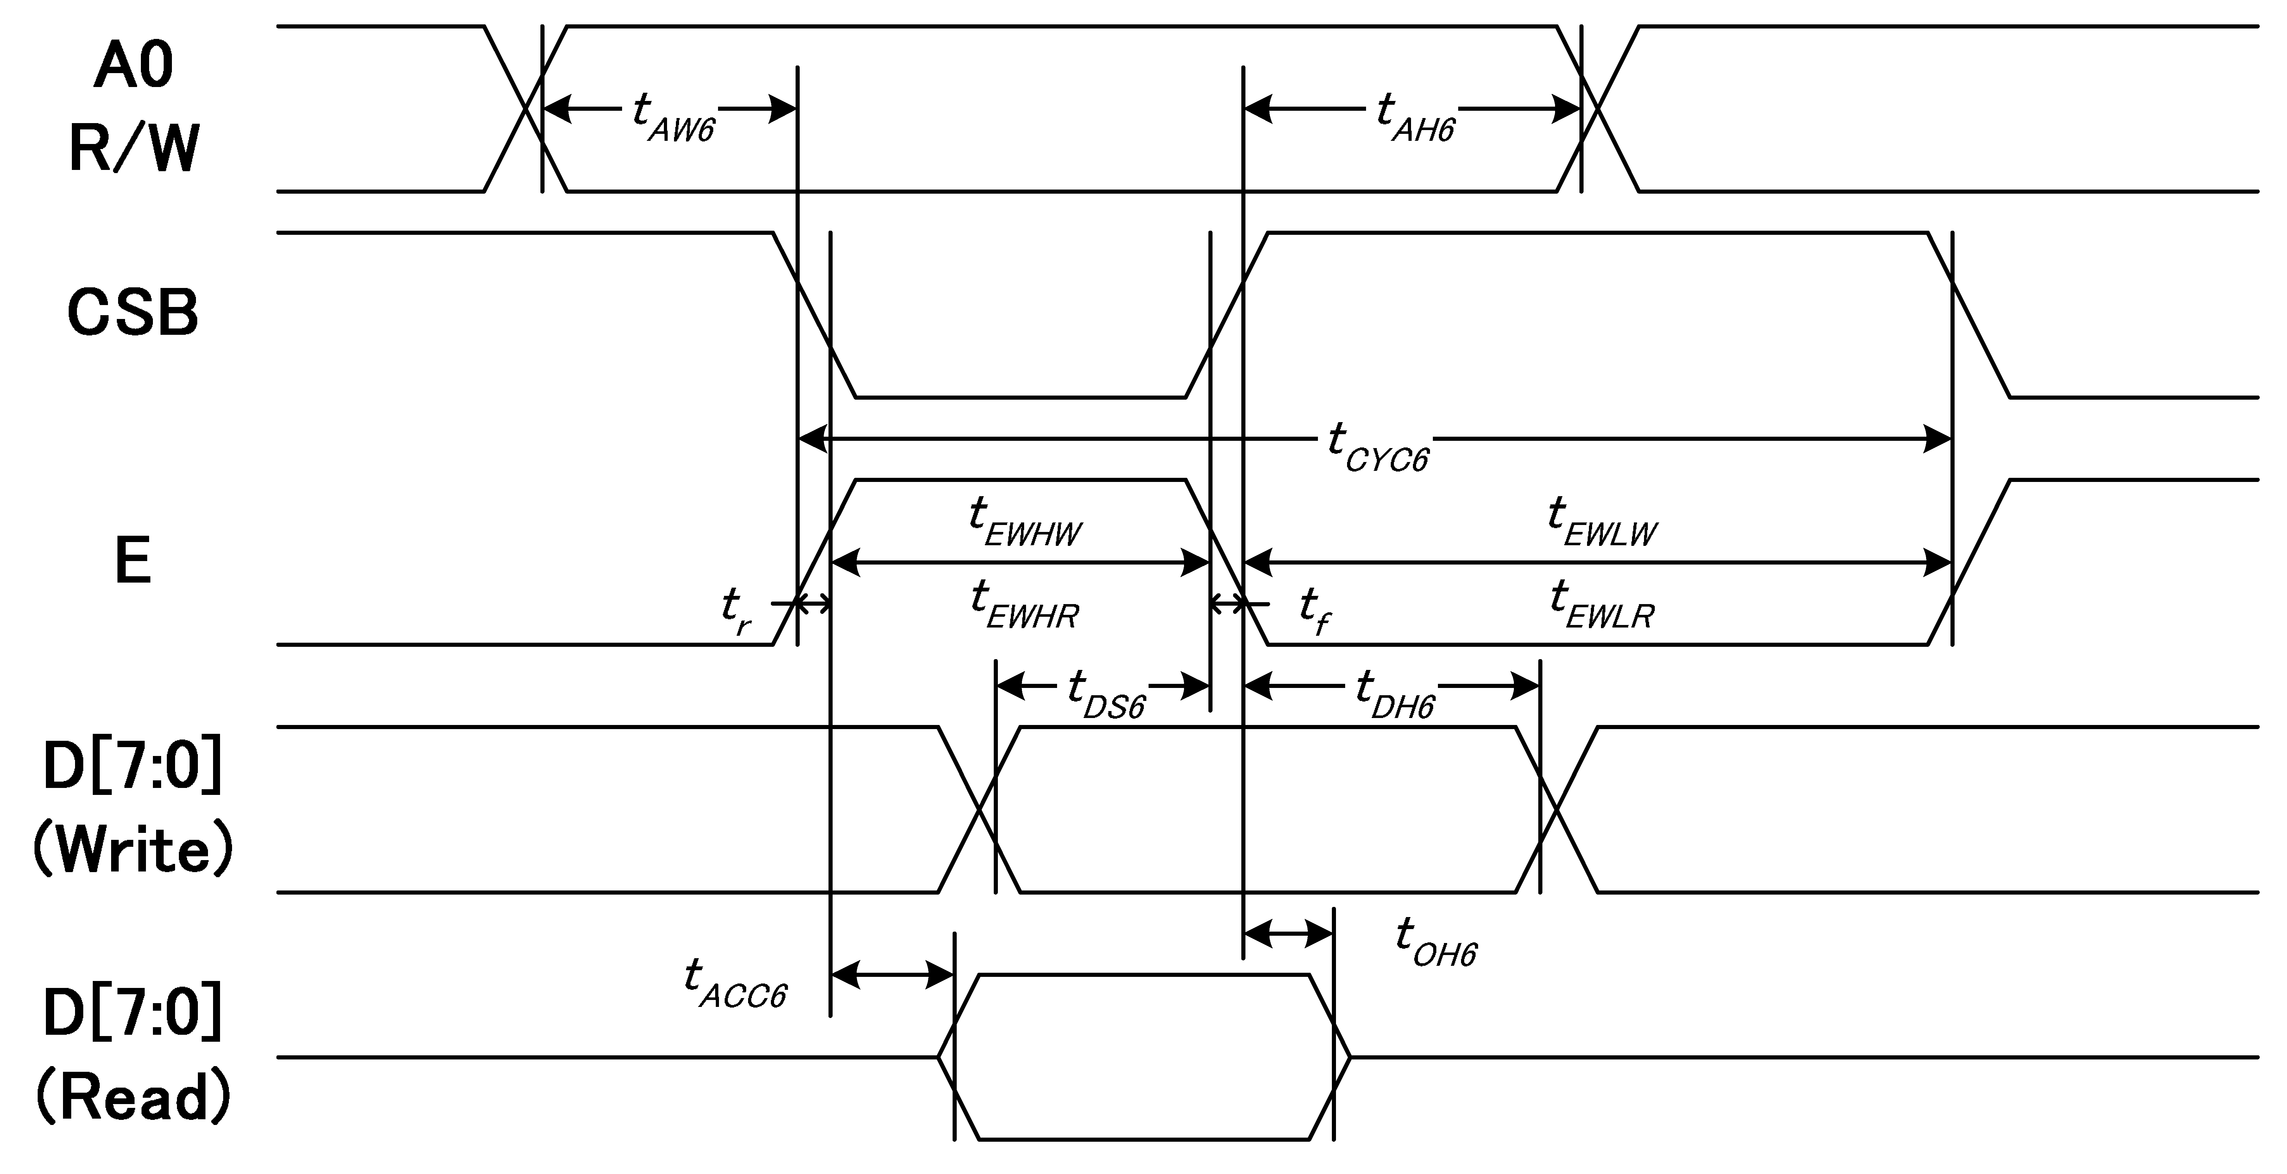
CS

System Bus Timing for 8080 Series MPU
(VDD=3.3V, Ta=25℃)

Item | Signal | Symbol | Condition | Min. | Max. | Unit
Address setup time | A0 | tAW8 |  | 0 | — | ns
Address hold time | A0 | tAH8 |  | 0 | — | ns
System cycle time | /WR | tCYC8 |  | 240 | — | ns
/WR L pulse width (WRITE) | /WR | tCCLW |  | 80 | — | ns
/WR H pulse width (WRITE) | /WR | tCCHW |  | 80 | — | ns
/RD L pulse width (READ) | RD | tCCLR |  | 80 | — | ns
/RD H pulse width (READ) | RD | tCCHR |  | 80 |  | ns
WRITE Data setup time | D[7:0] | tDS8 |  | 30 | — | ns
WRITE Data hold time | D[7:0] | tDH8 |  | 10 | — | ns
READ access time | D[7:0] | tACC8 | CL = 100pF | — | 70 | ns
READ Output disable time | D[7:0] | tOH8 | CL = 100pF | 5 | 50 | ns

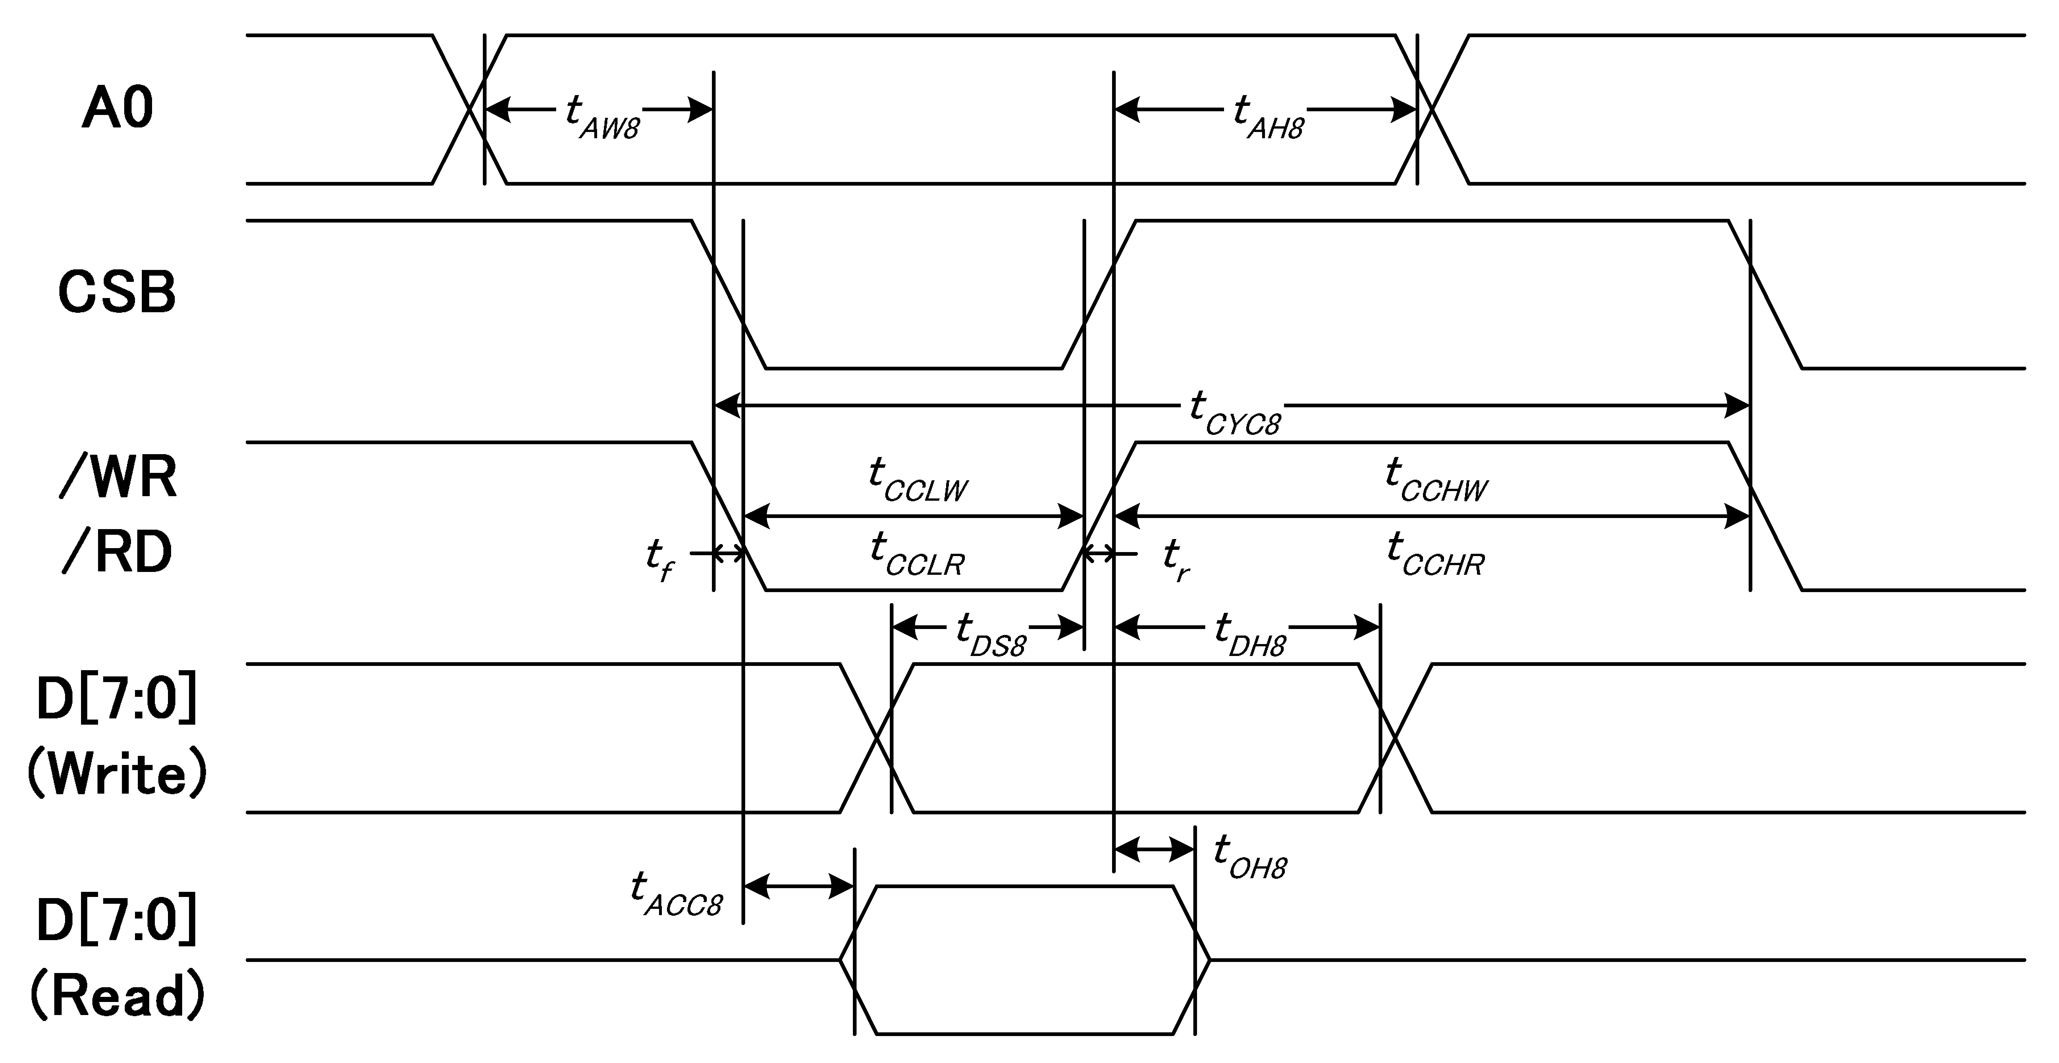
CS

System Bus Timing for 4-Line Serial Interface
(VDD=3.3V, Ta=25℃)

Item | Signal | Symbol | Condition | Min. | Max. | Unit
Serial clock period | SCLK | tSCYC |  | 50 | --- | ns
SCLK “H” pulse width | SCLK | tSHW |  | 25 | --- | ns
SCLK “L” pulse width | SCLK | tSLW |  | 25 | --- | ns
Address setup time | A0 | tSAS |  | 20 | --- | ns
Address hold time | A0 | tSAH |  | 10 | --- | ns
Data setup time | SDA | tSDS |  | 20 | --- | ns
Data hold time | SDA | tSDH |  | 10 | --- | ns
CS-SCLK time | CS | tCSS |  | 20 | --- | ns
CS-SCLK time | CS | tCSH |  | 40 | --- | ns

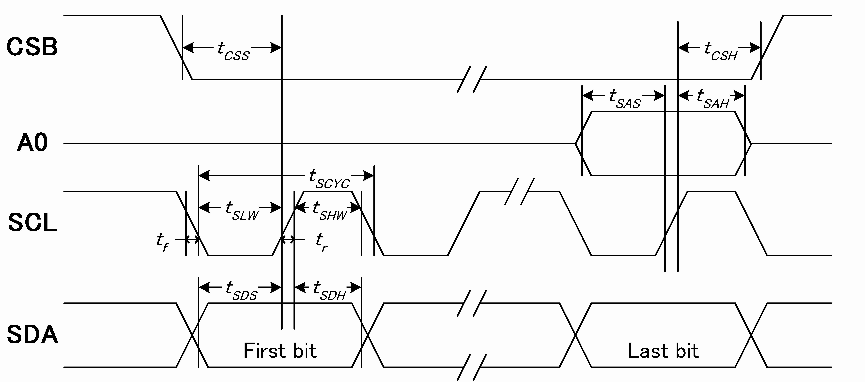
CS

6. ELECTRO-OPTICAL CHARACTERISTICS
Item | Symbol | Condition | Min. | Typ. | Max. | Unit | note
Viewing angle range | θ_{f} (12 o’clock) | When Cr≧2 | 35 | --- | --- | Degree | Note 2 Note 3  Note 4
Viewing angle range | θ_{b} (6 o’clock) | When Cr≧2 | 30 | --- | --- | Degree | Note 2 Note 3  Note 4
Viewing angle range | θ_{l} (9 o’clock) | When Cr≧2 | 30 | --- | --- | Degree | Note 2 Note 3  Note 4
Viewing angle range | θ_{r} (3 o’clock) | When Cr≧2 | 30 | 35 | --- | Degree | Note 2 Note 3  Note 4
Rise Time | T_{r} | V_{DD}-V₀=8.7V  Ta=25℃ |  | 112 |  | mS | Note 1
Fall Time | T_{f} | V_{DD}-V₀=8.7V  Ta=25℃ |  | 250 |  | mS | Note 1
Contrast | Cr | V_{DD}-V₀=8.7V  Ta=25℃ | --- | 5. 4 | ---
[Note 1] Definition of Response Time (Tr, Tf)
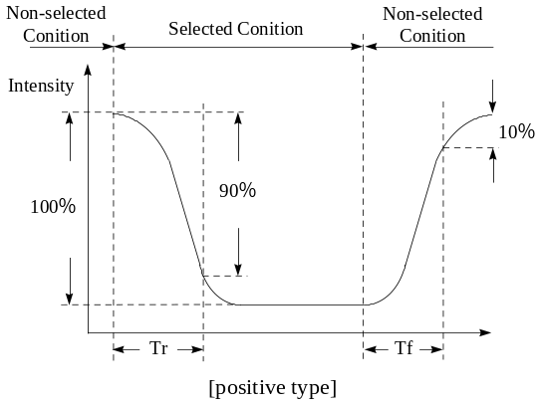
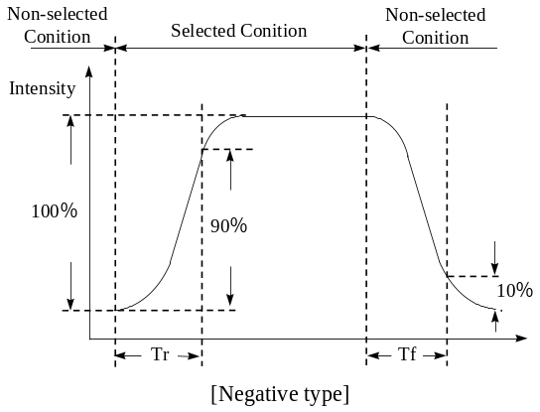

Conditions:
Operating Voltage : Vop Viewing Angle(θ, φ): 0° , 0°
Frame Frequency : 64 Hz Driving Wave form : 1/N duty, 1/a bias

[Note 2] Definition of Viewing Direction

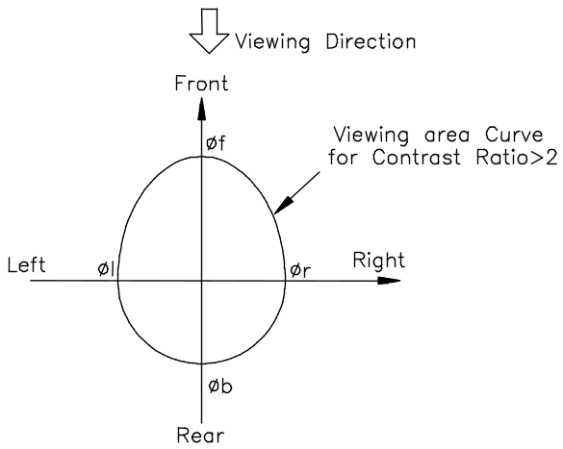

[Note 3] Definition of viewing angle

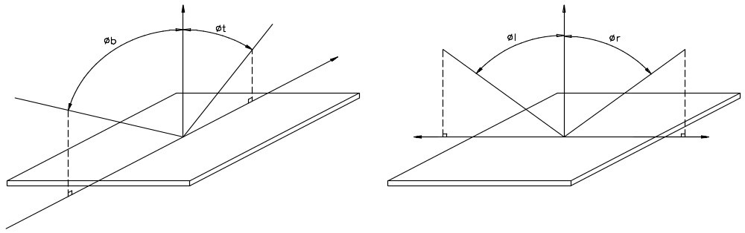

[Note 4] Description of Measuring Equipment
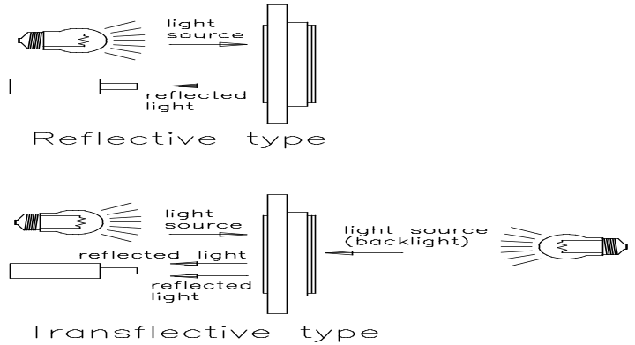

7. OPERATING PRINCIPLES & METHODS

INSTRUCTION | A0 |  |  | R/W |  | COMMAND BYTE |  |  |  |  |  |  |  |  |  |  |  |  |  |  | DESCRIPTION
INSTRUCTION |  |  |  |  |  | D7 | D6 |  | D5 |  | D4 |  | D3 |  | D2 |  | D1 |  | D0
(1) Display ON/OFF |  | 0 | 0 |  | 1 |  |  | 0 |  | 1 |  | 0 |  | 1 |  | 1 |  | 1 |  | D |  | D=1, display ON  D=0, display OFF
(2) Set Start Line |  | 0 | 0 |  | 0 |  |  | 1 |  | S5 |  | S4 |  | S3 |  | S2 |  | S1 |  | S0 |  | Set display start line
(3) Set Page Address |  | 0 | 0 |  | 1 |  |  | 0 |  | 1 |  | 1 |  | Y3 |  | Y2 |  | Y1 |  | Y0 |  | Set page address
(4) Set Column Address | 0 |  |  | 0 |  | 0 | 0 |  | 0 |  | 1 |  | X7 |  | X6 |  | X5 |  | X4 |  | Set column address (MSB)
(4) Set Column Address | 0 |  |  | 0 |  | 0 | 0 |  | 0 |  | 0 |  | X3 |  | X2 |  | X1 |  | X0 |  | Set column address (LSB)
(5) Read Status |  | 0 | 1 |  | 0 |  |  | MX |  | D |  | RST |  | 0 |  | 0 |  | 0 |  | 0 |  | Read IC Status
(6) Write Data |  | 1 | 0 |  | D7 |  |  | D6 |  | D5 |  | D4 |  | D3 |  | D2 |  | D1 |  | D0 |  | Write display data to RAM
(7) Read Data |  | 1 | 1 |  | D7 |  |  | D6 |  | D5 |  | D4 |  | D3 |  | D2 |  | D1 |  | D0 |  | Read display data from RAM
(8) SEG Direction |  | 0 | 0 |  | 1 |  |  | 0 |  | 1 |  | 0 |  | 0 |  | 0 |  | 0 |  | MX |  | Set scan direction of SEG MX=1, reverse direction MX=0, normal direction
(9) Inverse Display |  | 0 | 0 |  | 1 |  |  | 0 |  | 1 |  | 0 |  | 0 |  | 1 |  | 1 |  | INV |  | INV =1, inverse display  INV =0, normal display
(10) All Pixel ON |  | 0 | 0 |  | 1 |  |  | 0 |  | 1 |  | 0 |  | 0 |  | 1 |  | 0 |  | AP |  | AP=1, set all pixel ON  AP=0, normal display
(11) Bias Select |  | 0 | 0 |  | 1 |  |  | 0 |  | 1 |  | 0 |  | 0 |  | 0 |  | 1 |  | BS |  | Select bias setting  0=1/9; 1=1/7
(12)Read-modify-Write |  | 0 | 0 |  | 1 |  |  | 1 |  | 1 |  | 0 |  | 0 |  | 0 |  | 0 |  | 0 |  | Column address increment: Read:+0 , Write:+1
(13) END |  | 0 | 0 |  | 1 |  |  | 1 |  | 1 |  | 0 |  | 1 |  | 1 |  | 1 |  | 0 |  | Exit Read-modify-Write mode
(14) RESET |  | 0 | 0 |  | 1 |  |  | 1 |  | 1 |  | 0 |  | 0 |  | 0 |  | 1 |  | 0 |  | Internal reset
(15) COM Direction |  | 0 | 0 |  | 1 |  |  | 1 |  | 0 |  | 0 |  | MY |  | - |  | - |  | - |  | Set output direction of COM  MY=1, reverse direction MY=0, normal direction
(16) Power Control |  | 0 | 0 |  | 0 |  |  | 0 |  | 1 |  | 0 |  | 1 |  | VB |  | VR |  | VF |  | Control built-in power circuit ON/OFF
(17) Regulation Ratio |  | 0 | 0 |  | 0 |  |  | 0 |  | 1 |  | 0 |  | 0 |  | RR2 |  | RR1 |  | RR0 |  | Select regulation resistor ratio
(18) Electronic volume mode set Electronic volume register set | 0 |  |  | 0 |  | 1 | 0 |  | 0 |  | 0 |  | 0 |  | 0 |  | 0 |  | 1 |  | Set the V0 output voltage electronic volume register
 | 0 |  |  | 0 |  | 0 | 0 |  | EV5 |  | EV4 |  | EV3 |  | EV2 |  | EV1 |  | EV0
(19) Static indicator  ON/OFF  Static indicator  Register set | 0 |  |  | 0 |  | 1 | 0 |  | 1 |  | 0 |  | 1 |  | 1 |  | 0 |  | 0/1 |  | 0: OFF, 1: ON
 | 0 |  |  | 0 |  | 0 | 0 |  | 0 |  | 0 |  | 0 |  | 0 |  | 0 |  | Mode |  | Set the flashing mode
(20) Page Blink  Page selection | 0 |  |  | 0 |  | 1 | 1 |  | 0 |  | 1 |  | 0 |  | 1 |  | 0 |  | 1 |  | P7 - 0: 1 - blinking page  0 - no blinking, normal display
(20) Page Blink  Page selection | 0 |  |  | 0 |  | P7 | P6 |  | P5 |  | P4 |  | P3 |  | P2 |  | P1 |  | P0
(21). Driving Mode Set  Mode selection | 0 |  |  | 0 |  | 1 | 1 |  | 0 |  | 1 |  | 0 |  | 0 |  | 1 |  | 0 |  | Set the driving mode register  Driving capability (D0): (1)>(0)
(21). Driving Mode Set  Mode selection | 0 |  |  | 0 |  | 0 | 0 |  | 0 |  | 0 |  | 0 |  | 0 |  | 0 |  | D0
(22) Power Save | 0 |  |  | 0 |  | Compound Command |  |  |  |  |  |  |  |  |  |  |  |  |  |  | Display OFF + All Pixel ON
(23) NOP | 0 |  |  | 0 |  | 1 | 1 |  | 1 |  | 0 |  | 0 |  | 0 |  | 1 |  | 1 |  | No operation
(24) Test | 0 |  |  | 0 |  | 1 | 1 |  | 1 |  | 1 |  | - |  | - |  | - |  | - |  | Do NOT use.  Reserved for testing.
(24) Test | 0 |  |  | 0 |  | 1 | 1 |  | 0 |  | 1 |  | 0 |  | 1 |  | 0 |  | 0
(25) Oscillator Frequency  selection | 0 |  |  | 0 |  | 1 | 1 |  | 1 |  | 0 |  | 0 |  | 1 |  | 0 |  | 0/1 |  | 20KHz/33KHz (Default)  16.4KHz/ 27.06KHz

8. RELIABILITY
Environmental Test
No. | Test Item | Content of Test | Test Condition | Applicable Standard
1 | High temperature storage | Endurance test applying the high storage temperature for a long time. | 80 °C  200 hrs | ------
2 | Low temperature storage | Endurance test applying the low storage temperature for a long time. | -30 °C  200 hrs | ------
3 | High temperature operation | Endurance test applying the electric stress (Voltage & Current) and the thermal stress to the element for a long time. | 70 °C  200 hrs | ------
4 | Low temperature operation | Endurance test applying the electric stress under low temperature for a long time. | -20 °C  200 hrs | ------
5 | High temperature / Humidity storage | Endurance test applying the high temperature and high humidity storage for a long time. | 70 °C , 90 %RH  96 hrs | MIL-202E-103B  JIS-C5023
6 | High temperature / Humidity operation | Endurance test applying the electric stress (Voltage & Current) and temperature / humidity stress to the element for a long time. | 50 °C , 90 %RH  96 hrs | MIL-202E-103B  JIS-C5023
7  25°C  5min.  1 cycle  60°C  30min.  -10°C  30min. | Temperature cycle | Endurance test applying the low and high temperature cycle. | -10°C / 60°C  10 cycles | ------
Mechanical Test
8 | Vibration test | Endurance test applying the vibration during transportation and using. | 10∼22Hz → 1.5mmp-p  22∼500Hz → 1.5G  Total 0.5hrs | MIL-202E-201A  JIS-C5025  JIS-C7022-A-10
9 | Shock test | Constructional and mechanical endurance test applying the shock during transportation. | 50G half sign  wave 1l msedc  3 times of each direction | MIL-202E-213B
10 | Atmospheric pressure test | Endurance test applying the atmospheric pressure during transportation by air. | 115 mbar  40 hrs | MIL-202E-105C
Others
11 | Static electricity test | Endurance test applying the electric stress to the terminal. | VS=800V , RS=1.5 kΩ  CS=100 pF  10 time | MIL-883B-3015.1
Inspection after test: Inspection after 2～4 hours storage at room temperature ,the sample shall be free from defects:
- Air bubble in the LCD.
- Sealleak
- Non-display.
- Missing segments.
- Glass crack.
- Current Idd is twice higher than initial value.

9. QUALITY GUARANTEE

No | Item | Criteria
1 | inclusions (black spot, white spot, dust) | - round type  diameter mm(a*) no of defect*  a≦0.20 neglect  0.20＜a≦0.35 5max  0.35＜a none  - linear type  length mm(l) width mm(W) no. of defect  na W≦0.03 neglect  l≦3 0.03＜W≦0.08 6  3＜l 0.08＜W none
2 | scratch | - scratch on protective film is permitted.  - scratch on polarizer shall be as follow:  - round type  diameter mm(a*) no of defect  a≦0.15 neglect  0.15＜a≦0.20 2 max  0.20＜a none  - linear type  be judged bye 1.-(2) linear type
3 | dent | diameter ＜ 1.5mm
4 | bubble | not exceeding 0.5mm average diameter is acceptable between glass and polarizing film
5 | pin hole | (a+b)/2 ≦ 0.15mm  maximum number: ignored  0.15＜(a+b)/2≦0.20mm  maximum number:10
6 | dot width | design width ±15%
7 | dot defect | (a+b)/2≦0.20mm  maximum number: ignored  0.20＜(a+b)/2≦0.30mm  maximum number:5  x=width
8 | contrast irregularity(spot) | diameter spec no of defect  a≦0.50mm neglect  0.50＜a≦0.75 5  0.75＜a≦1.00 3  1.00＜a none
9 | color tone and uniformity | obvious uneven color is not permitted

10. Interface circuit and driving programme on LCM of dots matrix series .
（1）Interface circuit:

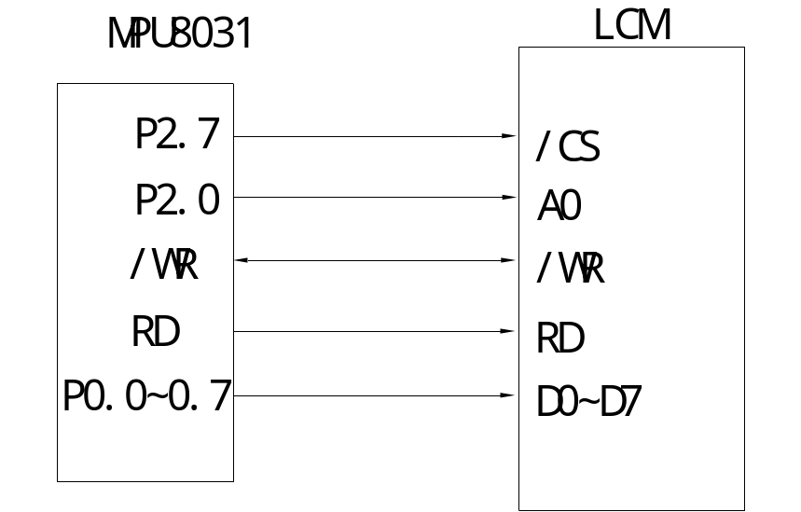

串口测试程序（其它技术参数请参考IC:ST7567)
//***************************************************************************
//连线表: CPU=W78E54B *
//CS=P3.0 SID=P3.1 SCK=P3.2 RS=P3.3 Fosc=12Mhz RST=P3.5 *
//***************************************************************************
#include <reg52.h>
#include <intrins.h>

#define LcmXPixel 128 //横向宽度
#define LcmYPixel 64 //纵向高度
#define MIN(A,B) ((A)<(B)?(A):(B))
#define Uchar unsigned char
#define Uint unsigned int

sbit CS = P3^0; //片选
sbit SID = P3^1; //数据
sbit SCK = P3^2; //Clock信号
sbit RS = P3^3; //数据指令选择
sbit Key = P3^4; //测试架锁定按键(测试架专用)
sbit RES = P3^5; //测试架复位是板载RC复位,可以不需要IO口操作

Uchar code ASCIIchardot[];
Uchar code bmp1[];
Uchar code bmp2[];
Uchar code bmp3[];
Uchar code ComTable[]={3,2,1,0,7,6,5,4,};

//串口模式下只能写不能读,也不能查忙,因此用户要控制好速度不要太快
void WriteCommand( Uchar CommandByte )
{
Uchar i;
CS=0;
RS=0; //Command
for(i=0;i<8;i++)
{ SCK=1;
SID=( (CommandByte>>(7-i)) &0x01);
SCK=0;
_nop_();
SCK=1;
}
}

void WriteData( Uchar DataByte )
{
Uchar i;
CS=0;
RS=1; //Data
for(i=0;i<8;i++)
{
SCK=1;
SID=( (DataByte>>(7-i)) &0x01);
SCK=0;
_nop_();
SCK=1;
}
}

void DelayMS(unsigned int MS)
{
unsigned char us,usn;
while(MS!=0)
{
usn = 2; //for 12M
while(usn!=0)
{
us=0xf6;
while (us!=0){us--;};
usn--;
}
MS--;
}
}

void DelayKey(unsigned int Second , unsigned int MS100)
{
unsigned int i;
for(i=0;i<Second*100+MS100*10;i++)
{
if(Key==0)
{
DelayMS(20);
while(Key==0) {DelayMS(20);}
break;
}
else DelayMS(10);
}
}

void LcmClear( Uchar FillData )
{
Uint i,j;
for(i=0;i<8;i++)
{
WriteCommand(0xB0|ComTable[i]); //Set Page Address
WriteCommand(0x10); //Set Column Address = 0
WriteCommand(0x01); //Colum from S1 -> S128 auto add
for(j=0;j<128;j++)
{
WriteData( FillData );
}
}
}

void LcmInit( void )
{
WriteCommand(0xAE); //Display OFF
WriteCommand(0xA2); //1/64 Duty 1/9 Bias
WriteCommand(0xA0); //ADC select S0->S131(玻璃设计用S1-S128)
WriteCommand(0xC0); //com1 --> com64
WriteCommand(0x24); //对某些模块没用,用的外部Rb/Ra
WriteCommand(0x81); //Sets V0
WriteCommand(48); //内部电位器调节对比度
WriteCommand(0x2F); //voltage follower ON regulator ON booster ON
WriteCommand(0xA6); //Normal Display (not reverse dispplay)
WriteCommand(0xA4); //Entire Display Disable
WriteCommand(0x40); //Set Display Start Line = com0
WriteCommand(0xB0); //Set Page Address = 0
WriteCommand(0x10); //Set Column Address 4 higher bits = 0
WriteCommand(0x01); //Set Column Address 4 lower bits = 1 , from IC SEG1 -> SEG128
LcmClear(0);
WriteCommand(0xAF); //Display ON
}

//显示ASICC字符的函数
void LcmPutChar(Uchar col,Uchar page,Uchar Order)
{
Uchar i;
Uint x;
x = (Order-0x20)*0x10; //ASICC字符从0x20开始,每个16 byte
WriteCommand(ComTable[page&0x07]|0xB0); //Set Page Address
WriteCommand( ((col+1)>>4) | 0x10); //Set Column Address High Byte
WriteCommand( (col+1)&0x0F ); //Low Byte Colum from S128 -> S1 auto add

for(i=0;i<8;i++)
{
WriteData( ASCIIchardot[x] );
x++;
}
page++; //下半字符page+1

WriteCommand(ComTable[page&0x07]|0xB0); //Set Page Address
WriteCommand( ((col+1)>>4) | 0x10); //Set Column Address High Byte
WriteCommand( (col+1)&0x0F ); //Low Byte Colum from S128 -> S1 auto add

for(i=0;i<8;i++)
{
WriteData( ASCIIchardot[x] );
x++;
}
page--; //写完一个字符page还原
}

//显示字符串的函数
void LcmPutStr(Uchar col,Uchar page,Uchar *puts)
{
while(*puts != '\0') //判断字符串时候显示完毕
{

if(col>(LcmXPixel-8)) //判断行末空间是否足够放一个字符,自动换行
{
page=page+2;
col=0;
}
if(page>(LcmYPixel/8-2)) //到了屏幕最下角,自动返回左上角
{
page=0;
col=0;
}
LcmPutChar(col,page,*puts);
puts++;
col=col+8; //下一个字符8列之后
}
}

//显示3位数的数值(0-255)
void LcmPutNum(Uchar col,Uchar page,Uchar Num)
{
Uchar a,b,c;
a=Num/100;
b=(Num%100)/10;
c=Num%10;
if(a==0) ; //也不写空格,直接跳过去//PutChar(col,page,0x20);
else LcmPutChar(col,page,a+0x30);

if(a==0 && b==0) ; //也不写空格,直接跳过去//LcmPutChar(col,page,0x20);
else LcmPutChar(col+8,page,b+0x30);

LcmPutChar(col+16,page,c+0x30);
}

void LcmPutBmp( Uchar *puts )
{
Uchar i,j;
Uint X=0;
for(i=0;i<(LcmYPixel/8);i++)
{
WriteCommand(0xB0|ComTable[i]); //Set Page Address
WriteCommand(0x10); //Set Column Address = 0
WriteCommand(0x01); //Colum from S1 -> S128 auto add
for(j=0;j<LcmXPixel;j++)
{
WriteData( puts[X] );
X++;
}
}
}

void main( void )
{
Uchar i;
Uchar contrast=48; //对比度=48(根据我们常用的外部电阻参数来的)
DelayMS(10);
RES = 0;
DelayMS(200);
RES = 1;
DelayMS(50);
LcmInit();
while(1)
{
LcmPutBmp(bmp1);
DelayKey(1,0);

for(i=(contrast-5);i<(contrast+5);i++)
{
WriteCommand(0x81); //Sets V0
WriteCommand(0x3F&i); //内部电位器调节对比度
LcmPutNum(10,2,i);
DelayKey(0,1);
}

WriteCommand(0x81); //Sets V0
WriteCommand(contrast); //恢复对比度
LcmPutNum(10,2,contrast);

LcmClear(0xff);
DelayKey(1,0);

LcmClear(0);
LcmPutStr(0,0,"CA12864I2 Program");
LcmPutStr(0,2,"SunSon ELEC-TECH");
LcmPutStr(0,4,"TEL:755-29970110");
LcmPutStr(0,6,"By LJ 2009.04.08");
DelayKey(1,0);
}
}

/* ASICC字库代码 8x16点阵 */
unsigned char code ASCIIchardot[16*96] = {
/*-- 文字: --*/
/*-- Fixedsys12; 此字体下对应的点阵为：宽x高=8x16 --*/
0x00,0x00,0x00,0x00,0x00,0x00,0x00,0x00,0x00,0x00,0x00,0x00,0x00,0x00,0x00,0x00,

/*-- 文字: ! --*/
/*-- Fixedsys12; 此字体下对应的点阵为：宽x高=8x16 --*/
0x00,0x00,0x0E,0x1F,0x1F,0x0E,0x00,0x00,0x00,0x00,0x00,0xB0,0xB0,0x00,0x00,0x00,

/*-- 文字: " --*/
/*-- Fixedsys12; 此字体下对应的点阵为：宽x高=8x16 --*/
0x00,0x1C,0x1C,0x00,0x00,0x1C,0x1C,0x00,0x00,0x00,0x00,0x00,0x00,0x00,0x00,0x00,

/*-- 文字: # --*/
/*-- Fixedsys12; 此字体下对应的点阵为：宽x高=8x16 --*/
0x00,0x04,0x1F,0x1F,0x04,0x1F,0x1F,0x04,0x00,0x40,0xF0,0xF0,0x40,0xF0,0xF0,0x40,

/*-- 文字: $ --*/
/*-- Fixedsys12; 此字体下对应的点阵为：宽x高=8x16 --*/
0x00,0x0C,0x1E,0x73,0x71,0x18,0x08,0x00,0x00,0x20,0x30,0x1C,0x9C,0xF0,0x60,0x00,

/*-- 文字: % --*/
/*-- Fixedsys12; 此字体下对应的点阵为：宽x高=8x16 --*/
0x18,0x3C,0x24,0x3D,0x1B,0x06,0x0C,0x00,0x00,0x60,0xC0,0xB0,0x78,0x48,0x78,0x30,

/*-- 文字: & --*/
/*-- Fixedsys12; 此字体下对应的点阵为：宽x高=8x16 --*/
0x00,0x0D,0x1F,0x12,0x1E,0x0C,0x00,0x00,0x00,0xE0,0xF0,0x10,0x90,0xE0,0xF0,0x90,

/*-- 文字: ' --*/
/*-- Fixedsys12; 此字体下对应的点阵为：宽x高=8x16 --*/
0x00,0x00,0x00,0x1C,0x1C,0x00,0x00,0x00,0x00,0x00,0x00,0x00,0x00,0x00,0x00,0x00,

/*-- 文字: ( --*/
/*-- Fixedsys12; 此字体下对应的点阵为：宽x高=8x16 --*/
0x00,0x00,0x03,0x0F,0x1C,0x10,0x00,0x00,0x00,0x00,0xE0,0xF8,0x1C,0x04,0x00,0x00,

/*-- 文字: ) --*/
/*-- Fixedsys12; 此字体下对应的点阵为：宽x高=8x16 --*/
0x00,0x00,0x10,0x1C,0x0F,0x03,0x00,0x00,0x00,0x00,0x04,0x1C,0xF8,0xE0,0x00,0x00,

/*-- 文字: * --*/
/*-- Fixedsys12; 此字体下对应的点阵为：宽x高=8x16 --*/
0x00,0x01,0x05,0x07,0x03,0x07,0x05,0x01,0x00,0x00,0x40,0xC0,0x80,0xC0,0x40,0x00,

/*-- 文字: + --*/
/*-- Fixedsys12; 此字体下对应的点阵为：宽x高=8x16 --*/
0x00,0x01,0x01,0x07,0x07,0x01,0x01,0x00,0x00,0x00,0x00,0xC0,0xC0,0x00,0x00,0x00,

/*-- 文字: , --*/
/*-- Fixedsys12; 此字体下对应的点阵为：宽x高=8x16 --*/
0x00,0x00,0x00,0x00,0x00,0x00,0x00,0x00,0x00,0x00,0x00,0x34,0x3C,0x38,0x00,0x00,

/*-- 文字: - --*/
/*-- Fixedsys12; 此字体下对应的点阵为：宽x高=8x16 --*/
0x00,0x01,0x01,0x01,0x01,0x01,0x01,0x00,0x00,0x00,0x00,0x00,0x00,0x00,0x00,0x00,

/*-- 文字: . --*/
/*-- Fixedsys12; 此字体下对应的点阵为：宽x高=8x16 --*/
0x00,0x00,0x00,0x00,0x00,0x00,0x00,0x00,0x00,0x00,0x00,0x30,0x30,0x30,0x00,0x00,

/*-- 文字: / --*/
/*-- Fixedsys12; 此字体下对应的点阵为：宽x高=8x16 --*/
0x00,0x00,0x00,0x01,0x07,0x1E,0x18,0x00,0x00,0x18,0x78,0xE0,0x80,0x00,0x00,0x00,

/*-- 文字: 0 --*/
/*-- Fixedsys12; 此字体下对应的点阵为：宽x高=8x16 --*/
0x00,0x00,0x0F,0x1F,0x10,0x16,0x1F,0x0F,0x00,0x00,0xE0,0xF0,0xD0,0x10,0xF0,0xE0,

/*-- 文字: 1 --*/
/*-- Fixedsys12; 此字体下对应的点阵为：宽x高=8x16 --*/
0x00,0x04,0x04,0x0C,0x1F,0x1F,0x00,0x00,0x00,0x00,0x00,0x00,0xF0,0xF0,0x00,0x00,

/*-- 文字: 2 --*/
/*-- Fixedsys12; 此字体下对应的点阵为：宽x高=8x16 --*/
0x00,0x0C,0x1C,0x10,0x11,0x1F,0x0E,0x00,0x00,0x30,0x70,0xD0,0x90,0x10,0x10,0x00,

/*-- 文字: 3 --*/
/*-- Fixedsys12; 此字体下对应的点阵为：宽x高=8x16 --*/
0x00,0x0C,0x1C,0x11,0x11,0x1F,0x0E,0x00,0x00,0x60,0x70,0x10,0x10,0xF0,0xE0,0x00,

/*-- 文字: 4 --*/
/*-- Fixedsys12; 此字体下对应的点阵为：宽x高=8x16 --*/
0x00,0x00,0x1F,0x1F,0x00,0x07,0x07,0x00,0x00,0xC0,0xC0,0x40,0x40,0xF0,0xF0,0x40,

/*-- 文字: 5 --*/
/*-- Fixedsys12; 此字体下对应的点阵为：宽x高=8x16 --*/
0x00,0x1F,0x1F,0x11,0x11,0x11,0x10,0x00,0x00,0x10,0x10,0x10,0x30,0xE0,0xC0,0x00,

/*-- 文字: 6 --*/
/*-- Fixedsys12; 此字体下对应的点阵为：宽x高=8x16 --*/
0x00,0x03,0x07,0x1E,0x1A,0x13,0x01,0x00,0x00,0xE0,0xF0,0x10,0x10,0xF0,0xE0,0x00,

/*-- 文字: 7 --*/
/*-- Fixedsys12; 此字体下对应的点阵为：宽x高=8x16 --*/
0x00,0x10,0x10,0x11,0x17,0x1E,0x18,0x00,0x00,0x00,0x70,0xF0,0x80,0x00,0x00,0x00,

/*-- 文字: 8 --*/
/*-- Fixedsys12; 此字体下对应的点阵为：宽x高=8x16 --*/
0x00,0x0E,0x1F,0x13,0x11,0x1F,0x0E,0x00,0x00,0xE0,0xF0,0x10,0x90,0xF0,0xE0,0x00,

/*-- 文字: 9 --*/
/*-- Fixedsys12; 此字体下对应的点阵为：宽x高=8x16 --*/
0x00,0x0F,0x1F,0x10,0x10,0x1F,0x0F,0x00,0x00,0x00,0x90,0xB0,0xF0,0xC0,0x80,0x00,

/*-- 文字: : --*/
/*-- Fixedsys12; 此字体下对应的点阵为：宽x高=8x16 --*/
0x00,0x00,0x00,0x06,0x06,0x06,0x00,0x00,0x00,0x00,0x00,0x30,0x30,0x30,0x00,0x00,

/*-- 文字: ; --*/
/*-- Fixedsys12; 此字体下对应的点阵为：宽x高=8x16 --*/
0x00,0x00,0x00,0x06,0x06,0x06,0x00,0x00,0x00,0x00,0x00,0x34,0x3C,0x38,0x00,0x00,

/*-- 文字: < --*/
/*-- Fixedsys12; 此字体下对应的点阵为：宽x高=8x16 --*/
0x00,0x01,0x03,0x06,0x0C,0x18,0x10,0x00,0x00,0x00,0x80,0xC0,0x60,0x30,0x10,0x00,

/*-- 文字: = --*/
/*-- Fixedsys12; 此字体下对应的点阵为：宽x高=8x16 --*/
0x00,0x02,0x02,0x02,0x02,0x02,0x02,0x00,0x00,0x80,0x80,0x80,0x80,0x80,0x80,0x00,

/*-- 文字: > --*/
/*-- Fixedsys12; 此字体下对应的点阵为：宽x高=8x16 --*/
0x00,0x10,0x18,0x0C,0x06,0x03,0x01,0x00,0x00,0x10,0x30,0x60,0xC0,0x80,0x00,0x00,

/*-- 文字: ? --*/
/*-- Fixedsys12; 此字体下对应的点阵为：宽x高=8x16 --*/
0x00,0x0C,0x1C,0x11,0x13,0x1E,0x0C,0x00,0x00,0x00,0x00,0xB0,0xB0,0x00,0x00,0x00,

/*-- 文字: @ --*/
/*-- Fixedsys12; 此字体下对应的点阵为：宽x高=8x16 --*/
0x0F,0x1F,0x10,0x11,0x13,0x12,0x1F,0x0F,0xE0,0xF0,0x10,0x90,0xD0,0x50,0xD0,0xD0,

/*-- 文字: A --*/
/*-- Fixedsys12; 此字体下对应的点阵为：宽x高=8x16 --*/
0x00,0x07,0x0F,0x18,0x18,0x0F,0x07,0x00,0x00,0xF0,0xF0,0x80,0x80,0xF0,0xF0,0x00,

/*-- 文字: B --*/
/*-- Fixedsys12; 此字体下对应的点阵为：宽x高=8x16 --*/
0x00,0x1F,0x1F,0x11,0x11,0x1F,0x0E,0x00,0x00,0xF0,0xF0,0x10,0x10,0xF0,0xE0,0x00,

/*-- 文字: C --*/
/*-- Fixedsys12; 此字体下对应的点阵为：宽x高=8x16 --*/
0x00,0x0F,0x1F,0x10,0x10,0x1C,0x0C,0x00,0x00,0xE0,0xF0,0x10,0x10,0x70,0x60,0x00,

/*-- 文字: D --*/
/*-- Fixedsys12; 此字体下对应的点阵为：宽x高=8x16 --*/
0x00,0x1F,0x1F,0x10,0x18,0x0F,0x07,0x00,0x00,0xF0,0xF0,0x10,0x30,0xE0,0xC0,0x00,

/*-- 文字: E --*/
/*-- Fixedsys12; 此字体下对应的点阵为：宽x高=8x16 --*/
0x00,0x1F,0x1F,0x11,0x11,0x11,0x10,0x00,0x00,0xF0,0xF0,0x10,0x10,0x10,0x10,0x00,

/*-- 文字: F --*/
/*-- Fixedsys12; 此字体下对应的点阵为：宽x高=8x16 --*/
0x00,0x1F,0x1F,0x11,0x11,0x11,0x10,0x00,0x00,0xF0,0xF0,0x00,0x00,0x00,0x00,0x00,

/*-- 文字: G --*/
/*-- Fixedsys12; 此字体下对应的点阵为：宽x高=8x16 --*/
0x00,0x0F,0x1F,0x10,0x10,0x1C,0x0C,0x00,0x00,0xE0,0xF0,0x10,0x90,0xF0,0xF0,0x00,

/*-- 文字: H --*/
/*-- Fixedsys12; 此字体下对应的点阵为：宽x高=8x16 --*/
0x00,0x1F,0x1F,0x01,0x01,0x1F,0x1F,0x00,0x00,0xF0,0xF0,0x00,0x00,0xF0,0xF0,0x00,

/*-- 文字: I --*/
/*-- Fixedsys12; 此字体下对应的点阵为：宽x高=8x16 --*/
0x00,0x00,0x10,0x1F,0x1F,0x10,0x00,0x00,0x00,0x00,0x10,0xF0,0xF0,0x10,0x00,0x00,

/*-- 文字: J --*/
/*-- Fixedsys12; 此字体下对应的点阵为：宽x高=8x16 --*/
0x00,0x00,0x00,0x00,0x00,0x1F,0x1F,0x00,0x00,0x60,0x70,0x10,0x10,0xF0,0xE0,0x00,

/*-- 文字: K --*/
/*-- Fixedsys12; 此字体下对应的点阵为：宽x高=8x16 --*/
0x00,0x1F,0x1F,0x01,0x07,0x1E,0x18,0x00,0x00,0xF0,0xF0,0x00,0xC0,0xF0,0x30,0x00,

/*-- 文字: L --*/
/*-- Fixedsys12; 此字体下对应的点阵为：宽x高=8x16 --*/
0x00,0x1F,0x1F,0x00,0x00,0x00,0x00,0x00,0x00,0xF0,0xF0,0x10,0x10,0x10,0x10,0x00,

/*-- 文字: M --*/
/*-- Fixedsys12; 此字体下对应的点阵为：宽x高=8x16 --*/
0x00,0x1F,0x1F,0x04,0x03,0x04,0x1F,0x1F,0x00,0xF0,0xF0,0x00,0x80,0x00,0xF0,0xF0,

/*-- 文字: N --*/
/*-- Fixedsys12; 此字体下对应的点阵为：宽x高=8x16 --*/
0x00,0x1F,0x1F,0x06,0x03,0x01,0x1F,0x1F,0x00,0xF0,0xF0,0x00,0x00,0x80,0xF0,0xF0,

/*-- 文字: O --*/
/*-- Fixedsys12; 此字体下对应的点阵为：宽x高=8x16 --*/
0x00,0x0F,0x1F,0x10,0x10,0x1F,0x0F,0x00,0x00,0xE0,0xF0,0x10,0x10,0xF0,0xE0,0x00,

/*-- 文字: P --*/
/*-- Fixedsys12; 此字体下对应的点阵为：宽x高=8x16 --*/
0x00,0x1F,0x1F,0x11,0x11,0x1F,0x0E,0x00,0x00,0xF0,0xF0,0x00,0x00,0x00,0x00,0x00,

/*-- 文字: Q --*/
/*-- Fixedsys12; 此字体下对应的点阵为：宽x高=8x16 --*/
0x00,0x0F,0x1F,0x10,0x10,0x1F,0x0F,0x00,0x00,0xE0,0xF0,0x10,0x18,0xFC,0xE4,0x00,

/*-- 文字: R --*/
/*-- Fixedsys12; 此字体下对应的点阵为：宽x高=8x16 --*/
0x00,0x1F,0x1F,0x11,0x11,0x1F,0x0E,0x00,0x00,0xF0,0xF0,0x00,0x80,0xF0,0x70,0x00,

/*-- 文字: S --*/
/*-- Fixedsys12; 此字体下对应的点阵为：宽x高=8x16 --*/
0x00,0x0C,0x1E,0x13,0x11,0x18,0x08,0x00,0x00,0x20,0x30,0x10,0x90,0xF0,0x60,0x00,

/*-- 文字: T --*/
/*-- Fixedsys12; 此字体下对应的点阵为：宽x高=8x16 --*/
0x00,0x10,0x10,0x1F,0x1F,0x10,0x10,0x00,0x00,0x00,0x00,0xF0,0xF0,0x00,0x00,0x00,

/*-- 文字: U --*/
/*-- Fixedsys12; 此字体下对应的点阵为：宽x高=8x16 --*/
0x00,0x1F,0x1F,0x00,0x00,0x1F,0x1F,0x00,0x00,0xE0,0xF0,0x10,0x10,0xF0,0xE0,0x00,

/*-- 文字: V --*/
/*-- Fixedsys12; 此字体下对应的点阵为：宽x高=8x16 --*/
0x00,0x1F,0x1F,0x00,0x00,0x1F,0x1F,0x00,0x00,0xC0,0xE0,0x30,0x30,0xE0,0xC0,0x00,

/*-- 文字: W --*/
/*-- Fixedsys12; 此字体下对应的点阵为：宽x高=8x16 --*/
0x00,0x1F,0x1F,0x00,0x03,0x00,0x1F,0x1F,0x00,0x80,0xF0,0x70,0x80,0x70,0xF0,0x80,

/*-- 文字: X --*/
/*-- Fixedsys12; 此字体下对应的点阵为：宽x高=8x16 --*/
0x00,0x18,0x1C,0x07,0x03,0x1C,0x18,0x00,0x00,0x70,0xF0,0x00,0x80,0xF0,0x70,0x00,

/*-- 文字: Y --*/
/*-- Fixedsys12; 此字体下对应的点阵为：宽x高=8x16 --*/
0x00,0x1E,0x1F,0x01,0x01,0x1F,0x1E,0x00,0x00,0x00,0x00,0xF0,0xF0,0x00,0x00,0x00,

/*-- 文字: Z --*/
/*-- Fixedsys12; 此字体下对应的点阵为：宽x高=8x16 --*/
0x00,0x10,0x10,0x11,0x13,0x1E,0x1C,0x00,0x00,0x70,0xF0,0x90,0x10,0x10,0x10,0x00,

/*-- 文字: [ --*/
/*-- Fixedsys12; 此字体下对应的点阵为：宽x高=8x16 --*/
0x00,0x00,0x1F,0x1F,0x10,0x10,0x00,0x00,0x00,0x00,0xFE,0xFE,0x02,0x02,0x00,0x00,

/*-- 文字: \ --*/
/*-- Fixedsys12; 此字体下对应的点阵为：宽x高=8x16 --*/
0x00,0x18,0x1E,0x07,0x01,0x00,0x00,0x00,0x00,0x00,0x00,0x80,0xE0,0x78,0x18,0x00,

/*-- 文字: ] --*/
/*-- Fixedsys12; 此字体下对应的点阵为：宽x高=8x16 --*/
0x00,0x00,0x10,0x10,0x1F,0x1F,0x00,0x00,0x00,0x00,0x02,0x02,0xFE,0xFE,0x00,0x00,

/*-- 文字: ^ --*/
/*-- Fixedsys12; 此字体下对应的点阵为：宽x高=8x16 --*/
0x00,0x10,0x30,0x60,0x60,0x30,0x10,0x00,0x00,0x00,0x00,0x00,0x00,0x00,0x00,0x00,

/*-- 文字: _ --*/
/*-- Fixedsys12; 此字体下对应的点阵为：宽x高=8x16 --*/
0x00,0x00,0x00,0x00,0x00,0x00,0x00,0x00,0x02,0x02,0x02,0x02,0x02,0x02,0x02,0x02,

/*-- 文字: ` --*/
/*-- Fixedsys12; 此字体下对应的点阵为：宽x高=8x16 --*/
0x00,0x00,0x40,0x60,0x70,0x10,0x00,0x00,0x00,0x00,0x00,0x00,0x00,0x00,0x00,0x00,

/*-- 文字: a --*/
/*-- Fixedsys12; 此字体下对应的点阵为：宽x高=8x16 --*/
0x00,0x00,0x04,0x04,0x04,0x07,0x03,0x00,0x00,0x60,0xF0,0x90,0x90,0xF0,0xF0,0x00,

/*-- 文字: b --*/
/*-- Fixedsys12; 此字体下对应的点阵为：宽x高=8x16 --*/
0x00,0x1F,0x1F,0x04,0x04,0x07,0x03,0x00,0x00,0xF0,0xF0,0x10,0x10,0xF0,0xE0,0x00,

/*-- 文字: c --*/
/*-- Fixedsys12; 此字体下对应的点阵为：宽x高=8x16 --*/
0x00,0x03,0x07,0x04,0x04,0x06,0x02,0x00,0x00,0xE0,0xF0,0x10,0x10,0x30,0x20,0x00,

/*-- 文字: d --*/
/*-- Fixedsys12; 此字体下对应的点阵为：宽x高=8x16 --*/
0x00,0x03,0x07,0x04,0x04,0x1F,0x1F,0x00,0x00,0xE0,0xF0,0x10,0x10,0xF0,0xF0,0x00,

/*-- 文字: e --*/
/*-- Fixedsys12; 此字体下对应的点阵为：宽x高=8x16 --*/
0x00,0x03,0x07,0x04,0x04,0x07,0x03,0x00,0x00,0xE0,0xF0,0x90,0x90,0x90,0x80,0x00,

/*-- 文字: f --*/
/*-- Fixedsys12; 此字体下对应的点阵为：宽x高=8x16 --*/
0x00,0x01,0x0F,0x1F,0x11,0x11,0x11,0x00,0x00,0x00,0xF0,0xF0,0x00,0x00,0x00,0x00,

/*-- 文字: g --*/
/*-- Fixedsys12; 此字体下对应的点阵为：宽x高=8x16 --*/
0x00,0x03,0x07,0x04,0x04,0x07,0x07,0x00,0x00,0xE2,0xF2,0x12,0x12,0xFE,0xFC,0x00,

/*-- 文字: h --*/
/*-- Fixedsys12; 此字体下对应的点阵为：宽x高=8x16 --*/
0x00,0x1F,0x1F,0x04,0x04,0x07,0x03,0x00,0x00,0xF0,0xF0,0x00,0x00,0xF0,0xF0,0x00,

/*-- 文字: i --*/
/*-- Fixedsys12; 此字体下对应的点阵为：宽x高=8x16 --*/
0x00,0x04,0x04,0x37,0x37,0x00,0x00,0x00,0x00,0x10,0x10,0xF0,0xF0,0x10,0x10,0x00,

/*-- 文字: j --*/
/*-- Fixedsys12; 此字体下对应的点阵为：宽x高=8x16 --*/
0x00,0x00,0x04,0x04,0x37,0x37,0x00,0x00,0x00,0x02,0x02,0x02,0xFE,0xFC,0x00,0x00,

/*-- 文字: k --*/
/*-- Fixedsys12; 此字体下对应的点阵为：宽x高=8x16 --*/
0x00,0x1F,0x1F,0x00,0x01,0x07,0x06,0x00,0x00,0xF0,0xF0,0x80,0xC0,0x70,0x30,0x00,

/*-- 文字: l --*/
/*-- Fixedsys12; 此字体下对应的点阵为：宽x高=8x16 --*/
0x00,0x10,0x10,0x1F,0x1F,0x00,0x00,0x00,0x00,0x10,0x10,0xF0,0xF0,0x10,0x10,0x00,

/*-- 文字: m --*/
/*-- Fixedsys12; 此字体下对应的点阵为：宽x高=8x16 --*/
0x00,0x07,0x07,0x04,0x07,0x04,0x07,0x03,0x00,0xF0,0xF0,0x00,0xE0,0x00,0xF0,0xF0,

/*-- 文字: n --*/
/*-- Fixedsys12; 此字体下对应的点阵为：宽x高=8x16 --*/
0x00,0x07,0x07,0x04,0x04,0x07,0x03,0x00,0x00,0xF0,0xF0,0x00,0x00,0xF0,0xF0,0x00,

/*-- 文字: o --*/
/*-- Fixedsys12; 此字体下对应的点阵为：宽x高=8x16 --*/
0x00,0x03,0x07,0x04,0x04,0x07,0x03,0x00,0x00,0xE0,0xF0,0x10,0x10,0xF0,0xE0,0x00,

/*-- 文字: p --*/
/*-- Fixedsys12; 此字体下对应的点阵为：宽x高=8x16 --*/
0x00,0x07,0x07,0x04,0x04,0x07,0x03,0x00,0x00,0xFE,0xFE,0x10,0x10,0xF0,0xE0,0x00,

/*-- 文字: q --*/
/*-- Fixedsys12; 此字体下对应的点阵为：宽x高=8x16 --*/
0x00,0x03,0x07,0x04,0x04,0x07,0x07,0x00,0x00,0xE0,0xF0,0x10,0x10,0xFE,0xFE,0x00,

/*-- 文字: r --*/
/*-- Fixedsys12; 此字体下对应的点阵为：宽x高=8x16 --*/
0x00,0x07,0x07,0x01,0x02,0x06,0x06,0x00,0x00,0xF0,0xF0,0x00,0x00,0x00,0x00,0x00,

/*-- 文字: s --*/
/*-- Fixedsys12; 此字体下对应的点阵为：宽x高=8x16 --*/
0x00,0x03,0x07,0x04,0x04,0x04,0x04,0x00,0x00,0x10,0x90,0x90,0x90,0xF0,0x60,0x00,

/*-- 文字: t --*/
/*-- Fixedsys12; 此字体下对应的点阵为：宽x高=8x16 --*/
0x00,0x04,0x1F,0x1F,0x04,0x04,0x04,0x00,0x00,0x00,0xE0,0xF0,0x10,0x10,0x10,0x00,

/*-- 文字: u --*/
/*-- Fixedsys12; 此字体下对应的点阵为：宽x高=8x16 --*/
0x00,0x07,0x07,0x00,0x00,0x07,0x07,0x00,0x00,0xE0,0xF0,0x10,0x10,0xF0,0xF0,0x00,

/*-- 文字: v --*/
/*-- Fixedsys12; 此字体下对应的点阵为：宽x高=8x16 --*/
0x00,0x07,0x07,0x00,0x00,0x07,0x07,0x00,0x00,0xC0,0xE0,0x30,0x30,0xE0,0xC0,0x00,

/*-- 文字: w --*/
/*-- Fixedsys12; 此字体下对应的点阵为：宽x高=8x16 --*/
0x00,0x07,0x07,0x00,0x03,0x00,0x07,0x07,0x00,0xC0,0xF0,0x30,0xC0,0x30,0xF0,0xC0,

/*-- 文字: x --*/
/*-- Fixedsys12; 此字体下对应的点阵为：宽x高=8x16 --*/
0x00,0x06,0x07,0x01,0x01,0x07,0x06,0x00,0x00,0x30,0x70,0xC0,0xC0,0x70,0x30,0x00,

/*-- 文字: y --*/
/*-- Fixedsys12; 此字体下对应的点阵为：宽x高=8x16 --*/
0x00,0x07,0x07,0x00,0x00,0x07,0x07,0x00,0x02,0xE2,0xF2,0x16,0x1C,0xF8,0xE0,0x00,

/*-- 文字: z --*/
/*-- Fixedsys12; 此字体下对应的点阵为：宽x高=8x16 --*/
0x00,0x04,0x04,0x04,0x05,0x07,0x06,0x00,0x00,0x30,0x70,0xD0,0x90,0x10,0x10,0x00,

/*-- 文字: { --*/
/*-- Fixedsys12; 此字体下对应的点阵为：宽x高=8x16 --*/
0x00,0x00,0x01,0x0F,0x1E,0x10,0x00,0x00,0x00,0x80,0xC0,0x78,0x3C,0x04,0x00,0x00,

/*-- 文字: | --*/
/*-- Fixedsys12; 此字体下对应的点阵为：宽x高=8x16 --*/
0x00,0x00,0x00,0x1F,0x1F,0x00,0x00,0x00,0x00,0x00,0x00,0xFE,0xFE,0x00,0x00,0x00,

/*-- 文字: } --*/
/*-- Fixedsys12; 此字体下对应的点阵为：宽x高=8x16 --*/
0x00,0x00,0x10,0x1E,0x0F,0x01,0x00,0x00,0x00,0x00,0x04,0x3C,0x78,0xC0,0x80,0x00,

/*-- 文字: ~ --*/
/*-- Fixedsys12; 此字体下对应的点阵为：宽x高=8x16 --*/
0x0C,0x18,0x10,0x18,0x0C,0x04,0x0C,0x18,0x00,0x00,0x00,0x00,0x00,0x00,0x00,0x00,

/*-- 文字:  --*/
/*-- Fixedsys12; 此字体下对应的点阵为：宽x高=8x16 --*/
0x00,0x1F,0x1F,0x1F,0x1F,0x1F,0x1F,0x00,0x00,0xF0,0xF0,0xF0,0xF0,0xF0,0xF0,0x00,
};

Uchar code bmp1[]={
/*-- 调入了一幅图像：E:\!Program\MobilePhone22.bmp --*/
/*-- 宽度x高度=128x64 --*/
0xFF,0x80,0xBF,0xA0,0xA0,0xA0,0xA0,0xA0,0xA0,0xA0,0xA0,0xA0,0xA0,0xA0,0xA0,0xA0,
0xA0,0xA0,0xA0,0xA0,0xA0,0xA0,0xA0,0xA0,0xA0,0xA0,0xA0,0xA0,0xA0,0xA0,0xA0,0xA0,
0xA0,0xA0,0xA0,0xA0,0xA0,0xA0,0xA0,0xA0,0xA0,0xA0,0xA0,0xA0,0xA0,0xA0,0xA0,0xA0,
0xA0,0xA0,0xA0,0xA0,0xA0,0xA0,0xA0,0xA0,0xA0,0xA0,0xA0,0xA0,0xA0,0xA0,0xA0,0xA0,
0xA0,0xA0,0xA0,0xA0,0xA0,0xA0,0xA0,0xA0,0xA0,0xA0,0xA0,0xA0,0xA0,0xA0,0xA0,0xA0,
0xA0,0xA0,0xA0,0xA0,0xA0,0xA0,0xA0,0xA0,0xA0,0xA0,0xA0,0xA0,0xA0,0xA0,0xA0,0xA0,
0xA0,0xA0,0xA0,0xA0,0xA0,0xA0,0xA0,0xA0,0xA0,0xA0,0xA0,0xA0,0xA0,0xA0,0xA0,0xA0,
0xA0,0xA0,0xA0,0xA0,0xA0,0xA0,0xA0,0xA0,0xA0,0xA0,0xA0,0xA0,0xA0,0xBF,0x80,0xFF,
0xFF,0x00,0xFF,0x00,0x00,0x00,0x00,0x00,0x00,0x00,0x00,0x00,0x7F,0x40,0x5F,0x4F,
0x5F,0x5F,0x5E,0x5C,0x58,0x58,0x50,0x50,0x50,0x50,0x50,0x50,0x50,0x50,0x58,0x58,
0x5C,0x5E,0x5F,0x5F,0x5F,0x5F,0x4F,0x5F,0x5F,0x57,0x4A,0x55,0x4A,0x55,0x4A,0x55,
0x4A,0x55,0x4A,0x54,0x48,0x53,0x44,0x4B,0x4B,0x4B,0x48,0x47,0x40,0x40,0x40,0x41,
0x42,0x42,0x42,0x45,0x49,0x45,0x45,0x45,0x42,0x40,0x40,0x40,0x40,0x47,0x48,0x47,
0x47,0x48,0x47,0x4B,0x45,0x42,0x40,0x40,0x43,0x45,0x45,0x48,0x4A,0x4A,0x45,0x40,
0x40,0x50,0x4A,0x55,0x4A,0x55,0x4A,0x55,0x4A,0x55,0x4B,0x57,0x4F,0x53,0x40,0x7F,
0x00,0x00,0x00,0x00,0x00,0x00,0x00,0x00,0x00,0x00,0x00,0x00,0x00,0xFF,0x00,0xFF,
0xFF,0x00,0xFF,0x00,0x00,0x00,0x00,0x00,0x00,0x00,0x00,0x00,0xFF,0x00,0xFF,0xE0,
0x80,0x00,0x00,0x00,0x00,0x00,0x00,0x00,0x00,0x00,0x00,0x00,0x00,0x00,0x00,0x00,
0x00,0x00,0x00,0x80,0xE0,0xFF,0xFF,0xDF,0xFF,0xFF,0xBF,0x55,0xAA,0x55,0xAA,0x55,
0xAA,0x55,0x00,0x02,0x05,0xFA,0x04,0x58,0x52,0xFD,0x00,0xFF,0x00,0x00,0x00,0x38,
0xC5,0xEE,0x9D,0x52,0x56,0x11,0xDE,0x4E,0x58,0x27,0x20,0x50,0xBF,0x00,0xFF,0xA0,
0xA0,0x18,0xA4,0x52,0x4D,0x88,0x07,0x25,0xDA,0x57,0x40,0x3D,0xAA,0xB4,0xAA,0x55,
0x25,0x05,0xA2,0x50,0xB8,0x7C,0x9E,0x7D,0xBA,0x55,0xAA,0xD5,0xEA,0xF5,0x00,0xFF,
0x00,0x00,0x00,0x00,0x00,0x00,0x00,0x00,0x00,0x00,0x00,0x00,0x00,0xFF,0x00,0xFF,
0xFF,0x00,0xFF,0x00,0x00,0x00,0x00,0x00,0x00,0x00,0x00,0x00,0xFF,0x00,0xFF,0x1F,
0x07,0x03,0x01,0x00,0x00,0x00,0x00,0x00,0x00,0x00,0x00,0x00,0x00,0x00,0x00,0x00,
0x00,0x01,0x03,0x07,0x1F,0xFF,0xFF,0xFF,0xFF,0xF7,0xFF,0x7F,0xBF,0x5F,0xAF,0x57,
0xAB,0x55,0xAA,0x55,0x2A,0x15,0x2A,0x15,0x2A,0x15,0xAA,0x14,0x08,0x00,0x00,0x02,
0x05,0x85,0x0A,0x1E,0x20,0x1D,0x95,0x8B,0x84,0x00,0x00,0x00,0x01,0x82,0x0C,0x12,
0x0E,0x02,0x1D,0x21,0x1D,0x84,0x03,0x00,0x00,0x00,0x81,0x00,0x05,0x0A,0x05,0x02,
0x01,0x04,0x0A,0x04,0x00,0x00,0x00,0x55,0xAA,0x55,0xAA,0x55,0xAA,0x55,0x00,0xFF,
0x00,0x00,0x00,0x00,0x00,0x00,0x00,0x00,0x00,0x00,0x00,0x00,0x00,0xFF,0x00,0xFF,
0xFF,0x00,0xFF,0x00,0x00,0x00,0x00,0x00,0x00,0x00,0x00,0x00,0xFF,0x00,0xEF,0xFF,
0xFF,0xFF,0xDF,0xFE,0x7E,0x7F,0x3E,0x3E,0x3F,0x3F,0x3B,0x3F,0x3F,0x3F,0x7F,0x7F,
0xF7,0xFF,0xFF,0xFE,0xFD,0xFD,0x7E,0xFD,0xFD,0xFE,0xFF,0xFF,0xFF,0xCF,0xC7,0xE3,
0xC7,0xCF,0xFF,0x7F,0xB7,0x5F,0xAB,0x55,0xAA,0x55,0x8A,0x01,0x00,0x01,0x10,0xA9,
0x68,0x55,0x04,0xB9,0xE8,0x19,0xC8,0x35,0xCA,0x13,0x0C,0x01,0xF0,0x09,0xA8,0xE9,
0x08,0xF1,0xB8,0xD5,0xFA,0x05,0xF8,0x01,0x40,0xA1,0x40,0xC1,0x20,0xD1,0xE8,0xE9,
0xE8,0xA9,0x50,0x21,0x00,0x01,0x02,0x55,0xAA,0x55,0xAA,0x55,0xAB,0x57,0x00,0xFF,
0x00,0x00,0x00,0x00,0x00,0x00,0x00,0x00,0x00,0x00,0x00,0x00,0x00,0xFF,0x00,0xFF,
0xFF,0x00,0xFF,0x00,0x00,0x00,0x00,0x00,0x00,0x00,0x00,0x00,0xFF,0x00,0xF9,0xF6,
0xFB,0xF6,0xF9,0x7F,0x3D,0x1F,0x3F,0x7F,0xFF,0xFF,0xFF,0xFF,0xDF,0xFF,0xFF,0xFF,
0xFD,0xFF,0xFF,0x7F,0xBF,0xDF,0xEF,0xDF,0xBF,0x7F,0xFF,0xFF,0xEF,0xFF,0xFF,0xFF,
0xFF,0xFF,0xE7,0xDB,0xDD,0xEE,0xDD,0xDB,0xE7,0x7F,0xFF,0x7F,0xFF,0x77,0xFF,0x7F,
0xFF,0x7F,0xFE,0x7F,0xFF,0x6F,0xFF,0x7F,0xFC,0x78,0xFC,0x78,0xFC,0x7F,0xFF,0x5F,
0xFF,0x7F,0xFF,0x73,0xE1,0x70,0xE1,0x73,0xFF,0x7F,0xFF,0x7F,0xFF,0x7F,0xFE,0x6D,
0xFD,0x7E,0xED,0x7D,0xFE,0x7F,0xFF,0x7F,0xFF,0x7F,0xFF,0xFD,0xF8,0xFC,0x00,0xFF,
0x00,0x00,0x00,0x00,0x00,0x00,0x00,0x00,0x00,0x00,0x00,0x00,0x00,0xFF,0x00,0xFF,
0xFF,0x00,0xFF,0x00,0x00,0x00,0x00,0x00,0x00,0x00,0x00,0x00,0xFC,0x04,0xF4,0xF4,
0x74,0xD4,0xF4,0xF4,0xF4,0xF4,0xF4,0xF4,0xB4,0xF4,0xF4,0xF4,0xF4,0xF4,0xF4,0xF4,
0xF4,0xF4,0xF4,0xC4,0xB4,0xD4,0xB4,0xC4,0xF4,0xF4,0xF4,0xF4,0xF4,0xF4,0xD4,0xF4,
0xF4,0xF4,0xF4,0xF4,0xE4,0xF4,0xF4,0xF4,0xF4,0xF4,0xF4,0xF4,0xF4,0xF4,0xF4,0xF4,
0xF4,0xE4,0xF4,0xF4,0xF4,0xF4,0xF4,0xF4,0xF4,0x74,0x34,0x74,0xF4,0xF4,0xF4,0xF4,
0xF4,0xF4,0xF4,0xF4,0xF4,0xF4,0xF4,0xF4,0xF4,0xB4,0xF4,0xF4,0xF4,0xF4,0x74,0xB4,
0xD4,0xE4,0xD4,0xB4,0x74,0xF4,0xF4,0xF4,0xF4,0xB4,0xF4,0xF4,0xF4,0x74,0x04,0xFC,
0x00,0x00,0x00,0x00,0x00,0x00,0x00,0x00,0x00,0x00,0x00,0x00,0x00,0xFF,0x00,0xFF,
0xFF,0x01,0xFD,0x05,0x05,0x05,0x05,0x05,0x05,0x05,0x05,0x05,0x05,0x05,0x05,0x05,
0x05,0x05,0x05,0x05,0x05,0x05,0x05,0x05,0x05,0x05,0x05,0x05,0x05,0x05,0x05,0x05,
0x05,0x05,0x05,0x05,0x05,0x05,0x05,0x05,0x05,0x05,0x05,0x05,0x05,0x05,0x05,0x05,
0x05,0x05,0x05,0x05,0x05,0x05,0x05,0x05,0x05,0x05,0x05,0x05,0x05,0x05,0x05,0x05,
0x05,0x05,0x05,0x05,0x05,0x05,0x05,0x05,0x05,0x05,0x05,0x05,0x05,0x05,0x05,0x05,
0x05,0x05,0x05,0x05,0x05,0x05,0x05,0x05,0x05,0x05,0x05,0x05,0x05,0x05,0x05,0x05,
0x05,0x05,0x05,0x05,0x05,0x05,0x05,0x05,0x05,0x05,0x05,0x05,0x05,0x05,0x05,0x05,
0x05,0x05,0x05,0x05,0x05,0x05,0x05,0x05,0x05,0x05,0x05,0x05,0x05,0xFD,0x01,0xFF,
};

Uchar code bmp3[]={
/*-- 调入了一幅图像：E:\!Program\MobilePhone3.bmp --*/
/*-- 宽度x高度=128x64 --*/
0xFF,0xFF,0xFF,0xFF,0xFF,0xFF,0xFF,0xFF,0xFF,0xFF,0xFF,0xFF,0xFF,0xFF,0xFF,0xFF,
0xFF,0xFF,0xFF,0xFF,0xFF,0xFF,0xFF,0xFF,0xFF,0xFF,0xFF,0xFF,0xFF,0xFF,0xFF,0xDF,
0xE7,0xC7,0xFF,0xFF,0xFF,0xFF,0xFF,0xFF,0xFF,0xFF,0xFF,0xE0,0x80,0x00,0x04,0xFE,
0x07,0x3F,0xFC,0xE0,0xC0,0x00,0x40,0xE0,0xF0,0xFC,0x3E,0x0F,0x01,0x01,0x03,0x07,
0x07,0x0F,0x0F,0x0F,0x0E,0x1E,0x1E,0x9C,0x9E,0x9C,0xDC,0xD8,0xD8,0xCC,0xC0,0x80,
0x80,0xC0,0xF0,0xFF,0xFF,0xFF,0xFF,0xFF,0xF8,0xC0,0x9C,0x24,0x43,0x40,0x20,0x1C,
0x00,0x00,0x00,0x00,0x00,0x00,0x00,0x00,0x00,0x00,0x00,0x00,0x28,0x24,0x22,0x21,
0x26,0x38,0x04,0x18,0xF0,0x17,0x10,0x10,0x14,0x18,0x10,0x00,0x00,0x00,0x00,0x00,
0xFF,0xFF,0xFF,0xFF,0xFF,0xFF,0xFF,0xFF,0xFF,0xFF,0xFF,0xFF,0xFF,0xFF,0xFF,0xFF,
0xFF,0xFF,0xFF,0xFF,0xFF,0xFF,0xFE,0xFE,0xFE,0xFE,0xFB,0xF3,0xD1,0xFB,0x79,0x7B,
0x7F,0xFF,0xFF,0xFF,0xFF,0xFF,0xFF,0xFF,0xFF,0xFF,0xFF,0x7F,0x7F,0x3F,0x3F,0x3F,
0x9F,0xCF,0x67,0x13,0x13,0x00,0x00,0x00,0x00,0x00,0x00,0x60,0xE0,0xE0,0xE0,0xC1,
0x81,0x83,0x03,0x03,0x03,0x03,0x07,0x06,0x07,0x07,0x0E,0x0C,0x08,0x10,0x00,0x00,
0x00,0x00,0x00,0x00,0xF0,0xF0,0xE0,0x00,0x00,0x0B,0x80,0x70,0x8C,0x08,0x10,0xE0,
0x00,0x00,0x00,0x00,0x00,0x00,0x00,0x00,0x00,0x00,0x00,0x00,0x04,0x08,0x32,0xC2,
0xC2,0x34,0x04,0x08,0x30,0xC0,0x60,0x18,0x0C,0x06,0x04,0x00,0x00,0x00,0x00,0x00,
0xFF,0xFF,0xFF,0xFF,0xFF,0xFF,0xFF,0xFF,0xFF,0xFF,0xFF,0xFE,0xFE,0xFF,0xFD,0xFD,
0xFF,0xFF,0xEB,0xCF,0xEC,0xCC,0xCC,0xFE,0xFE,0x7E,0x7F,0xFF,0xF7,0xFB,0xFD,0xFE,
0xFF,0xFF,0xF7,0xF9,0xF0,0xF8,0xF8,0xFC,0xFF,0xFF,0xF7,0xF2,0xF8,0xFC,0xFE,0xFF,
0xFF,0xFF,0xFF,0xFF,0xFF,0x7C,0x00,0x00,0x00,0x00,0x00,0x00,0x00,0x00,0x00,0x00,
0x40,0x80,0x80,0xC0,0x40,0x40,0xC0,0x80,0x80,0x00,0x00,0x00,0x00,0x00,0x00,0x00,
0x00,0x00,0x00,0x00,0x00,0x00,0x00,0x00,0x00,0x00,0x80,0x40,0x40,0x40,0x40,0x81,
0x00,0x00,0x00,0x00,0x00,0x00,0x00,0x00,0x00,0x00,0x00,0x00,0x02,0x82,0x73,0x20,
0x00,0x3F,0x20,0x40,0x40,0x3F,0x20,0x20,0x20,0x3F,0x00,0x00,0x00,0x00,0x00,0x00,
0x03,0x7F,0xFF,0xBF,0x1F,0xFF,0xFC,0x9E,0x9F,0xFF,0xDF,0xEF,0x73,0xF1,0xF8,0xF8,
0xFC,0xFC,0xFC,0xFE,0xFE,0x7E,0x3E,0x1E,0x0E,0x0E,0x0C,0x0C,0x8C,0x8C,0x84,0xE0,
0x20,0x91,0xC7,0xE8,0x30,0x20,0x20,0x60,0x41,0xC2,0xC4,0x85,0x89,0x9B,0x8B,0x8B,
0xE3,0xD7,0x99,0xE1,0x81,0x01,0x01,0x01,0x01,0x01,0x00,0x01,0x00,0x00,0x00,0x00,
0x00,0x00,0x00,0x00,0x00,0x00,0x00,0x00,0x00,0x00,0x00,0x00,0x00,0x00,0x00,0x00,
0x00,0x00,0x00,0x00,0x00,0x00,0x00,0x00,0x00,0x03,0x1C,0x08,0x00,0x00,0x00,0x00,
0x00,0x00,0x00,0x00,0x00,0x00,0x00,0x00,0x00,0x00,0x00,0x00,0x02,0x04,0xF8,0x04,
0x02,0xE2,0x42,0x82,0x02,0xFA,0x02,0x42,0x22,0xC2,0x02,0x00,0x00,0x00,0x00,0x00,
0xFF,0xFF,0xFF,0xFF,0xFF,0xFF,0x0F,0x01,0x00,0x00,0x80,0xC0,0xC0,0xE0,0xF1,0xF2,
0x72,0x74,0x74,0x78,0x78,0x30,0x30,0x20,0x00,0x00,0x00,0x00,0x00,0x00,0x00,0x00,
0x00,0xC0,0x1C,0x00,0x00,0x40,0x64,0x9E,0x3C,0xF8,0xD0,0xE0,0xE0,0x40,0xC0,0xC0,
0x80,0xC0,0xC0,0x00,0xE0,0x30,0x1E,0xFF,0xF7,0xFF,0x9F,0xDF,0x5F,0x1F,0x1F,0x1E,
0x7E,0x3C,0x3C,0x3B,0x30,0x70,0x60,0x00,0x00,0x00,0x00,0x00,0x00,0x00,0x00,0x00,
0x00,0x00,0x03,0x02,0x04,0x08,0x10,0x20,0x7F,0x80,0x00,0x00,0x00,0x00,0x00,0x00,
0x00,0x00,0x00,0x00,0x00,0x00,0x00,0x00,0x00,0x00,0x00,0x00,0x00,0x02,0x42,0x22,
0x3A,0x13,0x02,0xFE,0x02,0x03,0x0A,0x72,0x22,0x06,0x02,0x00,0x00,0x00,0x00,0x00,
0xFF,0xFF,0xFF,0xFF,0xFF,0xFC,0xFD,0xFD,0x7F,0x1F,0x0F,0x37,0x43,0x81,0x80,0x04,
0x19,0x13,0x27,0x4D,0xDE,0x9C,0xB4,0xB8,0xB8,0x78,0x30,0x10,0x00,0x00,0x00,0x00,
0x00,0x00,0x00,0x00,0x00,0x00,0x00,0x01,0x03,0x07,0x02,0x00,0x00,0x00,0x00,0x00,
0x00,0x00,0x00,0x00,0x00,0x00,0x00,0xC0,0xFF,0xFF,0xFF,0xFF,0xFF,0xFF,0xCF,0xC3,
0xC1,0x81,0x80,0x00,0x00,0x00,0x00,0x00,0x00,0x01,0x03,0x03,0x06,0x09,0x10,0x30,
0x68,0x86,0x01,0x00,0x00,0x00,0x01,0x3E,0xC0,0x41,0x02,0x04,0x0C,0x10,0x20,0x21,
0x00,0x00,0x00,0x00,0x00,0x00,0x00,0x00,0x00,0x00,0x00,0x00,0x00,0x01,0x02,0x04,
0x18,0xE0,0x00,0x00,0x00,0xFC,0x02,0x02,0x02,0x02,0x1E,0x00,0x00,0x00,0x00,0x00,
0xFF,0xFF,0xFF,0xFF,0xFF,0x3F,0x9F,0x8F,0xA7,0xC3,0xE1,0xE9,0xF0,0xC8,0xE5,0x72,
0xE1,0xC0,0x80,0x00,0x00,0x00,0x00,0x00,0x00,0x00,0x00,0x00,0x00,0x00,0x00,0x00,
0x00,0x00,0x00,0x20,0x61,0x61,0xE1,0xE3,0xC6,0x8C,0x0C,0x18,0x19,0x33,0x7F,0x00,
0x00,0x00,0x00,0x00,0x00,0x00,0x00,0x07,0xFF,0xFF,0xFF,0xFF,0xFF,0xFF,0xFF,0xFF,
0xFF,0xFF,0xFF,0xFF,0xFF,0x87,0x80,0x80,0x80,0x00,0x7F,0xE0,0x00,0x80,0xC0,0x30,
0x08,0x03,0x82,0x66,0x08,0x51,0xA2,0x54,0x88,0x10,0x20,0x00,0x01,0x06,0x08,0x80,
0x00,0x00,0x00,0x00,0x00,0x00,0x00,0x00,0x00,0x00,0x00,0x00,0x00,0x1F,0x00,0x00,
0x7F,0x02,0x0C,0xF1,0x50,0x10,0x18,0x16,0x10,0x11,0x10,0x00,0x00,0x00,0x00,0x00,
0xFF,0xFF,0xFF,0xFF,0xFF,0xFF,0xFF,0xFF,0xFF,0xFF,0xFF,0xFF,0xFF,0xFF,0xFF,0xFF,
0xFF,0xFF,0x7F,0x3F,0x1F,0x0F,0x07,0x03,0x03,0x01,0x01,0x00,0x00,0x00,0x00,0x00,
0x00,0x00,0x60,0xE0,0xE0,0xA0,0x30,0x20,0x68,0x78,0x68,0xF8,0xF0,0xE0,0xC0,0x00,
0x00,0x00,0x00,0x01,0x06,0x18,0xE0,0x80,0xFF,0xFF,0xFF,0xFF,0xFF,0xFF,0xFF,0xFF,
0xFF,0xFF,0xFF,0xFF,0xFF,0xFF,0xFF,0x3F,0x0F,0x07,0x01,0xC0,0x38,0x08,0x06,0x03,
0x3C,0xC0,0x23,0x10,0x70,0x00,0x00,0x00,0x0C,0x10,0x20,0xFF,0x80,0x00,0x00,0x00,
0x00,0x00,0x00,0x00,0x00,0x00,0x00,0x00,0x00,0x00,0x00,0x00,0x00,0xF8,0x00,0x00,
0xFE,0x00,0x00,0xFE,0x84,0x84,0xFC,0x84,0x84,0xFE,0x80,0x00,0x00,0x00,0x00,0x00,

};

以上规格修改不另通通

深圳市力先电子有限公司

