Ryan Monnier

CSD310

Module 1

8-Jan-2024

Link to GitHub repository:

<https://github.com/islys/csd-310.git>

Screenshot of GitHub repository:

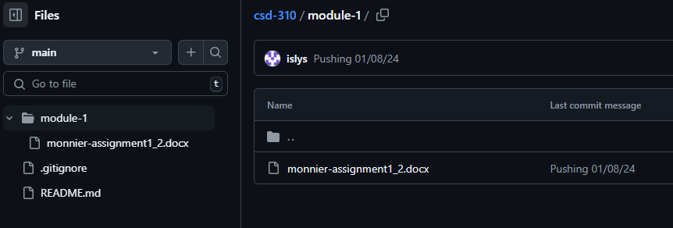

Screenshot of local directory:

