Ryan Monnier

CSD 325

Module 7 Assignment

16-Feb-2025

Github: <https://github.com/islys/csd-325>

1)

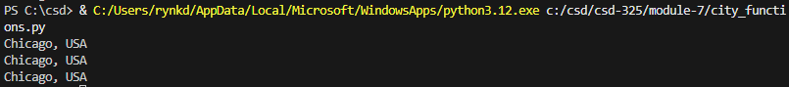

2)

3)

4)

5)

6)

7)

