Ryan Monnier

CSD 340

Module 5

2-April-2025

This is the general color pallet I intend to use for the bio site:

As for the style guide,

Headers:

I intend to have the main title of my bio person’s name as an h1 heading, and I think I’ll keep that persistent across the pages. The title or welcome message to each page will be h2 and if a title for the images ends up being necessary, I expect that I’ll use h3 to label them.

Links/Buttons:

I’m thinking that I can probably make buttons with the content of home/hobbies/about and use those as links to the various pages.

Text:

The bio in the ‘about’ page will be in paragraph form and wrapped with p tags

Lists:

The hobbies will be presented in an unordered list. The current plan is to have main bullets for the hobbies themselves and sub bullets for a little bit of information about the hobbies

If the Q/A is included in this project, that will be presented in an ordered list format where the questions are numbered and the answers are in sub bullets beneath them.

Wireframe for main page:

**Q/A:**

1. Can you tell me a little bit about yourself and your background?

I'm a 36-year-old woman in the Air Force. I was an Army brat growing up and moved around a lot, which exposed me to a lot of different places and people along the way. I went to college to become a teacher, but found I struggled too much with classroom management to be effective, so I joined the Air Force.

My first job in the Air Force was as a Korean Airborne Linguist, which required a year and a half dedicated to learning Korean followed by more job-specific training. I met my husband just after basic training, although we didn’t get to know each other until the first couple of months at the language school; he was training to become an Arabic Airborne Linguist.

We worked as linguists for a while (if you’re imagining it as exciting, it’s mostly not, sorry to disappoint) and got a dog together. Eventually we earned the opportunity to retrain into the Air Force’s Cyber career field and were selected for a competitive track with a long training pipeline. We got a second dog so our first angel dog would have a little demon sister, and then we decided to undertake Bellevue’s Software Design program to help supplement the skills we’re learning in the Air Force (and because I, personally, just have an interest in programming languages and web design).

1. Do you have any children? Pets?

We have two German Shepherds: Dizzy, who’s 6, and Zumi, who will be 2 soon. They’re both females and have surprisingly different personalities, but thankfully they get along well.

1. What are some of your most significant accomplishments, both personally and professionally?

When a work mentor introduced me to Microsoft’s Power Automate, I went on a self-teaching journey and became the guru of my work center, automating several important aspects of day-to-day workflow and leaving detailed documentation and guides behind when I moved on to train into Cyber.

Personally, in my mid-twenties I was proud to earn a black belt in Taekwondo, although I am years out of practice at this point. I also wrote a science fantasy novel, although I still have a lot of editing to do to achieve all of my goals for the book. I haven’t worked on it much in over a year because cyber and programming work take up so much of my creative drive, but I do hope to get back to it at least once I’m done with training.

1. What hobbies or activities are you passionate about, and why do you enjoy them?

Recently I have enjoyed indoor bouldering a lot because it is a puzzle and a workout in one. It feels very satisfying to figure out how to leverage my strength and skill to navigate challenging routes. I also enjoy playing board games with my husband and sometimes with other friends. I’m trying to get back into the habit of reading often, as well, because I think that will help rekindle my creativity for writing.

1. Can you describe any challenges or obstacles you've faced, and how you overcame them?

This questionnaire.

Jk.

I think one of the more challenging things I’ve faced was being let go after my first two years of teaching. It was what I’d gone to school for, and it was hard to imagine where to go from there. I really loved my taekwondo team at the time, so I wanted to stay in the area and continue to train and compete. I tried a handful of different jobs, including serving in a restaurant, substitute teaching, and a desk job assisting someone who negotiated purchasing contracts between tech companies and government agencies, but none of them really felt right. My car broke down and wasn’t worth more than parts, and between all of that and some romantic drama, I decided it was time to uproot myself and join the military to get a fresh start. It wasn’t easy, but I was fortunate enough to have my parents to fall back on while I went through the recruitment process, and everything has gone up from there.

1. What goals do you have for the future, and how are you planning to achieve them?

I want to finish revising my book, but that’s on the backburner for now. I would love to become a programmer and work on projects that interest me, such as software for language learning, creative writing, and education, and to that end I’m taking this course and going through my Air Force training. Combining these will give me a robust skillset and experience that I can apply to any projects that I seek out.

1. Is there a particular moment or experience in your life that has significantly shaped who you are today?

I suppose joining the Air Force, since it gave me needed stability and eventually led to me meeting my husband and finding a career path that I both enjoy and am good at. It’s also a challenging career; throughout my early life, I was usually one of the highest performing people in any given class or training (except physical things like sports), but as I have transitioned into this career field I have frequently found myself surrounded by such incredibly smart, talented, and hardworking people that I am usually middle-of-the-pack in performance, which has been a transition—but good for me!

1. How do you balance your personal life, hobbies, and professional responsibilities?

Do I?

It’s genuinely tough. My husband and I frequently wonder at how working parents juggle so much. We only have dogs and we find ourselves with an ever-mounting to-do list of “adulting.” But I suppose we prioritize the most important things, because we’re holding it together. It’s a balance that sometimes means we don’t vacuum for way too long considering we have German Shepherds… but the stability of the Air Force has afforded us the ability to save money, and we’re fortunate to be in a training environment that trusts us to be flexible with our time where needed as long as we’re getting everything that we need to done.

Honestly, two of our biggest “lifehacks” are having friends who are interested in coming over to play board games occasionally and having a dog walker come by at lunch to walk the dogs. Both of these things give us the kick in the rear we need to stay a little more on top of cleaning, which is probably what we have the hardest time keeping up with normally.

1. What would you consider your greatest strength, and how has it helped you in your career or personal life?

I tend toward positivity and being pretty laid-back as a person, which I think have really helped me to manage stress throughout my life. When times get hard, I know some people quickly lose sight of the bigger picture and memories of brighter days, but I have an easier time holding onto those things and putting the challenges I’m facing into perspective.

1. If you could give a version of yourself from 10 years ago a piece of advice or wisdom, what would it be?

I wouldn’t. I’m pretty happy with where I am in life, and I wouldn’t want to steer myself wrong with a bit of well-meaning advice that I didn’t have the context to appreciate at the time.

**About:**

Jessica is a 36-year-old Air Force member with a diverse background and a passion for technology. Growing up as an "Army brat," she moved frequently, gaining exposure to different cultures and experiences. She initially pursued a career in teaching, but after struggling with classroom management, she decided to join the Air Force, where her career took a new direction.

Starting out as a Korean Airborne Linguist, Jessica spent a year and a half learning the language, followed by additional specialized training. After a few years, she and her husband retrained into the Cyber career field, which sparked her interest in technology and software development. She is currently pursuing a software design program at Bellevue to further her skills in web design and programming languages.

Outside of her professional life, Jessica enjoys spending time with her two German Shepherds, Dizzy and Zumi, who keep her on her toes with their contrasting personalities. She also enjoys indoor bouldering, which she finds to be both a physical challenge and a mental puzzle, and playing board games with her husband and friends.

One of the defining moments in Jessica’s life came when she transitioned from teaching to the military. After being let go from her teaching job, she was uncertain about her future. Joining the Air Force provided her with stability and a fresh start, and it ultimately led her to meet her husband. This experience, while challenging, set the foundation for her growth both personally and professionally.

Throughout her career, Jessica has achieved several milestones she’s proud of. She became the go-to person for automating workflow in her work center using Microsoft’s Power Automate and earned a black belt in Taekwondo in her mid-twenties. While she’s currently focused on her career in Cyber and programming, she’s also working on revising a science fantasy novel—a project she plans to revisit once her training is complete.

Jessica’s goal is to become a programmer, working on projects that combine her interests in technology, language, and education. She envisions creating software for language learning, creative writing, and educational tools. With her ongoing training and a passion for learning, she’s building a future that blends her skills with her personal passions.

Balancing work, life, and hobbies isn’t always easy, but Jessica embraces it with a laid-back attitude and a focus on prioritizing what matters. Whether it’s managing her professional responsibilities or enjoying downtime with her dogs and husband, Jessica stays positive and focused on her long-term goals.

Hobbies Photos:

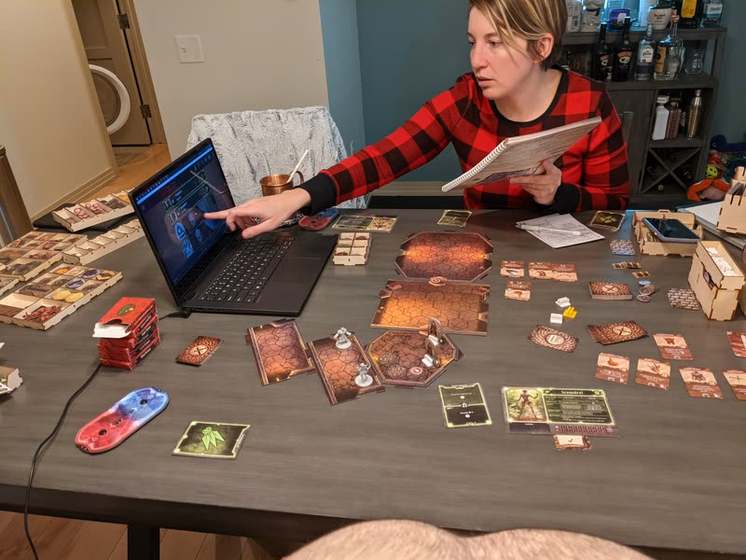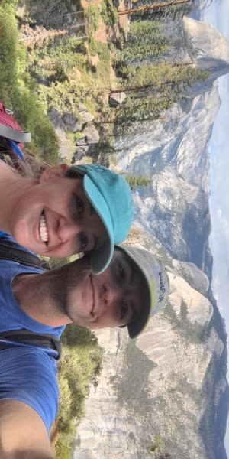

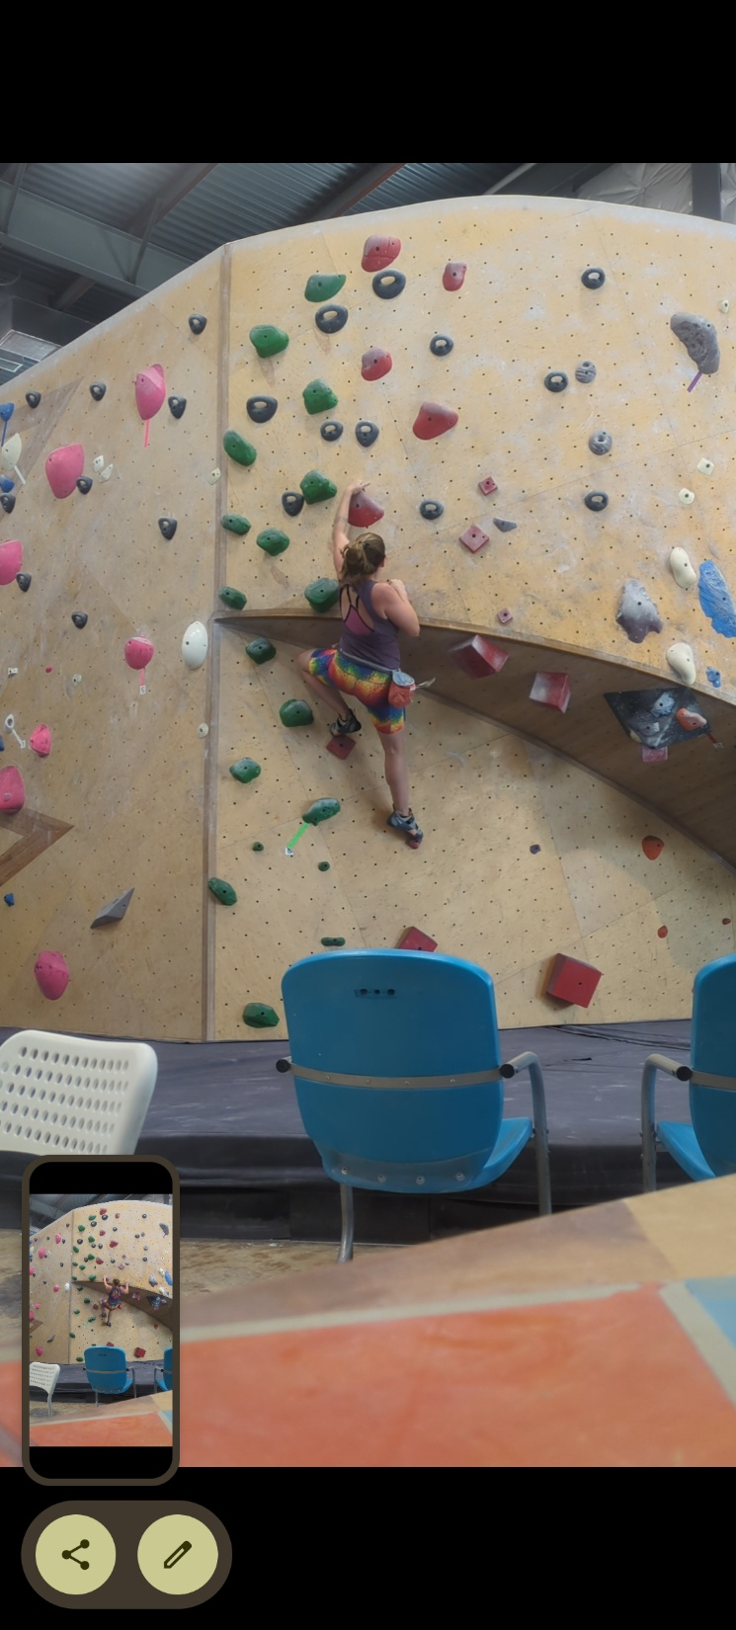

Life/Family/Job photos:

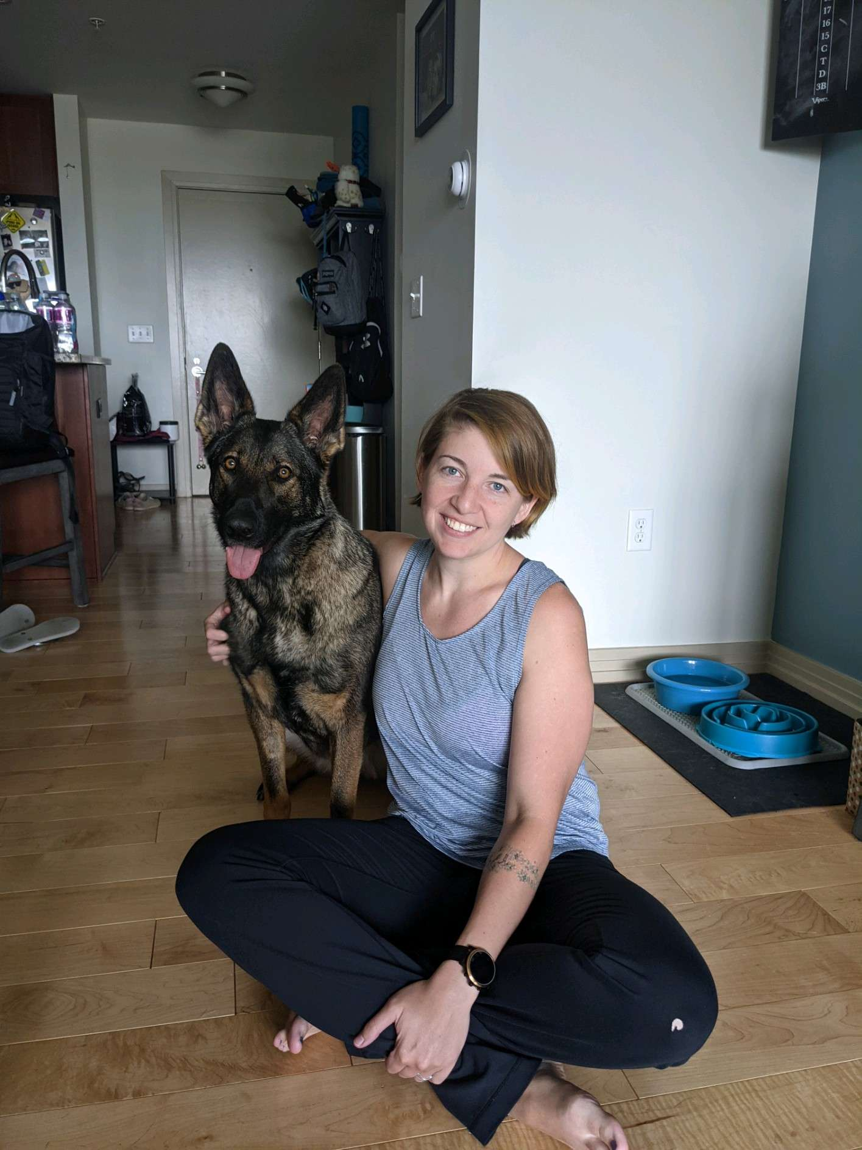



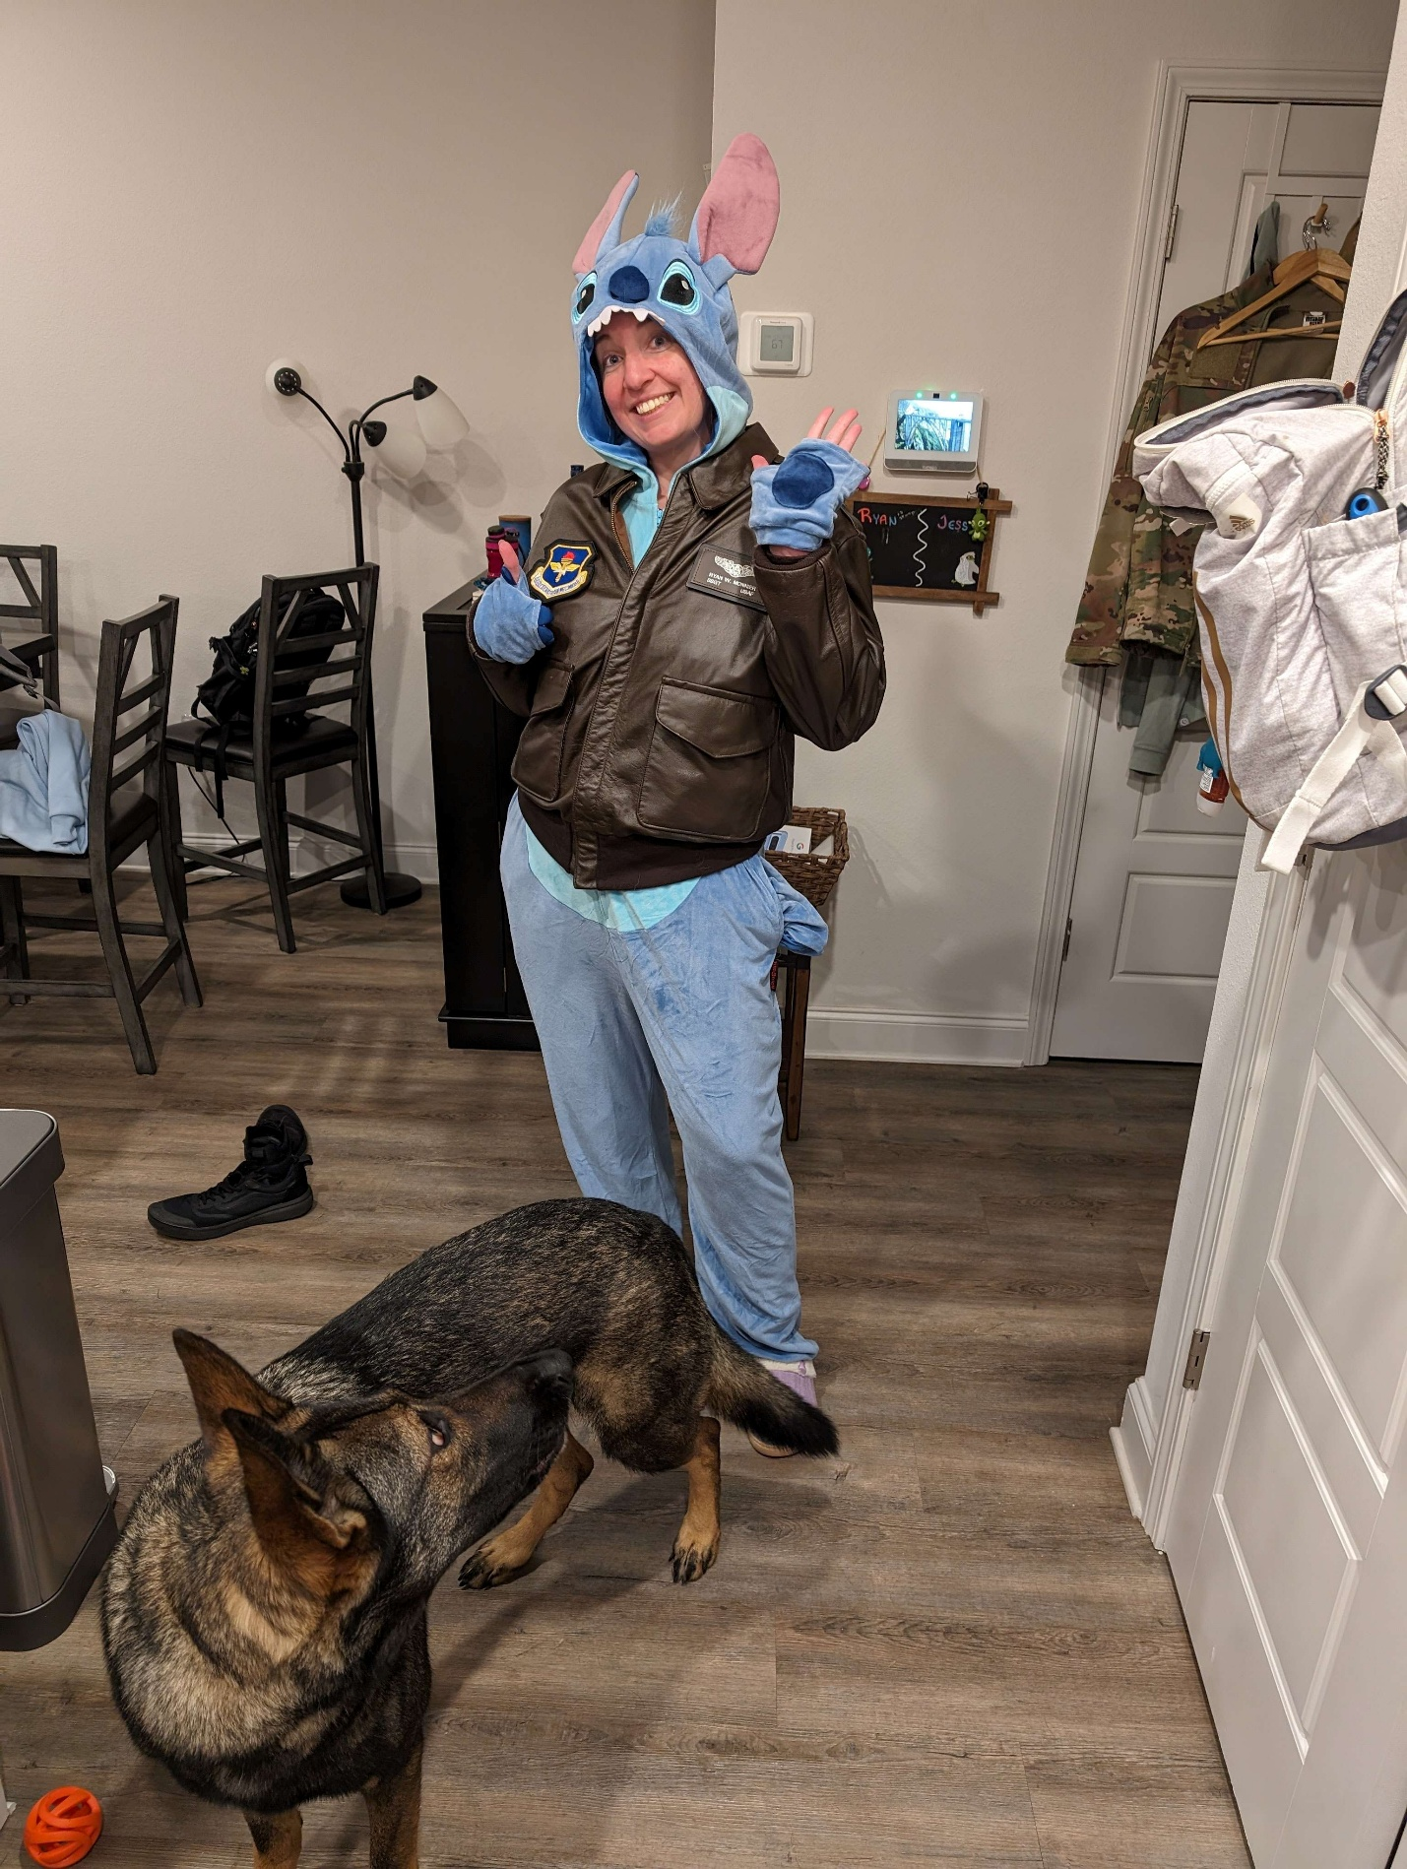

Portrait:

