Ryan Monnier

CSD 440

Module 1

26-Oct-2025

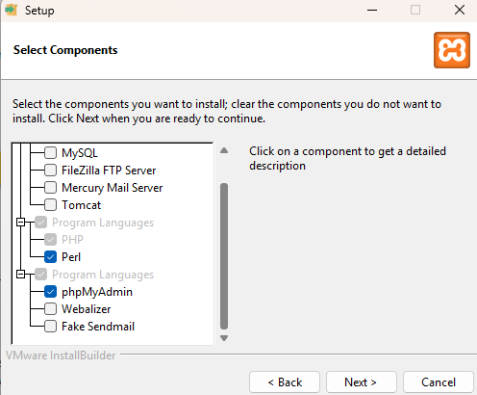

My first PHP script:

