ism0080

Christchurch Polytechnic Institute of Technology

Great Art

Website specification

# Overview

The overall purpose of the website is to share Hubert Humperdink’s art collection with the world. It will contain, home page, artist information (Wassily Kandinsky), a gallery page, 4 art pages, contact us, a blog and about us.

# Client Details

Hubert Humperdink - Great Art was started by Hubert Humperdinck when he was a schoolboy in Nelson in 1975, although it didn't have a name then. Hubert had an art teacher who would regularly bring artworks to school to show the pupils. The teacher would talk passionately about the different pieces of art. Hubert was hooked. He started to look around for artworks to collect for himself. In 1999 Hubert decided to make art collecting his main focus. He established his company, Great Art, and has been collecting art full-time ever since. Currently, he has hundreds of pieces of art, including many that are considered to be significant works. The idea came to him that it would be wonderful to be able to share his artworks with people from around the world, so he wants to start a website, which showcases the art he has collected.

# Goals

Hubert Humperdink’s main goal is to share art digitally with the world. There needs to be a mixture of images and text to give exposure of a range of artists which includes information such as: what they did, their paintings, etc…

# Objectives

1. The user needs the ability to submit information to a ‘contact us’ form.
2. The user is able to find out more information about a specific artist’s work.

# Target Audience

The target audience is quite general but is aimed mostly towards anyone interested in art from age of 13+. The website could also be useful for research projects so therefore targeted to anyone doing a project to do with art as well as just anyone wanting to know more about the art/artists and to see examples of artwork. His hobbies include painting, family, biking and playing piano.

# Personas

**Nigel Thornberry** – is a 32yr old family man that lives in Timaru, NZ. He has two children and works as an art teacher at the local high school. He really enjoys his contemporary era art and during his free time will paint whatever he can to get better at his passion.

**Thea Stark –** is a 13yr old first year high school student that lives in Wellington, NZ. She has never really had much experience with art but is quite enjoying her art class and wants to learn more. Her hobbies include football, basketball, singing, running and socialising with friends.

# Domain Name



*great-art.org.nz* is available at the cost of $19.99 a year.

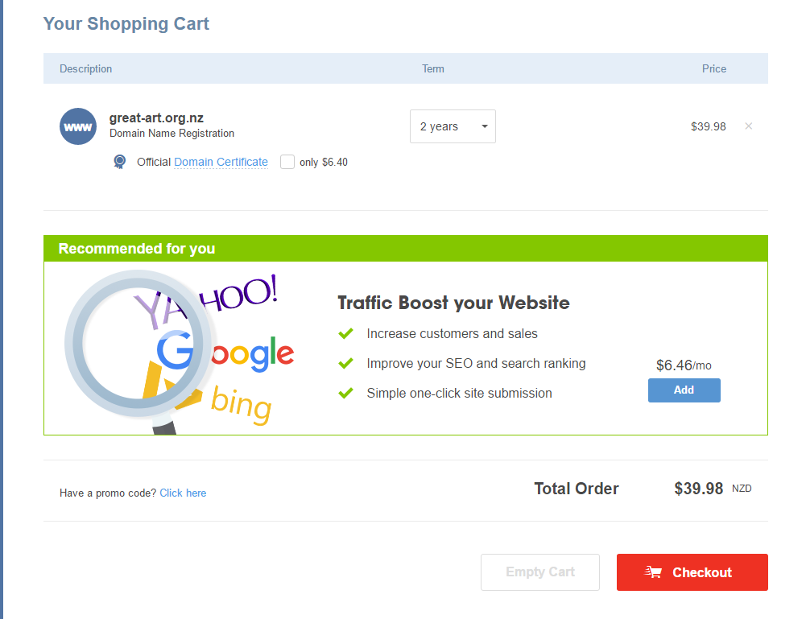

# Hosting

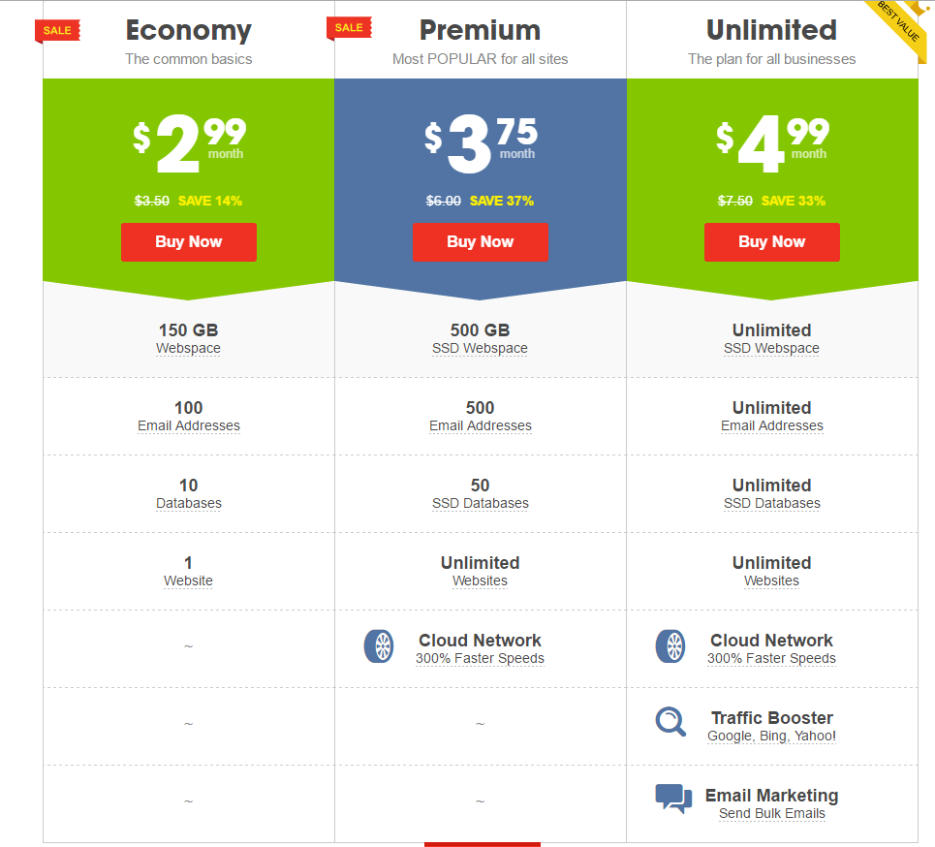Webhosting is for uploading all the files needed to display the website. The first option with [www.crazydomains.co.nz](http://www.crazydomains.co.nz). They have 3 different plans depending on the needs and whether the client wishes to future proof their website or just start small and think about big later.

The second is [www.webdrive.co.nz](http://www.webdrive.co.nz). This also has different plans depending on the needs.

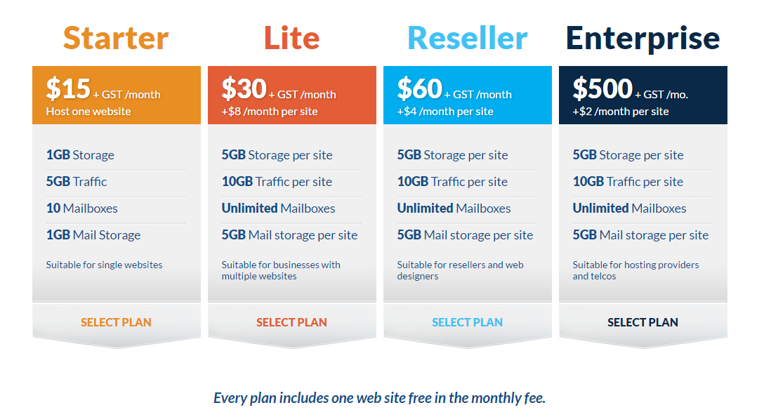Both plans are fairly similar the main difference is cost.

# Website Structure

* Home Page
* About Us
* Contact Us
* Gallery Page (roughly 10-12 images)
* 4 pages for specific paintings
* A blog page (not a real one – can’t create blog articles, just looks like a blog page with 3 or 4 articles on it)
* Artist Information (Info about artist - Wassily Kandinsky)

Total of 10 pages, newsletter sign up (not its own page necessarily)

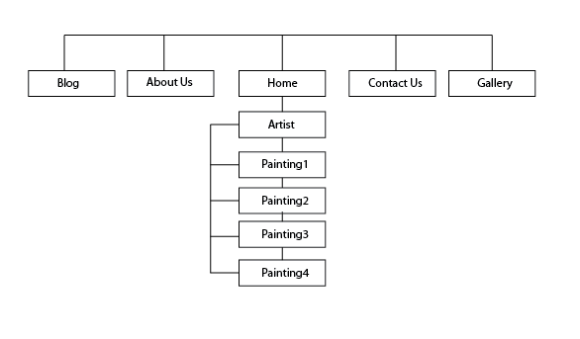

# User Interaction

The user should come to a home page with information about the site and content. 'Contact us' form, submitted by email, and ability to give feedback on the site. A newsletter subscription should also be present, informing of updates and additions to the site. The site will be accessible as referred to the site map.

I will do this by creating the website so that it is easy to navigate. This is done with easy to understand headings and use of a navigation bar with drop down menu. The homepage will be the default page.

# Website Content

Relevant content related to the artists.   
It is preferable to have Facebook liking/sharing enabled. Also Instagram features enabled as well.  
Provided by client - content about the company (about us).  
Provided by us - content about the artist (not too long, but substantial), content about the artwork.  
No specific. Clearly indicate the contents of the webpage and the company. Hopefully will attract more people.(Information on homepage)  
‘About Us’ Info supplied by the client

# Design

**Home Page**

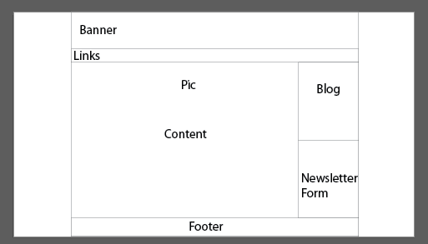Desktop

Mobile

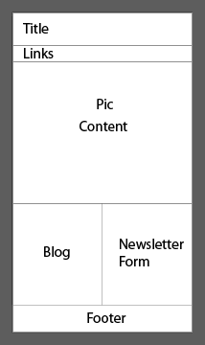

**Art Page**

Desktop

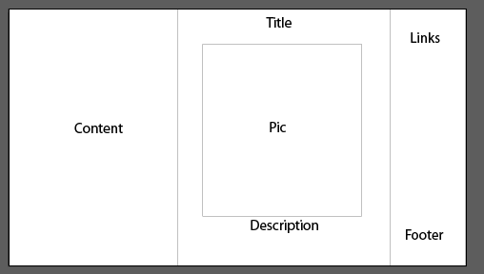

Mobile

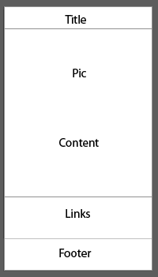

# Search Engine Optimisation

According to Googles own SEO PDF, some good techniques to implement into the website are:

1. Create unique, accurate page titles. Using title tags. Brief, but descriptive.
2. Use the ‘Description’ meta tag. Accurately summarize the page’s content using keywords.
3. Have a simple directory structure.
4. Easy site navigation
5. Have links to your website through other sites, such as a directory site.

# Timeline

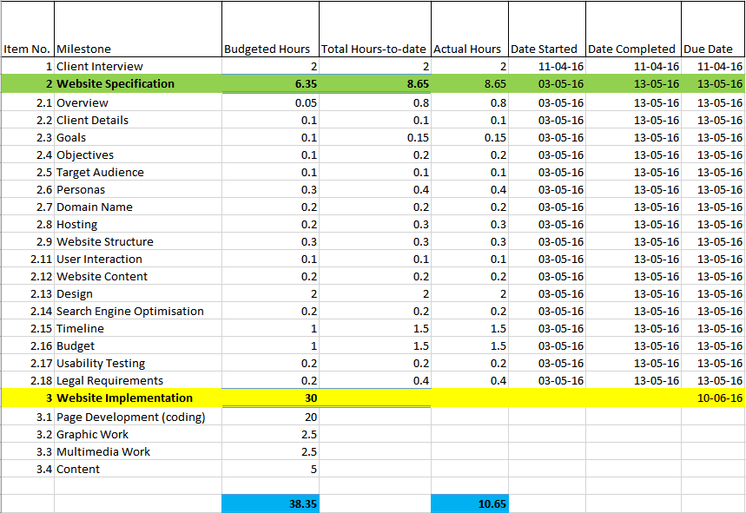

# Budget

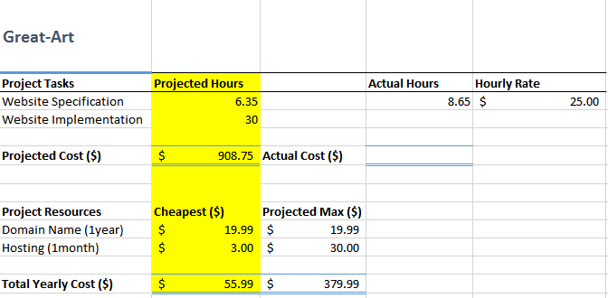

# Usability Testing

1. “Can you submit a ‘Contact Us’ form?” Note issues, if any, then resolve to make easy to use if any problems
2. “Can you navigate the site?” Tell them to go to a specific page then see if they can get there/ how long it takes.
3. “Can you subscribe to the newsletter?” Tell them to subscribe to the newsletter then see if they receive an email.

# Legal Requirements

(a)Copyright

Copyright will be under the ‘Great Art’ Company but any content that is published on the website, artist owns this. Users will be able to use content according to the copyright act. Be using a creative commons licence.

“A CLNZ Commercial Licence enables your business to:

* Gain advanced permission from publishers to copy, scan and share their work
* Minimise the risk of copyright infringement
* Maximise your current and any future resources

The CLNZ Commercial Licence is a time-saving and cost-effective way of securing instant permission, in advance, to photocopy from published material including books, journals and magazines. Not only does it give you increased legal protection but you also gain the assurance that the copyright owners will be paid when their work is copied.” *(http://www.copyright.co.nz/Licensing/Commercial/)*

(b)Privacy

There will be a ‘terms and conditions’ file that will be available to read before submitting to the form. It will basically say that ‘Great Art’ is able to use the information provided to get in contact with the user via email so that they can receive the email. There personal information will not be leaked or sold to advert companies.