

**School Automation Software**





**Winceron Software Technologies Pvt. Ltd.**

**Bangalore**



**About Us**

**Who Are We**

## ***Winceron*** *is providing IT solutions for different major educational segments since 2000.*

*Our niche and expertise in the education segment makes us the best qualified vendor for customized software development or IT Solutions for Schools and Colleges.*

*Apart from the Technical Skills,* ***Winceron*** *would provide IT consulting and recommendations to improve the existing administrative and management process.*

*Our areas of expertise include consultation, system analysis, design, development and support of software applications.*

*Our solutions are designed for dynamic environment, where business and technology strategies congregate.*

*Our Flagship* ***WINER*** *Software is used by different Educational institutions in India. We provide Customized as well as ready made products for school and colleges*

**WinEr Campus :** A complete campus management solution.

**WinEr School ERP :** A complete school management software.





**Major Benefits for school**

### Efficiency

Teaching staffs in many of the institutions are spending more time in non teaching jobs than teaching jobs. By using WinER, efficiency of teaching and non teaching staffs can be improved.

Following are few of the tasks in which efficiency can be improved

|  |  |
| --- | --- |
| **Teaching tasks** | **Non Teaching tasks** |
| Generation of mark cards. | Admission management |
| Promotion List and other consolidated reports | Fee collection and reports |
| Attendance marking and reports. | TC generation and record  maintenance |
| Student analysis and reporting's | Staff Performance analysis. |

### Faster Communications

Communication between school, parents and staff can be improved by using SMS mechanism. Circulars can be delivered to teaching staff, non teaching staff and parents in less than a minute.

Following are some other automated SMS communications possible using WinER

* Sending of exam result as SMS.
* Fee Reminders as SMS.
* Fee Bill Confirmation.
* Auto absent notification to parents.

### Security

More secure than manual record keeping mechanism. Un authorized users cannot access confidential data. Every actions can be traceable to the exact user.

### Better Control and Organized Record keeping

By using WinER, records can be organized effectively and reduce duplicate records.

WinER provides better control over the administration process.



**Complete School Management**

Parents

* Online Admission Request
* Parent Login
* Online Fee Payment
* SMS & Email Alerts
* 360 Degree Student Details

# Administration

#### Fee Management

* Inventory & Asset Management
* Staff Payroll
* Transportation Management
* Library Management
* Hostel/Boarding Management
* School Website & Announcements
* Alumni

Academics

* + Admission
  + Student Record Management
  + Time Table Generation
  + Exam management
  + Knowledge reporting
  + Grading and Rating
  + Promotion Management
  + Attendance Management

**Admission** Enquiry Registration

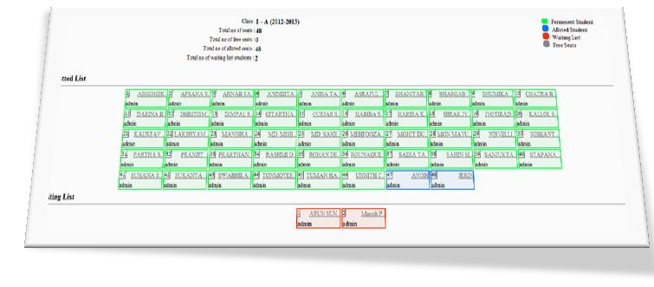

Ranking of students Seat Allotment

Joining Fees

Enroll Student

Multi level Approval

**Student Manager**

**Staff Manager**

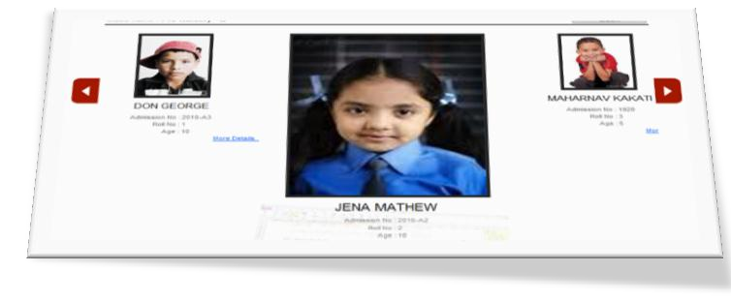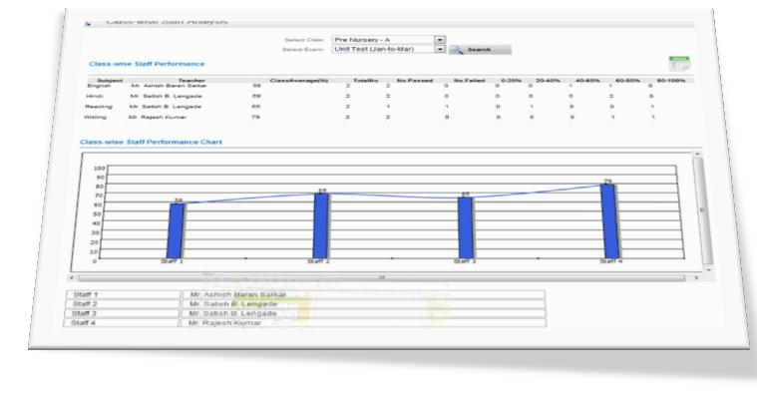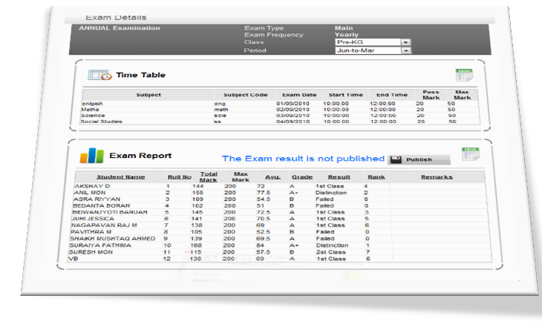

Cancel Enrollment Transfer Certificate

Search

Create Staff Assign Subjects Resignation

Performance Analysis

Search

Collect Fees Due Reports Paid Reports Forecasting Fee Rules

Bank Clearance

Schedule Exams Mark Entry

Report Generation

Publish as SMS

Half day/Full day marking

**Fee Manager**

**Exam Manager**

**Attendance**

Auto SMS to parents



Class / student wise report





[www.winceron.com](http://www.winceron.com/)



**Major Features**

**Class Manager**

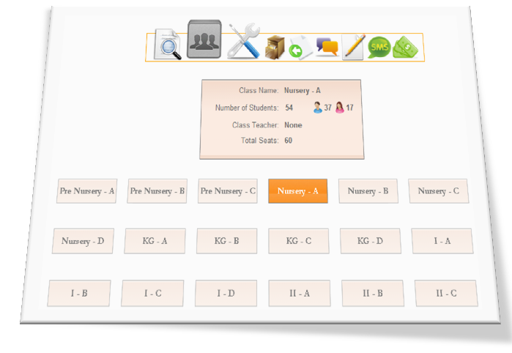

Class wise reports Change Division

Add or remove divisions

Import/Export student

Create Promotion list Manual Promotion

Auto Promotion

**Promotion**

**SMS Manager**

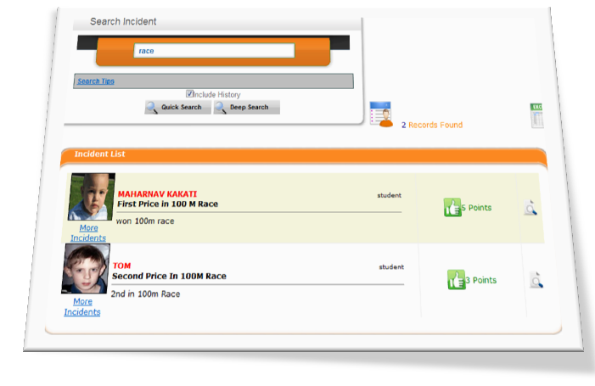

Circulars to Staff

Class wise SMS to Parents Auto SMS configuration Fee reminder SMS

Academic Achievements

Extra- curricular Achievements

**Knowledge Reporting**

**Student Rating**

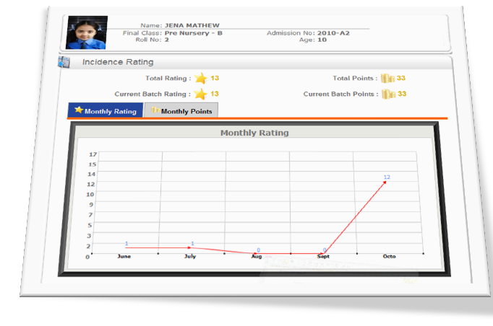

Medical Reporting

Auto rating based on Knowledge reports.

Manual rating.

Monthly School Rating reports

**Time Table**

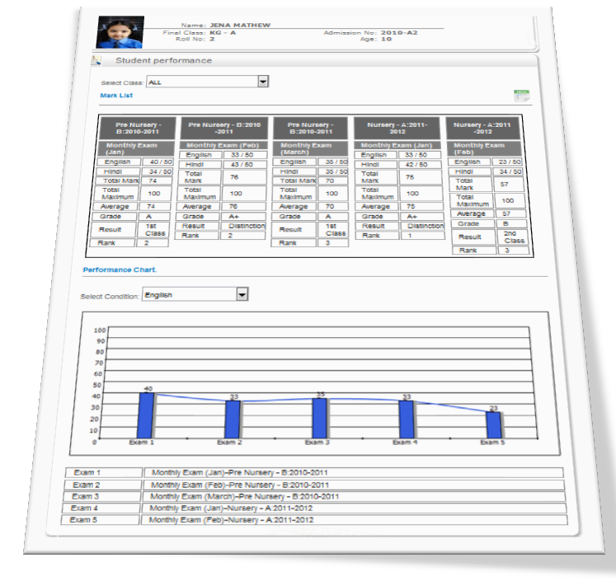

Manual/Auto Generation Class wise reports

Staff wise reports Staff Allotment SMS

Staff workload and warnings

Payslip generation

Salary paid/payable reports TDS/PF reports

Salary setting and Approval

**Payroll**

**Parent Login**

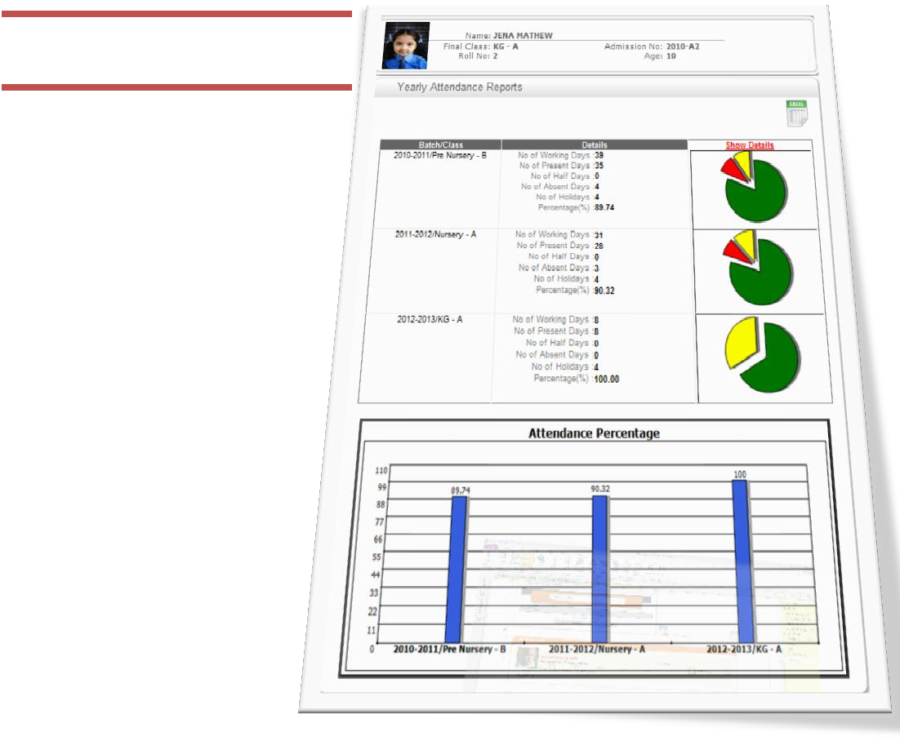

Fee details Exam Details Attendance

Other Disciplinary details



**Benefits for School**

**Security of students , Inside and out of school .**

*By using access card and SMS Security of students are improved.*

**Academic performance management.**

*System provide graphical and comparative reports on academic performance . Students and staff can be analyzed based on this.*

**Communication with parents.**

*By using SMS and Online Parent Login the communication between school and parents improves*

**Progress Card generations.**

*We provide Data entry operators for entering the Mark to the software and the progress card is auto generated.*

**Attendance management, Identification of late comers.**

*By using automated attendance management , every class teachers can save at least 5-10 minutes by not taking the attendance.*

**Fees Management.**

*Fees dues are generated automatically and can be send as SMS reminders.*

**Time table generation.**

*Time table generation can be automated using the software. Easily track the work load of teachers and auto replacement of alternate teachers.*

**Staff attendance and Leave management.**

*Staff Attendance and Leaves can be monitored .*

**IT Automation and administration.**

*We provide support in configuration and setting of the IT Solution.*

**Management analysis and reporting.**

*Any type of reports can be generated in a span of seconds .*



**Benefits for Parents**

**Security of the child , reaching class on time and returning on time .** *When ever student reach school premise , an SMS will go to parent with the In Time details . On exit another SMS will go with Exit Time.*

**Avoiding of class bunking and any other malpractices.**

*In case of student absent or late for multiple days , disciplinary reminder SMS will reach parent.*

**Performance in the academics .**

*Graphical Analysis and comparative progress card is generated and send to parents. Also Results are published in Online Web portals and as SMS.*

**Medical or health related issues.**

*Any medical or health related issues are tracked in the system and is communicated to parents through SMS ,Web or along with Progress report.*

**Performance of other activities, such as sports, arts, games etc.**

*Extra curricular activities are tracked and are give special points apart from*

*academics. Parents can monitor this through online.*

**Real-time monitoring of the student activities .**

*At any point of time , parents can login to online portal and check students , Fee , Exam, Attendance, Extra curricular activities etc.*

The Arrow of Improvement

through **WINER**

Improve in

Overall efficiency

Better control and performance monitoring of resources.

Faster Communication

Better data security than manual process.

Improvement in overall management of organization process

[www.winceron.com](http://www.winceron.com/)