Name: | Class:

Write the words. Score / 5

b ook 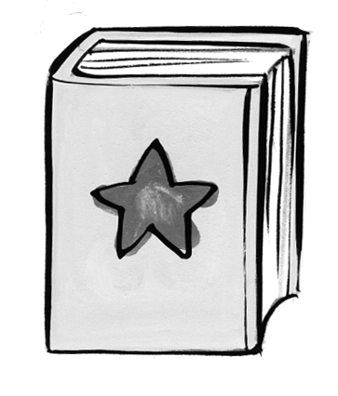 t _ ble 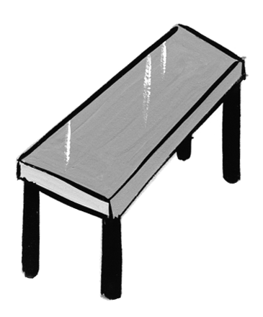

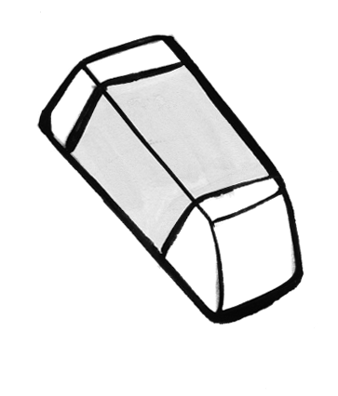
_ en 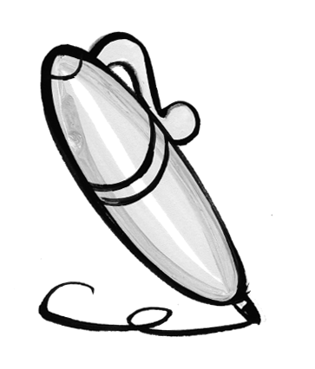 era _ er

cha _ r 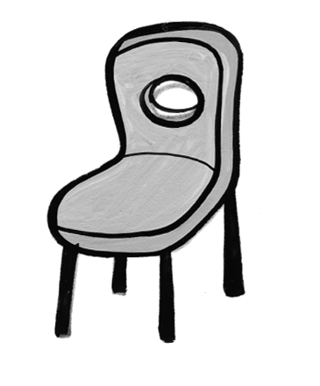 cray _ n 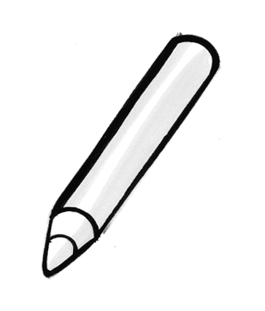


Listen and match. Score / 5
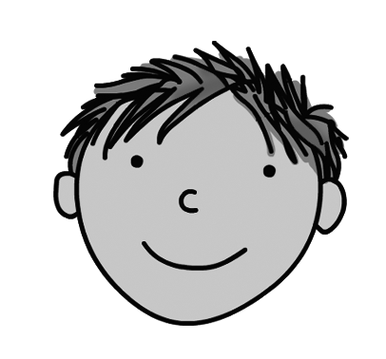
Hello. I’m fine, thank you.
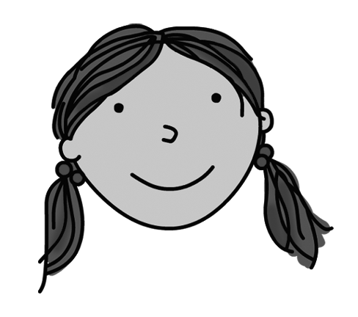
What’s your name? Hello.

Who’s that? I’m eight.

Goodbye. Goodbye.

How old are you? That’s Ben.

How are you? I’m Sarah.

Total unit score / 10

