Name: | Class:

Write. Score / 5

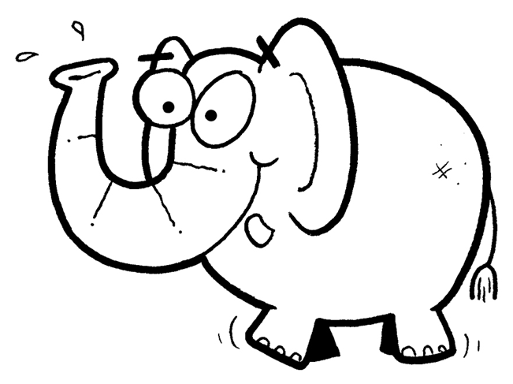
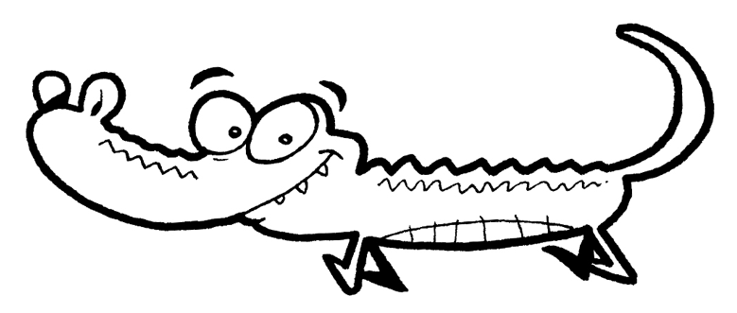
c r o c o d i l e _ _ _ _ _ _ _ _
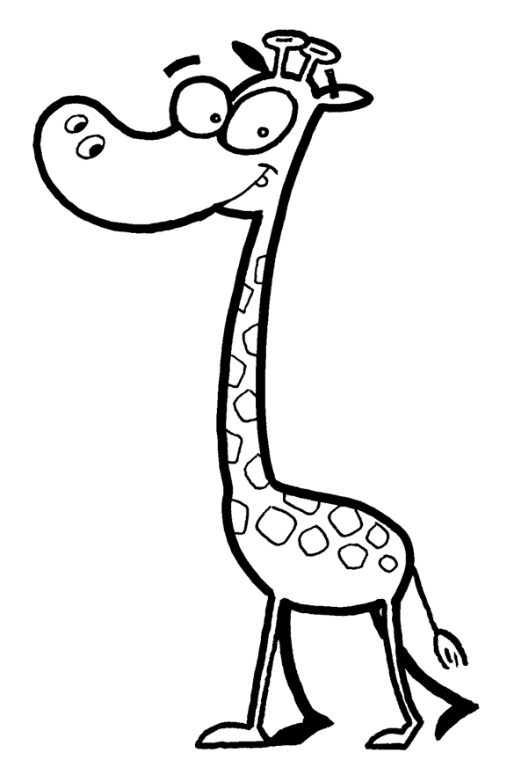

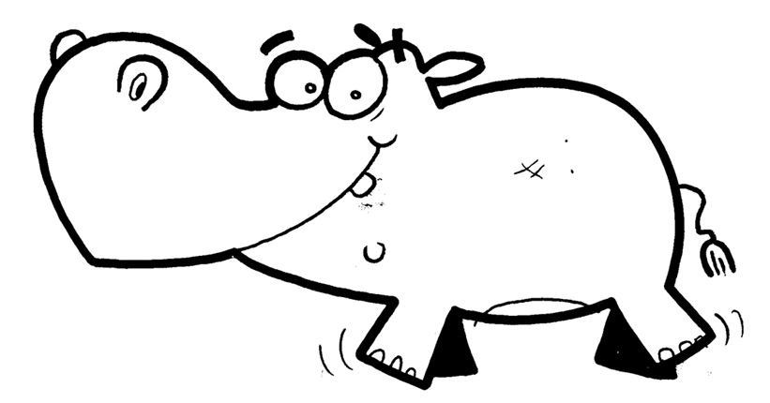
_ _ _ _ _ _ _ _ _ _ _ _

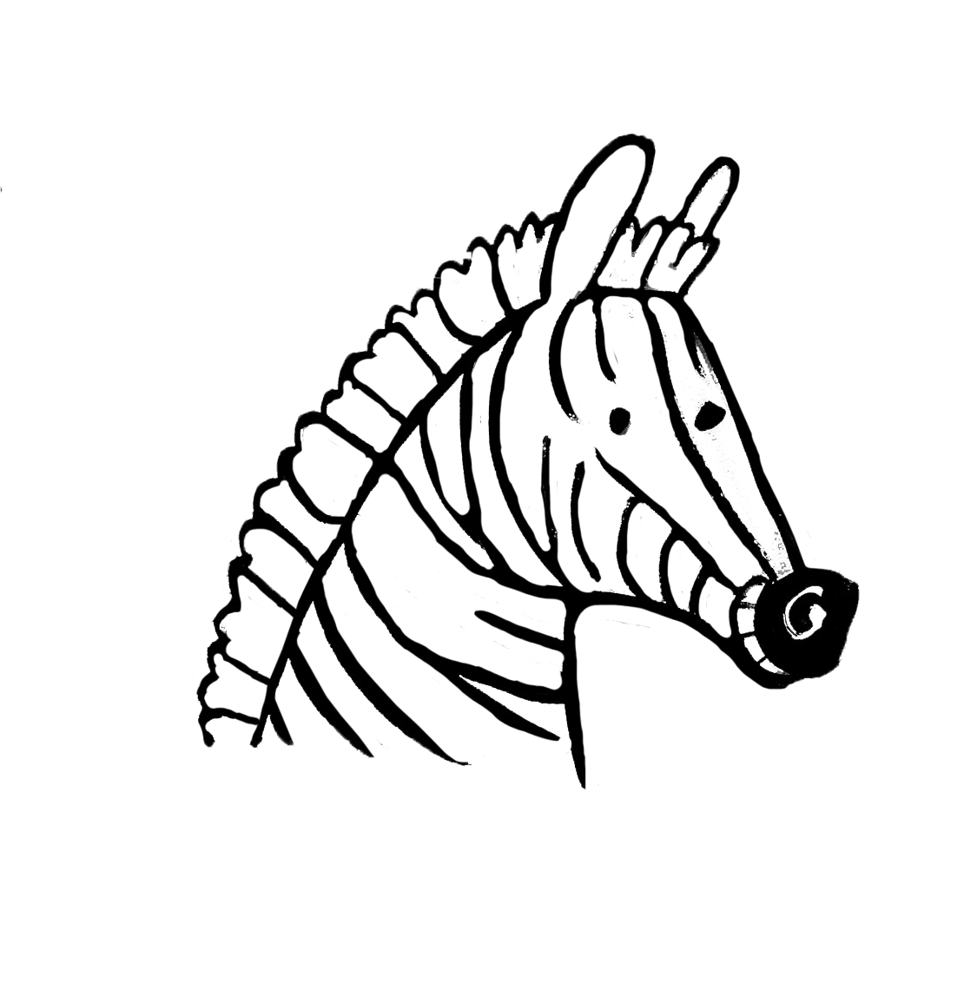
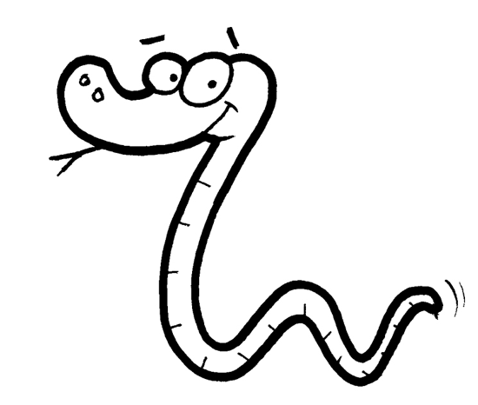

_ _ _ _ _ _ _ _ _ _

Look and circle. Score / 5

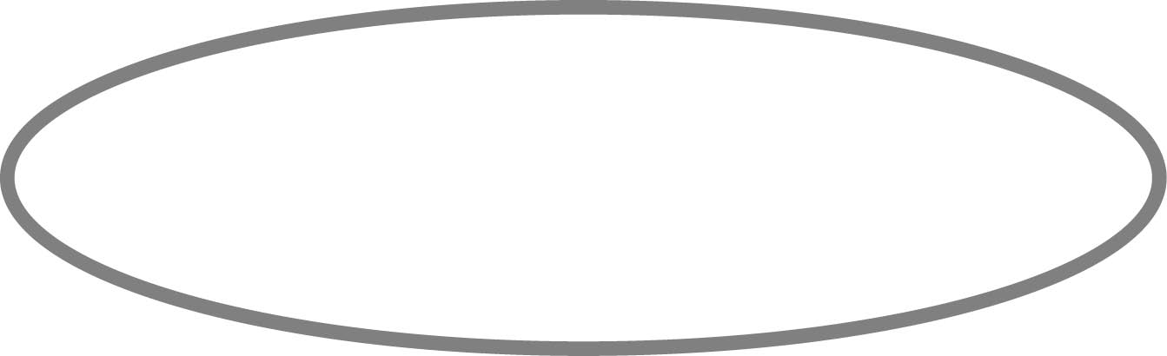
They have / don’t have hands. They have / don’t have feet.
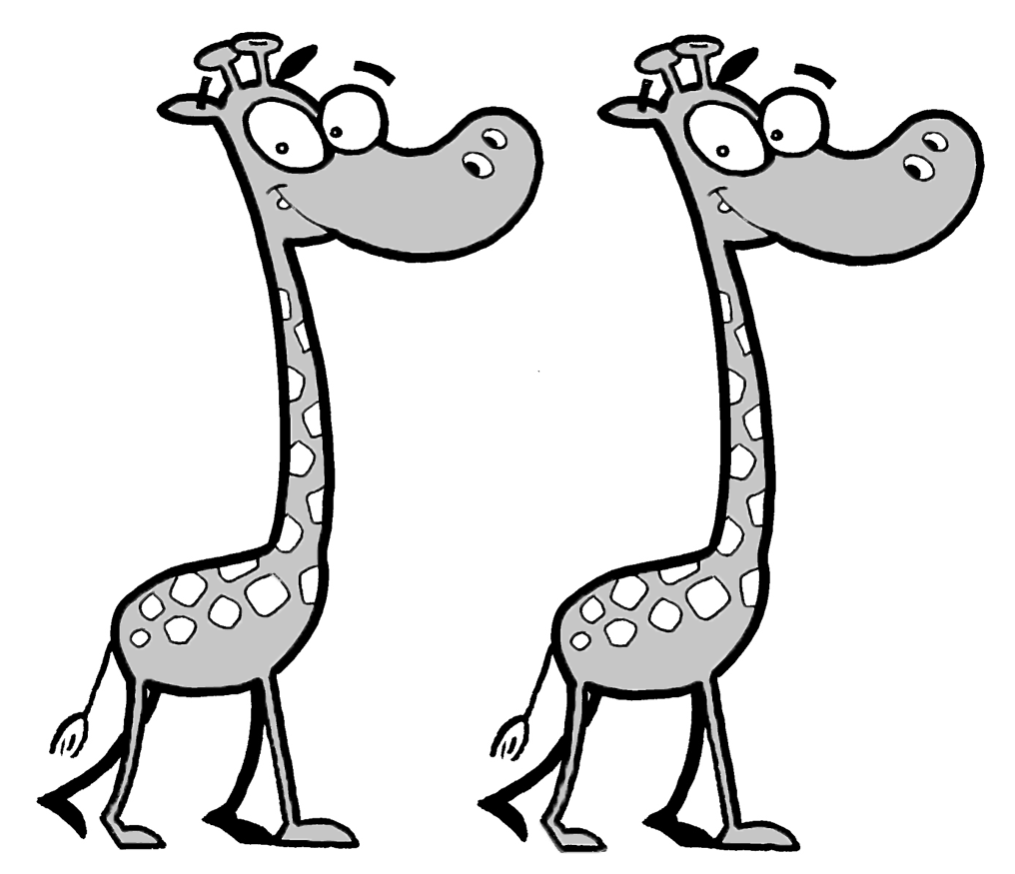
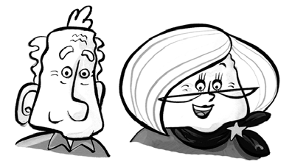

They have / don’t have teeth. They have / don’t have legs.
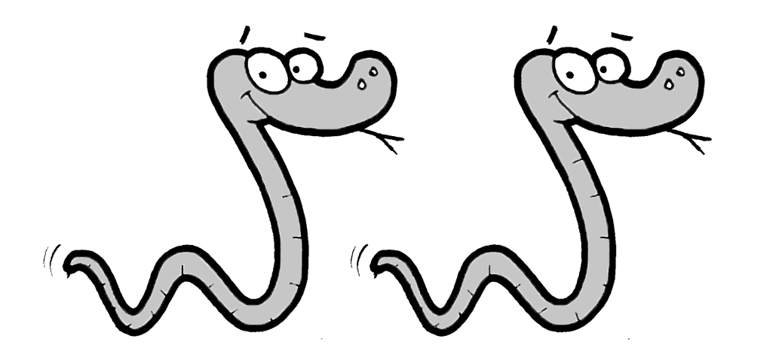
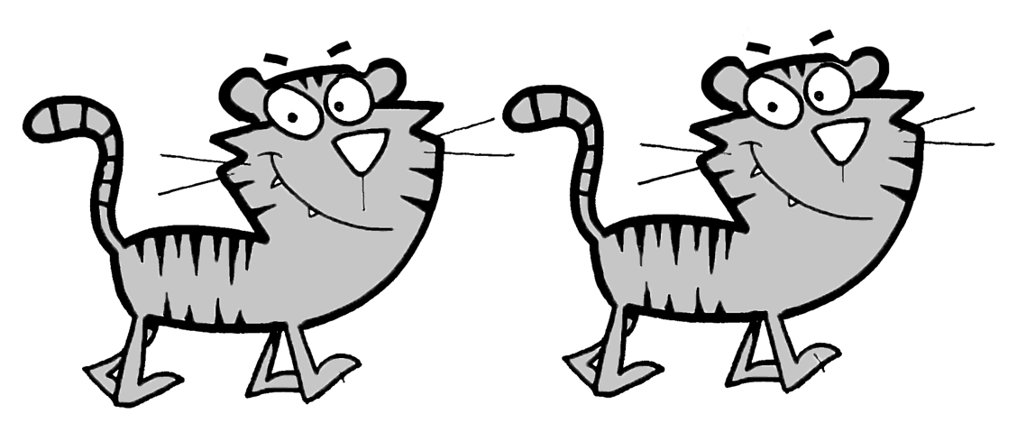

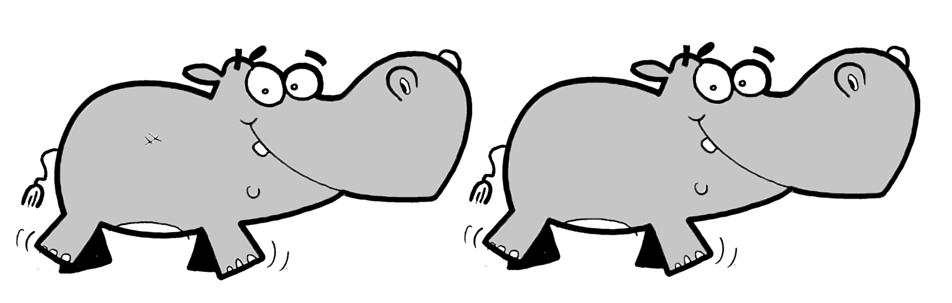
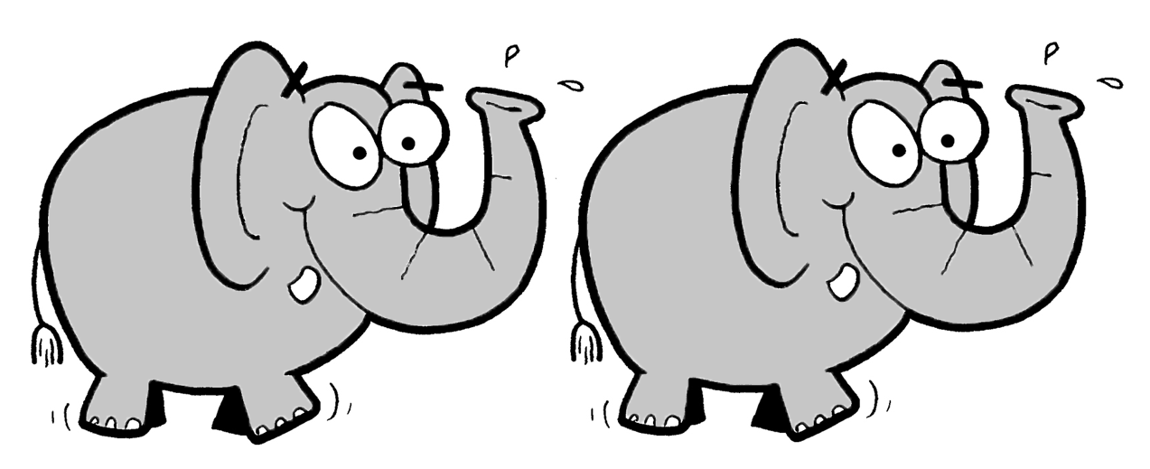
They have / don’t have arms. They have / don’t have tails.

Total unit score / 10

