Name: | Class:

Look and draw lines. Score / 5

bedroom kitchen dining room living room bathroom hallway

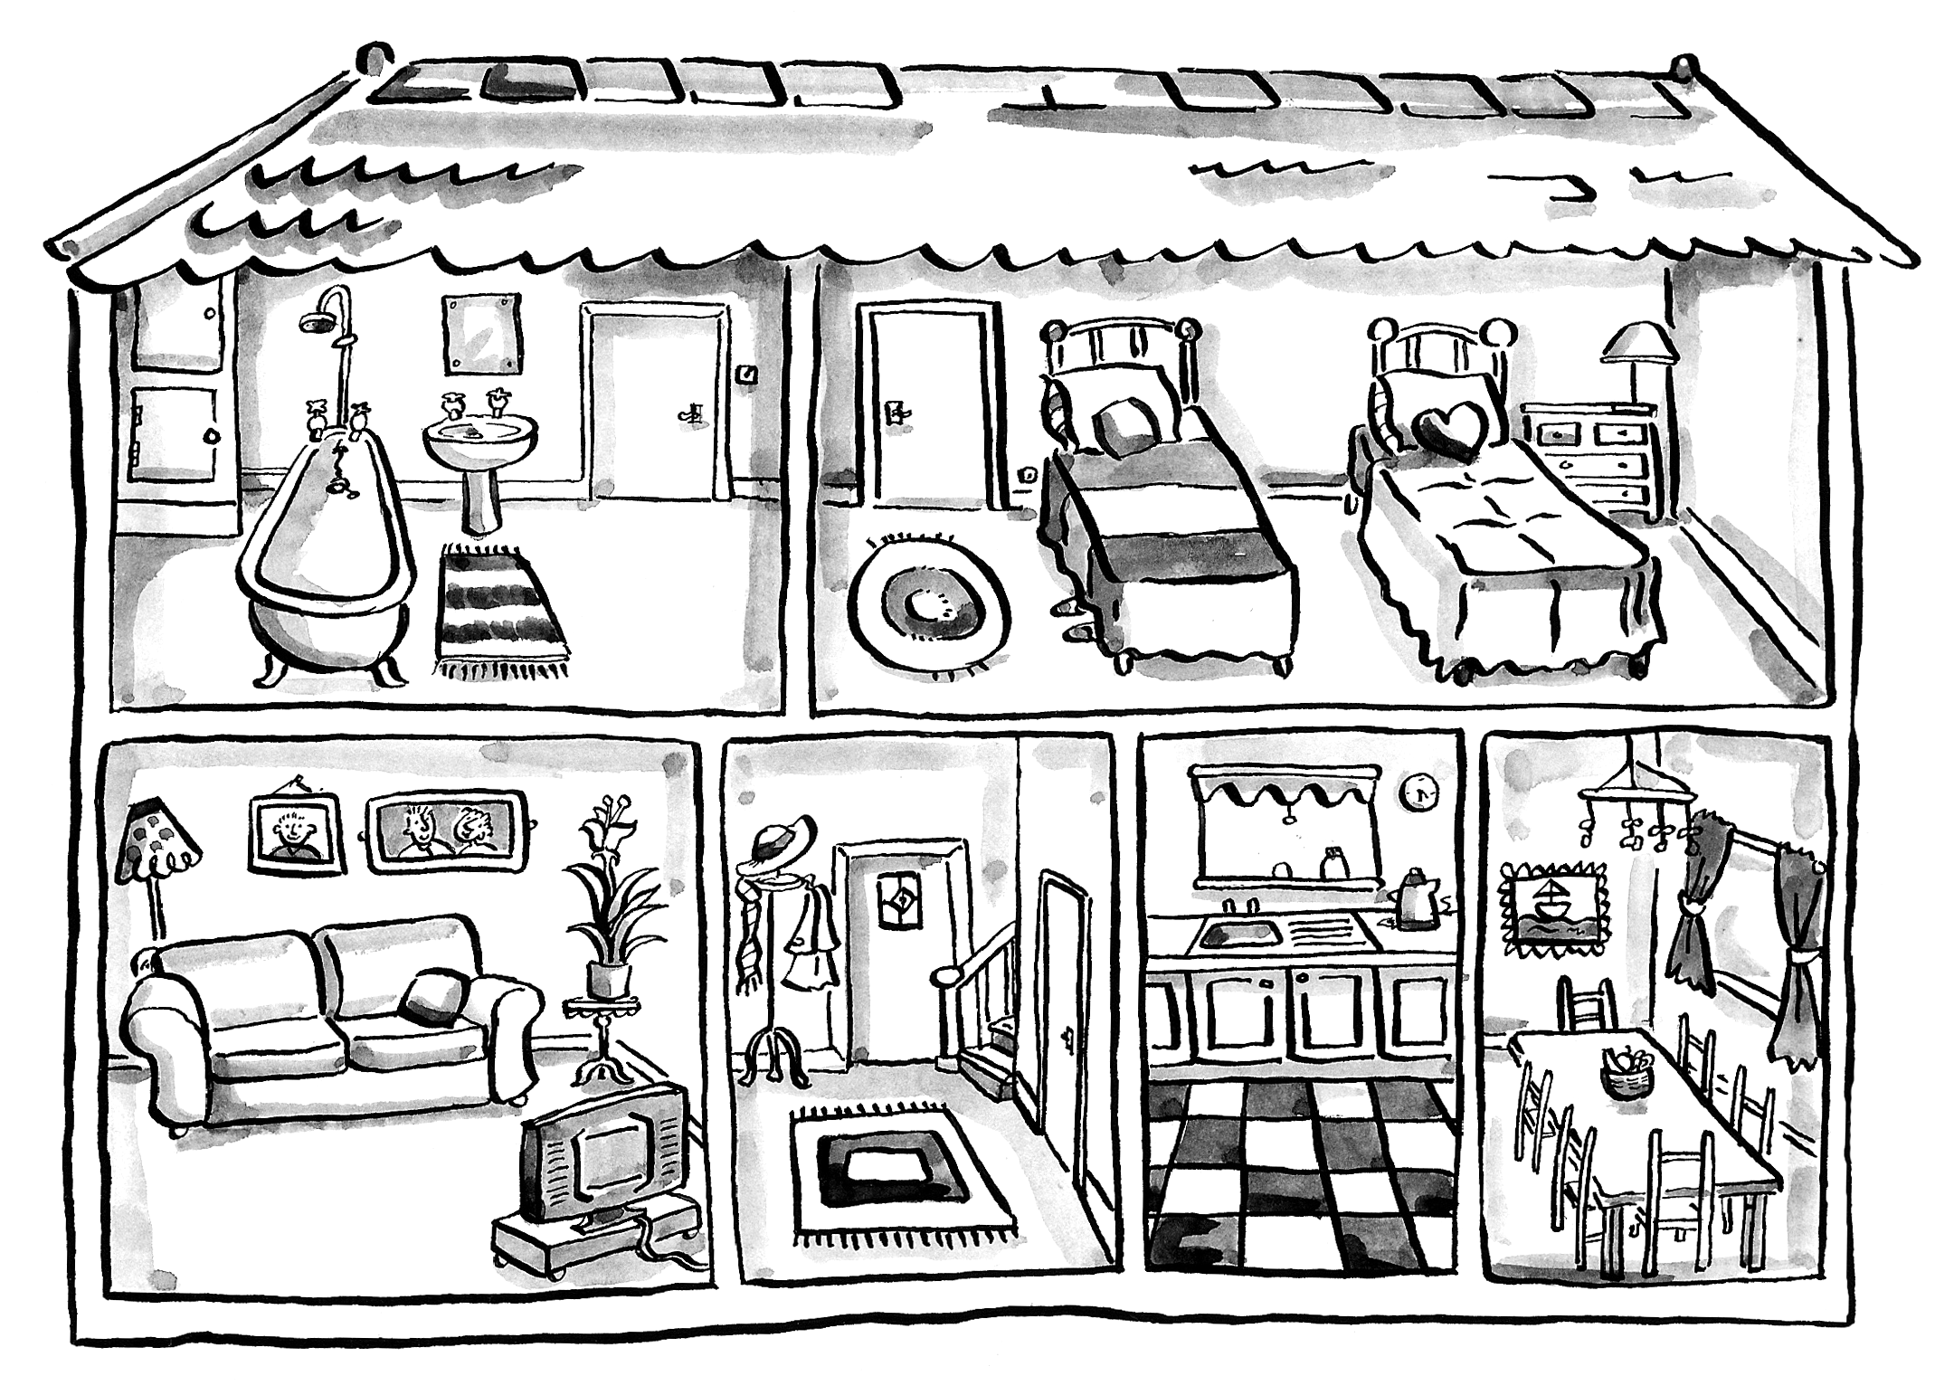

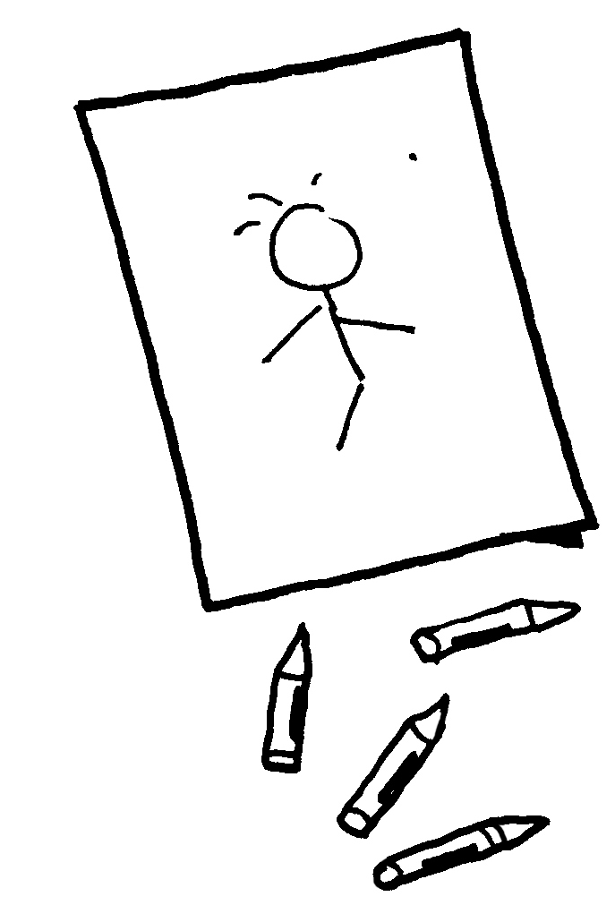
Order and write. Score / 5


drawing / He’s / a / picture. He’s drawing a picture.

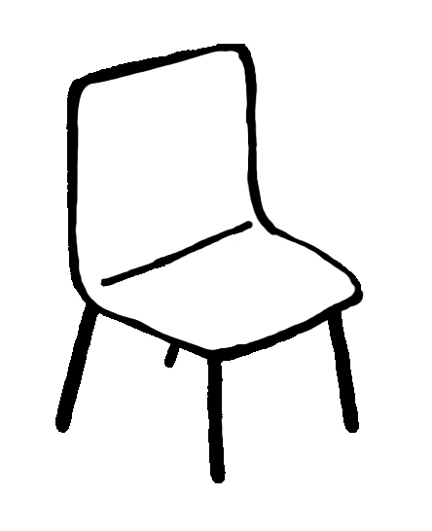
a / reading / She’s / book. _____________


on / sitting / a / He’s / chair. _____________

to / They’re / music. / listening ______________
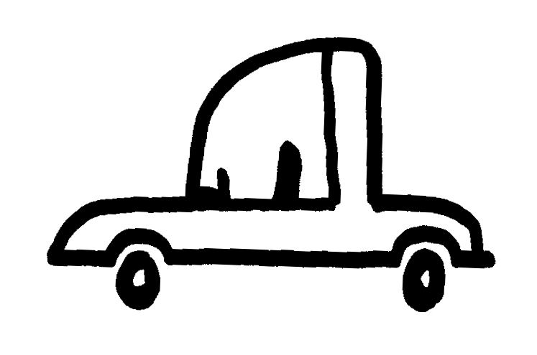

car. / a / driving / He’s ________________

tennis. / They’re / playing ____________

Total unit score / 10

