Name: | Class:

Read and circle. Score / 5


Maskman can fly / drive a helicopter.
Monty can talk / fly.
Scott can walk / swim to school.
Sally can read / sing a book.
Mr. Star can fly / play the guitar.
A dog can swim / drive.

Look and write the words. Score /10

playing driving flying swimming watching eating


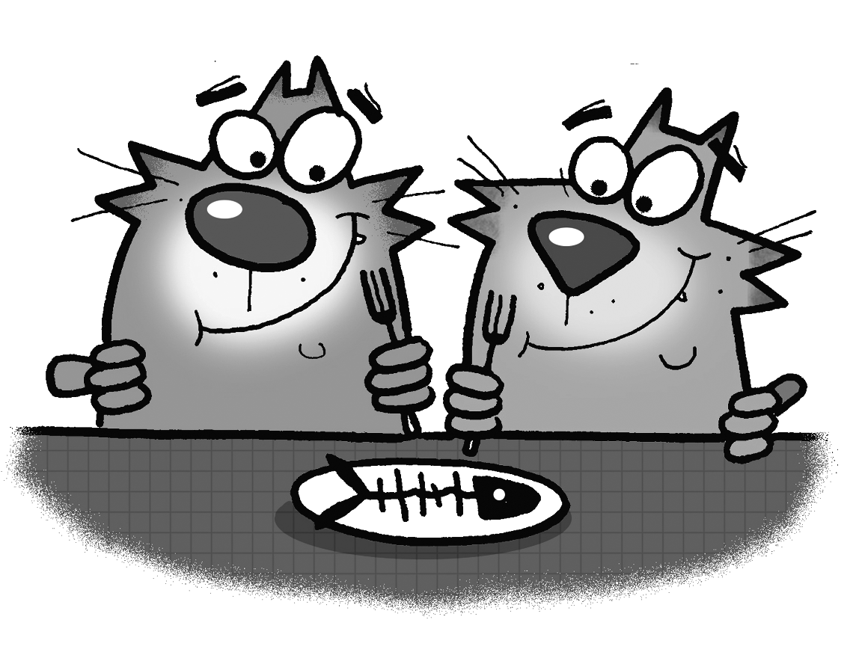
She’s playing the guitar.

They’re _____________ fish.
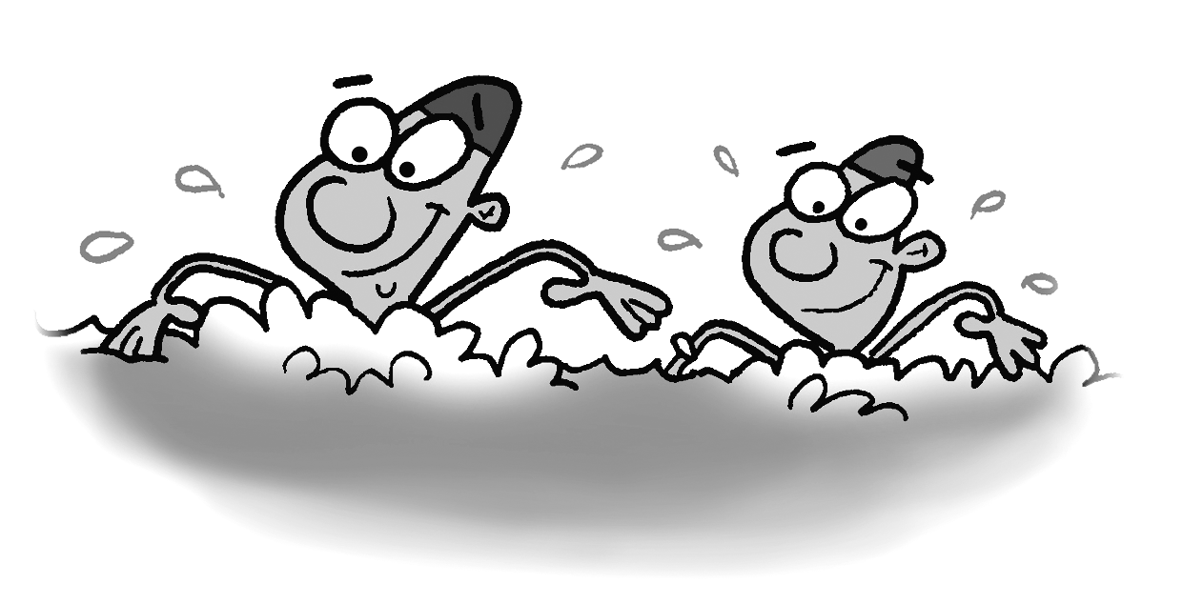
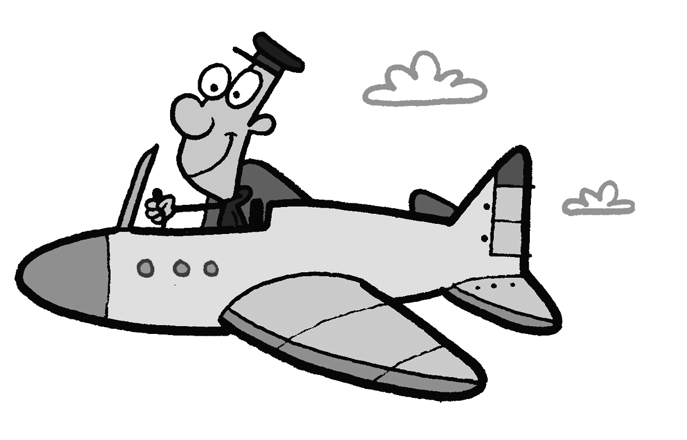
They’re _____________ .

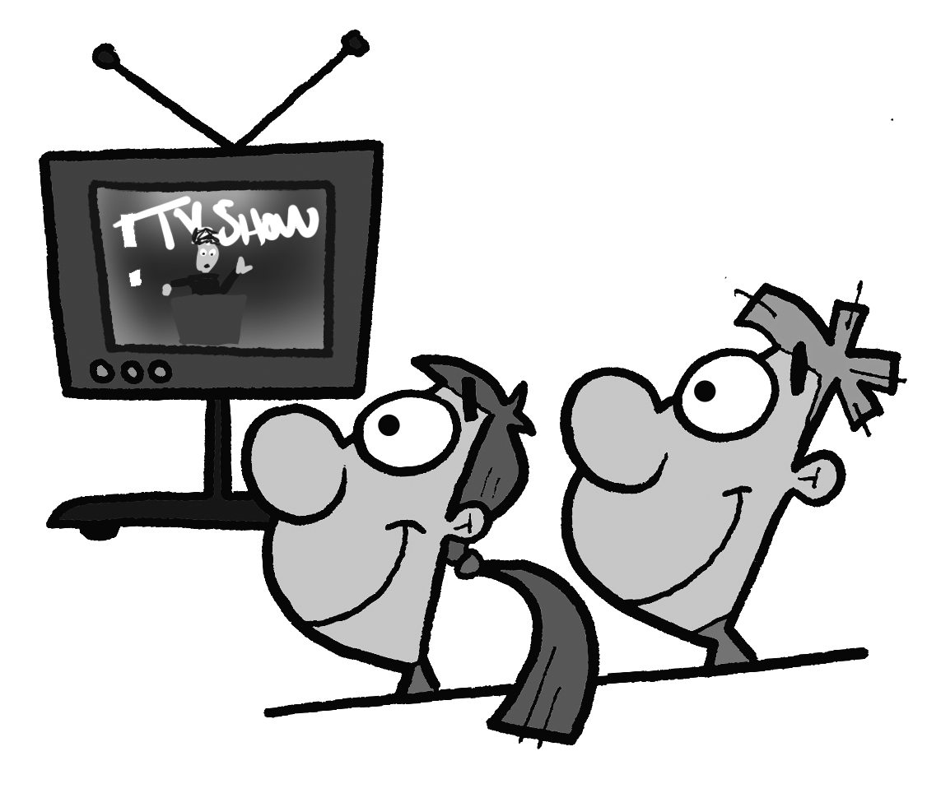
He’s _____________ a plane.

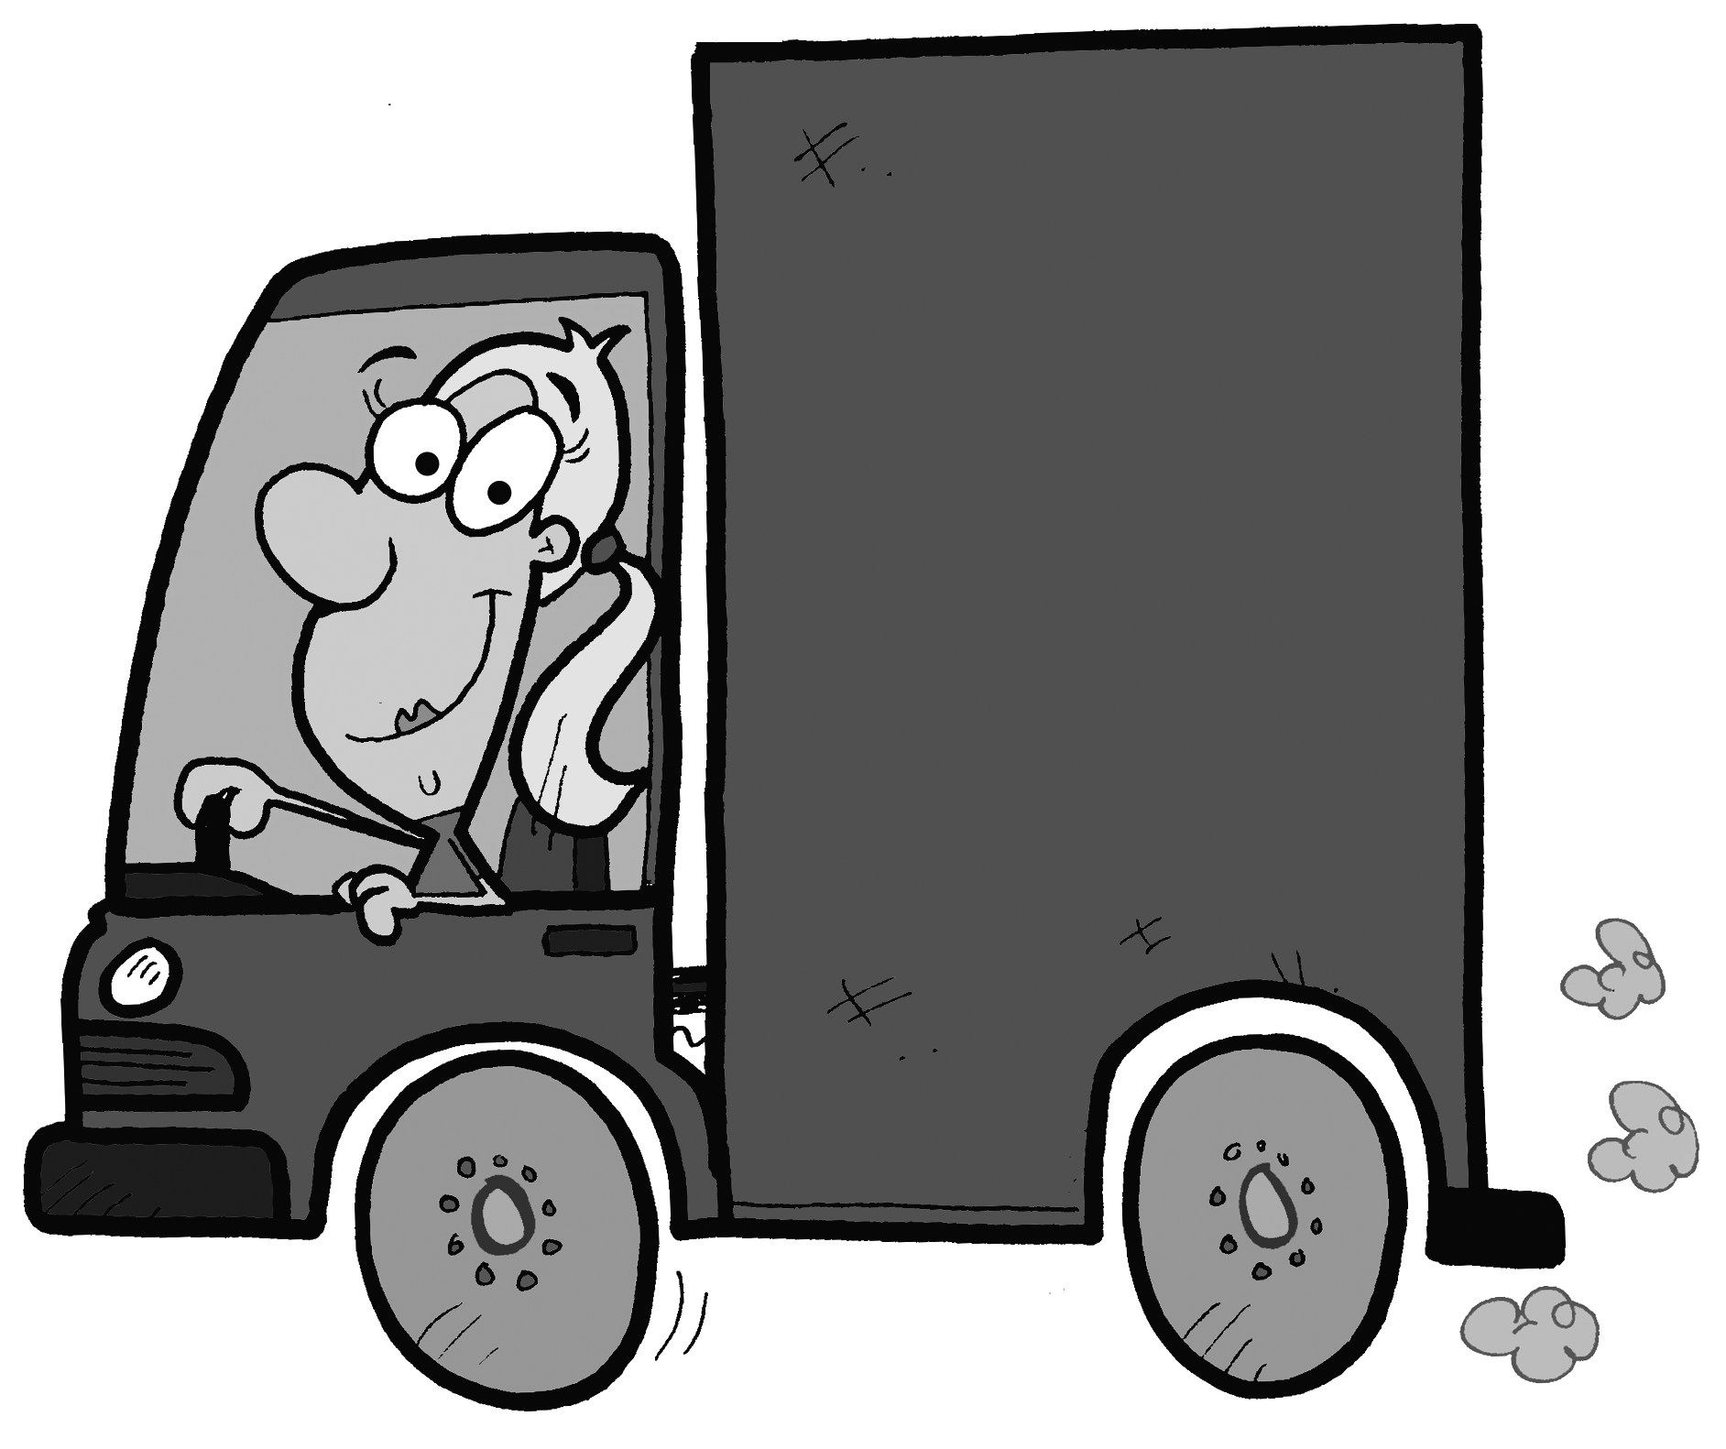
They’re _____________ TV.

She’s _____________ a truck.

Total review score / 15

