

1 Look and write. (10 points)
d, G, j, K, N, Q, t, V, v, y

2 Look and write. (5 points)
2 He’s Scott. 3 He’s Mr. Star. 4 She’s Marie. 5 She’s Suzy. 6 He’s Maskman.



1 Look and write. (5 points)
15, 20, eighteen, fourteen, 12

2 Read and circle. (5 points)
2 There isn’t, 3 There isn’t, 4 There’s, 5 There’s, 6 There’s



1 Look and write the words. (5 points)
2 kite, 3 camera, 4 watch, 5 robot, 6 computer game

2 Listen and draw lines. (5 points)
computer game – Jill, watch – Ann, robot – Sam, truck – Rick, camera – Ann

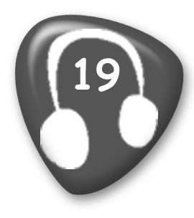
Whose kite is it? It’s Rick’s.
Whose camera is it? It’s Ann’s.
Whose robot is it? It’s Sam’s.
Whose computer game is it? It’s Jill’s.
Whose watch is it? It’s Ann’s.
Whose truck is it? It’s Rick’s.

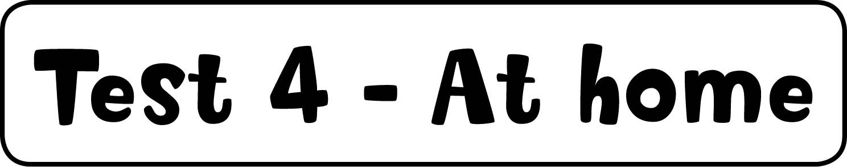

1 Look and write the words. (5 points)
2 phone, 3 couch, 4 mirror, 5 mat, 6 lamp

2 Listen, match, and color. (5 points)
John – green watch, purple kite;
Sue – red camera, yellow pants, red socks


Man: Whose are the white shoes?
Woman: The white shoes are John’s.
Man: Whose is the red camera?
Woman: The red camera is Sue’s.
Man: Whose is the green watch?
Woman: The green watch is John’s.
Man: Whose are the yellow pants?
Woman: The yellow pants are Sue’s.
Man: Whose is the purple kite?
Woman: The purple kite is John’s.
Man: Whose are the red socks?
Woman: The red socks are Sue’s.



1 Order and write. (5 points)
2 Is there a teacher? 3 There is a blackboard. 4 Are there eighteen desks?
5 Are there six rulers? 6 Is there a bookcase?

2 Look and write. (5 points)
2 on, 3 next to, 4 under, 5 on, 6 in



1 Look and write. (5 points)
2 grandpa, 3 Frank’s, 4 mommy, 5 Lenny’s/Sam’s, 6 Frank’s

2 Listen and write "yes" or "no." (5 points)
2 no, 3 yes, 4 no, 5 no, 6 yes

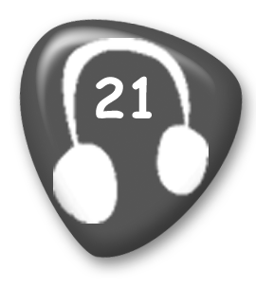
1 He’s hitting a ball.
2 He’s reading a book.
3 She’s jumping.
4 She’s kicking a ball.
5 He’s throwing a ball.
6 She’s running.

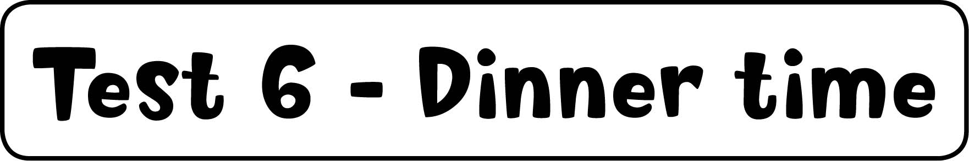

1 Write the words. (5 points)
2 eggs, 3 water, 4 juice, 5 chicken, 6 milk

2 Order and write. (5 points)
2 Can I have some chicken, please? 3 What’s his favorite breakfast?
4 Can I have an egg, please? 5 Can I have some rice, please?
6 His favorite breakfast is bananas.



1 Read and write. (5 points)
fish; birds; sheep, goats; spiders

2 Listen and check or put an X in the box. (5 points)
cow , lizard , spider , goat , sheep 

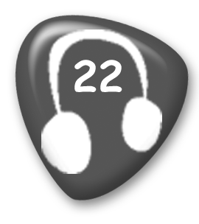
Girl: I like ducks. Boy: I don’t.
Girl: I like frogs. Boy: So do I.
Girl: I like cows. Boy: I don’t.
Girl: I like lizards. Boy: So do I.
Girl: I like spiders. Boy: I don’t.
Girl: I like goats. Boy: So do I.
Girl: I like sheep. Boy: I don’t.



1 Match. (5 points)
store – top right, park – right center, street – left center, café – bottom left,
hospital – bottom right

2 Look and check or put an X in the box. (5 points)
2 , 3 , 4 , 5 , 6 



1 Listen and write the number. (5 points)
She’s eating bread – 3, She’s eating cake – 5, He’s drinking juice – 4,
He’s playing – 6, She’s eating a banana – 2

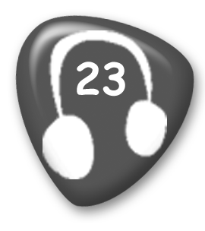
1 He’s sleeping.
2 She’s eating a banana.
3 She’s eating bread.
4 He’s drinking juice.
5 She’s eating cake.
6 He’s playing.

2 Look and write. (5 points)
babies – one, women – two, men – two, kites – one, bikes – one

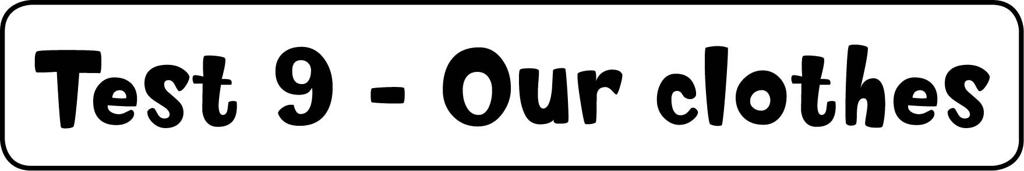

1 Listen and color. (5 points)
jeans – blue, shirt – yellow, glasses – black, hat – purple, handbag – red

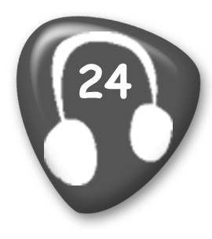
I’m wearing a gray dress.
I have a red handbag.
I’m wearing black glasses.
I’m wearing a yellow shirt.
I’m wearing a purple hat.
I’m wearing blue jeans.

2 Follow the lines. Write. (5 points)
3 No, he doesn't. 4 Yes, she does. 5 No, he doesn't. 6 Yes, she does. 7 No, he doesn't.



1 Match and write. (5 points)
2 hockey, 3 baseball, 4 Ping-Pong, 5 soccer, 6 basketball

2 Read and circle. (5 points)
2 don’t, 3 like, 4 like, 5 taking, 6 eating



1 Listen and number. (5 points)
cake – 2, orange – 6, sausage – 4, lemonade – 3, watermelon – 5

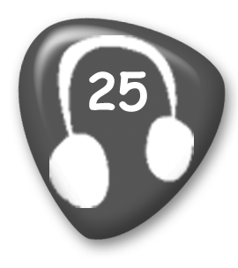
1 burger
2 cake
3 lemonade
4 sausage
5 watermelon
6 orange

2 Write the questions and answers. (5 points)
2 Yes, I’d love one. 3 Can I have some lemonade? 4 Here you go.
5 Would you like some watermelon? 6 No, thank you.



1 Write the words. (5 points)
2 shell, 3 ocean, 4 beach, 5 sun, 6 city

2 Listen and draw lines. (5 points)
1 beach – shell, 2 city – café, 3 mountains – bird

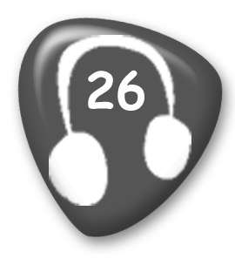
1 Girl: Let’s go to the beach. I love picking up shells!
2 Boy: Let’s go to the city. I like sitting in cafés!
3 Girl: Let’s go to the mountains. I like looking at the birds!



1 Write the questions and answers. (5 points)
2 Yes, she does. 3 Do you like going to the beach? 4 Yes, I do. 5 Does Rick like fishing? 6 No, he doesn’t.

2 Look and write. (5 points)
2 us, 3 me, 4 them, 5 him, 6 you



1 Read and answer. (5 points)
2 It’s rice. 3 They’re bananas. 4 It’s a cake. 5 They’re eggs. 6 They’re burgers.

2 Write. (5 points)
2 She’s reading. 3 They're swimming. 4 She’s painting. 5 He’s fishing.
6 We’re playing badminton.

3 Match and write. (5 points)
2 Jill’s, 3 Rick’s, 4 Kim’s, 5 Tony’s, 6 Lucy’s

4 Listen and color. (5 points)
Girl’s hat – green, Mommy’s T-shirt – yellow, Daddy’s T-shirt – purple, shells – blue,
tree – brown and green

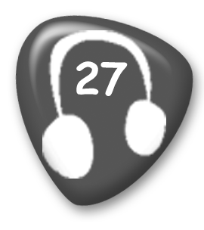
1 The bird is gray.
2 The girl’s hat is green.
3 Mommy’s T-shirt is yellow.
4 Daddy’s wearing a purple T-shirt.
5 The shells are blue.
6 The tree is brown and green.

