Name: | Class:

Look and write. Score / 5


11 18 14

eleven fifteen twenty _____ _____ twelve

Read and circle. Score / 5
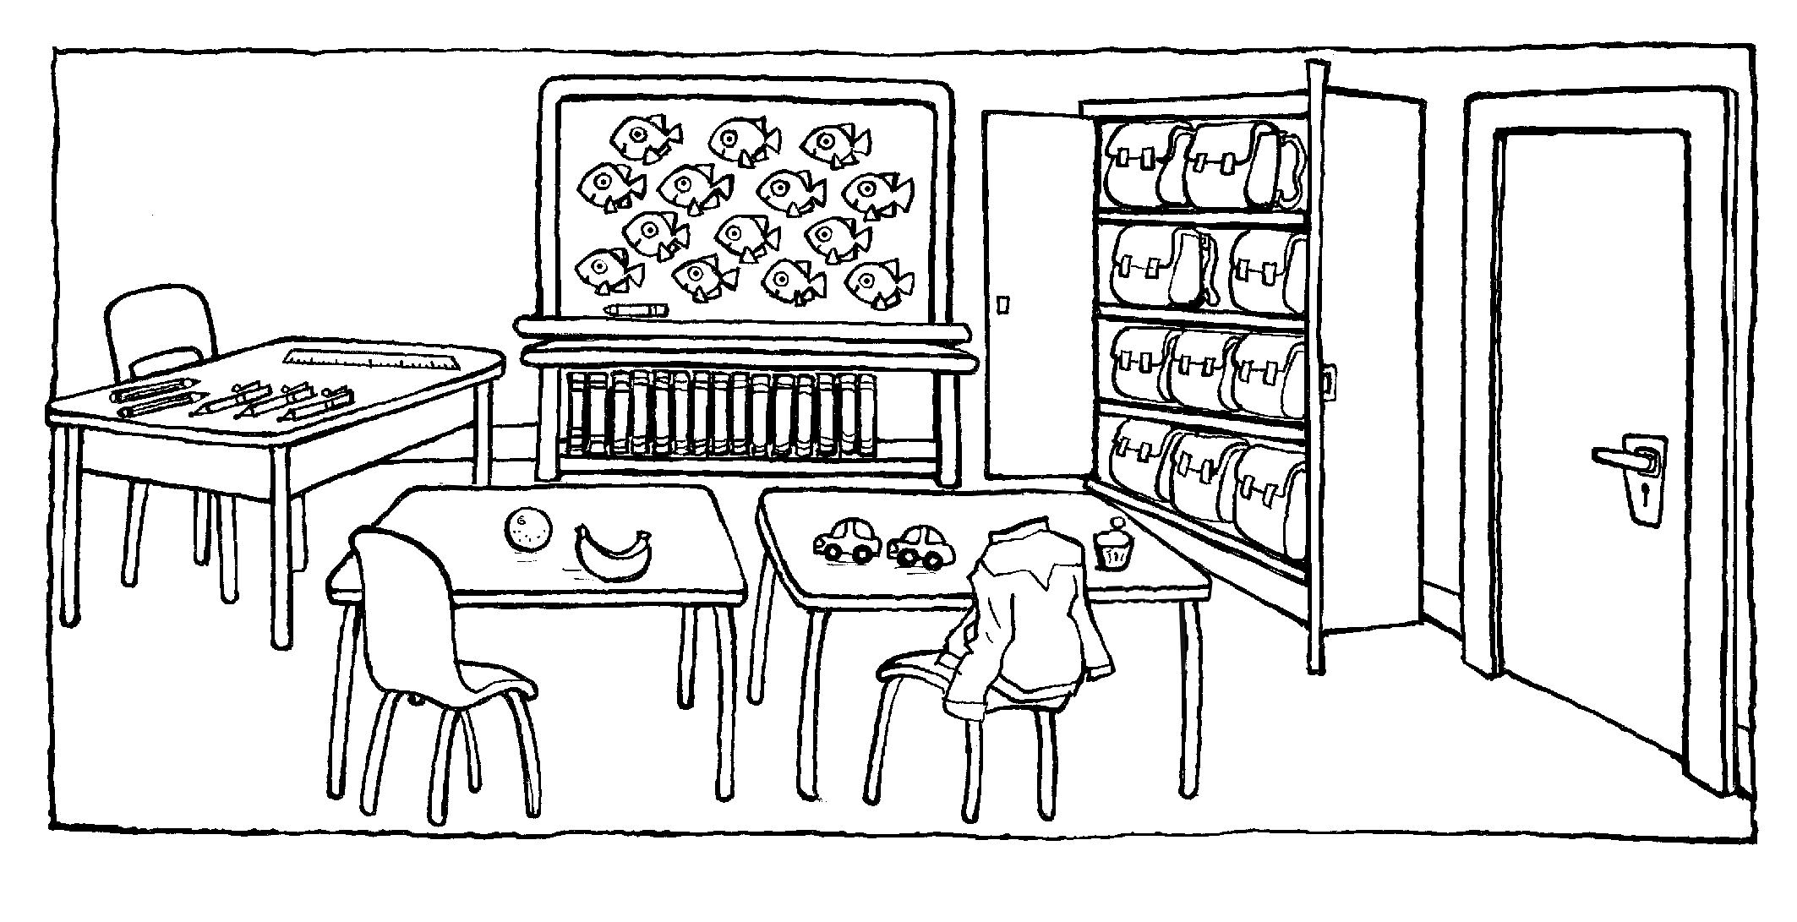

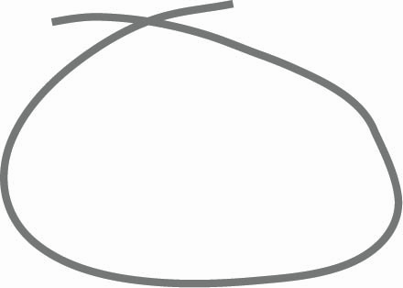


There ‘s / are desks in the classroom.
There is / are a cupboard in the classroom.
There aren’t / isn’t a poster in the classroom.
There ‘s / are a whiteboard in the classroom.
There ’s / are a ruler in the classroom.
There ‘s / are a bookcase in the classroom.

Total unit score / 10

