Name: | Class:

Look and write. Score / 5

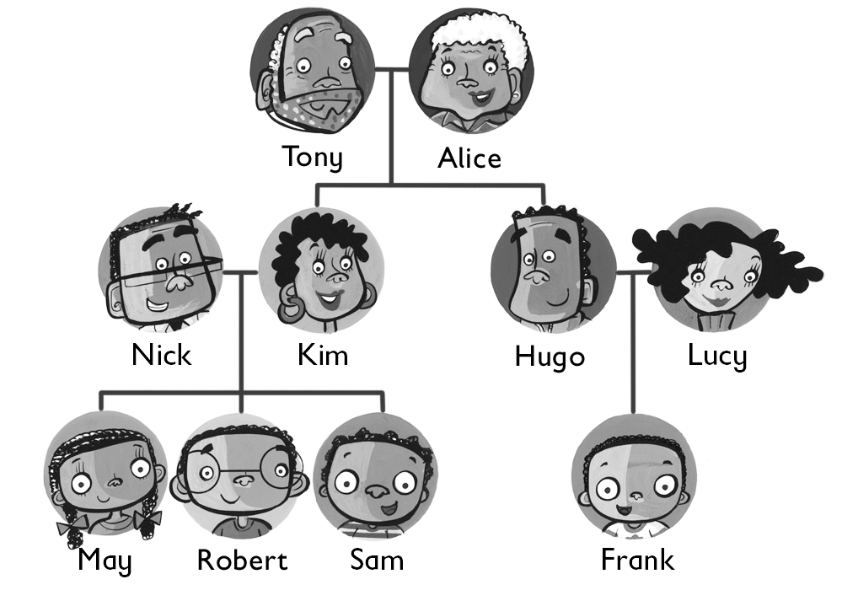
Hugo is Frank’s dad.

Tony is Sam’s ________.

Robert is ________ cousin.

Kim is May’s ________.

May is ________ sister.

Lucy is ________ mom.

Listen and write “yes” or “no.” Score / 5

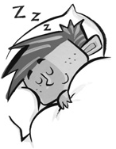

He’s hitting a ball. He’s reading a book.

yes ________
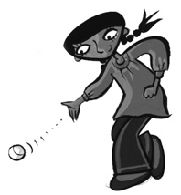
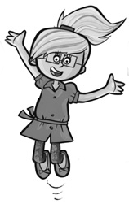
She’s jumping. She’s kicking a ball.

________ ________


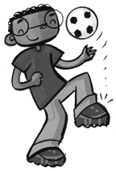
He’s throwing a ball. She’s running.

________ ________
Total unit score / 10

