Name: | Class:

Write the words. Score / 5
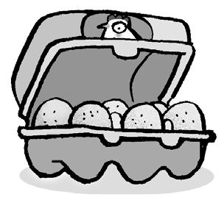

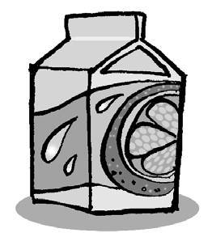

f r i e s _ g _ _

w _ _ _ _ _ u _ _ _
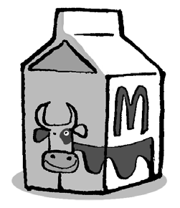
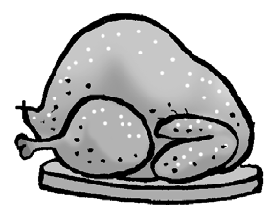
_ h _ _ _ e n m _ _ _

Order and write. Score / 5

fries, /please? /some / have / I / Can
Can I have some fries, please?

Can / have / some / I / meatballs, / please?
____________________________________

his / What’s / breakfast? / favorite
____________________________________

an / please? / egg, / have / I / Can
____________________________________

please? / have / I / rice, / Can / some
____________________________________

favorite / bananas. / breakfast / His / is
____________________________________

Total unit score / 10

