Name: | Class:
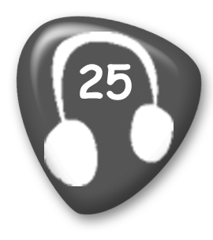
Listen and number. Score / 5
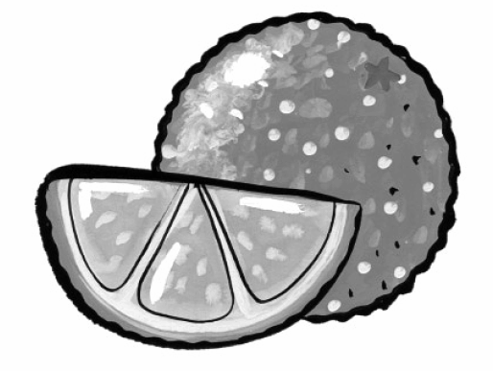
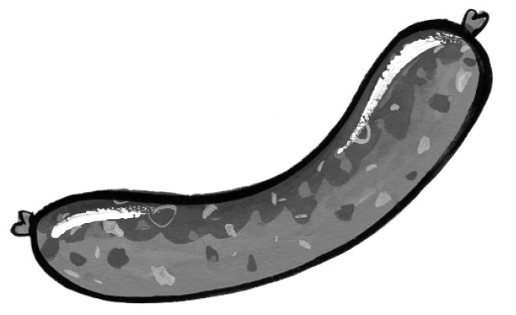
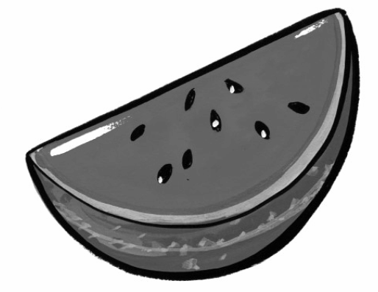
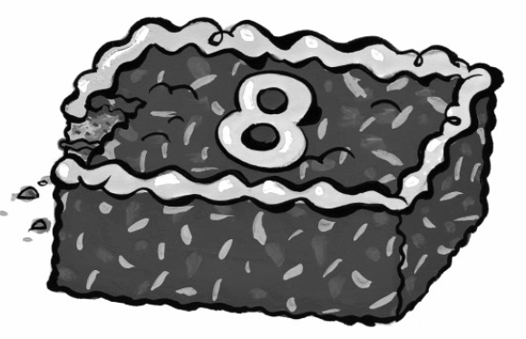
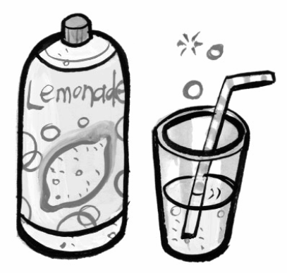
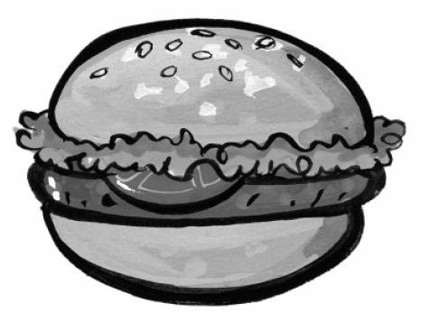




Write the questions and answers. Score / 5

sausage? / a / Would / like / you
Would you like a sausage?

I’d / Yes, / one. / love
____________________________________

some / Can / lemonade? / have / I
____________________________________

go. / you / Here
____________________________________

some / Would / like / watermelon? / you
____________________________________

you. / No, / thank
____________________________________

Total unit score / 10

