Name: | Class:

Order and write. Score /10

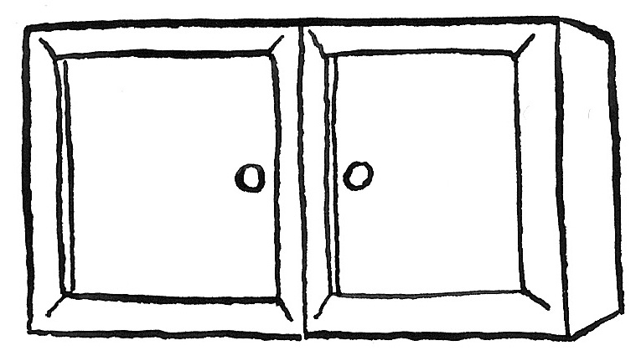
cupboards / are / there? / How / many
How many cupboards are there?
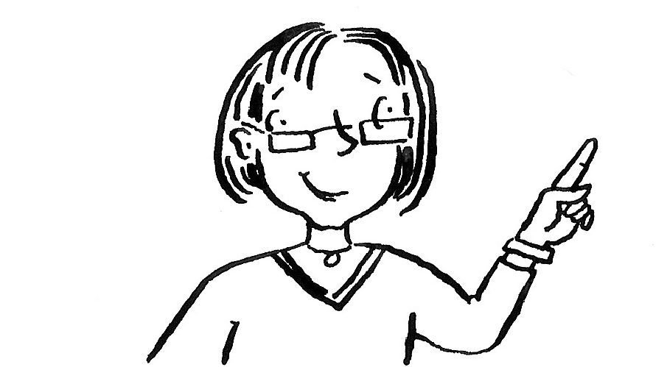
Is / teacher? / there / a
________________________
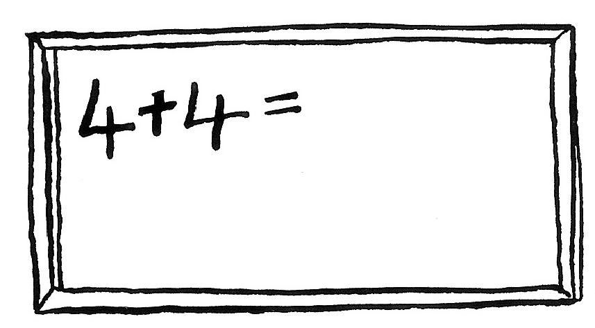
blackboard. / There / a / is
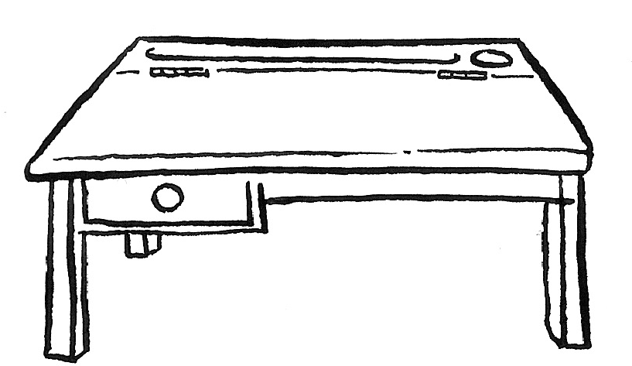
________________________
desks? / there / Are / eighteen
________________________
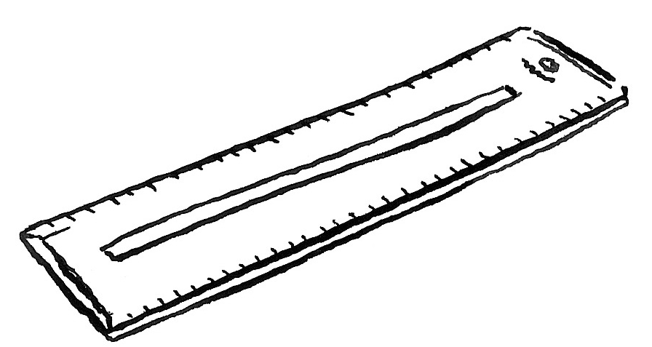
six / Are / there / rulers?
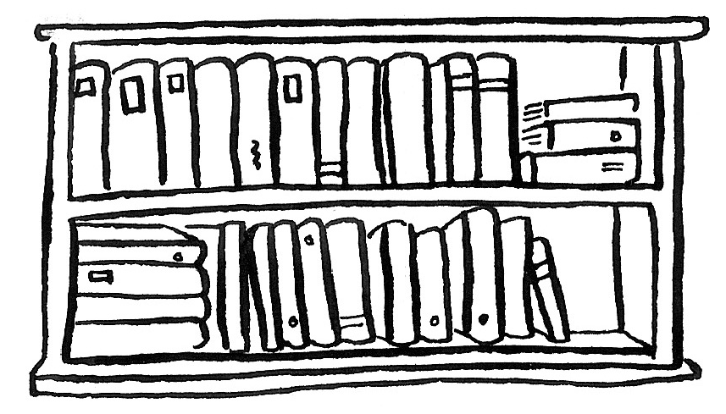
________________________
there / bookcase? / Is / a
________________________
Look and write. Score / 5

next to under on in on next to

The boy is next to the couch.
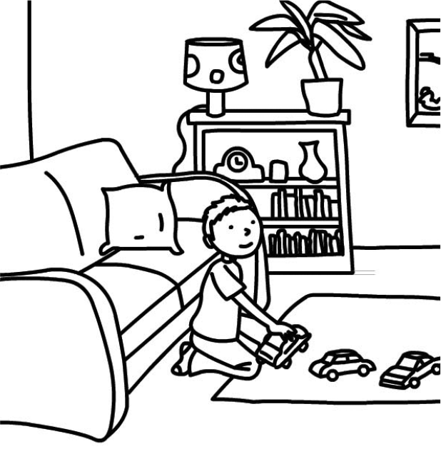
The cars are ____________ the rug.
The couch is ____________ the bookcase.
The clock is ____________ the lamp.
The lamp is ____________ the bookcase.
The books are ____________ the bookcase.
Total review score / 15

