Name: | Class:

Write the questions and answers. Score /10

picking / shells? / Does / up / Suzy / like
Does Suzy like picking up shells?
does. / she / Yes,
________________
Do / like / beach? / you / going / the / to
____________________________________
do. / I / Yes,
____________________________________
fishing? / Rick / Does / like
____________________________________
doesn’t. / No, / he
____________________________________

Look and write. Score / 5

him her you us them me



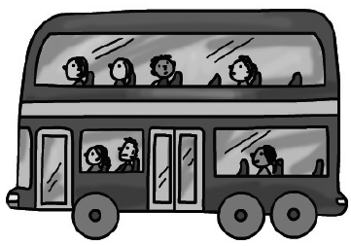
Look at her. Look at ______.
She’s wearing a skirt. We’re on the bus.

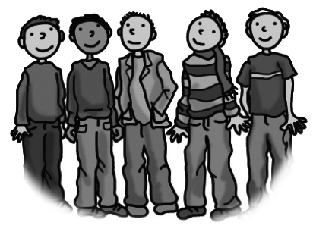
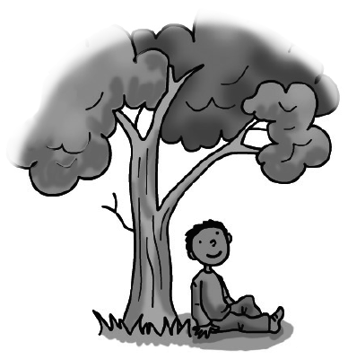
Look at ________. Look at ______.
I’m under a tree. Look at those men.
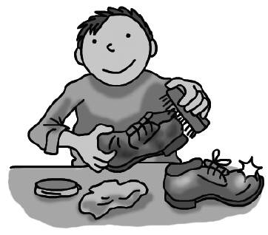
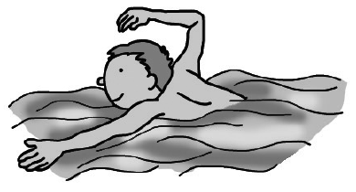
Look at ________. Look at ______.
He can swim. You’re cleaning a shoe.
Total review score / 15

