Name: | Class:

Look and write. Score / 6
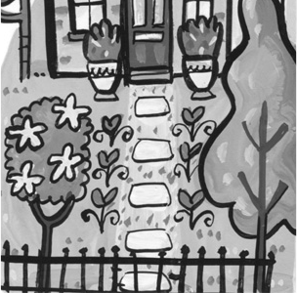
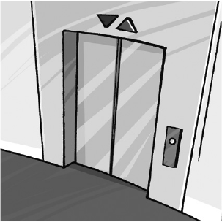
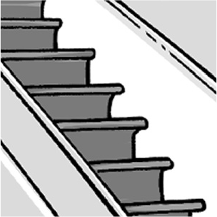
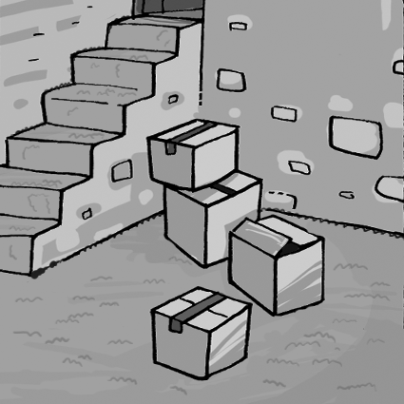
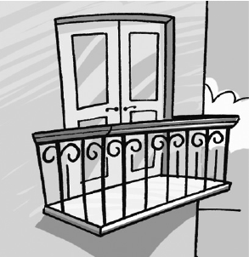
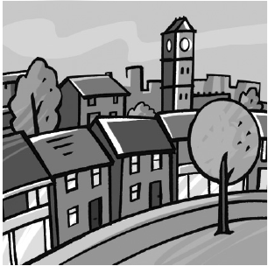
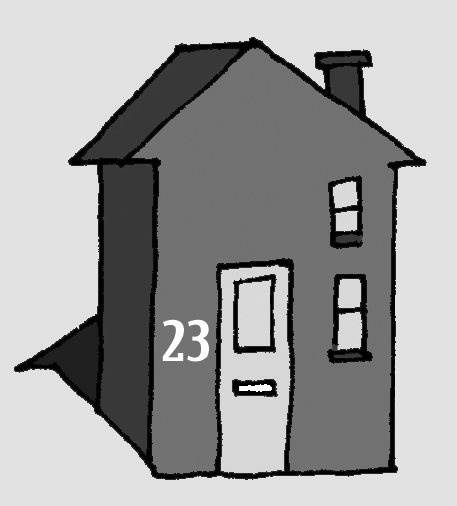

We live in a house in a t .

It has two floors and a b .

We don’t have a y ,

but we have a b .

We don’t have an e .–

We need to use the s .

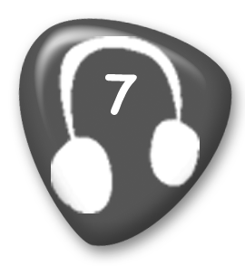
Listen and draw lines. Score / 10
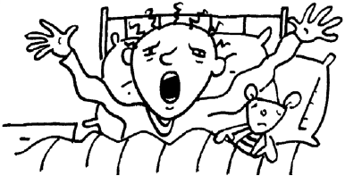
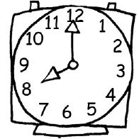
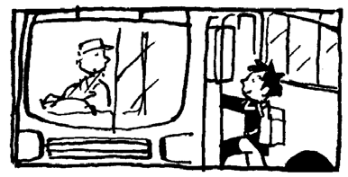
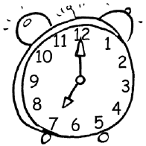

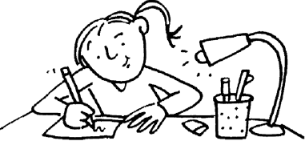
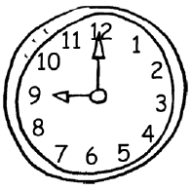
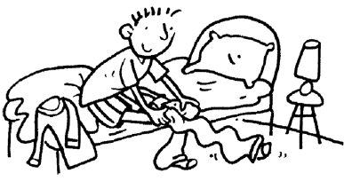


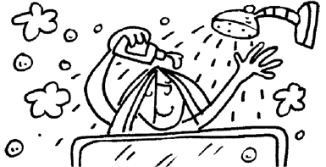
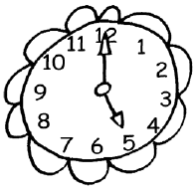

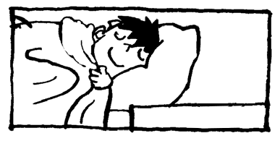


Look and write. Score / 5
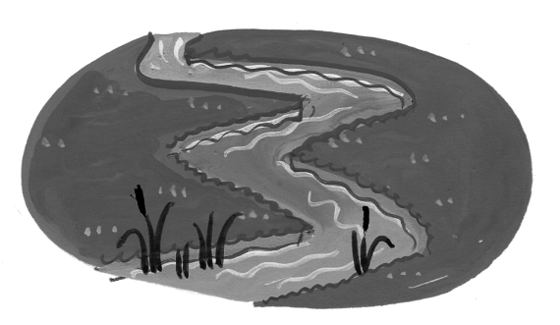
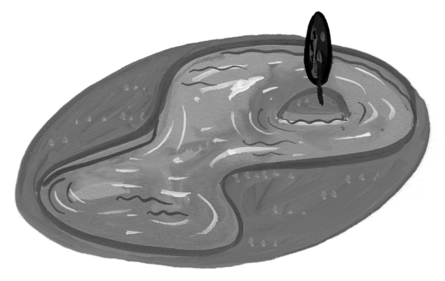
Peter wants to swim in the river .

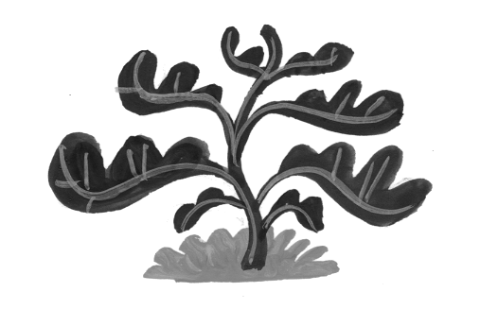
Jack wants to fish in the .

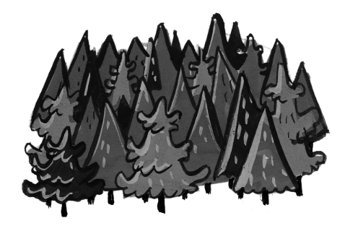
Lucy wants to draw a .

Jim wants to walk in the .
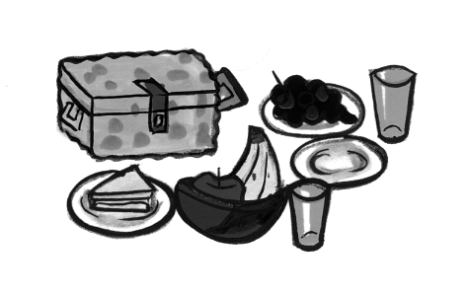
Sally wants to have a .
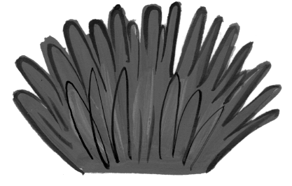
Mary wants to sit on the .

Read and write. Score / 4

This animal has four legs and a lot of hair on its head.
It’s very strong.
It’s a lion .

This animal lives in the ocean. It’s very smart, and it likes playing.
It’s a .

This animal lives in Australia. It has two legs, and it can jump.
It’s a .

This animal can fly, and sometimes it can talk.
It can be red, green, and blue.
It’s a .

This animal is big, and it sleeps when it’s cold.
It can be brown, white, or gray.
It’s a .

Total end of level score / 25

