Name: | Class:

Unscramble and write the words. Score / 7
tuan aunt prgnadsenart ________
gtheruda ________ nos ________

dggrhnaaduert ________ lenuc ________

ognrands ________ stapenr ________

Look and write. Score / 8

 = like  = love  = don’t like
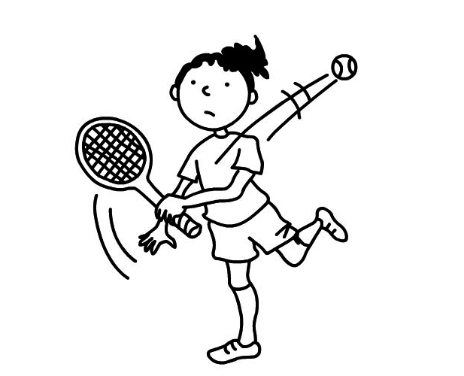

She ‘s playing tennis.

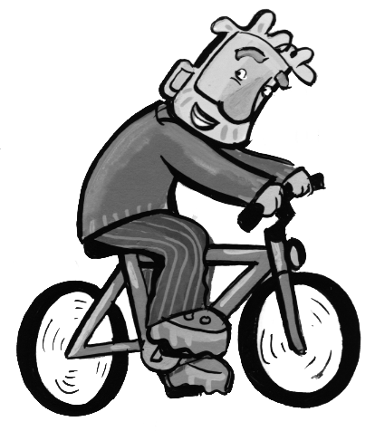
She doesn’t like playing tennis.

He ______________________.

He ______________________.
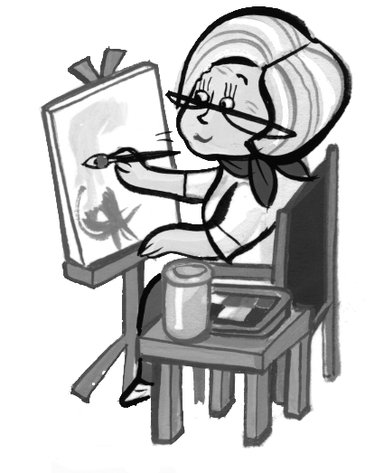
She ______________________.


She ______________________.
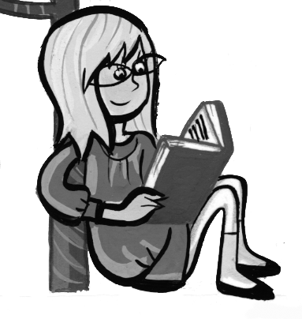
She ______________________.

She ______________________.
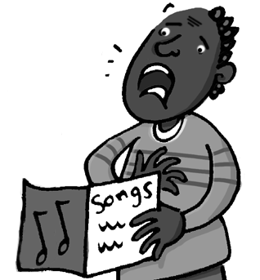
He ______________________.

He ______________________.
Total unit score / 15

