Name: | Class:

Write the words. Score /7
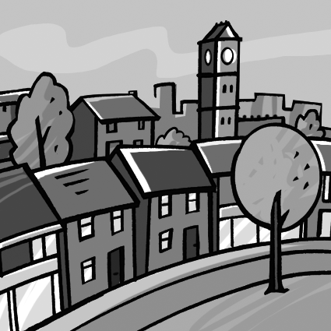
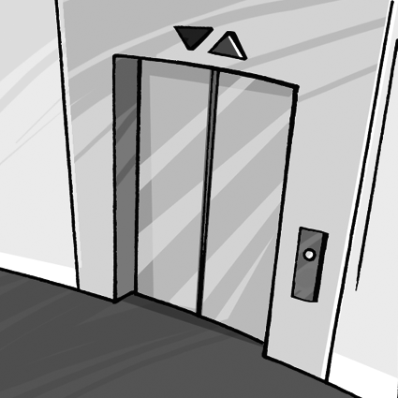
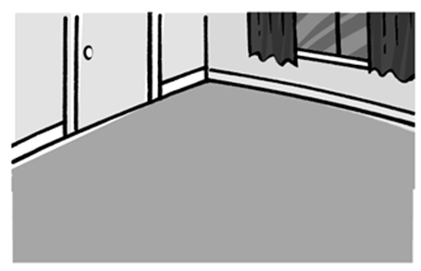
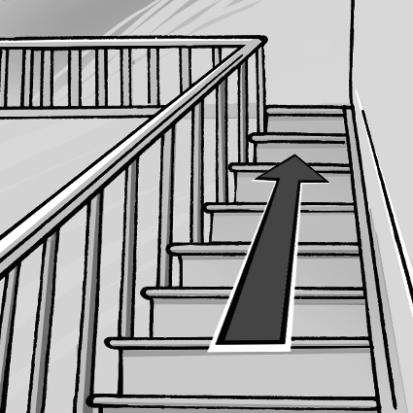

f l o o r _ _ _ _ _ _ _ _ _ _ _ _ _ _ _ _ _ _

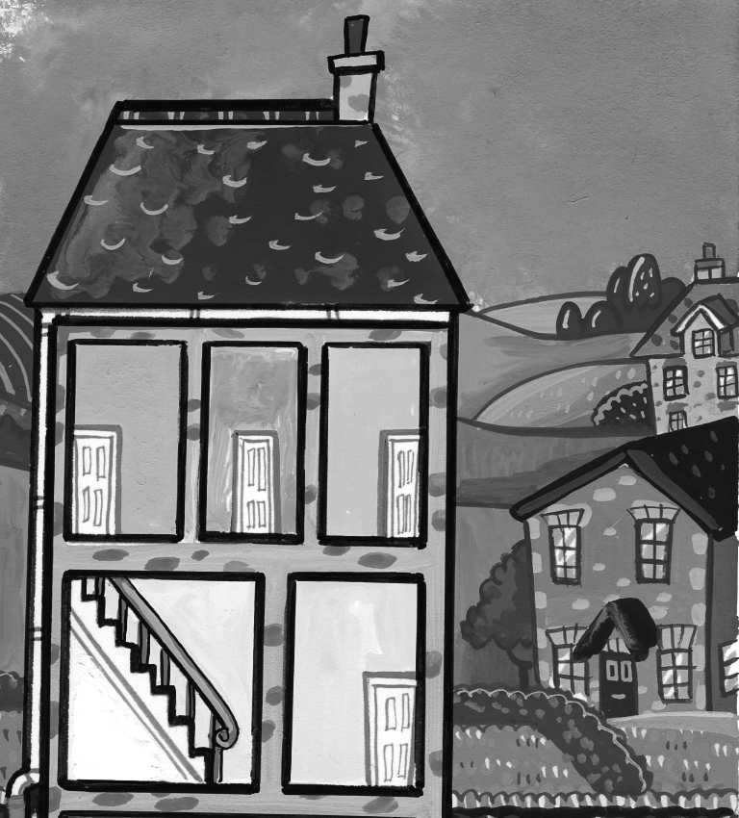
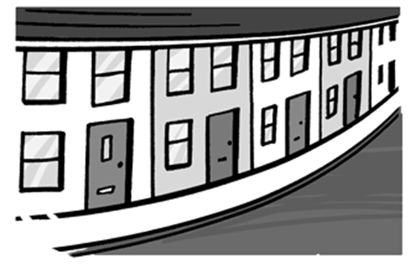
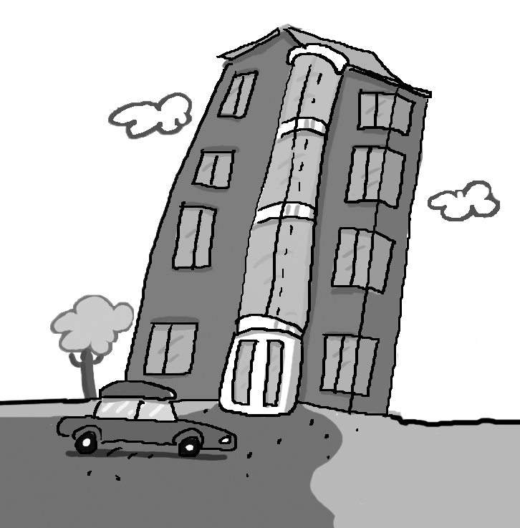
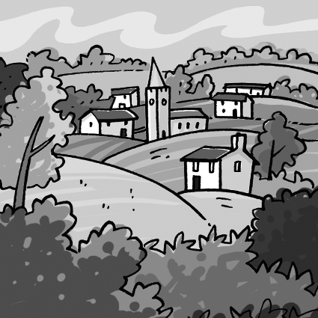

_ _ _ _ _ _ _ _ _ _ _ _ _ _ _ _ _ _ _ _ _ _ _ _ _ _

Put the words in order to make sentences. Score / 8

live / in / the / We / country.
We live in the country.

is / the / under / house. / basement / The
_____________________________________

number / I / at / 34. / live
_____________________________________

up / are / climbing / Two / the / stairs. / men
_____________________________________

elevator / goes / The / up and down.
_____________________________________
Total unit score / 15

