Name: | Class:

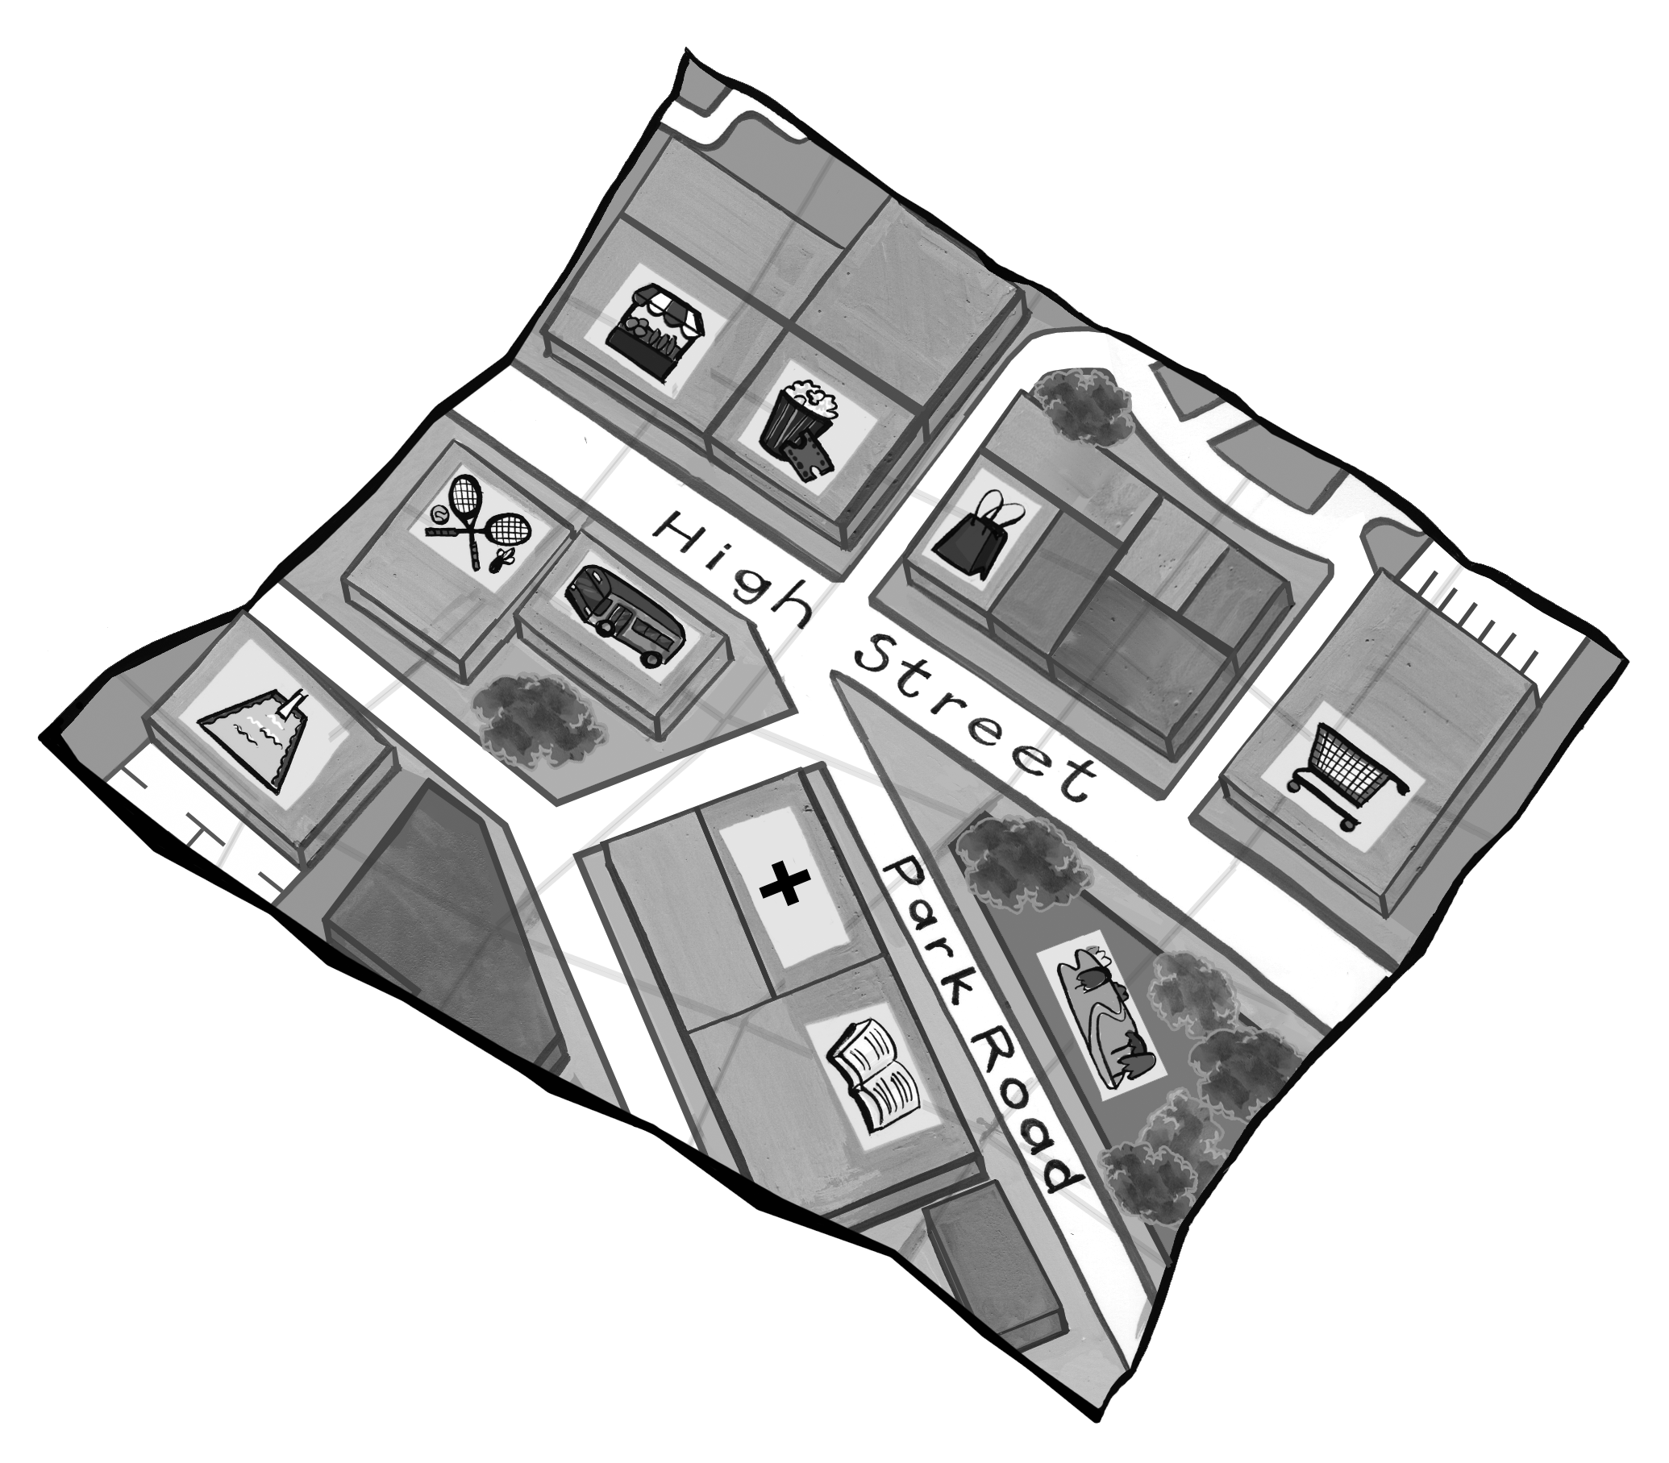
Read and circle. Score / 7
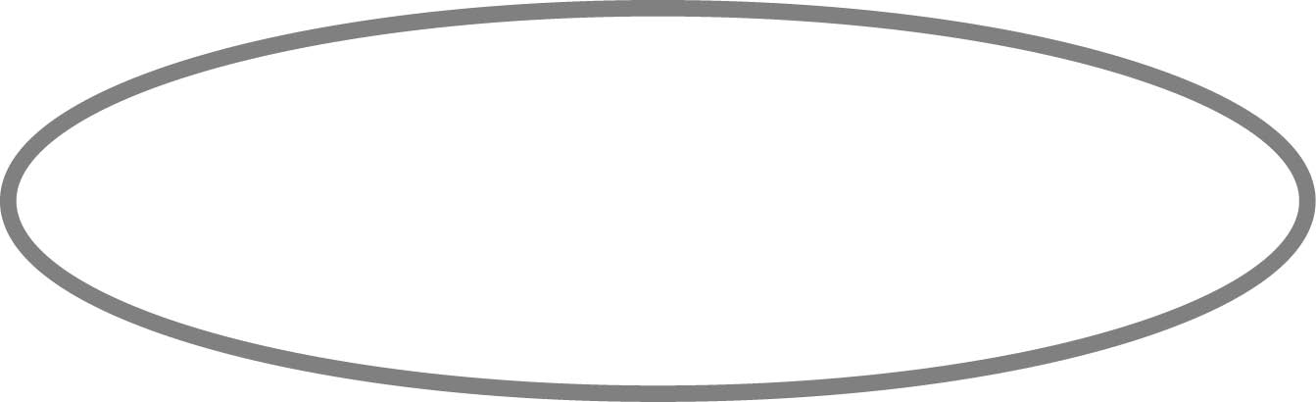
The market is behind / next to the movie theater.
The sports center is
in front of / next to the market.
The bus station is
next to / in front of the sports center.
The hospital is behind / next to the library.
The movie theater is in front of / next to the bus station.
The sports center is in front of / next to the swimming pool.
The park is behind / in front of the library.
The supermarket is next to / in front of the park.

Write can or must and write the letter. Score / 8
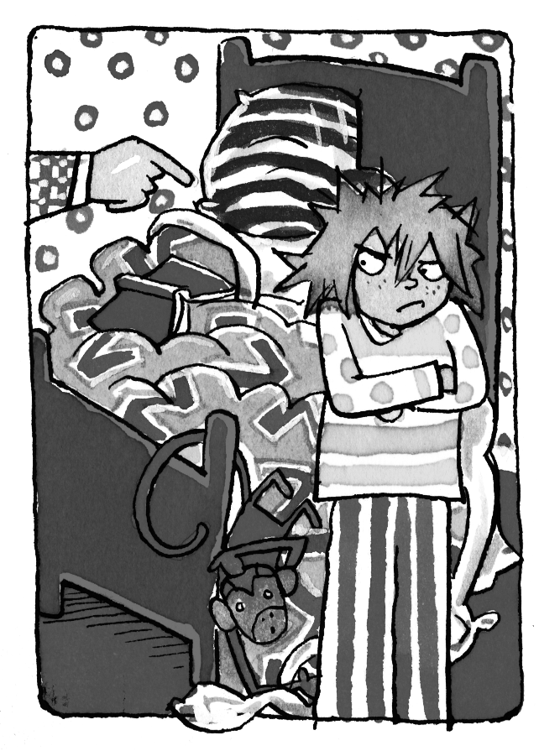
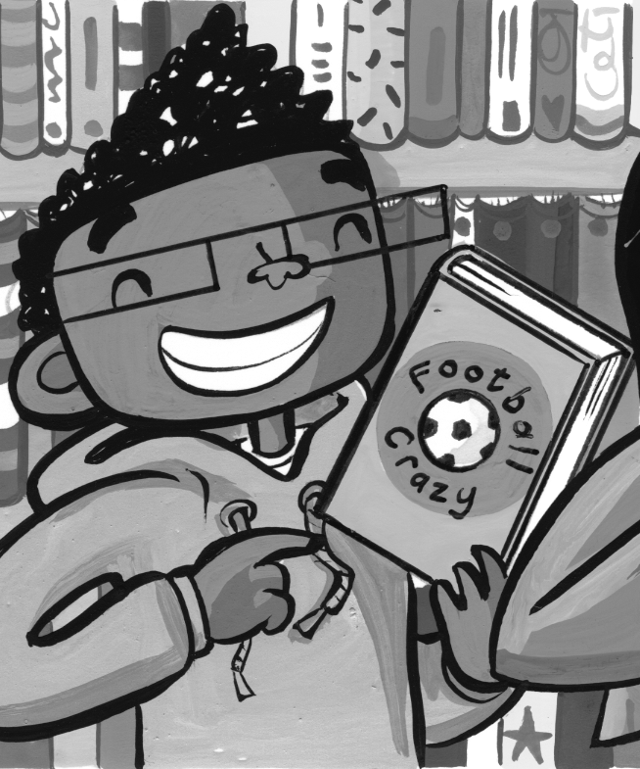
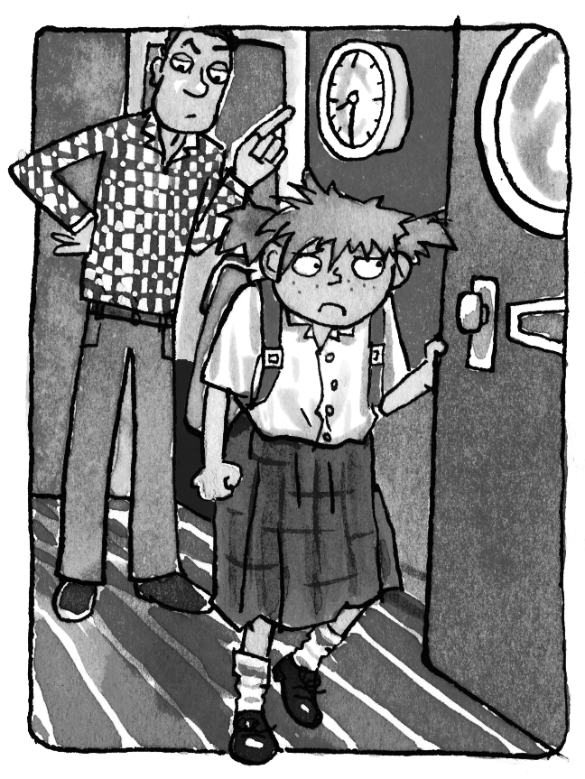
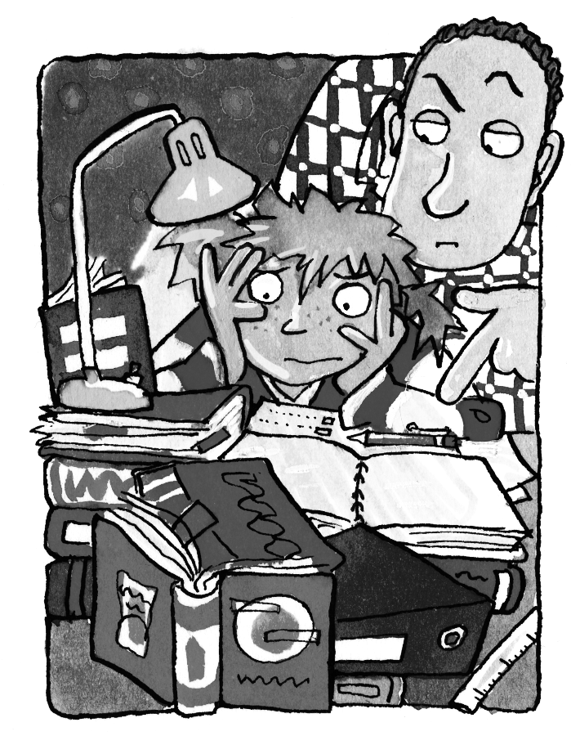
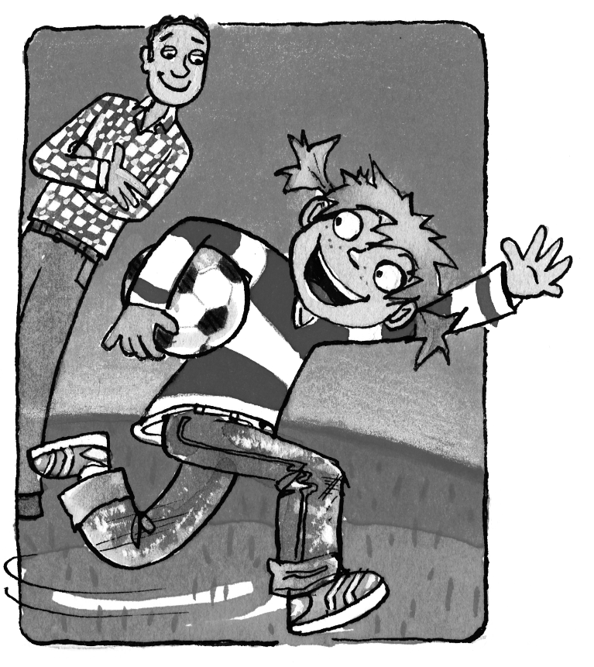

a b c d e
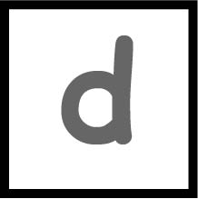
You can read a book in the library.

You __________ play soccer in the park.


You __________ go to school every day.

You __________ make your bed.

You __________ do your homework.

Total unit score / 15

