Name: | Class:

Look and write. Score /7

temperature cough backache headache earache
stomachache toothache cold
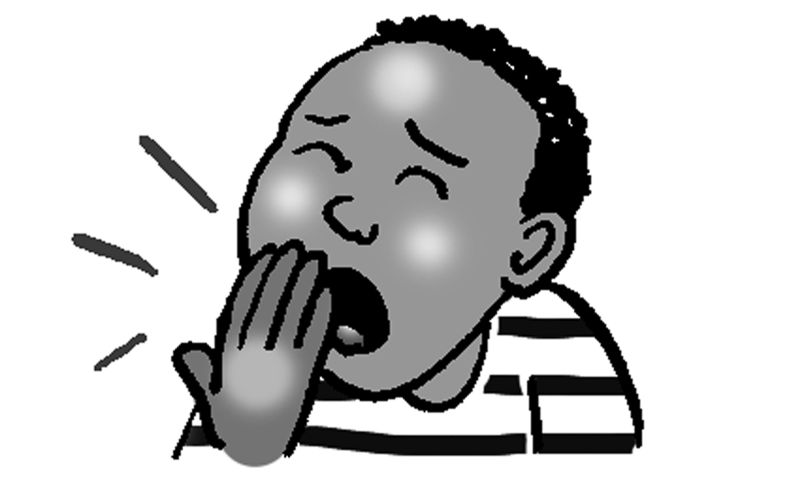
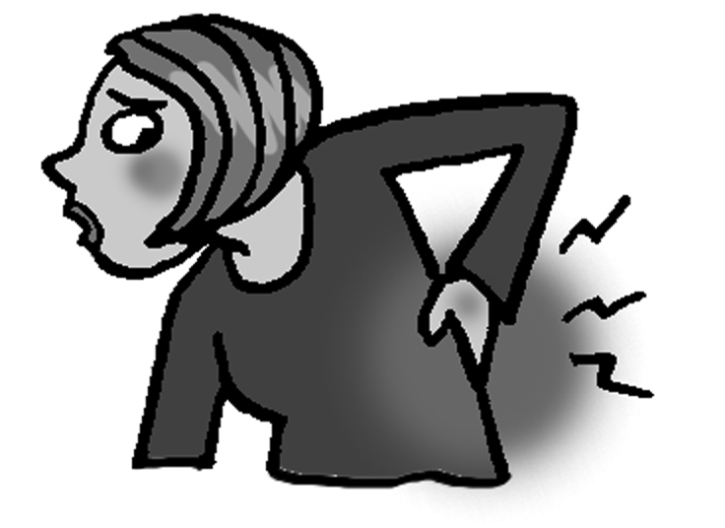
I have a loud cough .
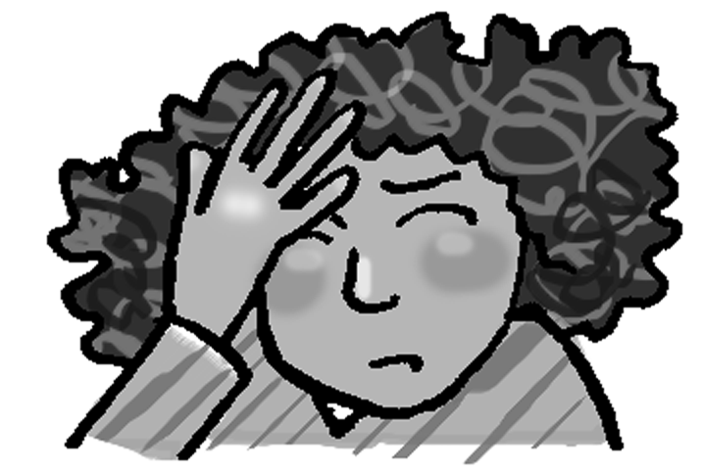
My back hurts. I have a ________________.
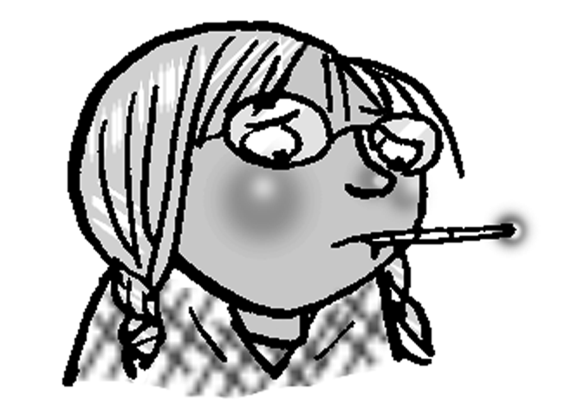
My head hurts. I have a _______________.
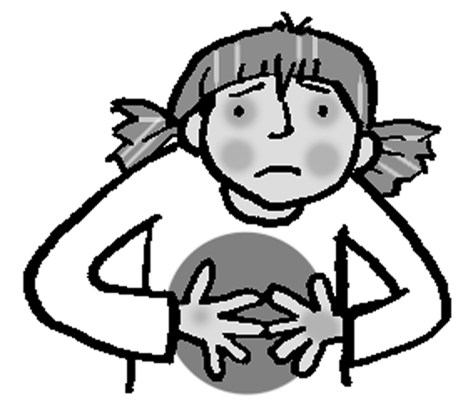
I’m hot. I have a ________________.
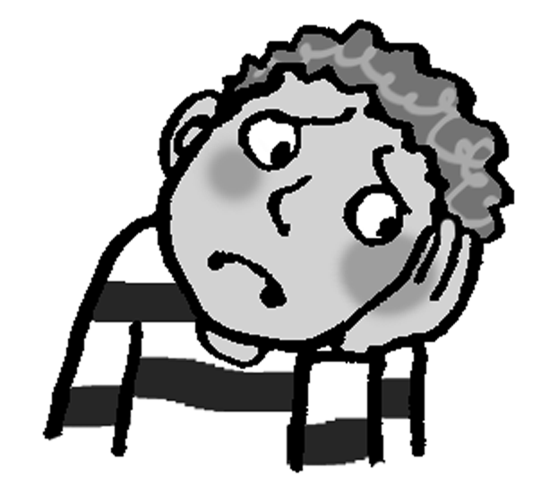

My stomach hurts. I have a ________________.
My tooth hurts. I have a ________________.
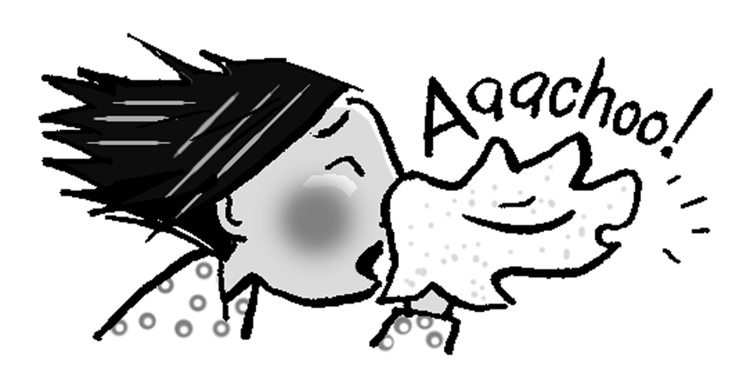
My ear hurts. I have an ________________.
Aaachoo! I have a ________________.

Write must or must not. Score /8
John has a temperature. He must stay in bed.
When you’re in the library, you __________ be quiet.
I have a cold. I __________ swim.
When your leg hurts, you __________ ride your bike.
You __________ have breakfast every day.
When you have a stomachache, you __________ eat candy.
Stella has a headache. She __________ read today.
He has a toothache. He __________ go to the dentist.
We __________ do our homework before we watch TV.
Total unit score / 15

