Name: | Class:

Look and match. Score / 5
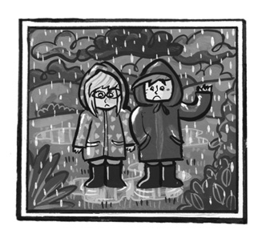

rainbow

cloudy



windy

raining



snowing

sunny

Listen and write. Score / 10

is was were are is wet hot
sunny rainbow windy snow cold

Robert is at the beach today.

It’s hot and _________!
Scott and Stella _________ in the country yesterday.

It was very _________.
Today Suzy and Dotty _________ at the lakes.
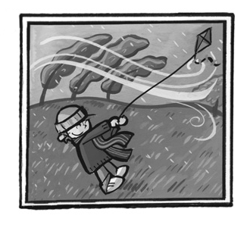
There’s a beautiful _________!
Scott _________ in the country yesterday.
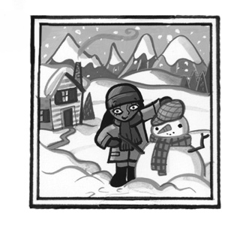
It was very _________.
Today Eva _________ in the mountains.
It’s _________, and there’s lots of _________.

Total unit score / 15

