Name: | Class:

Look and write. Score / 7
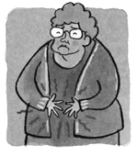
What’s the matter with her? She has a stomachache.
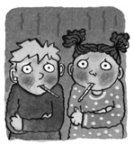
What’s the matter with ____? They have _________.
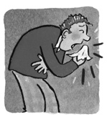
What’s the matter with ______? He has _________.
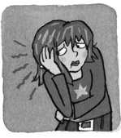
What’s the matter with ______? She has ________.
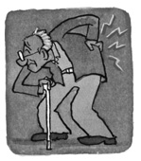
What’s the matter with ______? He has _________.

Look and write. Score / 8

a drink a chair some cake a jacket some ice cream



I’m hungry. Should I get you some cake?



I’m thirsty. ____________________



I’m cold. ____________________



I’m hot. ____________________



I’m tired. ____________________

Total review score / 15

