Name: | Class:

Look and write. Score / 10
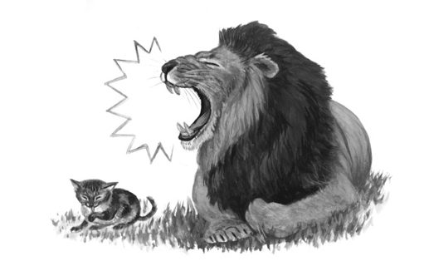
The cat is quieter than the lion. (quiet)

The lion ______________________. (strong)

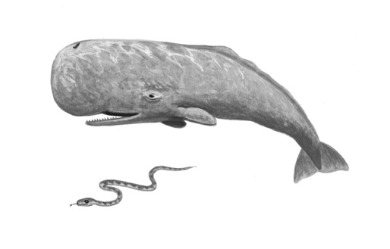
The whale ____________________. (big)

The snake ____________________. (thin)
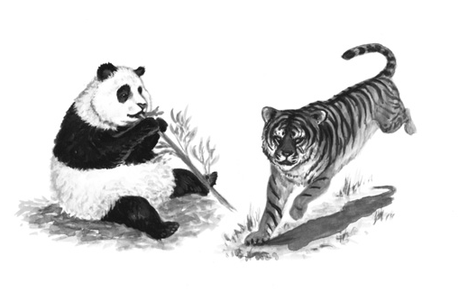

The panda ____________________. (fat)

The tiger ____________________ . (quick)

Read and circle. Score / 5


We wasn’t / weren’t at the beach yesterday.

I was / were at home yesterday.

It was / wasn’t sunny yesterday. It was cloudy.

They were / weren’t at school yesterday. It was Sunday!

Where were / was you yesterday?

It was / were snowing yesterday, but today it’s raining.

Total unit score / 15

