

1 Listen and write the number. (5 points)
news−4, comedy−2, weather−3, documentary−6, series−5


1 Do you love sports? Don’t forget to watch the tennis tonight at eight o’clock. It’s an exciting game!
2 On Channel 1 this afternoon, you can see The Naughty King. It’s a comedy movie for kids and adults. Turn it on at four thirty. See the funny things the king does when he goes to London.
3 It rained on Monday, it rained on Tuesday, and it rained on Wednesday. What’s the weather like today? Can you leave your umbrellas at home? Watch the weather at a quarter to seven on Channel 3 to find out.
4 The news this afternoon has a lot of very interesting stories. You can find out about all the things that happen in the world. So don’t forget to turn on your TV at a quarter after three.
5 At twenty after five, see the first episode of Smart Kids. Today, Jack and Sally have a big problem when they catch a bus to the city. Don’t forget episode 2 is on tomorrow at the same time.
6 Do you know what a zebra eats for breakfast? Or how many hours a giraffe sleeps? Channel 4’s very interesting documentary on African animals answers these questions and many more.

2 Read and correct the sentences. (10 points)
2 twenty-five after eight, 3 nine o’clock, 4 a quarter to eleven, 5 twelve thirty, 6 ten after four



1 Read and check or put an X in the box. (5 points)
2 a , b , 3 a , b , 4 a , b , 5 a , , 6 a , b

2 Read, look, and write. (10 points)
2 works, 3 quarter, 4 going, 5 isn’t, 6 are

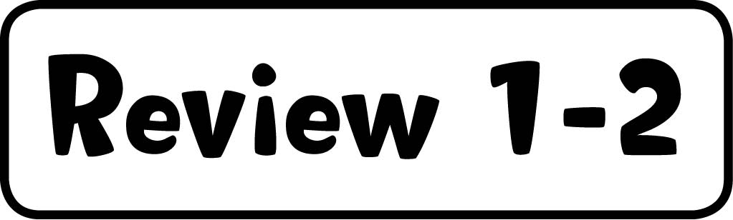

1 Circle the word that doesn't belong. (5 points)
2 job, 3 hairbrush, 4 clock, 5 thief, 6 movie theater

2 Look at the pictures. Then read and write. (10 points)
2 He’s going to play soccer at twenty-five after three.
3 He’s going to sleep at twenty to ten.
4 She’s going to brush her teeth at twenty after seven.
5 They’re going to skate at twenty-five to five.
6 They’re going to buy a computer at ten after ten.

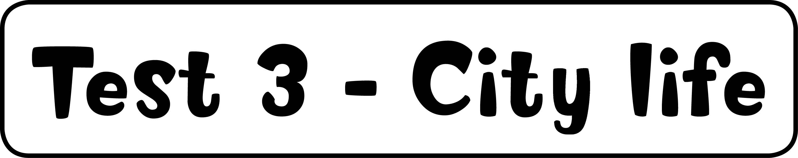

1 Listen and circle. (5 points)
2 park, 3 morning, 4 in the park, 5 went by taxi, 6 wants to go


Boy: Hello, Lucy. Did you have a good day yesterday?
Lucy: It was fantastic! I went to a big park downtown with my family.
Boy: Is that the park near the bus station?
Lucy: No, it’s near the museum, and the train station is across the street.
Boy: Oh, I know it. Did you go skating in the afternoon?
Lucy: No, I went skating with my sister before lunch.
Boy: So did you go home early?
Lucy: No, we didn’t. After skating, we sat on the grass and ate some sandwiches, and then we went shopping.
Boy: Did you walk to the store?
Lucy: No, we took a taxi. When it crossed over the bridge, we saw the theater.
Boy: Oh, it’s beautiful. I saw Romeo and Juliet there last year.
Lucy: Wow! I’m going to ask my mom if we can go to the theater soon.

2 Look at the map, read, and write. (10 points)
2 toy store, 3 swimming pool, 4 park, 5 shoe store, 6 bus stop



1 Read and choose the best answer. (5 points)
2 f, 3 c, 4 d, 5 a, 6 b

2 Listen and check the box. (10 points)
2 a, 3 b, 4 a, 5 c, 6 b


1 What was Ali doing when he hurt his leg?
Woman: Is your leg OK, Ali?
Ali: No, I hurt it yesterday.
Woman: Were you skiing?
Ali : No, I went skiing on Saturday. Then I played in the snow on Sunday, but didn’t have any problems.
Woman: So, what happened?
Ali : Well, on Monday, I went swimming, and my little brother wanted to play. I hurt my leg when I was playing in the water with him.

2 What was the weather like when they were driving home?
Man: What a terrible drive!
Girl: I know. We couldn’t see a lot. You did very well, Dad!
Man: I suppose a little fog is better than a storm.
Girl: Yes, I hate lightning. I think it’s going to be cold tomorrow.
Man: Let’s stay at home then. I don’t want to drive with ice on the road, too!
Girl: OK.

3 When is Anna going to take a vacation?
Anna: I’m very tired. I need a vacation!
Man: Why don’t you go next month?
Anna: In March? That’s impossible. I have a lot of work to do.
Man: Well, you could go in October.
Anna: Mm, maybe, but October is cold and windy. I want to go sailing and relax on the beach. I’m going to take a vacation in June.
Man: Good idea.

4 What was Sam doing at two o’clock yesterday afternoon?
Sam: I had a great afternoon yesterday.
Girl: Where were you? I called you at two, but you didn’t answer your phone.
Sam: I was in the country. I never take my phone when I go there. I like walking and climbing and having some quiet time.
Girl: So were you walking up a mountain when I called?
Sam: No, I walked all morning, so at two I was sitting under a tree, I think.
Girl: You live in a different world, Sam!

5 What disaster did Ed hear about on the news last night?
Ed: Did you watch the news last night?
Woman: No, Ed, I didn’t. I don’t watch a lot of TV. But I saw the news about the volcano in Italy last week.
Ed: That was terrible. Yesterday they showed a very dangerous hurricane that was moving across the Pacific Ocean.
Woman: Oh, no.

6 What was Paul doing at four thirty yesterday?
Girl: What did you do after school, Paul?
Paul: I caught the bus home.
Girl: Oh, I thought you played soccer on Mondays.
Paul: No, I play soccer on Tuesdays. Yesterday, I went straight home. At four thirty I was finishing my homework.

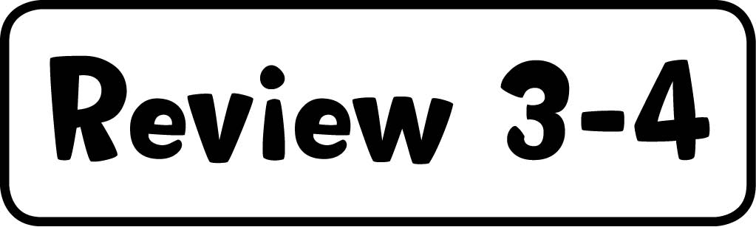

1 Read and match. (5 points)
2 our boat hit an iceberg. 3 when I cut my foot. 4 did you visit Rome? 5 when her mom arrived home.
6 when they were having a picnic?

2 Read and write the words. (10 points)
2 firefighter, 3 February, 4 tsunami, 5 straight ahead, 6 library, 7 police station, 8 island, 9 fog,
10 bus stop, 11 restaurant



1 Write the material. (5 points)
2 plastic, 3 wool, 4 wood, 5 glass, 6 metal

2 Listen and complete. (10 points)
2 paper, 3 outside, 4 plastic bags, 5 glass, 6 angry


Girl: Hi, Ben!
Ben: Hi!
Girl: Can I ask you some questions for my school project?
Ben: Of course.
Girl: Thanks. It’s about recycling. So do you recycle every day?
Ben: No, not every day. I usually recycle things once a week, on Saturdays.
Girl: OK. What things do you recycle?
Ben: A lot of paper.
Girl: Where do you take the paper?
Ben: There are some bins outside the supermarket for recycling. So I go there.
Girl: Do you take your plastic bags there, too?
Ben: Not usually. I try to reuse plastic bags. When I go to the supermarket, I always take a plastic bag with me. Then they don’t have to give me a new bag.
Girl: That’s a good idea. Do you think it’s easy to recycle?
Ben: Yes. In our town, you can recycle paper, plastic, glass, and clothes.
Girl: Excellent.
Ben: Yes, but lots of people don’t recycle. Yesterday, I went to the beach, and there was a lot of trash on it. I was really angry!

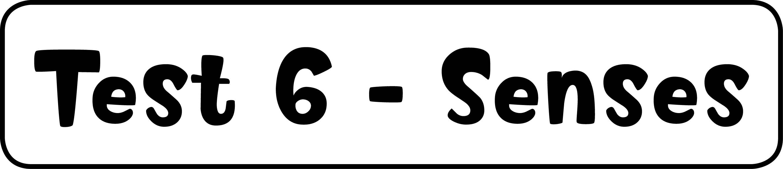

1 Look at the picture. Read and check or put an X in the box. (5 points)
2 , 3 , 4 , 5 , 6

2 Read and complete. (10 points)
2 toppings, 3 tomatoes, 4 cabinet, 5 cut, 6 five

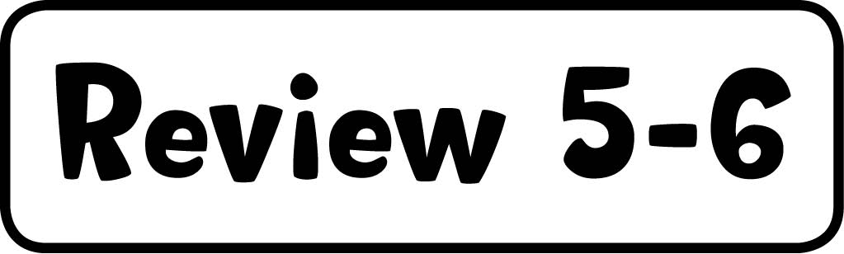

1 Listen and write the number. (5 points)
2 hamburger, 3 crown, 4 cupcakes, 5 coffee, 6 notebook


1 They are made of leather. They protect your feet. They look like sneakers, but you don’t play sports when you wear them.
2 It looks like a big sandwich. You can put tomato and lettuce in it. It’s not a good idea to eat it every day. People eat it with fries.
3 It looks like a hat, but it’s made of gold. It’s very expensive. A king or queen wears it.
4 They are round. They sometimes taste like chocolate. You eat them at birthday parties.
5 It looks like cola, but it isn’t cold. It’s a hot drink. People drink it in the morning or after a meal. It smells strong.
6 It can be big or small. You use it at school. It’s made of paper. It has a lot of pages. You can recycle it.

2 Circle the correct answer. (10 points)
2 knife, 3 looks, 4 is, 5 five, 6 tastes, 7 knows, 8 Their, 9 Glass, 10 sugar, 11 Italian



1 Complete the sentences. (5 points)
2 after meals, 3 near a busy road, 4 the habitat where you live, 5 before meals, 6 in the country

2 Listen and check or put an X in the box. (10 points)
2 , 3 , 4 , 5 , 6 , 7 , 8 , 9 , 10 , 11


1 This reptile has stripes.
2 It lives in the ocean.
3 This is an endangered animal.
4 It has a long tail.
5 This is a very big insect.
6 It has long arms.
7 This animal is extinct.
8 It uses wings to fly.
9 This animal lives in hot places.
10 It has large spots on its legs.
11 This animal wakes up at night.



1 Correct the sentences. (10 points)
2 He has won. 3 He has dropped the eggs. 4 She has brushed her hair. 5 They have visited the castle.
6 She has cleaned the kitchen.

2 Listen and write the number. (5 points)
soccer–2, skiing–3, track and field–4, ice-skating–5, golf–6


1 My sport is very exciting. I do it in winter because you need snow. I go with my friends. We sit on a sled and go very fast down big hills.
2 You do my sport on a team. It’s easy to play. You need a ball and some friends. You have to kick the ball well and run a lot. You have to score goals to win.
3 I do my sport in the winter. I go to the mountains with my family. We go down the mountains really fast. Then we get on a ski lift. It takes us back to the top of the mountains.
4 You have to run fast and jump high in my sport. I throw things, too. My sport is very important in the Olympic Games.
5 You can do my sport outside on a frozen lake. But usually I go to an ice rink with my friends. It’s cold there. I love dancing on the ice.
6 My sport is very difficult. You have to play outside on a course. There are eighteen holes, and you hit a very small ball. You have to get the ball in the holes.

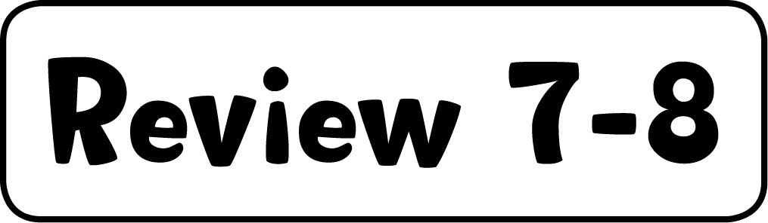

1 Read and match. (5 points)
2 She’s so happy because she’s won the competition. 3 When the sun is strong, you should wear a hat.
4 The teacher’s angry because her students haven’t done their homework. 5 Have you ever been
ice-skating? 6 They haven’t cleaned the bathroom this week.

2 Listen and check. (10 points)
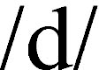

3 , 4 , 5 , 6 , 7


1 He’s climbed the mountain. Climbed.
2 We wanted to eat salad. Wanted.
3 She used a computer. Used.
4 Some frogs are spotted. Spotted.
5 He started his homework. Started.
6 Pandas are endangered. Endangered.
7 Have they cleaned the car? Cleaned.

