Name: | Class:

Look at the pictures and complete the words. Score / 5
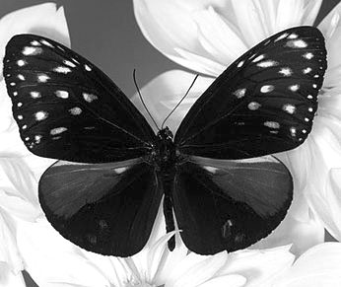

mana g e r but _ _ _ _ _ _

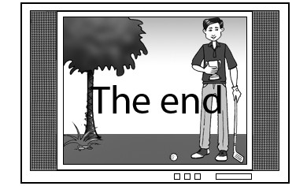
on _ _ _ scr _ _ _

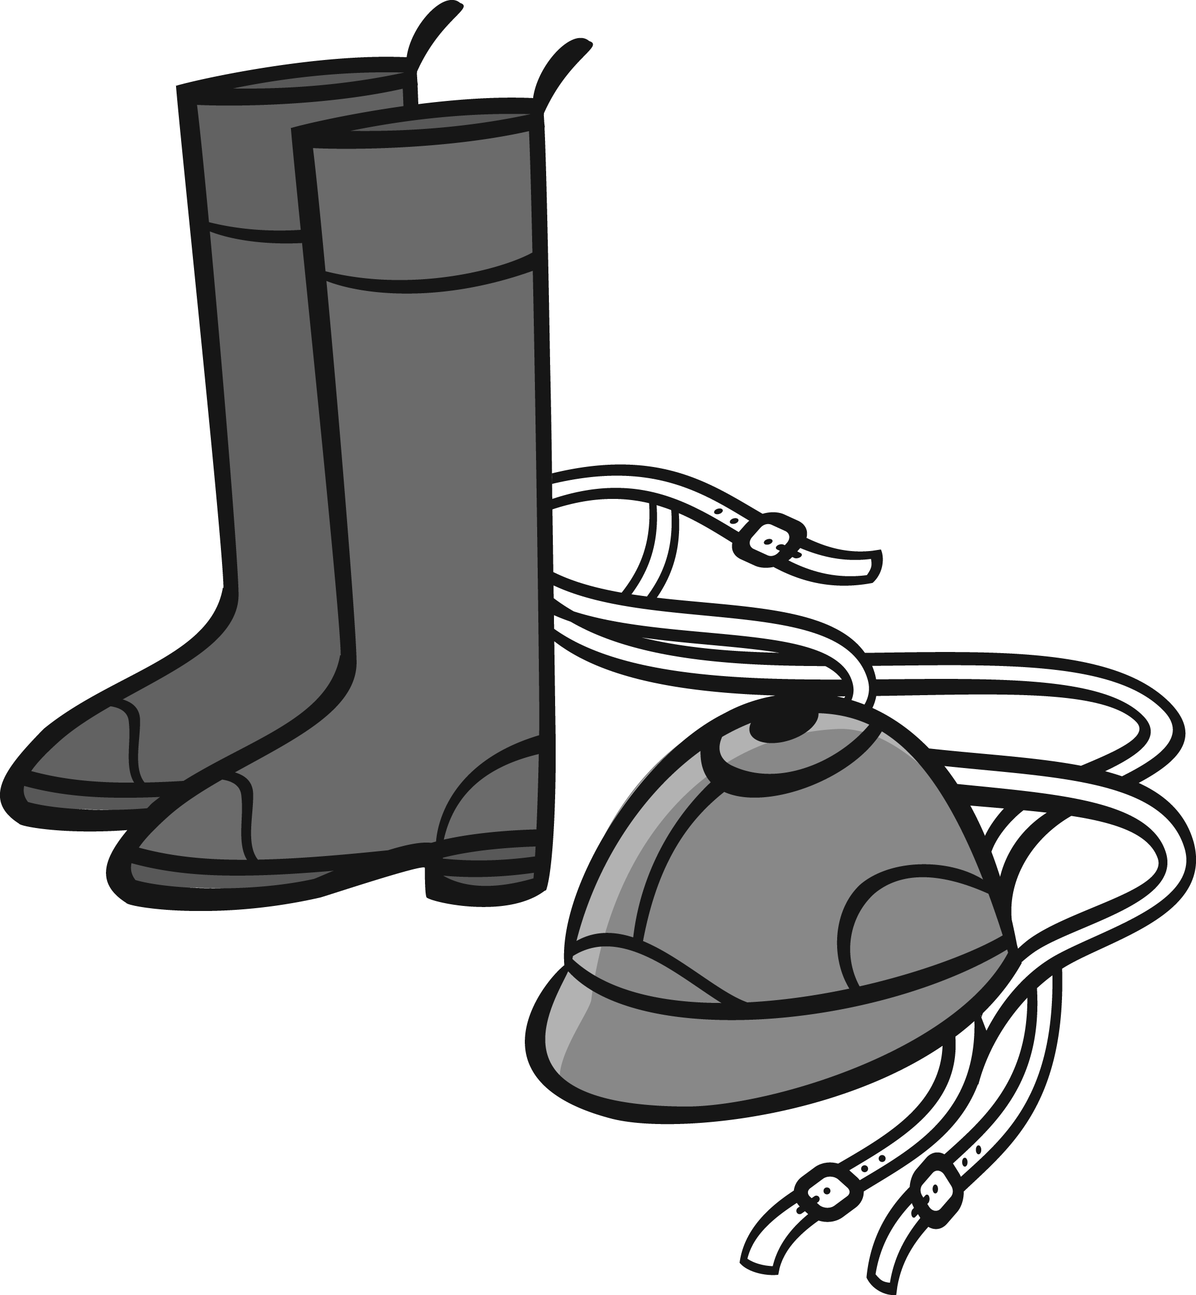
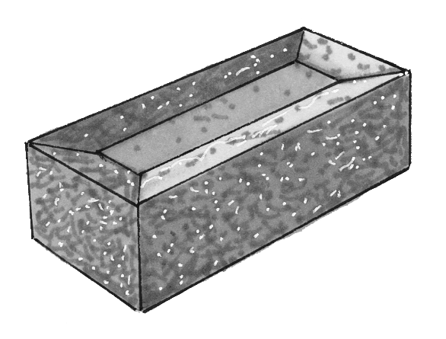
horse _ _ _ _ br _ _ _

_ _ _ _ _ _
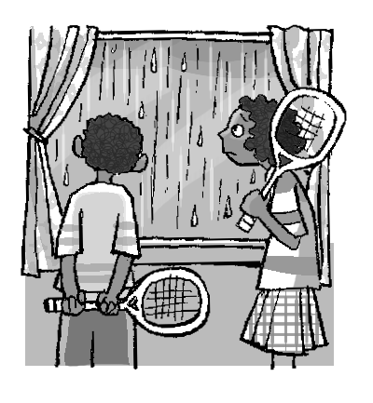
Make negative sentences. Score / 10

They’re going to play tennis.
They aren’t going to play tennis. ________

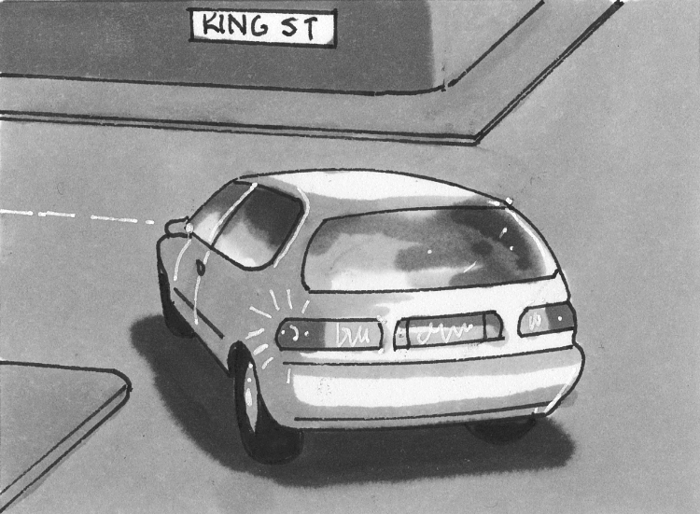
The car is turning right.
________________________

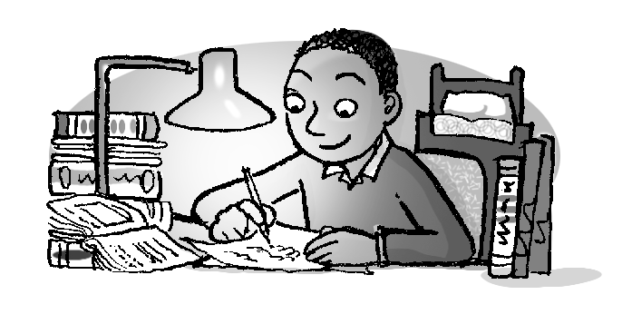

He has finished his homework.
________________________

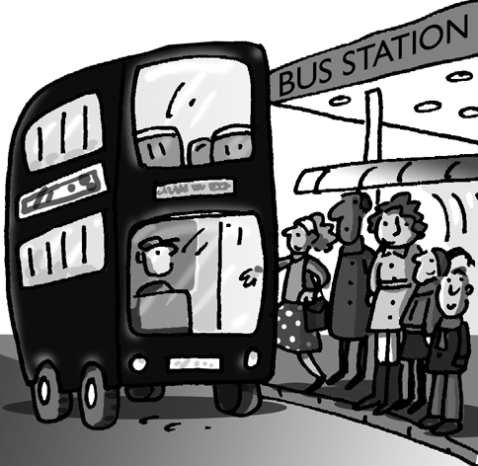
It was raining when the bus arrived.
________________________
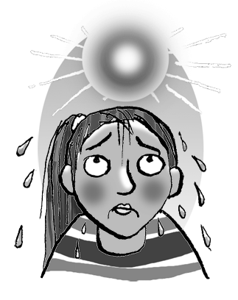

She looks cold.
________________________
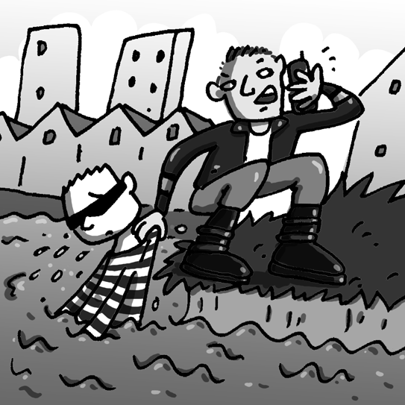

The thief escaped.
________________________
Complete the table. Score / 10

uniform episode reporter rubber medal turn on
bus driver hurricane stone track and field lightning

TV | work | weather | materials | sports
___________ | __uniform _ | ___________ | ___________ | ___________
___________ | ___________ | ___________ | ___________ | ___________
 | ___________

Order the questions. Look, write, and answer. Score / 10

work in the kitchen brushing his teeth on the corner
a doctor a snowman of wood

What / she / to / is / going / do / ? chairs / of / are / What / the
What is she going to do? / made / ? ____________
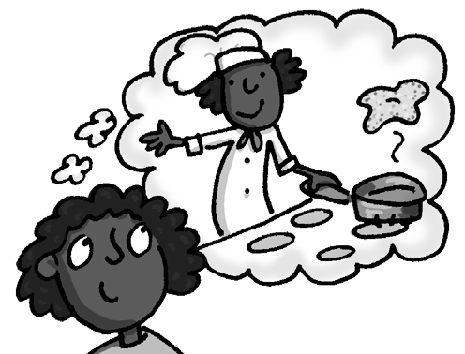
She’s going to work in the kitchen. They are made ___________.
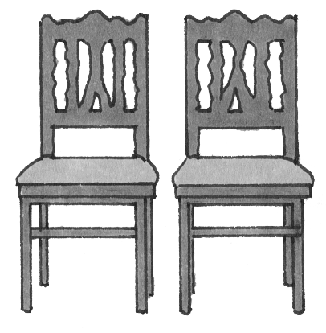

have / What / done / children / the / ? ten / doing / at / was / ten /
__________________ What / he / after / ?
They’ve made ___________. __________________
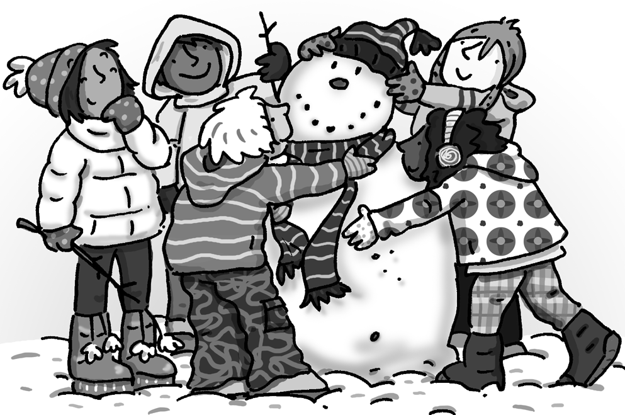
He was ___________.
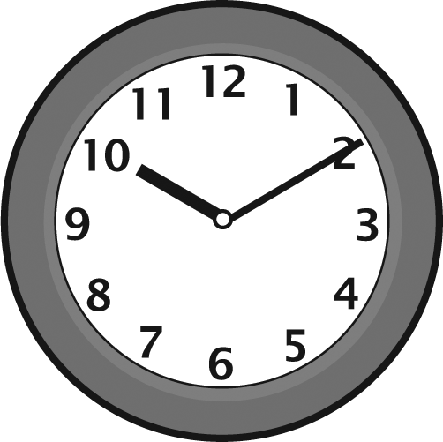
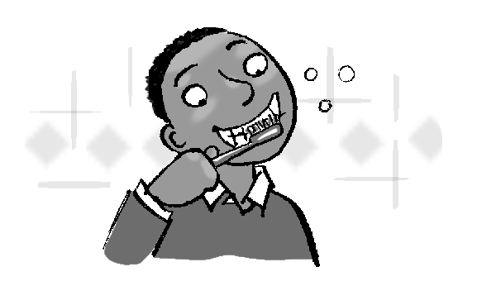

should / do / he / What / ? Where / he / waiting / is / ?
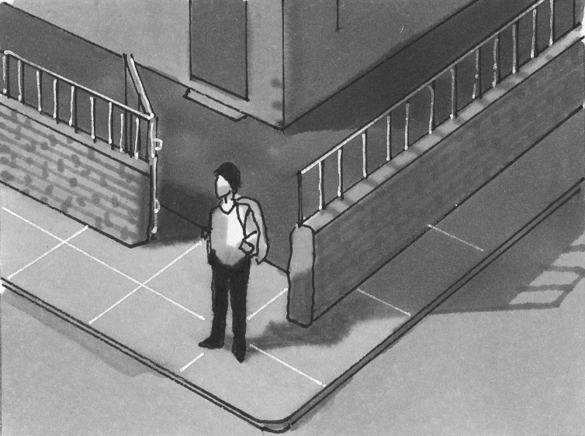
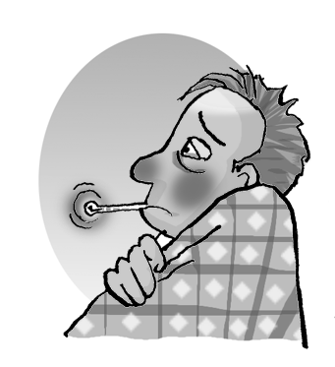
__________________ _____________
He should see _________. He’s He’s waiting _______.

Total end of level score / 35

