Name: | Class:

Read and check () or put an X in the box. Score / 5

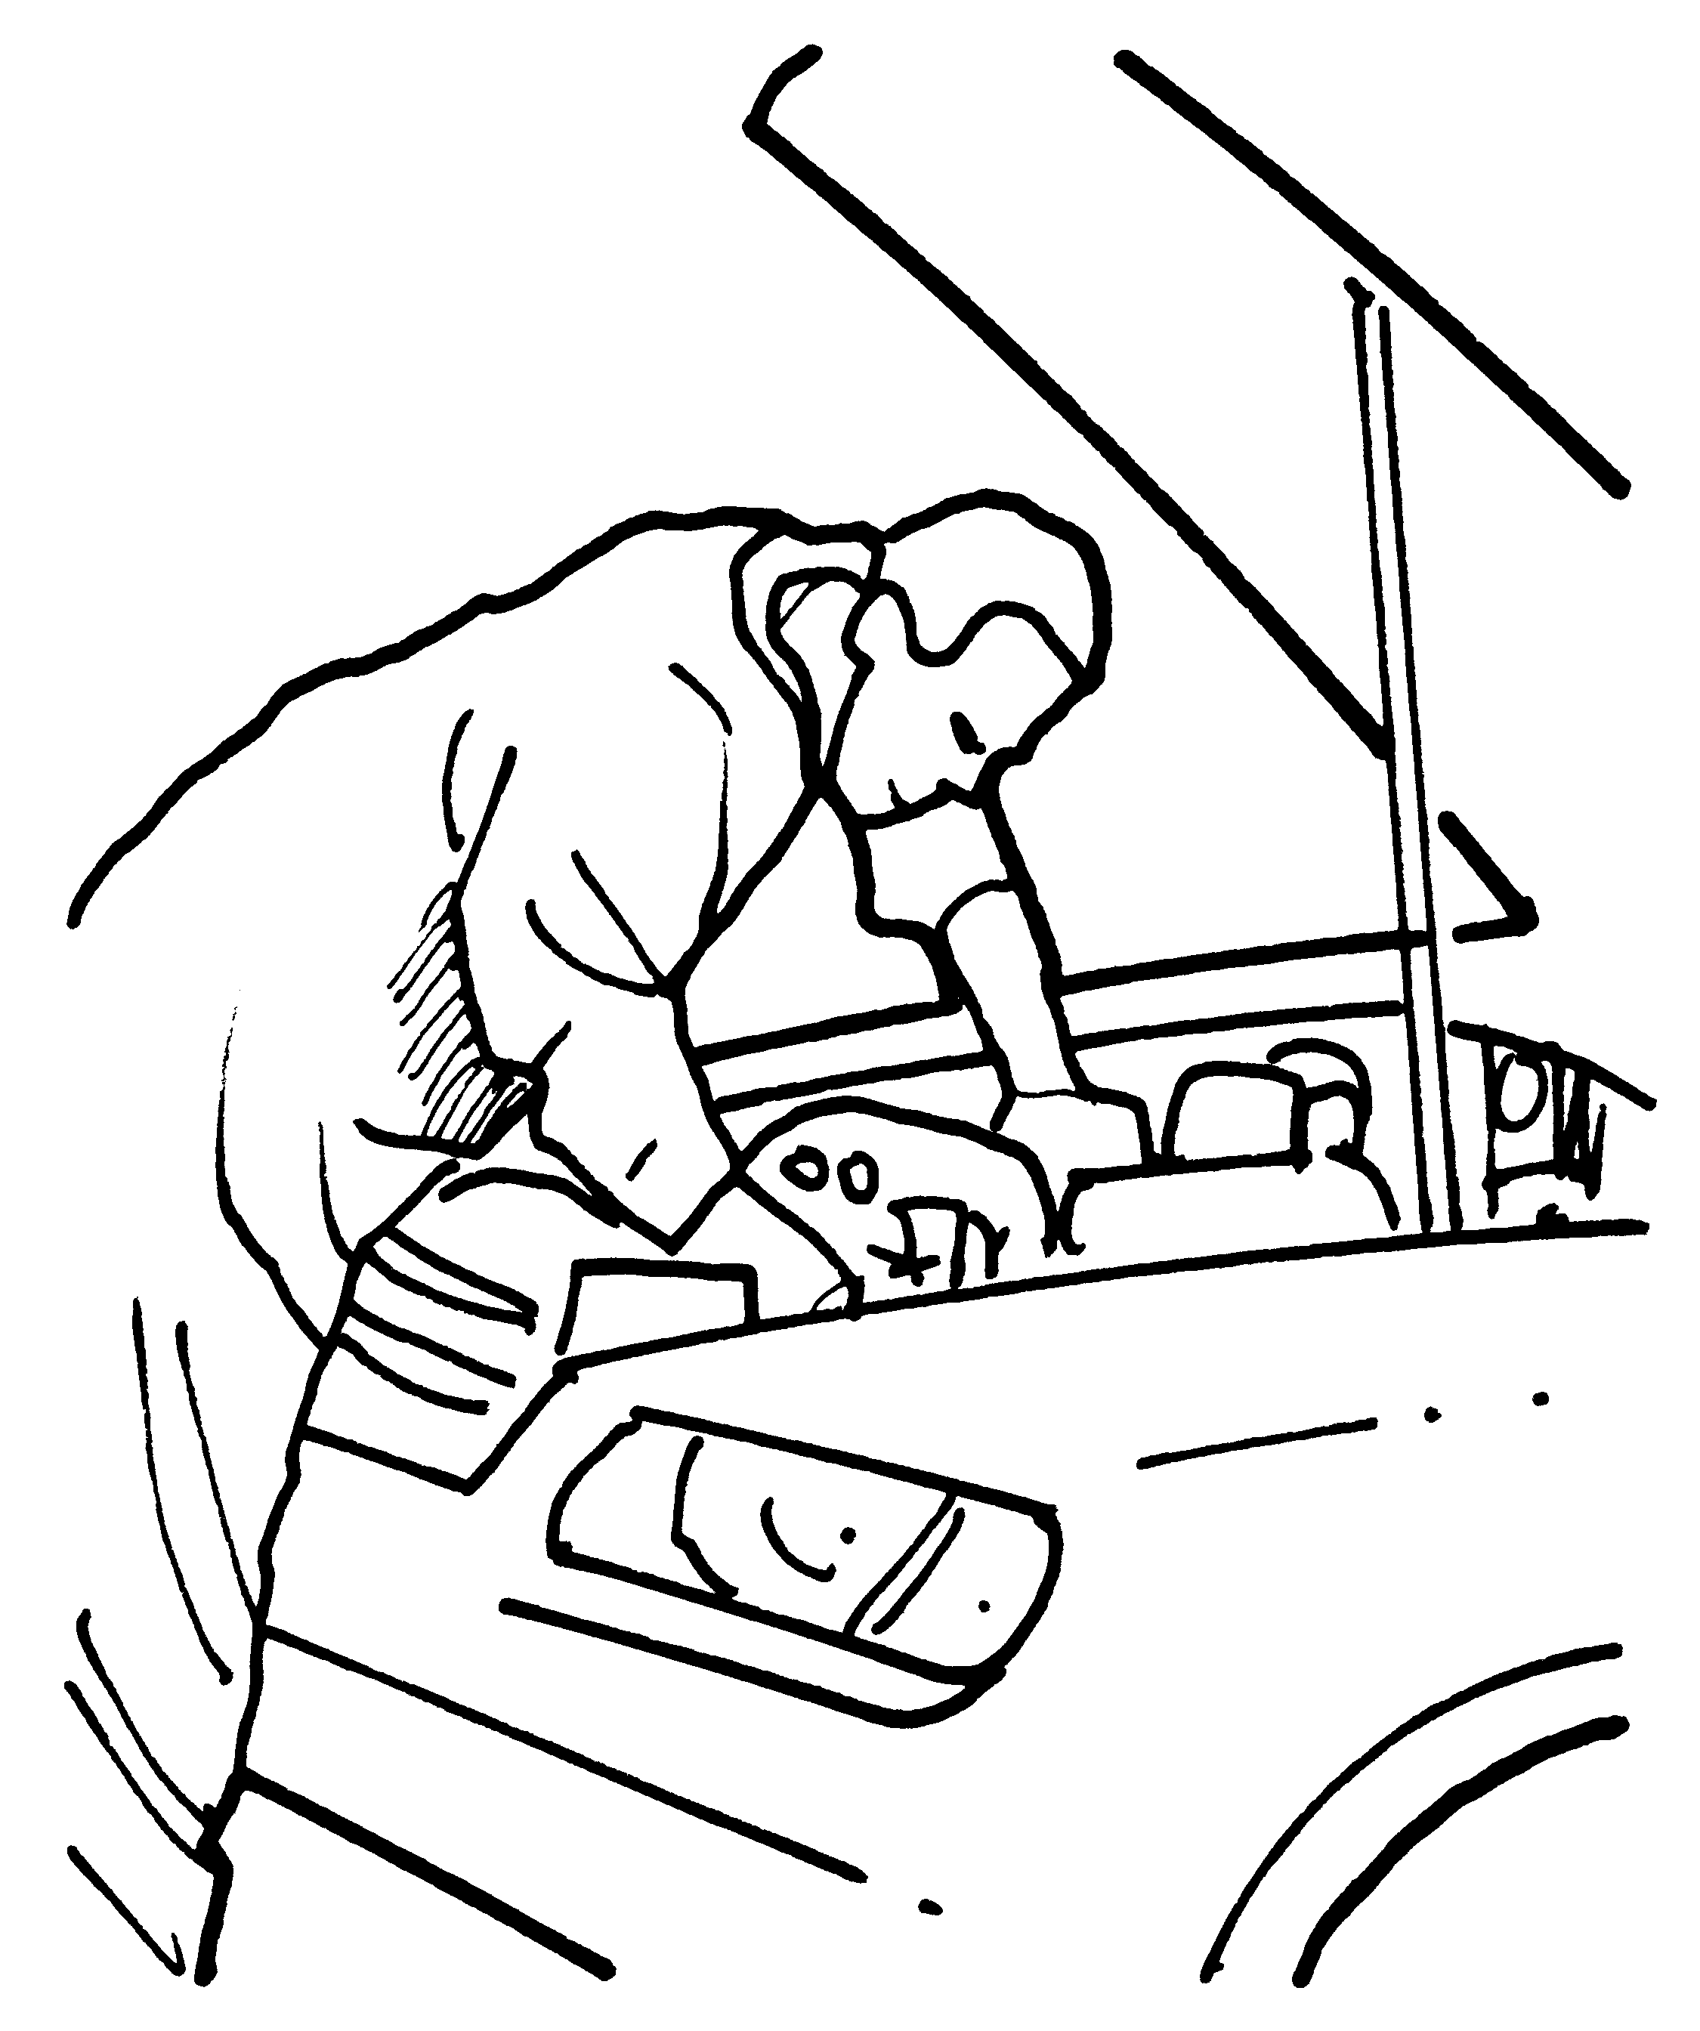
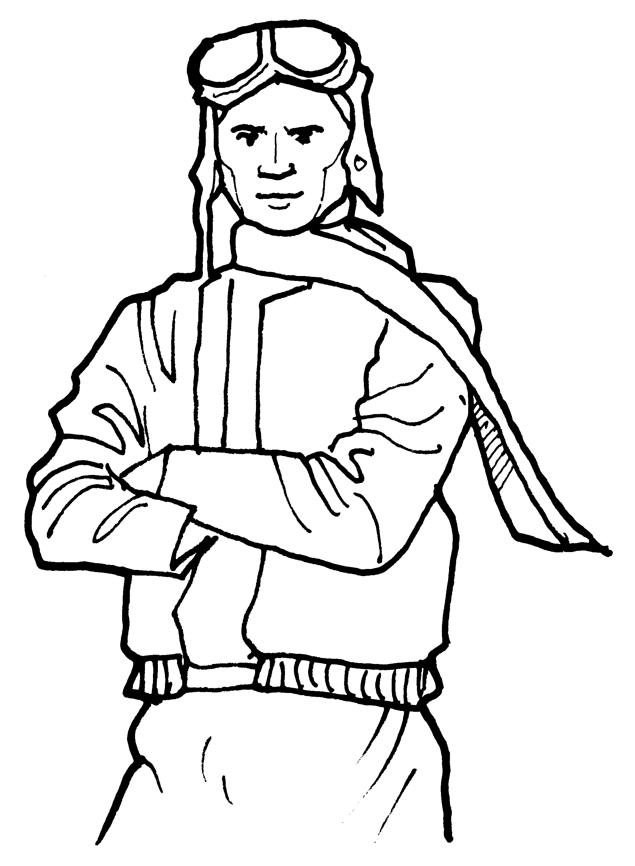


a He drives a car. a He gets dirty.

b He travels a lot. b He works in a kitchen.

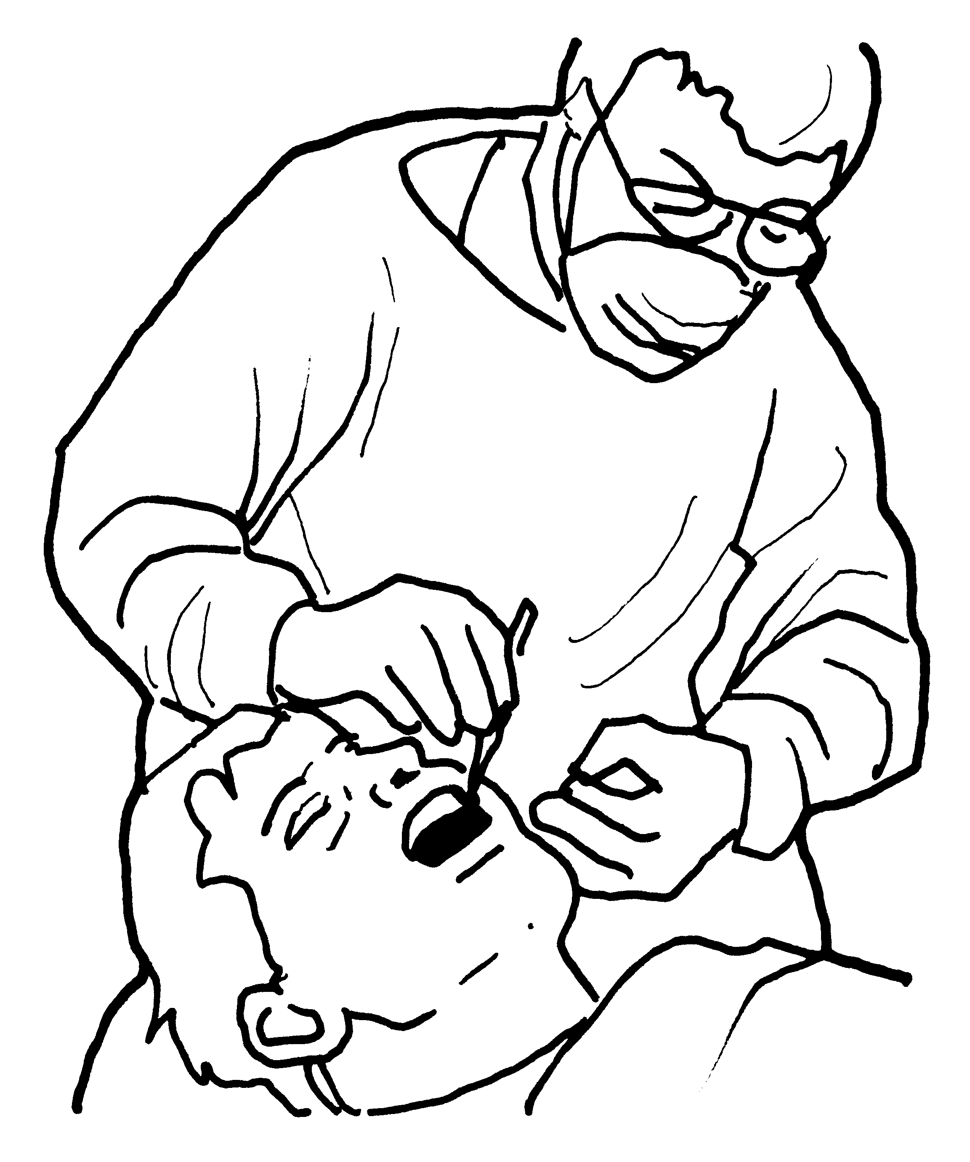
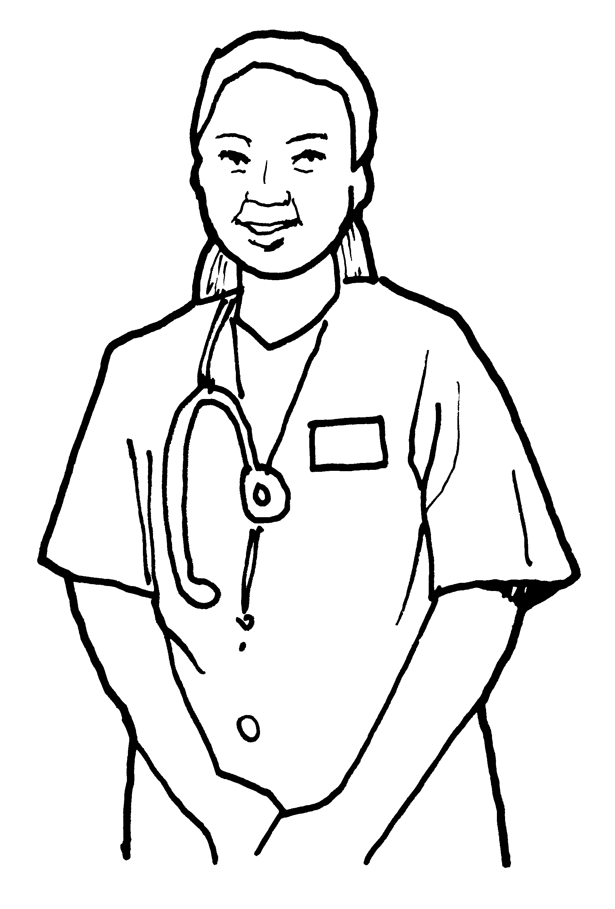
a She takes care of a He works at a school.
people. b He wears gloves and
b She repairs cars. a mask.

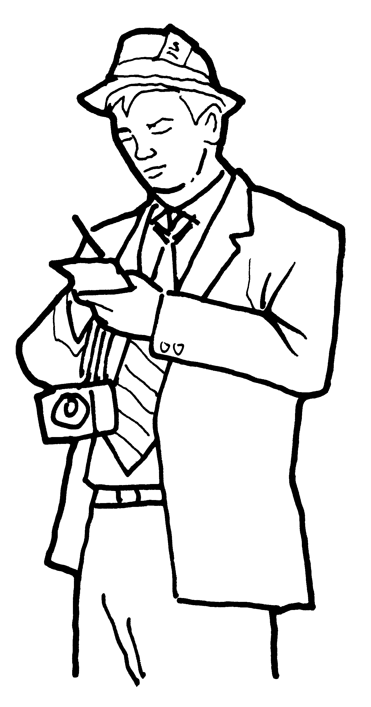

a She visits a lot of a He takes a lot of pictures.
airports. b He has to wear a
b She types very fast. special uniform.

Read, look, and write.

1 | cook | scientist | artist |  | 2 | work | working | works
3 | quarter | half | clock |  | 4 | goes | go | going
5 | is | isn’t | aren’t |  | 6 | are | aren’t | they
Tommy is a (1) cook______ at a very good hotel. He (2) ________
during the week and sometimes on the weekends. He usually gets up at
a (3) ________ to six because he starts work at seven. Today, he’s cooking soup in the kitchen. He’s (4) ________ to have a busy day because a lot of people are going to eat at the hotel. Tommy likes having a lot of things to do, but he (5) ________ going to do everything today. There are three chefs who (6) ________ going to help him. Score / 10

Total unit score / 15

