Name: | Class:

Listen and circle. Score / 5


Lucy had a good / bad day in the city yesterday.
Lucy went to the museum / park.
Lucy skated with her sister in the morning / afternoon.
Lucy had something to eat in the park / in a restaurant.
Lucy walked / went by taxi to the store.
Lucy wants to go / went to the theater.

Look at the map, read, and write. Score / 10

Go straight ahead and take the third street on
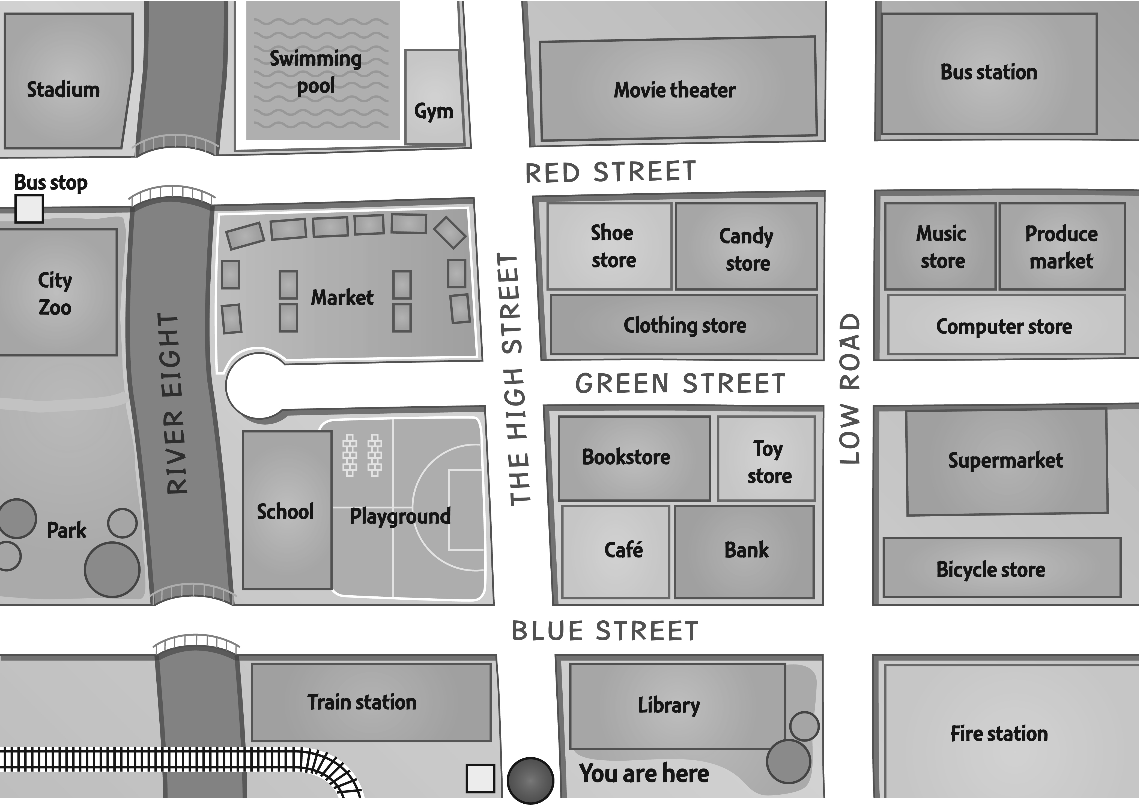
the right. What’s on the left at the end of the
street? bus station___

Go up High Street and turn right onto
Green Street. Walk past the bookstore.
What’s next to it? __________

Go straight ahead and turn left after the
market. What’s across from it? __________

Take the first street on the left and cross over the bridge.
What’s on the right? __________

Go straight ahead, turn right onto Red Street, and stop.
What’s on the corner next to the candy store? __________

Go up High Street and take the third street on the left.
Go straight ahead, past the market and over the river.
What’s outside the zoo? __________

Total unit score / 15

