Name: | Class:

Read and choose the best answer. Score / 5

a Yes, I did every exercise. b I’m sorry, you can’t.
c Yes, I know I took it home. d Not really!
e I’m sorry! I had a disaster this morning. f I couldn’t find my schoolbag.

Teacher: Late again, Emma? Emma: _ I think my brother moved
Emma: e it when I was taking a shower.
Teacher: What happened? Teacher: Did you take your bag home?

Emma: _ My bag was in my Emma: _ When I was doing it, I was
room when I was doing listening to music.
my homework. Teacher: Oh, I see. Did you finish your
Teacher: Was it difficult? homework?

Emma: _ Emma: _ My homework is in my
Teacher: Can I have your schoolbag!

homework, please?

Listen and check () the box. Score / 10

What was Ali doing when he What was the weather like
hurt his leg? when they were driving home?

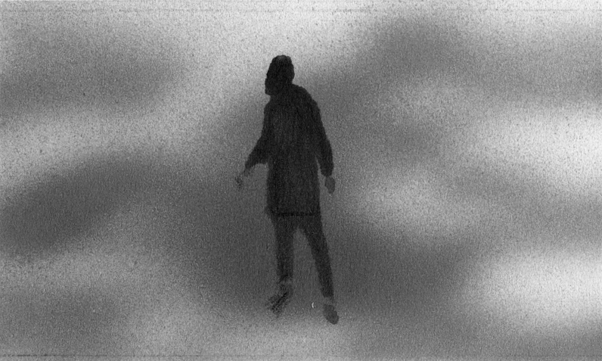

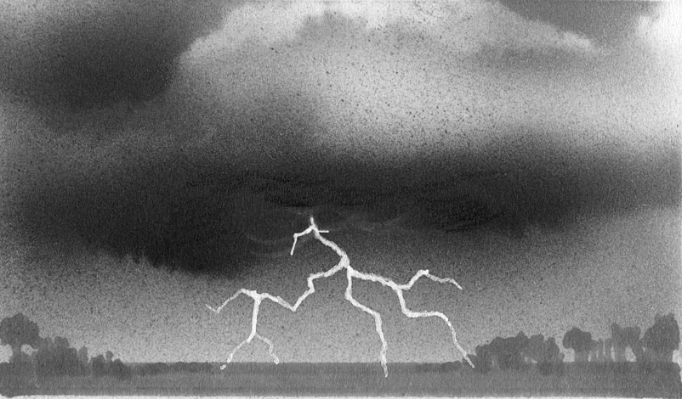
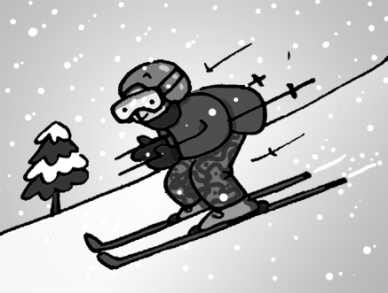
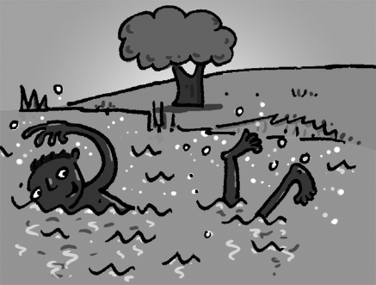
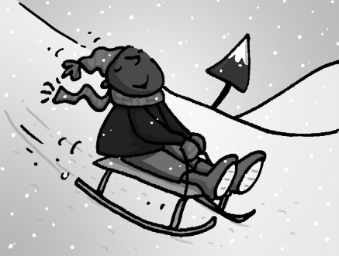
a b c a b c


When is Anna going to take What was Sam doing at 2 o’clock
a vacation? yesterday afternoon?
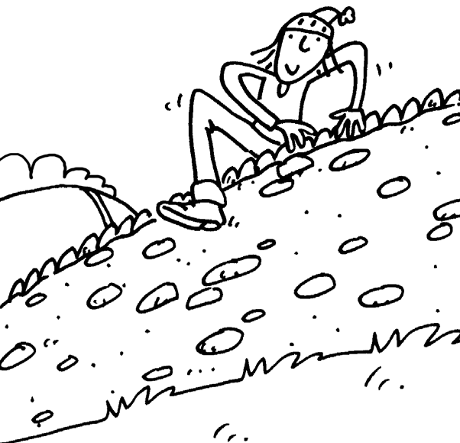
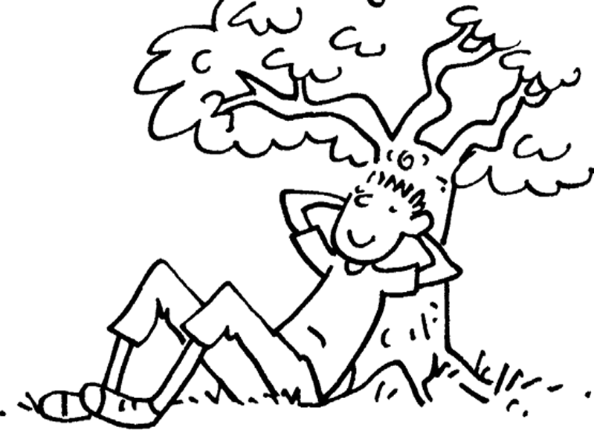
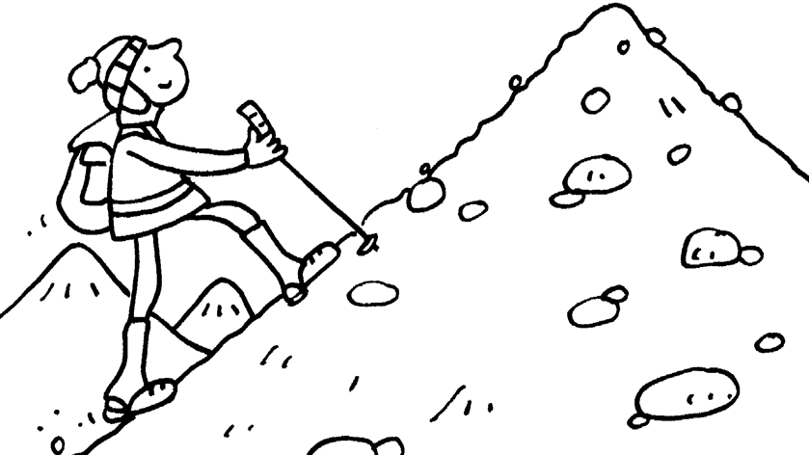
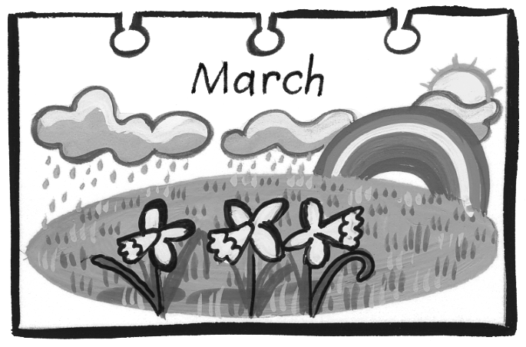
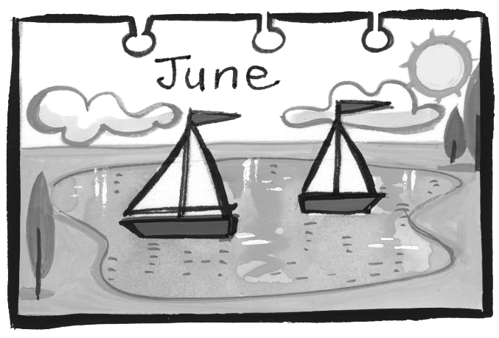
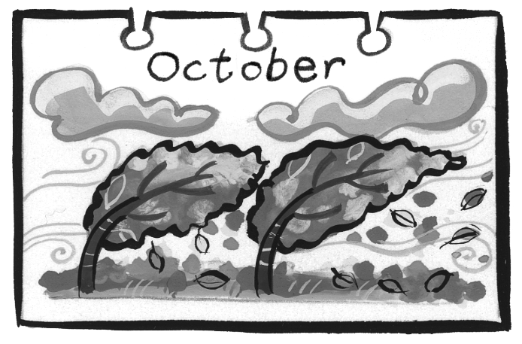
a b c a b c

What disaster did Ed hear What was Paul doing at four
about on the news last night? thirty yesterday?
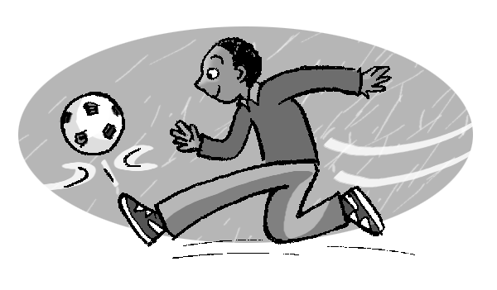
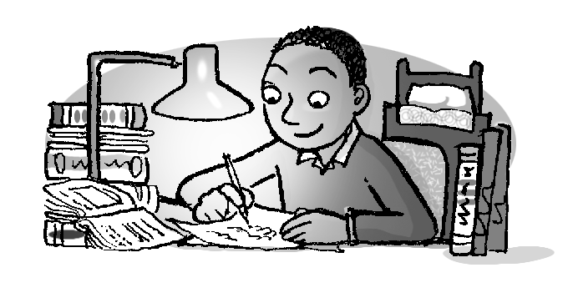
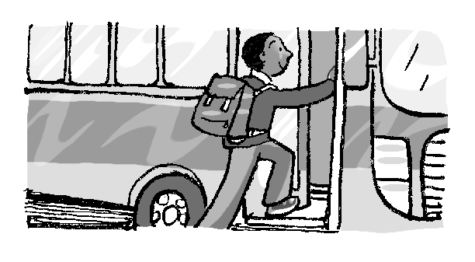
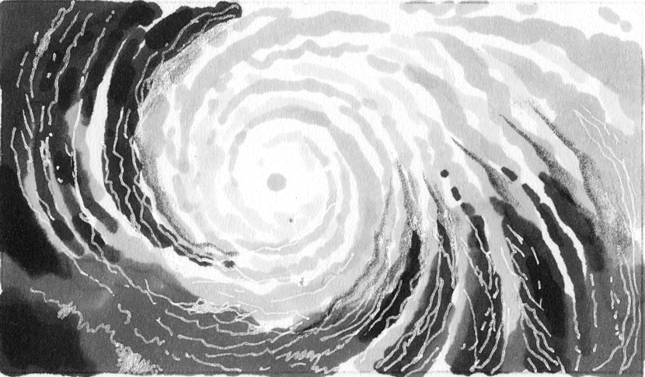
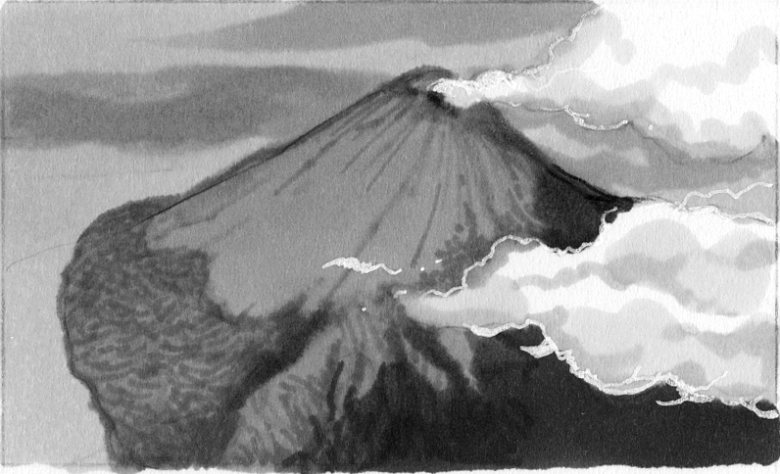
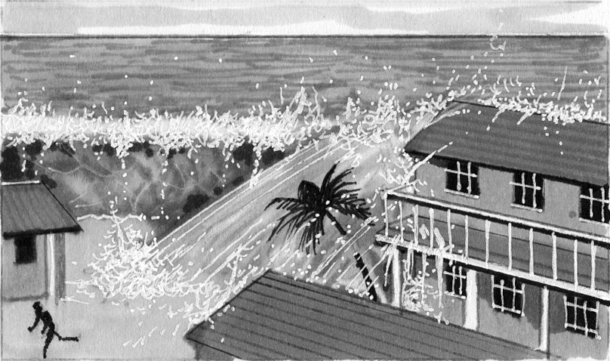
a b c a b c

Total unit score / 15

